高雄市立林園高級中學 國中部 103學年度 第 2 學期 2 年級 英語 科 第 1 次 段考試題卷
班級： 座號： 姓名：
本次測驗，試題共有4頁。第一～四大題為聽力測驗，第五～十一大題為紙筆測驗。請將答案用印刷體寫在答案卷上，測驗結束時將答案卷交回。

一、根據圖表，聽完問題後選出正確的答案：每題1分，共5分
MaMa’s Fruit Stand
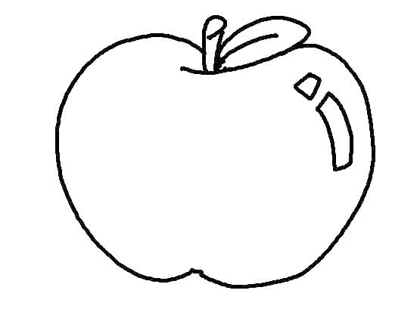  NT$30 | 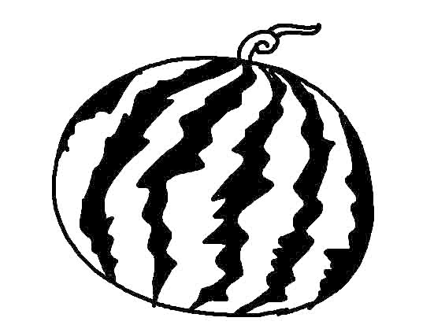  NT$120 | 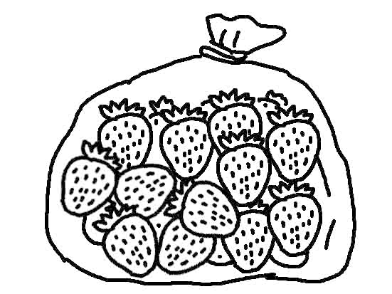  NT$100
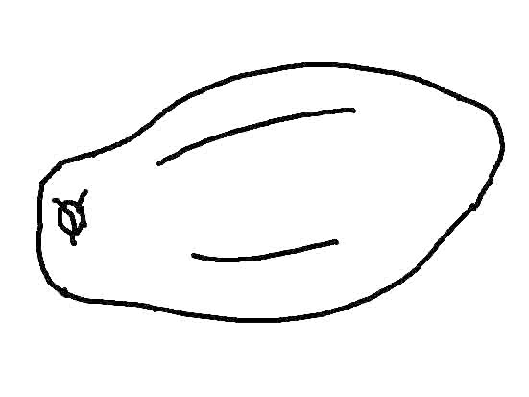  NT$50 | 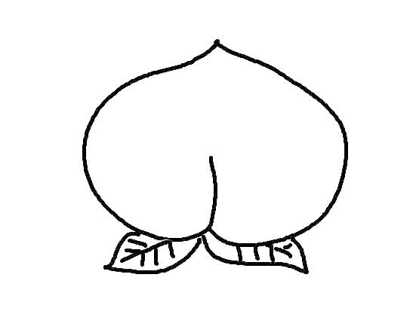  NT$80 | 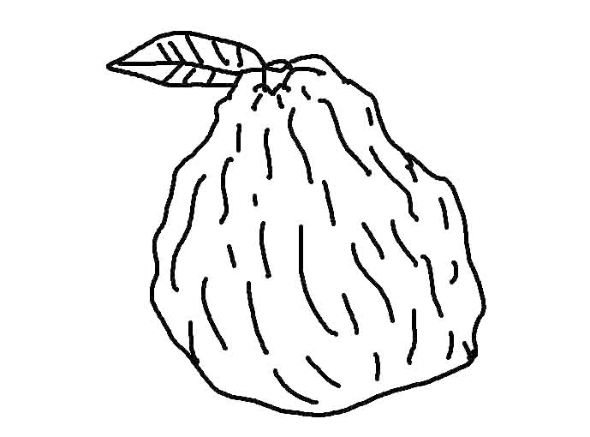  NT$10
Open hours: 17:00~20:00, Tue.~Sun.

( ) 1. (A) Peach. (B) Apple. (C) Guava.
( ) 2. (A) Guava. (B) Apple. (C) Watermelon.
( ) 3. (A) Strawberry. (B) Peach. (C) Lemon.
( ) 4. (A) On Friday. (B) On Thursday. (C) On Monday.
( ) 5. (A) Strawberry. (B) Watermelon. (C) Peach.

二、看圖選出正確的句子代碼：每題1分，共5分
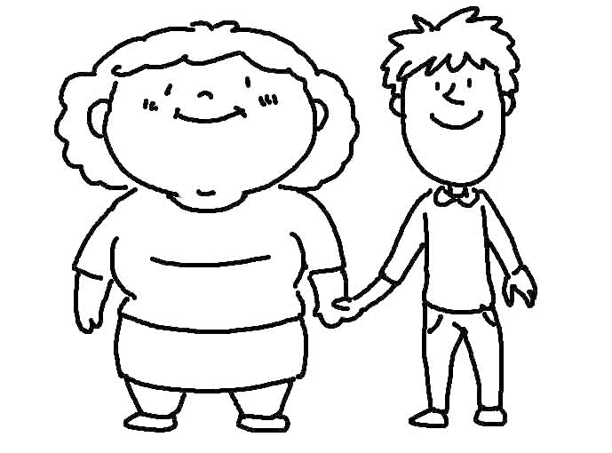
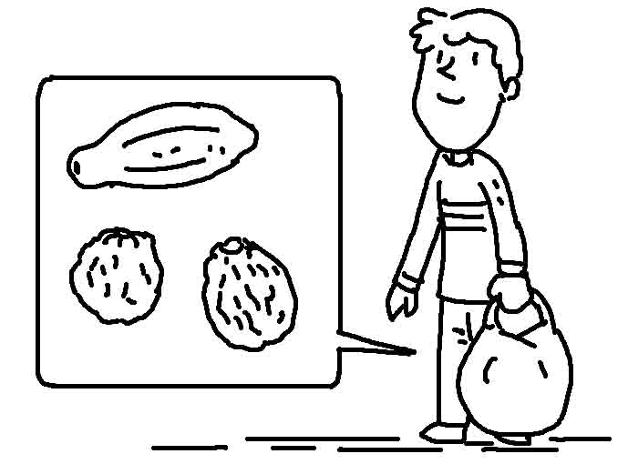
1.( ) 2. ( ) 3. ( )

P.1
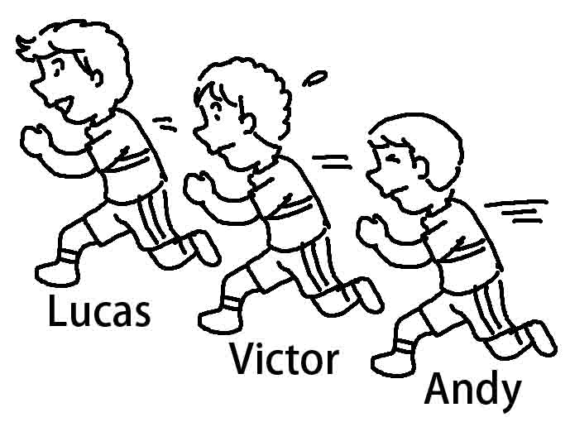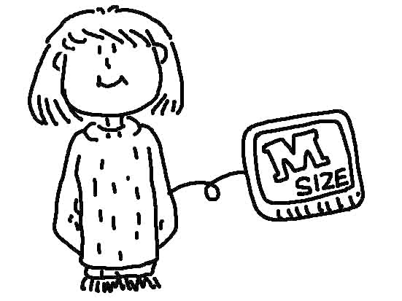
4. ( ) 5. ( )

三、根據聽到的內容，選出合適的回應：每題2分，共10分
( ) 1. (A) Sorry, I’m not sure of the size. (B) Good idea! (C) It was a long story.
( ) 2. (A) Amanda is. (B) Yes, Amanda is. (C) Yes, that girl is Amanda.
( ) 3. (A) Lemon pie. (B) It’s from my mom. (C) Yes, it tastes very delicious.
( ) 4. (A) Yes, it should be OK. (B) Let’s go shopping now. (C) Yes, I think so.
( ) 5. (A) Yes, it’s very beautiful. (B) I’m collecting chopsticks now. (C) Let’s keep looking.

四、根據聽到的對話內容與問題，選出正確的答案：每題2分，共10分
( ) 1. (A) All of them. (B) Seven of them. (C) Three of them.
( ) 2. (A) About NT$2,000. (B) About NT$2,500. (C) About NT$1,000.
( ) 3. (A) English homework. (B) Math homework. (C) Science homework.
( ) 4. (A) Blue. (B) Purple. (C) Pink.
( ) 5. (A) Nora. (B) Peter. (C) Annie.

五、文意字彙：每題2分，共10分
1. After dinner, we have lemon pie for d___t.
2. Fred is shopping at the night market with his f___n friends.
3. It is more d___s for people to ride a motorcycle than to take a train.
4. I want to buy a sweater. Are there any c____ng stores near here?
5. It is about 10 k____ers from here to Taipei City Hall.

六、寫出下列形容詞的比較級或最高級：每題2分，共10分
原級 | 比較級 | 最高級
early | (1)
hot |  | (2)
large | (3)
comfortable |  | (4)
good | (5)

七、文法選擇：每題2分，共10分
( ) 1. All of ____ are studying.
(A) student (B) students (C) the student (D) us

P.2
( ) 2. ____ of the cat’s eyes are big.
(A) Two (B) Both (C) Much (D) One
( ) 3. How much is that book?
= ____ is the price of that book?
(A) What (B) How (C) When (D) Who
( ) 4. Helen is ____ than Tina.
(A) more taller (B) much more taller (C) much taller (D) much more pretty
( ) 5. Mark is the nicest student in our class.
= _______________
(A) Mark is nicer than all the students in our class. (B) Mark is nicer than the other students in our class. (C) The other students in our class are nicer than Mark. (D) Mark is the nicest than the other students in our class.

八、填充：每題2分，共10分
1. You can find stuff 1 lower prices 2 the Internet.
2.Thousands 3 people stood together and counted 4 to the new year.
3.This bright blue shirt would look good 5 my vest.

九、克漏字選擇：每題2分，共10分
Lucy: Hey, Susan. You look great and much 1 than before.
Susan: Really? Thank you. My mother told me to eat 2 fast food and do more exercise. I’m 3 than before. How about you? You look 4 , too.
Lucy: Thanks. I like my school life now. My math is 5 than before, and I have more friends.
Susan: Awesome!
( ) 1. (A) drier (B) fatter (C) shorter (D) thinner
( ) 2. (A) less (B) more (C) fewer (D) better
( ) 3. (A) funnier (B) lazier (C) friendlier (D) healthier
( ) 4. (A) free (B) sick (C) great (D) poor
( ) 5. (A) worse (B) better (C) bigger (D) smarter

十、句型：每題2分，共10分 ( 錯1字扣1分 )
1. A bike is cheaper than a car. ( 用 A car 開頭改寫句子 )

2. Two of the boys like dogs. ( 依畫線部分造原問句 )

3. 我弟弟身高六呎二吋。 ( 把這句改寫成英文 )

P.3
4. 你的麵包全都是新鮮的。 ( 把這句改寫成英文 )

5. 他們是我最好的朋友。 ( 把這句改寫成英文 )

十一、閱讀測驗：每題2分，共10分
 | Place | Opening year | Height (高度)
Burj Khalifa | Dubai | 2010/01/04 | 828m
Taipei 101 | Taipei | 2004/12/31 | 509.2m
Shanghai World Financial Center | Shanghai | 2008/08/30 | 492m
International Commerce Center | Hong Kong | 2011/03 | 484m
Petronas Towers | Kuala Lumpur | 1997/07/10 | 452m
( ) 1. Which one is the oldest?
(A) Burj Khalifa. (B) Taipei 101. (C) Shanghai World Financial Center. (D) Petronas Towers.
( ) 2. Which is the tallest from 2005 to 2009?
(A) Burj Khalifa. (B) Taipei 101. (C) Petronas Towers. (D) Shanghai World Financial Center.
( ) 3. Where could people visit the tallest building in 2011?
(A) Dubai. (B) Taipei. (C) Shanghai. (D) Hong Kong.

Eason wants to buy a tablet PC. Here are the four tablet PCs for him to choose. Look at the chart and answer the questions.

 | Tablet PC 1 | Tablet PC 2 | Tablet PC 3 | Tablet PC 4
Screen | 10 inches | 12 inches | 7 inches | 14 inches
Price | NT$ 9,999 | NT$ 12,999 | NT$ 10,999 | NT$ 12,000
Capacity | 16GB | 16GB | 4GB | 8GB
Color | black | white | gray | white
Discount | x | 30% off | 10% off | x
Real Price | ? | ? | ? | ?

chart 圖表 capacity 容量 discount 折扣

( ) 4. Which tablet PC has the biggest screen?
(A) Tablet PC 1. (B) Tablet PC 2. (C) Tablet PC 3. (D) Tablet PC 4.
( ) 5. Finally, Eason decided to buy Tablet PC 3. What might be the reason? decide 決定 reason 理由
(A) Because it’s the cheapest. (B) Because it’s the smallest.
(C) Because its capacity is the biggest. (D) Because he loves the color black.

P.4
高雄市立林園高級中學 國中部 103學年度 第 2 學期 2 年級 英語 科 第 1 次 段考答案卷
班級： 座號： 姓名：
一、根據圖表，聽完問題後選出正確的答案：每題1分，共5分
1. | 2. | 3. | 4. | 5.
二、看圖選出正確的句子代碼：每題1分，共5分
1. | 2. | 3. | 4. | 5.
三、根據聽到的內容，選出合適的回應：每題2分，共10分
1. | 2. | 3. | 4. | 5.
四、根據聽到的對話內容與問題，選出正確的答案：每題2分，共10分
1. | 2. | 3. | 4. | 5.
五、文意字彙：每題2分，共10分
1. | 2. | 3. | 4. | 5.
六、寫出下列形容詞的比較級或最高級：每題2分，共10分
(1). | (2). | (3). | (4). | (5).
七、文法選擇：每題2分，共10分
1. | 2. | 3. | 4. | 5.
八、填充：每題2分，共10分
1. | 2. | 3. | 4. | 5.
九、克漏字選擇：每題2分，共10分
1. | 2. | 3. | 4. | 5.
十、句型：每題2分，共10分 ( 錯1字扣1分 )
1.
2.
3.
4.
5.
十一、閱讀測驗：每題2分，共10分
1. | 2. | 3. | 4. | 5.

高雄市立林園高級中學 國中部 103學年度 第 2 學期 2 年級 英語 科 第 1 次 段考解答
班級： 座號： 姓名：
- 根據圖表，聽完問題後選出正確的答案：每題1分，共5分
1.A | 2.A | 3.C | 4.C | 5.B
二、看圖選出正確的句子代碼：每題1分，共5分
1.A | 2.B | 3.B | 4.B | 5.C
三、根據聽到的內容，選出合適的回應：每題2分，共10分
1.B | 2.A | 3.A | 4.C | 5.B
四、根據聽到的對話內容與問題，選出正確的答案：每題2分，共10分
1.B | 2.C | 3.C | 4.A | 5.C
五、文意字彙：每題2分，共10分
1.dessert | 2.foreign | 3.dangerous | 4.clothing | 5.kilometers
六、寫出下列形容詞的比較級或最高級：每題2分，共10分
(1).earlier | (2).hottest | (3).larger | (4). (the) most comfortable | (5).better
七、文法選擇：每題2分，共10分
1.D | 2.B | 3.A | 4.C | 5.B
八、填充：每題2分，共10分
1.at | 2.on | 3.of | 4.down | 5.with
九、克漏字選擇：每題2分，共10分
1.D | 2.A | 3.D | 4.C | 5.B
十、句型：每題2分，共10分 ( 錯1字扣1分 )
1.A car is more expensive than a bike.
2.How many of the boys like dogs?
3.My brother is six feet two inches tall.
4.All of your bread is fresh.
5.They are my best friends.
十一、閱讀測驗：每題2分，共10分
1.D | 2.B | 3.A | 4.D | 5.B

