高雄市立林園高級中學 國中部 103學年度 第2學期 2 年級 英語科 第2次段考 試題卷
班級： 姓名： 座號：
本次測驗，試題共有4頁。第一~四大題為聽力測驗，第五~十大題為紙筆測驗。請將答案寫在答案卷上，測驗結束時將答案卷交回。
一、根據聽到的對話內容，敘述正確者寫T，錯誤者寫F：每題1分，共5分
1. The man is looking for a post office.
2. They’re on Yellow Street now.
3. It takes about five minutes to walk to the post office.
4. The woman wants the man to run to the bus stop quickly.
5. The bus stop is on the other side of Blue Street.

二、看圖選出正確的句子代碼：每題1分，共5分

1. 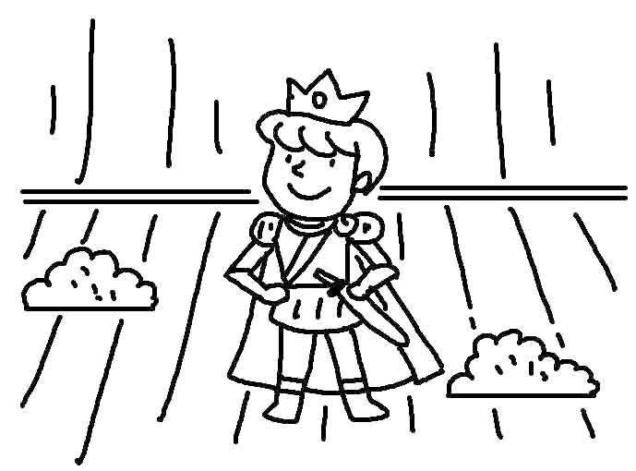 2. 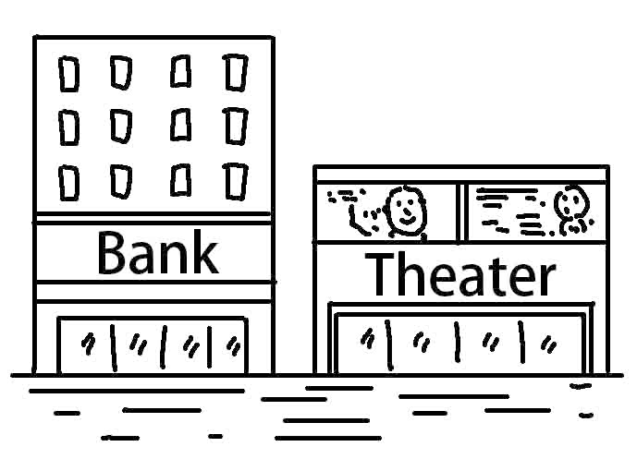 3. 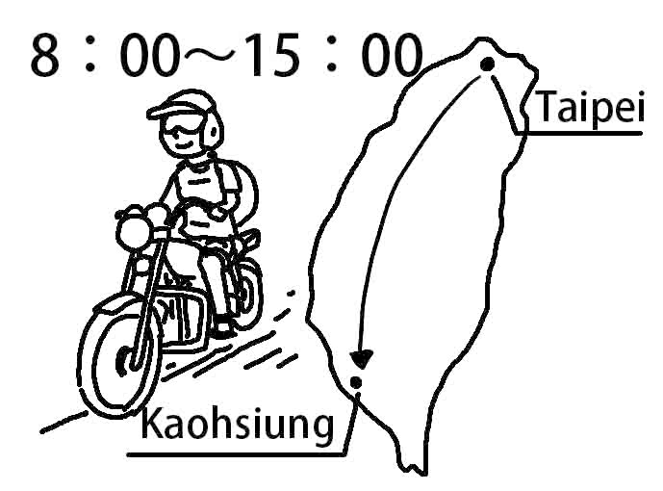

4. 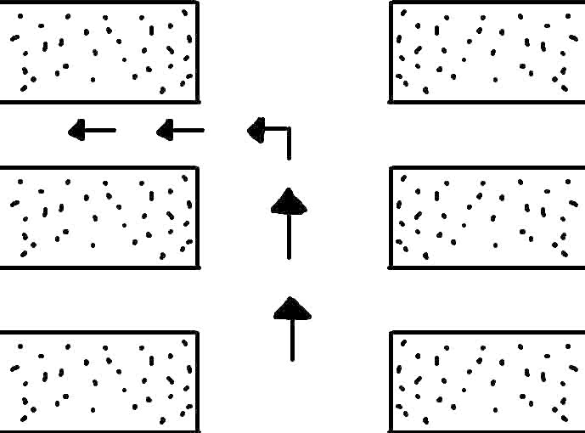 5. 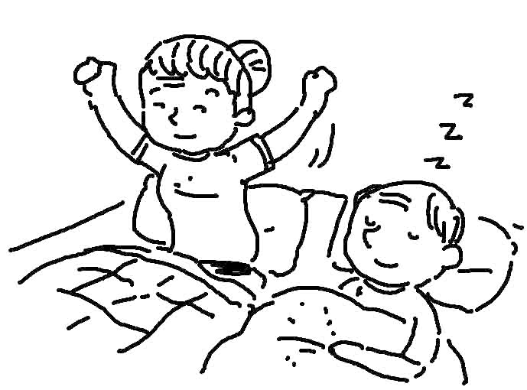

三、根據聽到的內容，選出正確的圖片代碼：每題2分，共10分
1. (A) 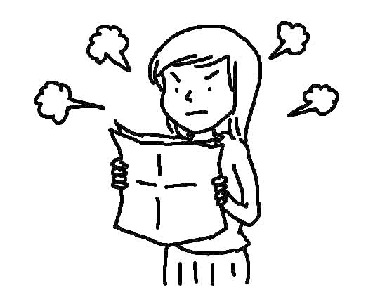 (B) 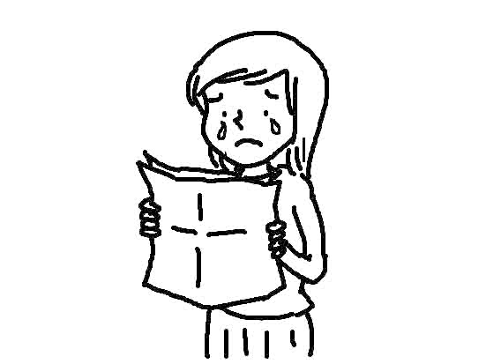 (C) 
2. (A) 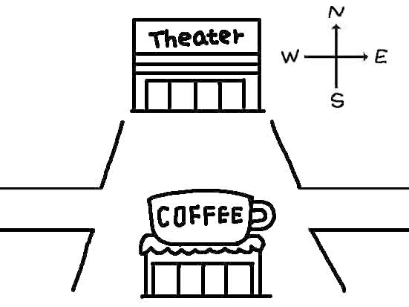 (B) 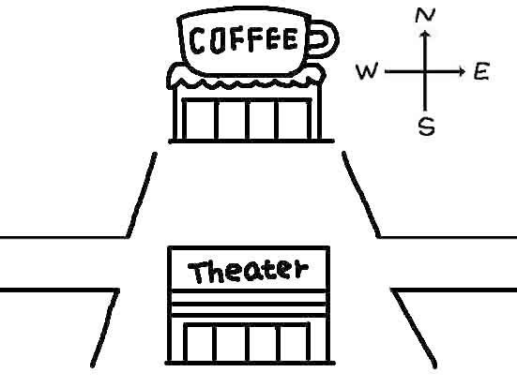 (C) 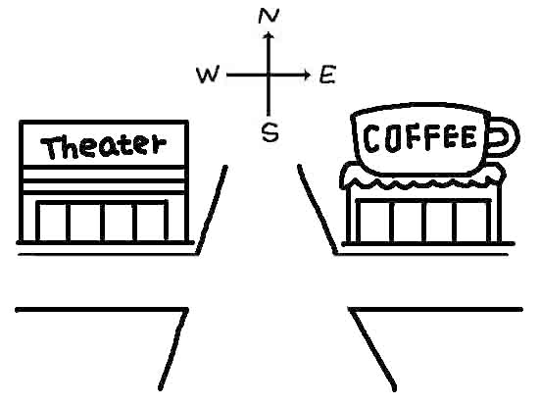
3. (A) 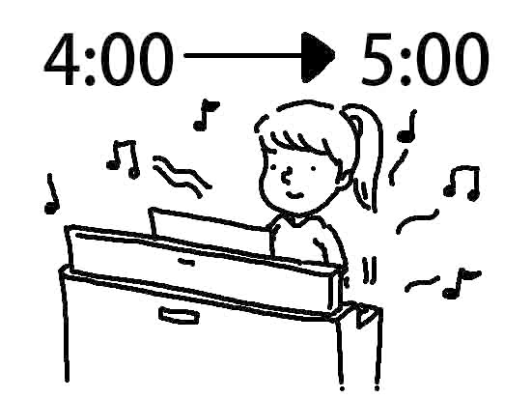 (B) 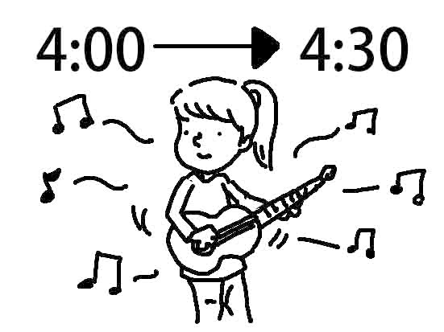 (C) 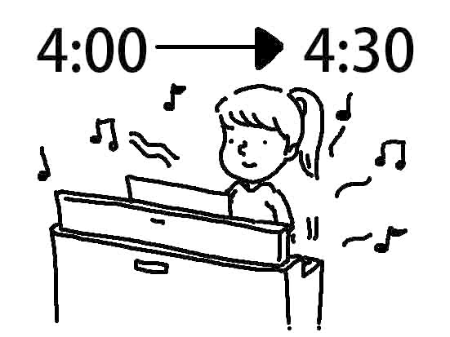
4. (A) 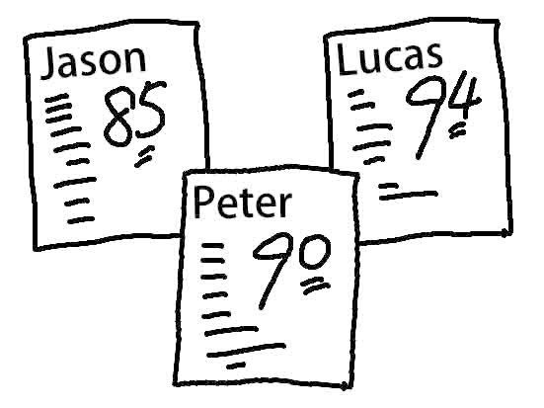 (B) 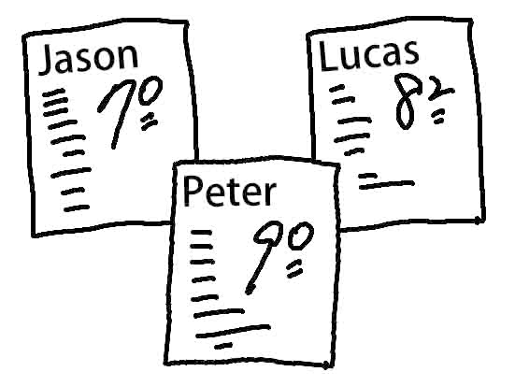 (C) 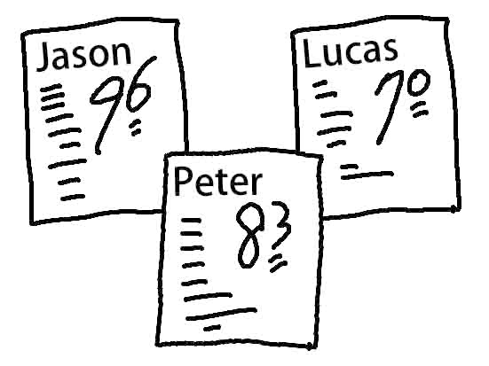
5. (A) 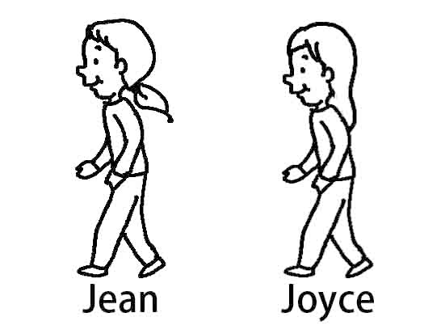 (B) 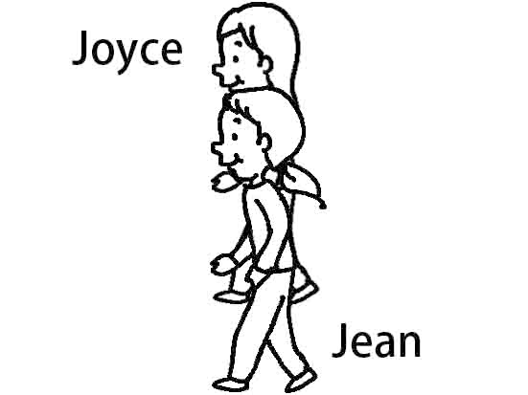 (C) 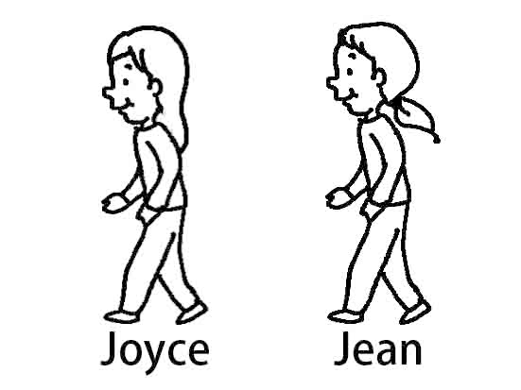

四、根據聽到的對話內容與問題，選出正確的答案：每題2分，共10分
1. (A) She was making chocolate cake.
(B) She was doing the dishes.
(C) She was cooking dinner.
2. (A) Someone bumped into（撞到）him.
(B) He twisted his ankle.
(C) He missed the relay baton（接力棒）.
3. (A) Sarah. (B) Jimmy. (C) Johnson.
4. (A) He will watch TV. (B) He will have some cake. (C) He will take a bath.
5. (A) Milk tea. (B) Coffee. (C) Tea.

五、文意字彙：每題2分，共10分
1. Diana is b e. She is not afraid to touch the snake.
2. While I was walking in the dark yesterday, a dog s y jumped out and bit me on the leg.
3. Please be careful. Someone might follow you and s l the diamond from you.
4. Stephenie Meyer is a su l novelist. Her books sell well.
5. My father is a f y worker. He works very hard every day.

六、填空（依提示填入正確的形容詞或副詞）：每格1分，共10分
1. John can run (1) . He is a (2) runner. (fast)
2. Uncle Ben cooks (1) . He is a (2) cook. (good)
3. Helen is a (1) girl. She dances (2) . (beautiful)
4. Jenny went home (1) after school. She was (2) today. (happy)
5. Mom asked us to keep (1) because Dad was sleeping. We had to talk (2) . (quiet)

七、配合題（根據圖片選出正確答案）：每題2分，共10分
(A) go north (B) turn right (C) turn left (D) next to (E) between (F) go over
Dora is visiting the zoo.
★Dora wants to see the bears and hippos. She should 1. .

★Dora wants to see the kangaroos and koalas. She should 2. the bridge and 3. .

★The rabbits are 4. the sheep.

★The tigers are 5. the lions and the zebras.

八、對話與文法：每題2分，共10分
1. Evan: Would you please give me some tips for playing basketball well?
Joe: Sure. It’s not hard at all. And then you’ll be good at playing it.
(A) Just keep laughing. (B) Just keep walking. (C) Just keep practicing. (D) Just keep biting your nails.
2. John: What does “once upon a time” mean? Amy: It means “ .”
(A) to live by oneself (B) a long time ago (C) only for one time (D) a clock on the table
3. Anna: Is James a careful driver? Lisa: Yes, .
(A) his red car is fast (B) his car is wonderful (C) he drives terribly (D) he drives carefully
4. Oh, NO! I lost the key _______ the drawer. We are ________ trouble now.
(A) to ; in (B) of ; under (C) for ; on (D) with ; around
5. Please stop _______ with your friends. You should be quiet in the library.
(A) talk (B) talked (C) to talk (D) talking

九、克漏字與閱讀測驗：每題2分，共20分
(一)
We went to Nemo Musical yesterday. I also went to the movie Finding Nemo 1. . But the musical
was 2. because the fish were played by people, and they could all skate and sing together. I like the
musical 3. the movie.
Do you know what language they speak in the musical? Do you understand the lyrics? 4. There is
a Chinese subtitle beside the stage. That means you can read it when you watch the musical. Next time when you
go to a musical, you can enjoy it 5. .
musical 歌舞劇 play 扮演 lyrics 歌詞 subtitle 字幕 stage 舞台
1. (A) all the time (B) at the same time (C) a few years ago (D) a few years later
2. (A) much interesting (B) more interesting (C) even interesting (D) the most interesting
3. (A) much than (B) worse than (C) most than (D) better than
4. (A) Don’t worry. (B) Don’t be afraid. (C) Don’t think about it. (D) Be careful.
5. (A) hard (B) easily (C) friendly (D) carefully

(二)
6. Where is the supermarket?
(A) It is next to the fast food restaurant.
(B) It is in front of the department store.
(C) It is on the corner of Second Road and Blue Street.
7. Where is the bakery?
(A) It is next to the church.
(B) It is in front of the hotel.
(C) It is across from the church.
8. Where is the museum?
(A) It is on White Street.
(B) It is across from the fire station.
(C) It is between the bank and the park.
9. Sally is at the bus stop. She can to get to the library.
(A) go north along Second Road and turn left on Blue Street
(B) go west along Second Road and turn right on Red Street
(C) go west along Second Road and turn left on Red Street
10. Lily is on White Street, near the flower shop. She can
to get to the bank.
(A) go north along White Street and turn left on Second Road
(B) go west along White Street and turn right on First Road
(C) go north along White Street and turn left on First Road

十、依提示作答：每題2分，共10分 (分段給分)
1. Jenny came to the meeting early today. (用be動詞改寫句子)

2. A queen lived there. She lived in a castle with a tower. (用There倒裝句合併句子)

3. 不好意思。你可以告訴我們去郵局的路嗎？ (翻成英文)

4. 直走一個街區，然後你將會看到它在左邊。(翻成英文)

5. 巨人和公主從此以後過著幸福快樂的生活。(請以過去式翻成英文)

高雄市立林園高級中學 國中部 103學年度 第2學期 2年級 英語科 第2次段考 解答
一、根據聽到的對話內容，敘述正確者寫T，錯誤者寫F：每題1分，共5分
1. T | 2. F | 3. F | 4. T | 5. T
二、看圖選出正確的句子代碼：每題1分，共5分
1. B | 2. C | 3. A | 4. B | 5. A
三、根據聽到的內容，選出正確的圖片代碼：每題2分，共10分
1. B | 2. A | 3. C | 4. A | 5. C
四、根據聽到的對話內容與問題，選出正確的答案：每題2分，共10分
1. A | 2. B | 3. C | 4. C | 5. A

五、文意字彙：每題2分，共10分
1. brave | 2. suddenly | 3. steal | 4. successful | 5. factory
六、填空（依提示填入正確的形容詞或副詞）：每格1分，共10分
1.(1) fast | 1.(2) fast | 2.(1) well | 2.(2) good
3.(1) beautiful | 3.(2) beautifully | 4.(1) happily | 4.(2) happy
5.(1) quiet | 5.(2) quietly

七、配合題（根據圖片選出正確答案）：每題2分，共10分
1. B | 2. F | 3. C | 4. D | 5. E
八、對話與文法：每題2分，共10分
1. C | 2. B | 3. D | 4. A | 5. D
九、克漏字與閱讀測驗：每題2分，共20分
1. C | 2. B | 3. D | 4. A | 5. B
6. C | 7. A | 8. B | 9. B | 10. C

十、依提示作答：每題2分，共10分 (分段給分)
1. Jenny was early / to the meeting today.
2. There lived a queen / in a castle with a tower.
3. Excuse me. Could you tell us / the way to the post office?
4. Go straight for one block, / and then you’ll see it on the left.
5. The giant and the princess / lived happily ever after.

