高雄市立林園高級中學 國中部 103學年度 第2學期 2年級第3次段考 (英語科) 試題卷
班級： 姓名： 座號：
◎本試卷共（ 5）頁
壹. 聽力測驗
一、選出句子中出現的單字：每題 1 分，共 5 分
( ) 1. (A) brush (B) kiss (C) hang (D) agree
( ) 2. (A) nighttime (B) tired (C) inspiring (D) proud
( ) 3. (A) jeans (B) pants (C) skirts (D) shorts
( ) 4. (A) homework (B) worker (C) housework (D) difficulties
( ) 5. (A) honest (B) public (C) able (D) proud

二、根據聽到的內容，選出正確的圖片代碼：每題 1 分，共 5 分
( ) 6. (A) 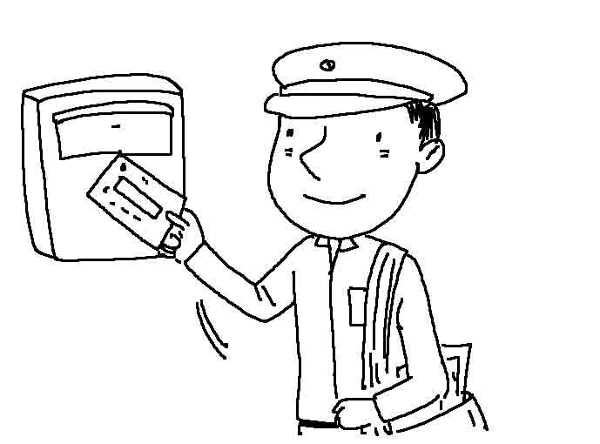 (B) 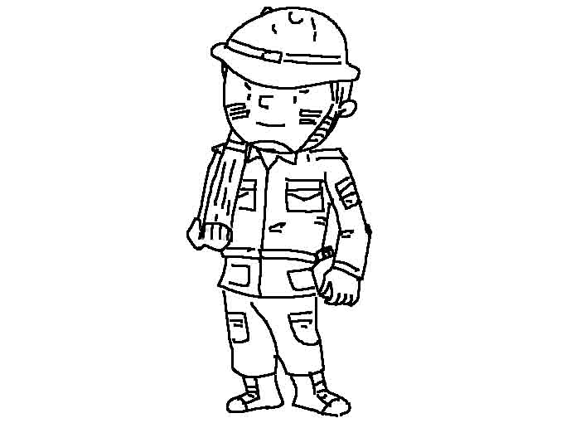 (C) 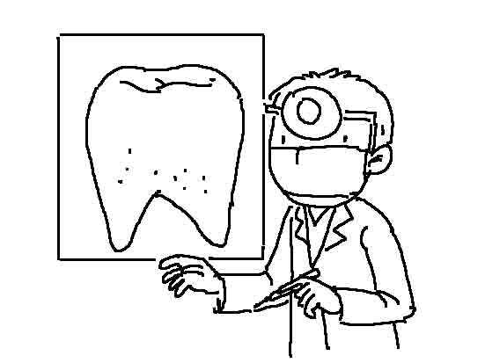
( ) 7. (A) 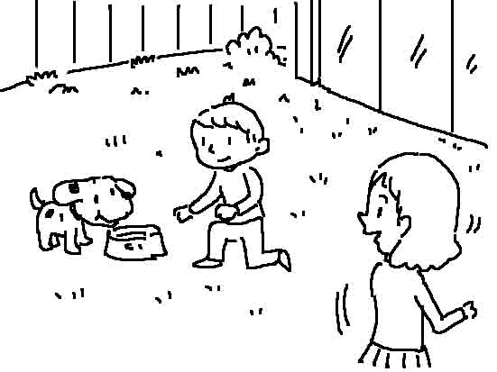 (B) 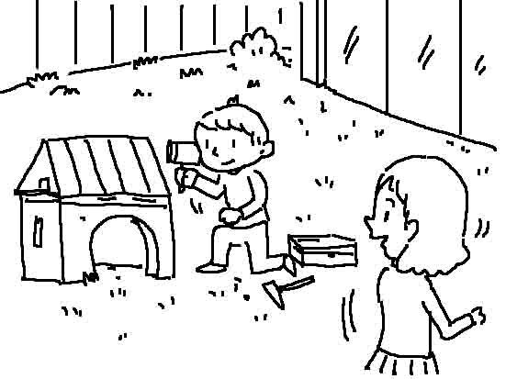 (C) 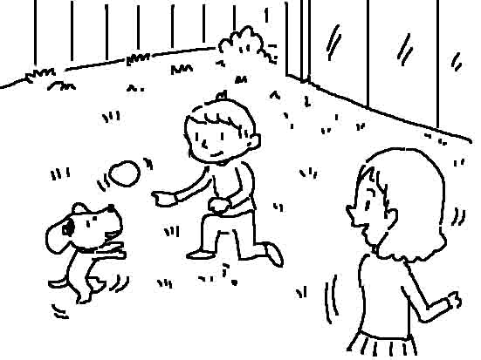
( ) 8. (A) 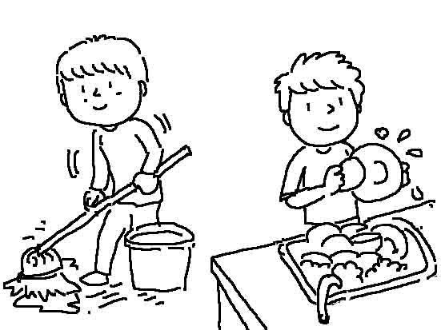 (B) 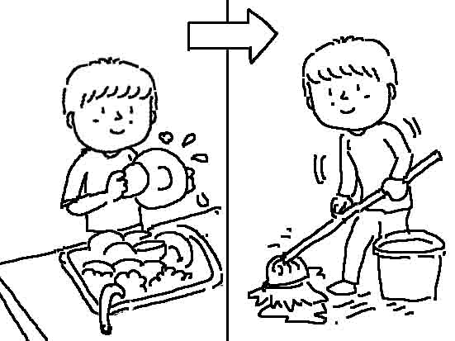 (C) 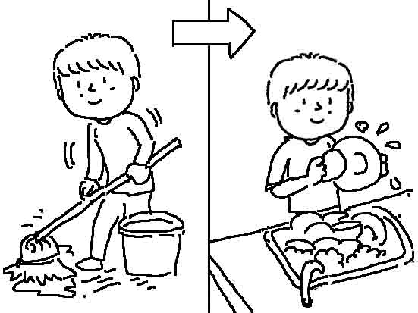
( ) 9. (A) 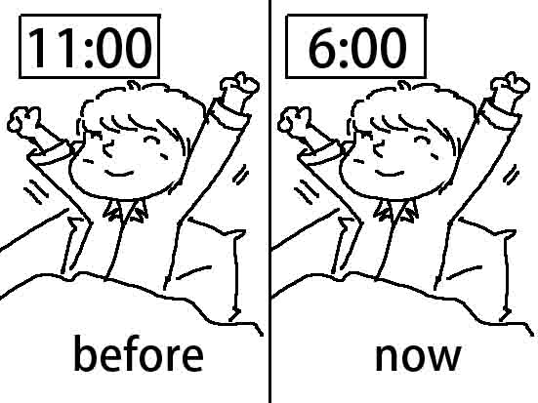 (B) 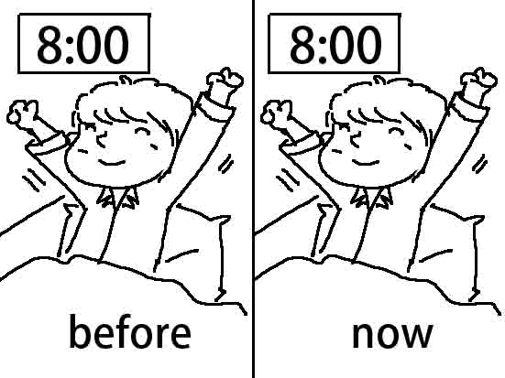 (C) 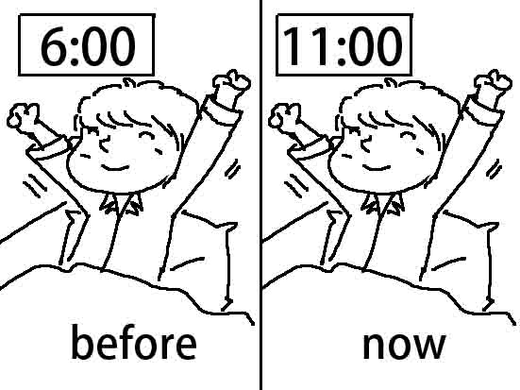
( ) 10. (A) 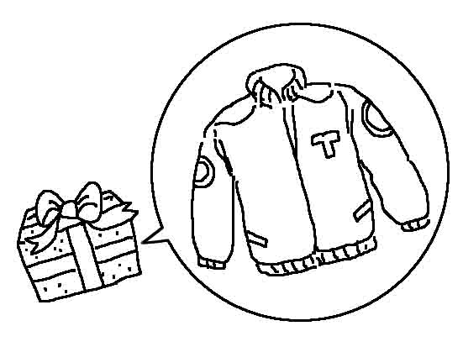 (B) 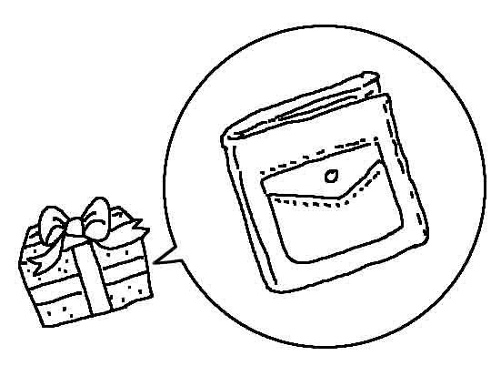 (C) 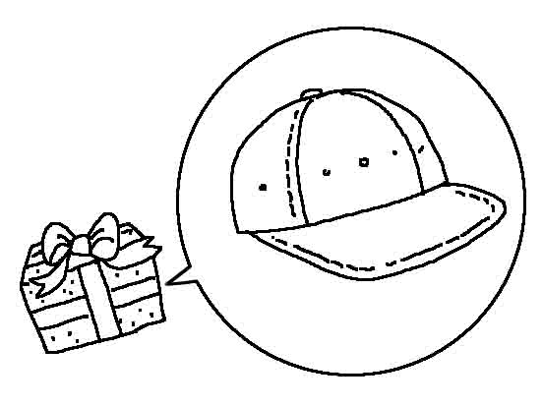
三、根據聽到的內容，選出合適的回應：每題 2分，共 10分
( ) 11. (A) Yes, I felt better after talking to you.
(B) No, I don’t like the story at all.
(C) Well, if we believe in ourselves, we can do anything.
( ) 12. (A) Yes, he’s quite a man.
(B) You can also visit his website.
(C) His courage is really inspiring.
( ) 13. (A) Yes, the cookies on the table look delicious.
(B) Sorry, it was me. I was too hungry then.
(C) Sarah taught me the way to make cookies.
( ) 14. (A) Why not?
(B) Sorry, I’m very busy tonight.
(C) Yes, this Saturday is OK with me.
( ) 15. (A) Yes, my mom had me do the dishes yesterday.
(B) I saw you mopping the floor at that time.
(C) My mom did.

四、根據聽到的對話內容與問題，選出正確的答案：每題 2分，共10分
( ) 16. (A) He doesn’t have a big dinner with his family.
(B) He doesn’t do the housework.
(C) He doesn’t play basketball with his friends.
( ) 17. (A) Emma. (B) The boy’s uncle. (C) Emma’s uncle.
( ) 18. (A) He wasn’t listening to music.
(B) He wasn’t watching TV.
(C) He wasn’t doing his homework.
( ) 19. (A) A shopkeeper. (B) A secretary. (C) A customer.
( ) 20. (A) She doesn’t have him sweep the floors.
(B) She doesn’t have him iron all the shirts.
(C) She doesn’t have him do the dishes.

貳. 閱讀理解:每題2分，共70 分
( )21. It swims fast. It’s dangerous. It has sharp teeth. It’s a _____. (A) whale (B) ship (C) shark
( )22. Dad and Mom always _____ each other when they come home after work. (A) hug (B) courage (C) quite
( )23. I left my cellphone at home. Can I ______ yours? (A) lend (B) borrow (C) pay
( )24. Don’t _____ too much time watching TV. (A) cost (B) pay (C) spend
( )25. He flew back to the USA.=_________ (A) He flew a kite in the USA. (B) He took a plane back to the USA.
(C) He went back to the USA by boat.
( )26. We _____ a strange sound from the kitchen just now. (A) watched (B) smelled (C) heard
( )27. I spend only NT$60 ______ my lunch every day. (A) on (B) with (C) at (D) of
( )28. Let’s go hiking together if it _____ tomorrow. (A) didn’t rain (B) won’t rain (C) doesn’t rain (D) wasn’t raining
( )29. My daughter _____ study at the library every night, but now she studies at home.
(A) used to (B) is used to (C) was used to (D) uses to
( )30. I usually do the dishes _____ I have my dinner. (A) when (B) after (C) and (D) as
( )31. I heard someone _____ in the next room. (A) sang (B) to sing (C) sings (D) singing
( )32. In 1912, the Titanic was the biggest ship in the world. It _____ three years and ____ $7,500,000 to build the ship.
(A) took / cost (B) spent / cost (C) cost / took (D) took / spent

At ten o’clock yesterday, Henry and his family were on a farm. They saw many animals there. They saw some rabbits 1 grass and some pigs 2 next to a pond. While the cow 3 water from the pond, a turkey was walking around. When Henry saw the turkey, he 4 at it. The turkey got angry and ran after Henry. Henry ran away and fell on the ground. He hurt 5 . He didn’t have a good time.

( )33. (A) eats (B) ate (C) eating (D) is eating
( )34. (A) sleeps (B) slept (C) sleeping (D) is sleeping
( )35. (A) drank (B) was drinking (C) drink (D) will drink
( )36. (A) is shouting (B) was shouting (C) shouts (D) shouted
( )37. (A) itself (B) herself (C) himself (D) themselves
On February 13, 2011, Yani Tseng won an important golf game in Australia. At that exciting moment, Yani was number 1 in women’s world golf. Below is the interview:
38. When did you start playing golf? _______
39. Who helped you over time?________
40. After winning the game today, how are you going to celebrate?________

(A) Without my coach, Sung-go, it would be impossible for me to win. My parents also helped me a lot all the time.
(B) I can’t wait to enjoy seafood with my mom. Before the game, I had to avoid eating any of my favorite food.
(C) The first time I tried this great sport with my dad, I was only five. The experience is still fresh in my mind.
(D) Yes. Sorenstam told me, “Winning is like a puzzle with nine pieces. You can’t miss any of them.”

My mother is a shopkeeper. She has many customers. So she hired Justin to help her 41 small jobs in the clothing store. He did a lot of work on his first day.
First, Mom had Justin hang up the new coats, jackets, shirts, and skirts. Next, Mom asked him 42 the floor and lamps. Justin also folded all of the jeans, shorts, and T-shirts. He did quite well, 43 Mom let him go home early.
Mom used to be very tired after work. But that night she had the energy to play badminton with me.

( )41. (A) with (B) in (C) to (D) doing
( )42. (A) clean (B) cleaning (C) to clean (D) cleaned
( )43. (A) but (B) because (C) so (D) although

10th Anniversary Party at Ms. Dolphin’s Hamburger Palace
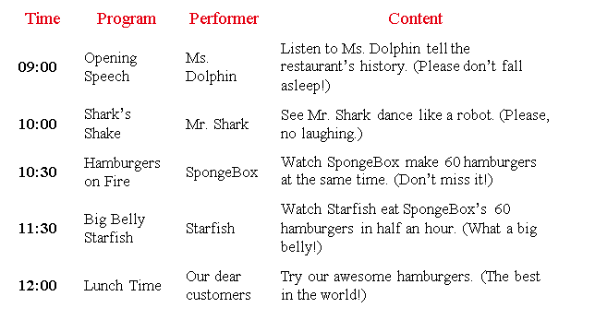

( )44. Who will make hamburgers at the party? (A) Mr. Shark. (B) Ms. Dolphin. (C) SpongeBox. (D) Starfish.
( )45. Which is NOT true? (A) The restaurant was open ten years ago. (B) There will be five performers. (C) Starfish can eat a lot of hamburgers in a short time. (D) Customers can eat hamburgers for free at the party.

Running is a very popular sport. Millions of people run because they enjoy it or want to be in good shape. A runner does not need a special talent or equipment—only well-cushioned shoes and comfortable clothes.
Daily running improves a person’s physical condition. It helps oxygen run through your body and it makes your heart and leg muscles stronger. Running helps you control your weight because when you run you burn up a lot of calories. It also helps you fight off stress after a tiring day in school or at work.
Many runners take part in long distance races. The most popular events are marathons. They are held in many cities all over the world and, for a good runner, taking part in a famous marathon is very important in his running career. Famous marathons are often held in big cities like New York, Boston, London, and Berlin. The marathon is the longest running event in the world. Its name goes back to the story of a Greek soldier who, in 490 B.C. , ran from the small village of Marathon to Athens, about 41 kms away. He wanted to tell the people there that the Greek army had defeated the Persians. The distance the soldier ran has become the standard of each marathon ever since.
talent天分 equipment設備 improve改善 well-cushioned有良好緩衝的 physical condition身體狀況 oxygen氧氣 muscle肌肉 calories卡路里 stress壓力 take part in參加 distance距離 Athens雅典 Greek希臘人 Persians波斯人 defeat打敗

( )46. What CAN’T we know from the reading?
(A) Running helps people keep in good shape. (B) Running helps people get stronger.
(C) A good runner may want to join a marathon to challenge himself.
(D) People need good equipment to help them run faster.
( )47. What does “They” mean in the reading?
(A) Marathons. (B) Runners. (C) Cities. (D) People.
( )48. Which is true about a marathon?
(A) In a marathon, runners have to run less than forty kilometers.
(B) The name of “marathon” comes from a Greek soldier.
(C) Some famous marathons are held far away from the big cities.
(D) It’s many good runners’ dream to run in a famous marathon.

The Beatles were one of the most famous rock and pop groups in history. The “Fab Four”, as the Beatles were called, came from Liverpool, England. Most of the songs were written by John Lennon and Paul McCartney. George Harrison played the lead guitar and Ringo Starr played drums. In the past 50 years the Beatles have sold over a billion records and CDs. They had more number one hits than any other British pop group.
Towards the end of the 1950s John Lennon formed a group called the “Quarrymen”. Up to 1960 they changed their names a few times but finally called themselves the Beatles. In the early phase the Beatles were influenced by American rock-and-roll musicians like Chuck Berry and Elvis Presley. In 1961 a Liverpool record store owner, Brian Epstein, became their manager. The first hit single Love Me Do became an immediate success. Teenagers all over England went crazy when they saw and heard the new stars, not only because of the music but because of their personality and new hairstyle.
billion十億 phase階段 influence影響 manager經理 single單曲 immediate立刻 personality人格

( )49. Who was NOT one of the Beatles?
(A) John Lennon. (B) Elvis Presley. (C) Ringo Starr. (D)Paul McCartney.
( )50. Which is true about the Beatles?
(A) They were the most successful pop group in England in history.
(B) Chuck Berry was once their manager.
(C) The name of the group was “Fab Four” in the very beginning.
(D) Teenagers loved the songs of the Beatles, but they didn’t like their hairstyle.

A lantern poem is a short, shaped one like a lantern. It is usually created as follows:
※ Line 1: a noun with one syllable or word
※ Line 2: two syllables or words describing the noun
※ Line 3: three syllables or words describing the noun
※ Line 4: four syllables or words describing the noun
※ Line 5: another word with one syllable and close meaning or idea for Line 1
While creating the poems, young students will have fun reading and making them easily.
noun 名詞 syllable 音節 describe 解釋

( )51. According to the reading, which of the following is a “lantern poem”?
(A) Juice (B) path (C) My teacher gives us homework
Drink it in the woods Hard to do
It’s yummy two roads diverging from it Every day
It’s good for you I choose to Writing for hours
slurp camp or
Reading for hours
Kids need a break
(D) Day
Bright, Sunny
Raining, Shining, Heating
Morning, Afternoon, Evening, Bedtime
Darkening, Cooling, Scaring
Dark, Cold
Night
( )52. Which is NOT true about a lantern poem?
(A) It is simple and interesting for children to write.
(B) It appears to be the shape of a lantern.
(C) We should think about the rhyme(押韻) while creating it.
(D) Words in the first line and the last line are related(相關的).
( )53. Judy is trying to make a lantern poem. This is her work:
Line 1: Love
Line 2: Flow out
Line 3: Through my eyes
Line 4: And sends to you
Line 5: ________
Which word is better to be filled in the blank?
(A) Body (B) Heart (C) House (D) Space

New Zealand is in the south-eastern Pacific Ocean and it has two larger island, North Island and South Island, and 54 smaller islands. The islands have many special animals and plants different from those anywhere else in the world, such as kiwi and kiwi fruit. The islands were first inhabited by the Maori people from Polynesia around 1000 AD. The Dutch found out the islands in the 1600s and named them “New Zealand” 55 they never lived there; Captain James Cook brought the British to the islands in 1769. By 1800, more and more visitors from Europe came and lived in these lands. inhabit居住
( )54. (A) many other (B) any other (C) all the other (D) another
( )55. (A) when (B) so (C) because (D) though
高雄市立林園高級中學 國中部 103學年度第2學期 2年級第3次段考 (英文科) 作答卷
班級： 姓名： 座號：

2年級 ( 英文科) 第3 次段考--答案（年級、科目請標示清楚，謝謝！）
1~10 AADCB CBBCB
11~20 CBBAC CBBAA
21~30 CABCB CACAB
31~40 DACCB DCCAB
41~50 ACCCB DADBA
51~55 ACBAD

