高雄市立林園高級中學 國中部 103學年度 第二學期 三年級 英語科 第一次段考 試題卷
班級： 姓名： 座號：
◎本試卷共（4）頁
一、聽CD，配合圖片選出最適當的答案。：（5%）
1.
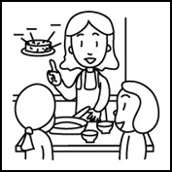
2.
(A)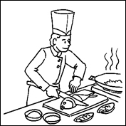 (B)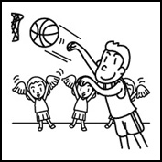
3.
(A)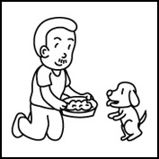 (B)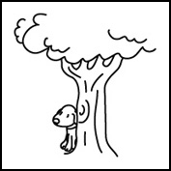 (C)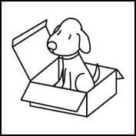
4.
(A)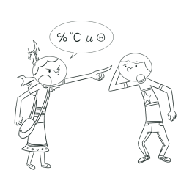 (B)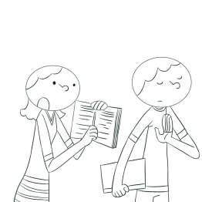 (C) 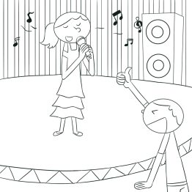
5.
(A)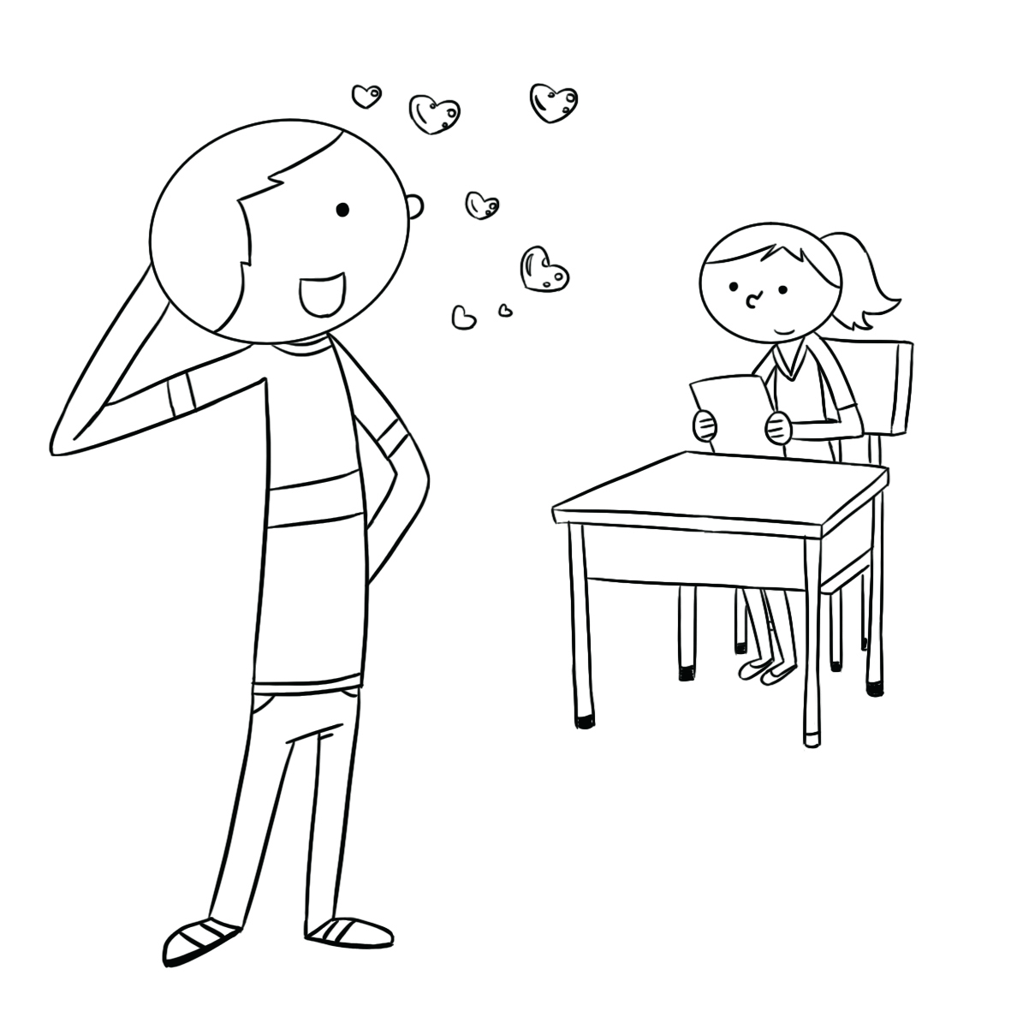 (B)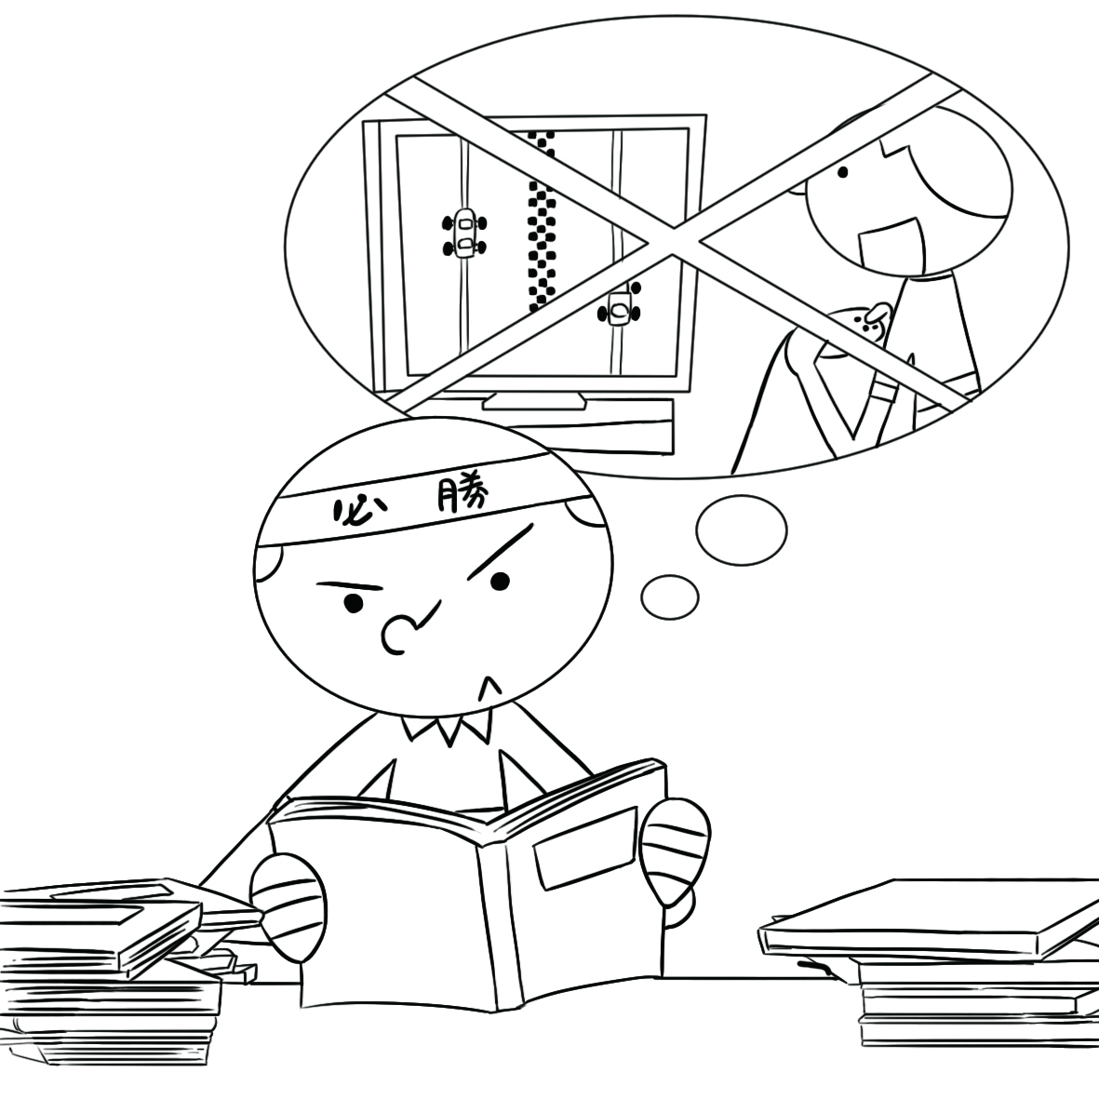 (C) 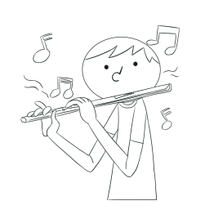

二、聽CD中的題組，選出正確的答案。：（5%）
(A)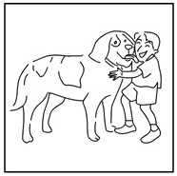 (B)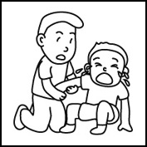 (C)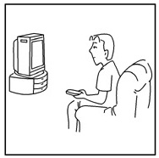
(D)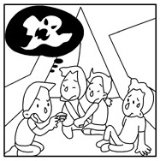 (E)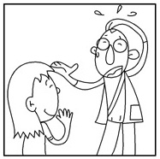 (F)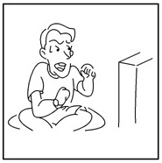

(1) (2) (3) (4) (5)

三、聽CD，選出適當的回應句。：（10%）
1. (A) She made that by hand. (B) She reads the news online every morning. (C) She was shocked and couldn’t speak.
2. (A) I went on a picnic and felt cold. (B) I keep a diary. (C) I feel worried as long as I go out.
3. (A) Wow, you really catch my eye. (B) You bet!The bird’s eye view is great. (C) Sure, I’ll take care of them.
4. (A) Her heart stopped beating for a second. (B) Yes, her heart has broken. (C) Yes, she’s ready for the spelling test.
5. (A) Because you feed on grass and live in groups. (B) In order to write a bestseller. (C) Because you can help them.

四、聽CD中的對話，選出適當的答案。：（10%）
1. (A) There is a traffic jam. (B) Being late is in her blood. (C) She thinks it’s no big deal.
2. (A) They will go there on foot. (B) They will take a taxi. (C) They will drive there.
3. (A) He can’t find his glasses. (B) He hasn’t published them yet. (C) He’s been busy.
4. (A) Hosts. (B) Writers. (C) Bestsellers.
5. (A) He wants her to quit playing computer games. (B) He wants her to go to school every day.
(C) He wants her to lend him the computer.

五、填入適當的單字並依句意變化。（10%）
accident | according to | appear | blood | explain
host | instead | publish | purpose | quit

1. The writer has already ______ ten books so far.
2. If you ______ smoking, you’ll surely have fewer health problems.
3. A：Jason didn’t do his homework yesterday. ______, he played computer games all day. B：No wonder Mom was angry.
4. A：Sally, why were you so late? You just missed an important meeting.
B：Let me ______. I was late because my car broke down on my way here.
5. Little Connie sings so well. Many people think that music is in her ______.
6. Those fish were grouped ______ their sizes, and they were put in different fish tanks. 【fish tank 魚缸】
7. I didn’t do it on ______. Please forgive me. 【 forgive 原諒】
8. Sam lost his wallet, but he didn’t ______ to be worried.
9. A terrible car ______ happened this morning, and several people got hurt.
10. Since Helen is a good speaker, her friend, Jessie, invited her to be the ______ of her wedding ceremony.
【wedding ceremony 結婚典禮】

六、綜合測驗。（20%）
1. （ ）Jeff didn’t do his homework, and ______ did his brother. (A) too (B) so (C) either (D) neither
2. （ ）The train had already left when Peter and Helen ______ to the train station.
(A) get (B) was getting (C) got (D) had got
3. （ ）Could you call me ______ you arrive at the airport? (A) as long as (B) as soon as (C) as far as (D) as fast as
4. （ ）We were ______TV at nine o’clock last night. (A) watching (B) watch (C) watched (D) watches
5. （ ）______ problems were very serious in this country. A lot of African Americans（非裔美國人）were treated badly.
(A) Vocational (B) Comfortable (C) Racial (D) Green
6. （ ）When you face ______, don’t be afraid and report（報告）it to your teachers right away.
(A) sliding (B) publishing (C) bullying (D) filling
7. （ ）As long as it ______, we will stay at home and watch TV. (A) will rain (B) rains (C) rained (D) is going to rain
8. （ ）Kevin used to ______ a glass of warm water before he went to bed. (A) drinking (B) drank (C) drink (D) drunk
9. （ ）A：Can you lend me an eraser? I forgot to bring my pencil box.
B：Here ______. (A) are you (B) is it (C) you go (D) we go
10.（ ）A：I had no money in my pocket. B：Neither ______ she. (A) has (B) does (C) had (D) did

七、克漏字。（10%）
Joyce had a busy day today. She had a meeting in Taipei and __1.__ take the first airplane there. __2.__, she got up too late. That was because she watched a scary movie last night and did not sleep well.When she arrived at the airport, the first airplane__3.__ already. Then, Joyce decided __4.__ the THSR. Luckily, she took one that would arrive at Taipei before the meeting. On the THSR, Joyce __5.__ herself again and again. She would not watch any scary movies when she needed to get up early the next day. 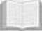 THSR 臺灣高鐵
（ ）1. (A) have to (B) has to (C) had (D) had to
（ ）2. (A) However (B) Besides (C) For example (D) Beside
（ ）3. (A) leaves (B) is leaving (C) has left (D) had left
（ ）4. (A) took (B) taking (C) to take (D) taken
（ ）5. (A) said (B) spoke (C) talked (D) told

八、閱讀測驗。（10%）
Sam: I talked my parents into getting a new cellphone for me last night, but neither of them liked the idea.
Uncle Bob: Why not?
Sam: They think I spend too much time on my cellphone, and they don’t think I need a new one.
Uncle Bob: They have a point. Your cellphone is fine; you don’t really need a new one.
Sam: But I want a smartphone like yours.
Uncle Bob: As soon as you get to make money on your own, you can buy anything that you like. Right now just focus on your studies.
Sam: All right. I’ll do what I’m told.
（ ）1. What does the sentence “They have a point.” mean?
(A) Their math is pretty good.
(B) They are right.
(C) They have something in common.
(D) They have the same idea.
（ ）2. Which is NOT true about Sam?
(A) He will listen to what his uncle has told him.
(B) He will concentrate on his studies.
(C) He will give all the money to his parents.
(D) He does not have a smartphone, but his uncle does.

Lantern Festival
The Lantern Festival marks the end of the Chinese New Year celebrations.During the time of the festival, lanterns can be seen at temples and on the streets.Children also go out with paper lanterns to have fun on the night of the festival.
In ancient times, the lanterns were only for the emperor and the rich, and they usually looked quite simple.Today, they are made in different shapes and sizes.For example, they are often made in the shape of the animal sign for that year. No matter what the lanterns look like, people carry them for the same reason: to wish for a bright future.

（ ）3. What CAN’T we learn from the reading?
(A) How to make lanterns.
(B) Why people carry lanterns.
(C) How the lanterns have changed.
(D) When and where the lanterns can be seen.
（ ）4. Which of the following is closest in meaning to ancient?
(A) Fresh.
(B) Old.
(C) Boring.
(D) Different.
（ ）5. Which is NOT said in the reading?
(A) Lanterns are made in different shapes and sizes today.
(B) People think the lanterns can bring them a good future.
(C) People carried lanterns on the Lantern Festival, but now they don’t.
(D) People stop celebrating Chinese New Year after the Lantern Festival.
九、完成句子。（20%：每句2分）
1. You can borrow my car. / You return my car by six.（以 ... as long as ... 合併句子）
________________________________________________________________________
2.The teacher came in. / The students became quiet.（以 ... as soon as ... 合併句子）
________________________________________________________________________
3. Lisa saw me. / Lisa ran away.（以 As soon as ... 合併句子）
________________________________________________________________________
4. and / broke / Richard / not / his parents. / the vase / asked / his sister / tell / to （重組句子）
________________________________________________________________________
5. 為什麼你沒辦法準時交作業？
____________ ____________ you can’t hand in the homework on time?
6. 我經常忘記帶手錶。這沒什麼大不了的。
I usually forget to bring my watch. It’s no ____________ ____________.
7. 她非常的感動以致於她想幫助他們藉由寫作找回自己的聲音。
She was so ____________ that she wanted to help them find their voices ____________ writing.
8. 我的學生們對這個消息反應不一。他們有些人很開心，但是有些人感到難過。
My students ____________ ____________ to the news.Some of them were happy, but the others felt sad.
9. 這個媽媽不停告訴她的孩子們要小心火。
________________________________________________________________________
10. Cindy 一開始同意和我們一起工作，但她很快地就改變她的心意了。
________________________________________________________________________

*試題結束，請將答案書寫於答案卷*

高雄市立林園高級中學 國中部 103學年度 第二學期 三年級 英語科 第一次段考 作答卷
班級： 姓名： 座號：
一、聽CD，配合圖片選出最適當的答案。：（5%）（每題1分）
1. | C | 2. | B | 3. | A | 4. | B | 5. | B
二、聽CD中的題組，選出正確的答案。：（5%）（每題1分）
1. | D | 2. | A | 3. | C | 4. | B | 5. | E
三、聽CD，選出適當的回應句。：10％（每題2分）
1. | C | 2. | C | 3. | C | 4. | C | 5. | C
四、聽CD中的對話，選出適當的答案。：（10%）（每題2分）
1. | A | 2. | B | 3. | C | 4. | B | 5. | A
五、填入適當的單字並依句意變化。（10%）（每題1分）
1. | published | 2. | quit | 3. | Instead | 4. | explain | 5. | blood
6. | according to | 7. | purpose | 8. | appear | 9. | accident | 10. | host
六、綜合測驗：20％（每題2分）
1. | D | 2. | C | 3. | B | 4. | A | 5. | C
6. | C | 7. | B | 8. | C | 9. | C | 10. | D
七、克漏字測驗：10％（每題2分）
1. | D | 2. | A | 3. | D | 4. | C | 5. | D
八、閱讀測驗：10％ （每題2分）
1. | B | 2. | C | 3. | A | 4. | B | 5. | D
九、完成句子：20％ （每題2分）
1. You can borrow my car as long as / you return it by six.
2. The students became quiet as soon as / the teacher came in.
3. As soon as Lisa saw me/, she ran away.
4. Richard broke the vase and asked his sister /not to tell his parents.
5. How come you can’t hand in the homework on time?
6. I usually forget to bring my watch. It’s no big deal.
7. She was so moved that she wanted to help them find their voices by writing.
8. My students reacted differently to the news. Some of them were happy, but the others felt sad.
9. The mother kept telling her kids / to be careful with fire.
10. Cindy agreed to work with us at first, / but she changed her mind quickly.

