高雄市立林園高級中學 國中部 103學年度第二學期 三年級 英語科 第二次段考試題卷
班級： 姓名： 座號：
____________________________________________________________________________________________________

◎本試卷共＜5＞頁
壹、【聽力測驗，共30分】
一、聽CD，配合圖片選出最適當的答案。
(每題1分，共10%)：
1.
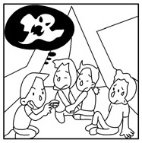
2.
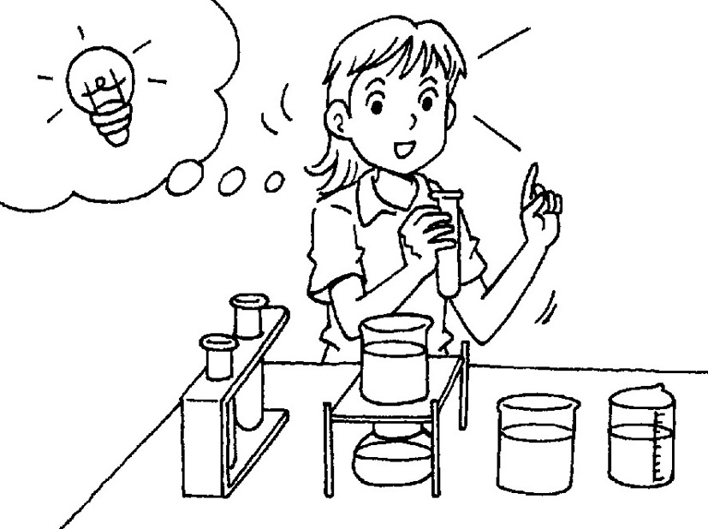
3.
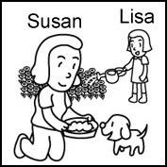
4.
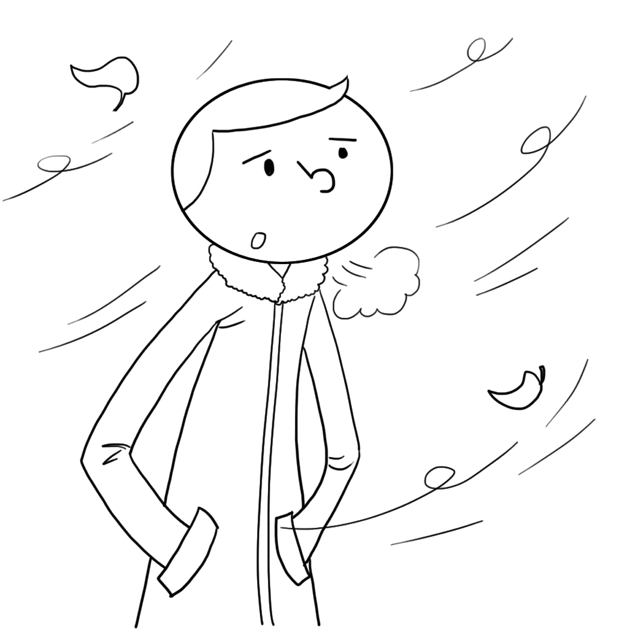
5.
(A)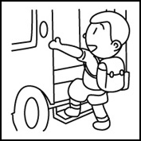 (B)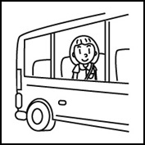
6.
(A)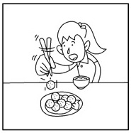 (B)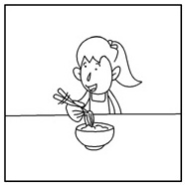

7.
(A)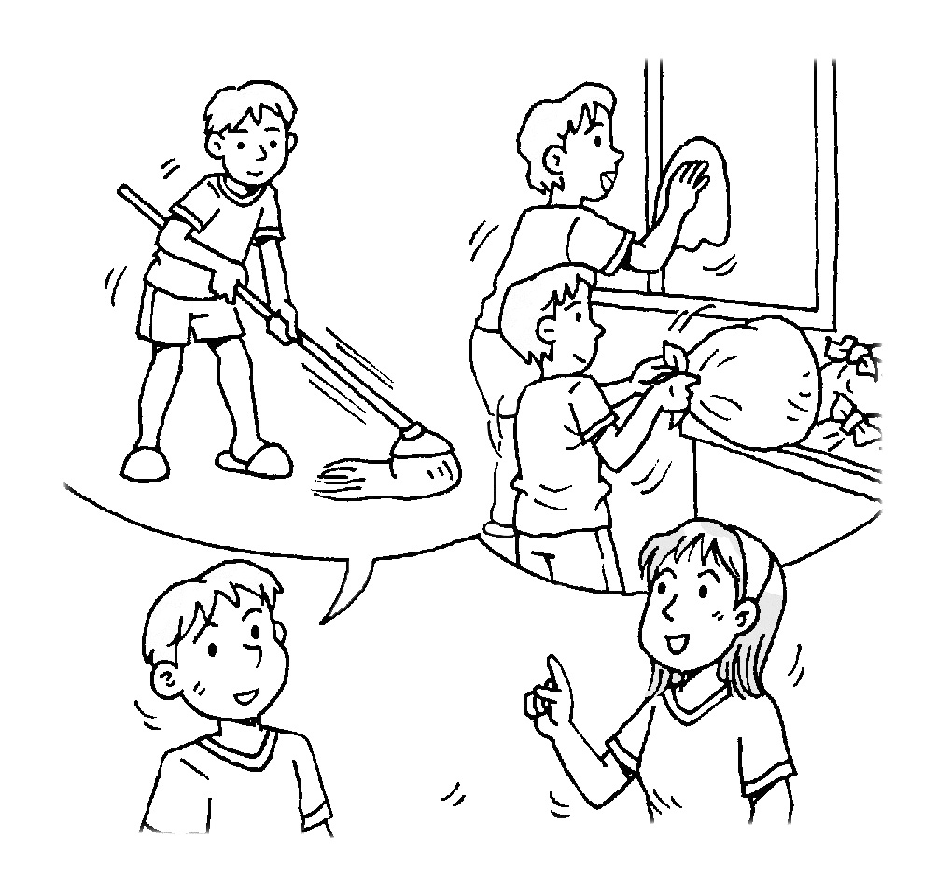 (B)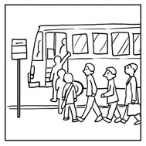
(C)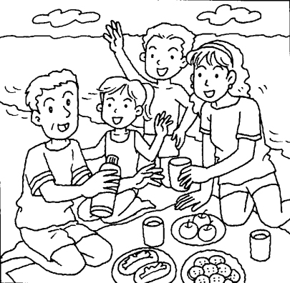
8.
(A)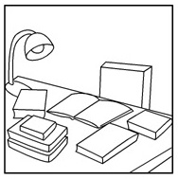 (B)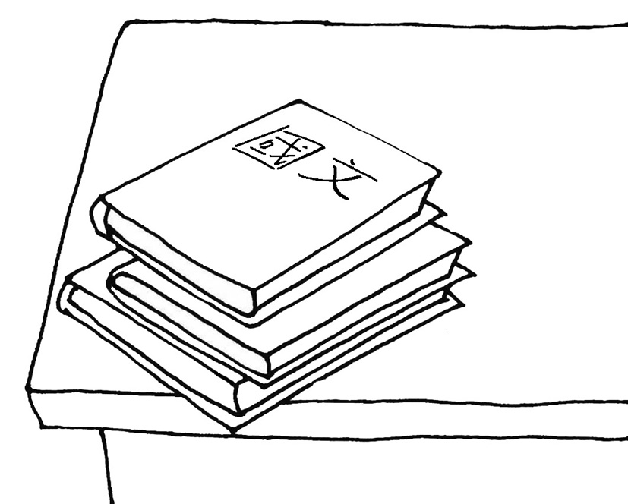
(C)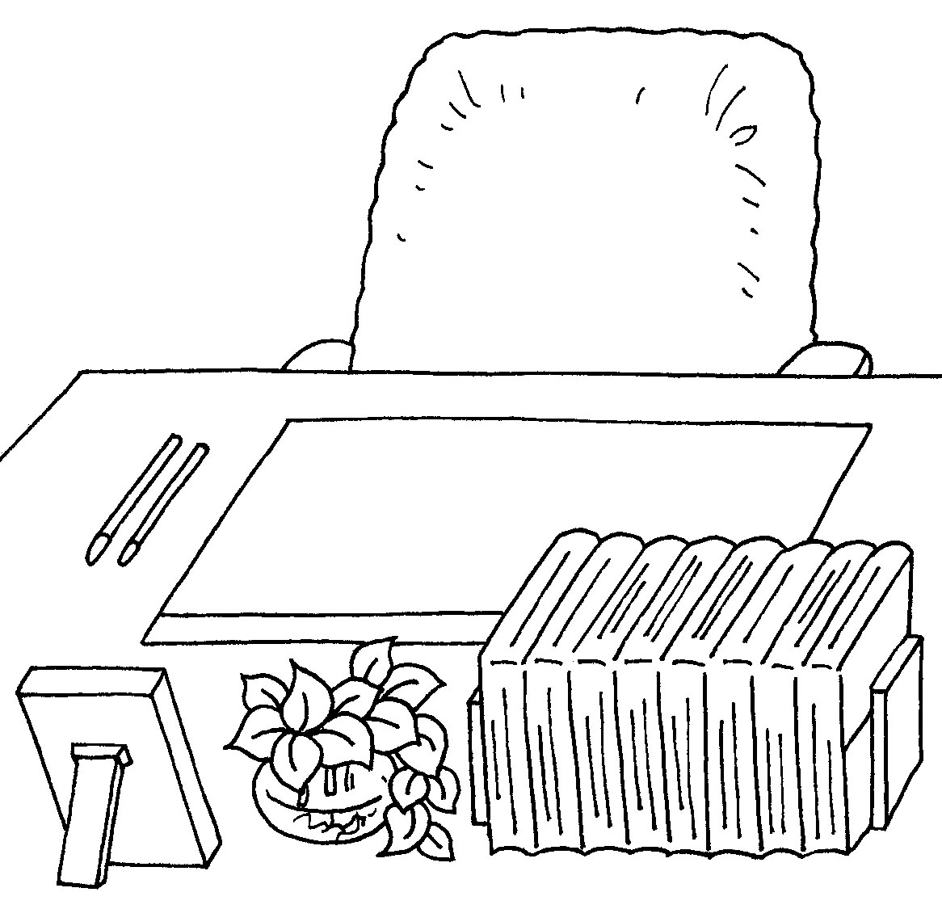
9.
(A)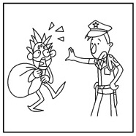 (B)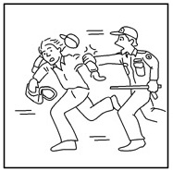
(C)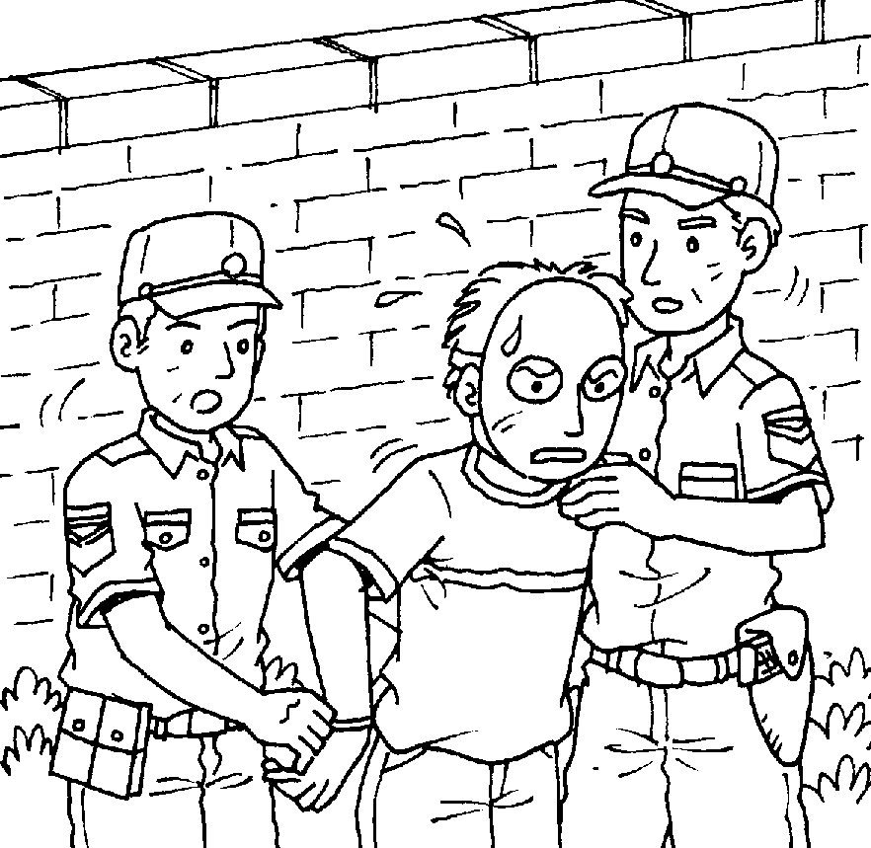
10.
(A)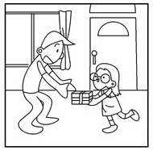 (B)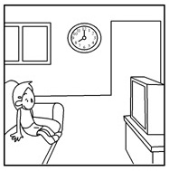
(C)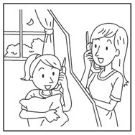

二、聽CD，選出適當的回應句。 (每題2分，共10%)
11.
(A) Maybe you can take it away. (B) Maybe you can order another one. (C) Maybe you can turn it off.
12.
(A) No, I volunteered to help. (B) No, I never put it off. (C) No, she made me do it.
13.
(A) Through the Internet. (B) I usually do online shopping. (C) Always get in touch with them.
14.
(A) Nothing smelly in the refrigerator. (B) Sure. A bottle of milk and some pork.
(C) Of course. It’s a fridge of high technology.
15.
(A) No, you have to turn it on. (B) No, you’re the next. (C) No, you should turn it down.

三、聽CD中的對話，選出適當的答案。(每題2分，共10%)
16.
(A) They shouldn’t wear shoes. (B) They shouldn’t take off their shoes. (C) They shouldn’t look for their shoes.
17.
(A) She volunteered to help her brother. (B) She helped her brother for a reward. (C) She made her brother help her.
18.
(A) No, his boss is too busy. (B) No, the man doesn’t have time. (C) Yes, he has created the opportunity.
19.
(A) The movie doesn’t have an ending. (B) The man didn’t see the whole movie.
(C) The woman’s friend called on her last night.
20.
(A) He used to live in Taipei. (B) He no longer lives on the farm. (C) He’s lived on the farm for a year.

貳、【紙筆測驗，共70分】
一、字彙測驗 (每題1分，共16%) (21~26：課本習作)
21. （ ）Though Jack was poor and sick, he never ______ writing. That is why he finally became a successful writer. (A) agreed to (B) gave up (C) looked for (D) thought of
22.（ ）Eric： Can you ______ at 8：30? I don’t want to sleep too long.
Tina： No problem. (A) take me out (B) pick me up (C) wake me up (D) wait for me
23.（ ）Jessie ______ the computer and went to sleep.
(A) turned off (B) cared about (C) thought of (D) got on
24.（ ）Morris didn’t go to Sandy’s birthday party because nobody ______ the news to him.
(A) paid forward (B) passed on (C) gave back (D) asked for
25. ( ) Nick is always willing to help others and doesn’t want anything ______.
(A) in return (B) after all (C) for the better (D) right away
26.（ ）John is an active (積極的) language learner. He always takes a ______ with him.
(A) story (B) sentence (C) dictionary (D) conversation
27.（ ）A：When can I use the computer? B：Now it’s your ______.
(A) test (B) time (C) team (D) turn
28.（ ）It is ______ for fish to live without water. (A) weak (B) impossible (C) amazing (D) pleasure
29.（ ）Although Tina’s best friend has moved to Taipei, she still keeps in ______ with him.
(A) eye (B) sofa (C) habit (D) touch
30.（ ）My sister doesn’t go out, but she still can place an ______ on the Internet.
(A) lab (B) function (C) order (D) odor
31.（ ）Watching the Earth from the ______ is cool, but it costs a lot.
(A) apartment (B) outer space (C) airport (D) station
32.（ ）The weather has changed a lot. Many countries are trying hard to deal with ______ warming.
(A) moved (B) racial (C) global (D) better
33.（ ）My husband is too ______ at work. He can’t even sleep well at night.
(A) curious (B) slender (C) moved (D) stressful
34.（ ）Hey, guys! Thank you for helping me ______ my hard time. I’ll remember you forever.
(A) get through (B) go through (C) go ahead (D) get to
35. （ ） Cindy：I don’t know how to solve (解決) the math questions. Can you lend me your math ______.
Bill：Don’t worry. I can teach you.
(A) lesson (B) yearbook (C) magazine (D) workbook
36.（ ）______ makes our life more convenient. We can do our work more easily.
(A) Technology (B) Freedom (C) Temperature (D) Cartoon

二、配合題 (每題1分，共8%) (課本習作)
1. 填入正確的代號A~E，完成句子。
(A) Please show me another.
(B) Can I have another piece, please?
(C) One is from Canada, another is from Japan,
and the other is from Australia.
(D) Some of them are red, and the others are white.

37. There are several eggs on the table. ( )
38. I don’t like this T-shirt. ( )
39. She has three foreign friends. ( )
40. The cake is so delicious. ( )

2. 閱讀填空，將符合的敘述A~D 填入空格中。(課本習作)
(A) that he worked in
(B) that I could do it
(C) that loved to bully others
(D) that wanted to exercise with me

Last year, I was a shy and weak eighth grader. After school, some strong boys 41.____ often laughed at me and called me names. I felt lonely and terrible. One day, a kind stranger, Tony, came up to help me, and we became friends. He invited me to the gym 42.____. My life started to change.
Tony helped me start an exercise program that I really liked. At first, I didn’t think 43.____, but soon I became stronger and happier. I also learned that eating health food was important. With this new knowledge, my body became stronger. I also met people 44.____. Soon I had many new friends. I felt great! Thanks to Tony, I am a different person now.
call somebody names 罵人；辱罵

三、文法選擇 (每題2分，共30%) (45~54：課本習作)
45.（ ） Brian had someone ___________ his car. (A) fix (B) to fix
46.（ ） I want my room ___________ larger and brighter. (A) be (B) to be
47.（ ） Tina’s husband told her ___________ their son after school. (A) pick up (B) to pick up
48.（ ） Megan asked her mom ___________ her _________ over at a friend’s home.
(A) let; sleep (B) to let; to sleep (C) to let; sleep (D) let; to sleep
49.（ ） My mother made me ___________ my brother __________ home earlier.
(A) to tell; to come (B) to tell; come (C) tell; come (D) tell; to come
50.（ ） When the race is about to start, I can feel my heart ___________ . (A) to beat (B) beat
51.（ ） Nick looked ___________ , and his parents looked at him __________ when he won the first prize.
(A) happy; happy (B) happy; happily (C)happily; happy (D) happily; happily
52.（ ） Jeremy decided ___________ an NBA player, and that’s why he never stops __________.
(A) becoming; practicing (B) to become; to practice
(C) becoming; to practice (D) to become; practicing
53.（ ） We plan ___________ to the beach and enjoy __________ there.
(A) to go; to swim (B) to go; swimming (C) going ; to swim (D) going; swimming
54.（ ） The robot ___________ a real person. How amazing! (A) looks (B) looks like
55.（ ） The birthday party was called _____ because of the accident. (A) off (B) on (C) down (D) up
56.（ ） I like the music. It ______ beautiful. (A) hears (B) listens (C) sounds (D) enjoys
57.（ ） What are your tips ______ learning Japanese? You speak Japanese well.
(A) with (B) in (C) on (D) for
58.（ ） Jenny has four bags. One is blue, another is red, and ______ are yellow.
(A) the other (B) others (C) another (D) the others
59.（ ） Don’t forget the lamp. Remember ______ before you leave.
(A) to turn it off (B) to turn off it (C) turning it off (D) turning off it

四、對話與完成句子(每題2分，共6%)： (課本習作)
60. （ ）A：Have you heard the good news? Joe and Linda are going to tie the knot. B：______
(A) Wow! Finally. They’ve waited so long for this moment.
(B) It’s good to know that they still keep in touch.
(C) What? They really need to get through it.
61. （ ）A：Carrie’s dog has just given birth to three puppies. B：______
(A) Is this their puppy love? (B) Let’s keep in touch with her before leaving.
(C) Again? So now, there are ten dogs in her house.
62. （ ）A：Do you know that Alfred moved out and is now living by himself?
B：He’s only seventeen, isn’t he? A：______
(A) Why don’t you make a deal with him? (B) Didn’t you know that he came of age last year?
(C) You bet. He keeps complaining to me.

五、閱讀測驗(每題2分，共10%)

1.
Yellow Dress
Tina had a yellow dress
Bought from the department store.
It looked as beautiful as the moon,
And as bright as the sun.

Tina wore all the time
The yellow dress I felt so right.
Every day from day to night
I saw her in the dress so bright.

“Buy me a yellow dress,”
I cried to Dad and Mom,
“As beautiful and bright
As the dress the girl living near has!”

I cried and cried and cried,
Until they said with sad eyes,
“We need food for your baby brother,
And clothes for your coming sister.”

Since then I’ve learned
Tina’s yellow dress
Is better to dream of
Than to ask for.

【續次頁】

63.（ ）Why does the writer say, “Every day from day to night / I saw her in the dress so bright.”?
(Ａ) The dress Tina wore was a school uniform. (Ｂ) The writer liked the dress very much.
(Ｃ) The writer lived with Tina. (Ｄ) The writer kept dreaming of the yellow dress in the middle of the night.
64.（ ）Which was NOT true about the yellow dress?
(Ａ) It was bought from the department store. (Ｂ) It had sun shapes on it.
(Ｃ) It belonged to Tina. (Ｄ) It looked very beautiful on Tina.
65.（ ）What did the writer’s parents mean by their words?
(Ａ) They would get a new dress for her coming sister.
(Ｂ) They would ask Tina where to get the yellow dress.
(Ｃ) They liked the yellow dress more than the writer did.
(Ｄ) They did not have money to buy a dress for the writer.

2.
Have you ever dreamed of being a pilot? Many people are crazy about aircraft. Even if you don’t have the chance to be a pilot, it’s cool to see the military helicopter-- Apache, which has the latest technology. However, Apaches are not opened to the public. It’s not allowed for ordinary people to step on them. The celebrity Janet Lee has no idea about that. She even posted a photo with the Apache on Facebook. The post drew a lot of attention and many people blamed the military for the misuse of power. The event hurt the military’s reputation and many soldiers were punished.

aircraft 飛機 military 軍方 helicopter 直升機 celebrity 名人 soldier 軍人 punish 處罰

66.（ ）What can we learn from the above paragraph?
(Ａ) Everyone can step on Apaches. (Ｂ) Nobody was punished in the event.
(Ｃ) Everyone can be a pilot. (Ｄ) The military should keep Apache a secret.
67.（ ）The meaning of the underlined word reputation is closest to
(Ａ) fame (Ｂ) popularity (Ｃ) power (Ｄ) use

【試題結束】

高雄市立林園高級中學 國中部 103學年度第二學期 三年級英語科 第二次段考解答

1. C | 2. A | 3. A | 4. A | 5. A
6. A | 7. A | 8. C | 9. B | 10. A
11. B | 12. A | 13. A | 14. B | 15. B
16. A | 17. B | 18. A | 19. B | 20. B
21. B | 22. C | 23. A | 24. B | 25. A
26. C | 27. D | 28. B | 29. D | 30. C
31. B | 32. C | 33. D | 34. A | 35. D
36. A | 37. D | 38. A | 39. C | 40. B
41. C | 42. A | 43. B | 44. D | 45. A
46. B | 47. B | 48. C | 49. D | 50. B
51. B | 52. D | 53. B | 54. B | 55. A
56. C | 57. C | 58. D | 59. A | 60. A
61. C | 62. B | 63. B | 64. B | 65. D
66. D | 67. A

