高雄市立林園高級中學國中部 104學年度第一學期一年級 英語科 第二次段考試題卷
班級： 姓名： 座號：
◎本試卷共＜4＞頁
壹、【聽力測驗，共30分】(1-10題每題1分，共10%)

一、聽CD，字首發音相同的選 A，否則選 B。：
1.
(A)相同 (B) 不同
2.
(A)相同 (B) 不同
3.
(A)相同 (B) 不同
4.
(A)相同 (B) 不同

二、聽CD，若符合圖意或表格內容的選 A，否則選 B
5.
(A) True (B) False
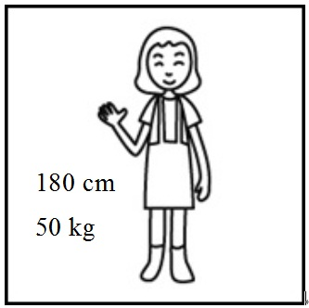
6.
(A) True (B) False
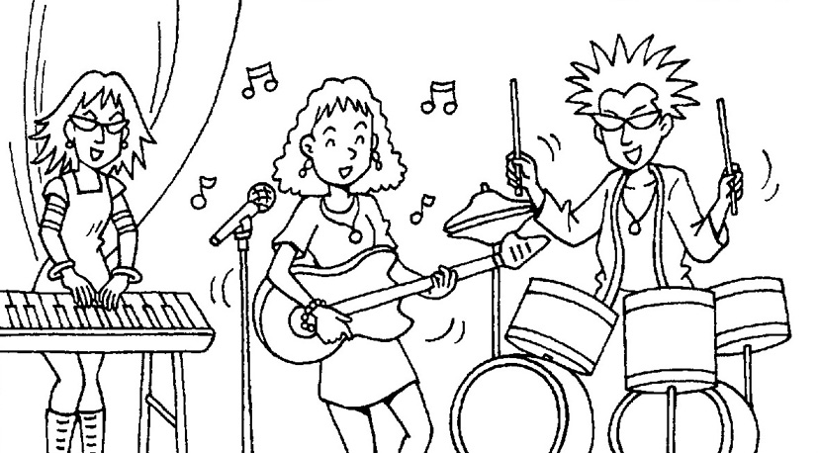
7.
(A) True (B) False

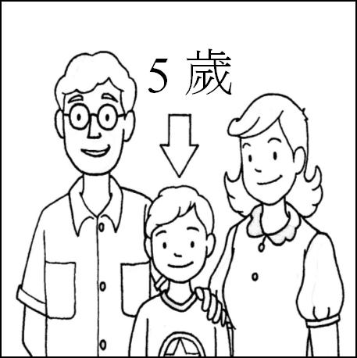
8.
(A) True (B) False

9.
(A) True (B) False
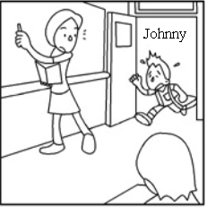
10.
(A) True (B) False
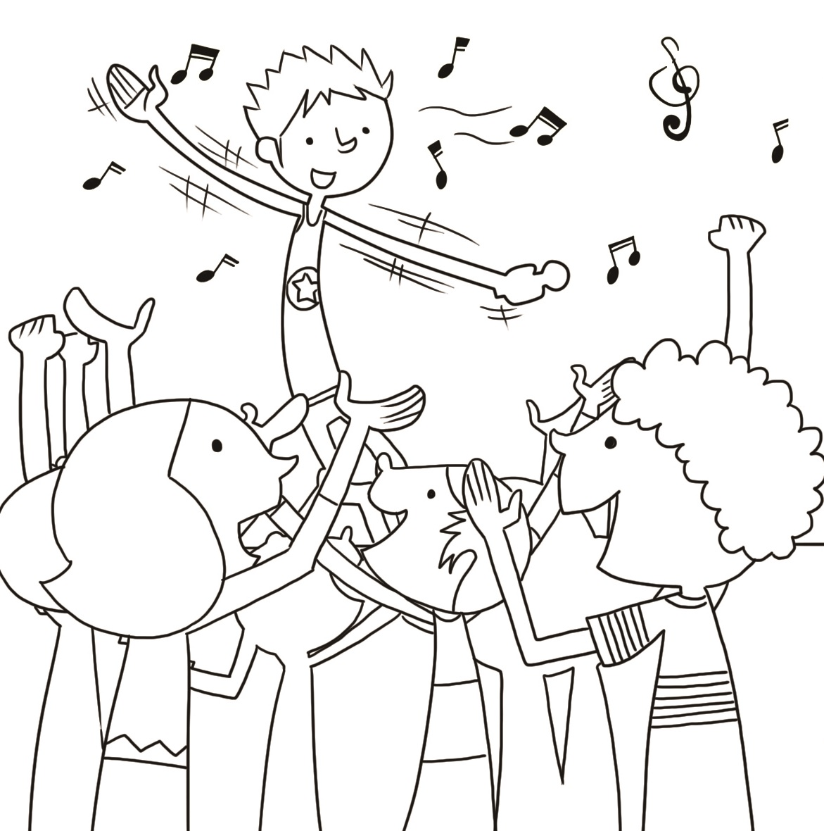

三、聽CD中的對話，選出適當的答案。(11-20題每題2分，共20%)：
11.
(A) Yes, he is from Canada.
(B) No, he isn’t.
(C) No, he is from the UK.
12.
(A) Yes, she is tall.
(B) No, she is short.
(C) No, she is heavy.
13.
(A) In a movie theater.
(B) In a factory.
(C) In a toy store.

四、聽CD，選出適當的回應句。：
14.
(A) Yes, he is a salesman. (B) Yes, he is. (C) No, my voice is not good.
15.
(A) No, he is thin. (B) No, he is heavy. (C) My father is a thin man.
16.
(A) Let’s hurry! (B) Let’s be quiet! (C) Let’s talk!

17.
(A) It’s not nice. (B) OK. (C) Wait for me.
18.
(A) Thank you. (B) Yes, it’s my key. (C) No, it’s over here.

五、聽CD中的題組，選出正確的答案。：Question：
19.
(A) The UK. (B) The USA. (C) The ROC.
20.
(A) Yes, she is. (B) No, she’s an actress. (C) No, she’s a waitress.

-- 聽力測驗結束 --

貳、【紙筆測驗，共70分】
一、字彙測驗 (每題1分，共8%) (1-4：課本習作P.23；請依字首提示作答)

1 | 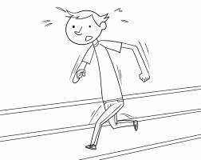  r_________ | 2 |   f___________ | 3 |   l______________ | 4 | 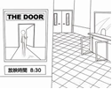  m_______ t_________
5 | s_______________  father | 6 |   r________________ | 7 |   t________________ | 8 |   h__________________

二、看圖，使用祈使句，依句意填入適當的字詞。(每格1分，共10%) 課本習作P.24
1.  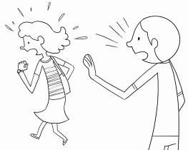  ____________ for me. | 2.  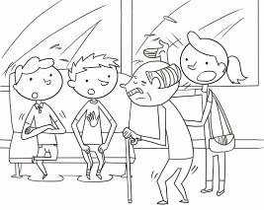  ____________ ____________, young men. | 3.  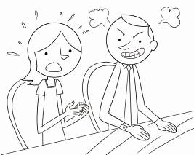  ____________ ____________ your cellphone.
4.  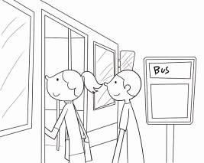  Let’s ____________ ____________ the bus. | 5.  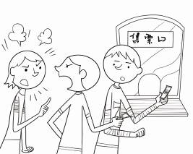  Please ____________ ____________ ____________.

三、選擇 (每格1分，共10%)
- （ ）The singer is good. By the ＿＿＿, he is my brother.
(A) wonder (B) way (C) year (D) food
- （ ）A：Is Linyuan (林園) famous ＿＿＿ its onions(洋蔥)?
B：Yes. The onions are delicious. (美味的).
(A) at (B) for (C) on (D) to
- （ ）＿＿＿ open the book. Close it.
(A) Not let’s (B) Let’s no (C) No let’s (D) Let’s not
- （ ）Tom：＿＿＿ they smart phones?
Mary：No, they ＿＿＿ .
(A) Aren’t; are (B) Are; are (C) Is; isn’t (D) Aren’t; aren’t
- （ ）Don’t leave your umbrella＿＿＿ the bus.
(A) in (B) on (C) to (D) for
- （ ）Tina is from Canada. Peter is from Canada, ＿＿＿.
(A) and (B) no (C) too (D) not
- （ ）A：＿＿＿ are the puppies?
B：They are two.
(A) Who (B) How old (C) What (D) Where
- （ ） ＿＿＿ open the door, Jack.
(A) Don’t, please. (B) Please, don’t (C) Don’t please (D) Please don’t
- （ ）A：Who is that man?
B：That’s David. He helps (幫助) me with my homework. He is ＿＿＿..
(A) nice (B) sorry
(C) bad (D) uncle
- （ ）Brian：Hi, Michelle. Is Mr. Wang your teacher?
Michelle：＿＿＿ He is my teacher.
(A) Yes, you are right.
(B) No wonder.
(C) No, he is 32 years old.
(D) Nice to meet you.

四、看圖，觀察數字排列，填入適當的英文數字 (每格2分，共8%) 課本習作P.14
- 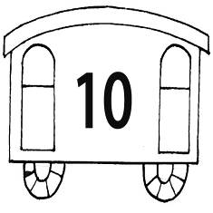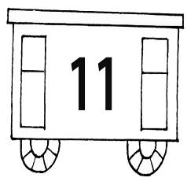  ten eleven ____________ | - 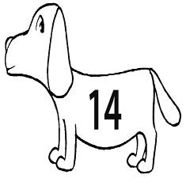  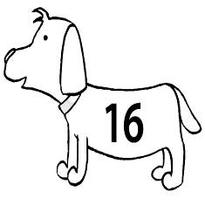  fourteen ____________ sixteen
- 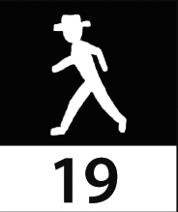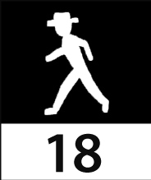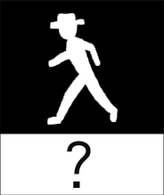  nineteen eighteen ____________ | 4. 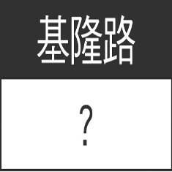 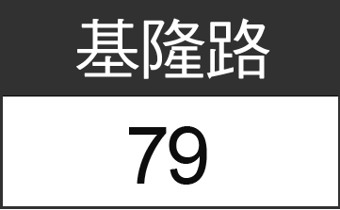 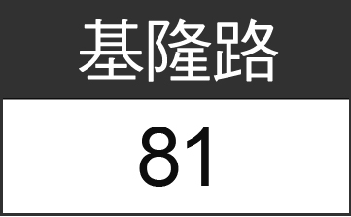  ____________ seventy-nine eighty-one

五、讀句子，填入適當的字詞。（每字限填一次）。(每格2分，共10%) 含課本習作8%, P.23
hurry leave voice quiet smart
1. Tina is a ____________ girl.
2. The woman is a famouse singer. She has a beautiful _____________.
3. We are late! Let’s ____________.
4. Please don’t talk. Be ____________. The movie is on.
5. Let’s not ____________ those boys here.
六、依提示回答問題 (每題2分，共10%) 課本習作P.16、P.20、P.26
- Cathy is a girl. She is young and cute. (合併句子)
____________________________________
- Don’t close your book.（改為肯定句，並加入 please）
____________________________________
- Jenny is a good student.（以祈使句改寫）
____________________________________
- cat / favorite pet. / Vicky’s / is / This (句子重組)
____________________________________
- from? / are / waitresses / those / Where (句子重組)
____________________________________

七、閱讀測驗： (每題2分，共14%)
Many students in our school are sick. Teacher Chen tells us to do the following:
- Wash our hands before lunch.
- Don’t be the lunch helper at school if we are sick.
- Don’t use the same cups to drink water.
- Don’t go to school if we are sick.
- Wear a mask.
- Tell the teachers or school nurses if we are sick.
If we follow the rules, we can help ourselves and others to stay healthy.

( ) 1. If Nick is sick, he should _________.
sick 生病 tell告訴 following以下 lunch午餐
helper 幫手 if 如果 use 使用 cup 杯子 drink 喝
wear 戴 mask 口罩 ourselves 我們自己
others 其他人 stay 保持、待 healthy 健康
should 應該 may 可能 each other 互相

- go to school
- wash hands after lunch
- stay at home
- watch TV

( ) 2. If we follow the rules, we may ___________.
(A) help each other to stay healthy. (B)wear a mask
(C) get sick (D)eat lunch

- * 1-3格請根據文意填入適當的形容詞；4-5請選出適當的答案
Jassie and Lisa are twins but they are very different. Jassie is heavy but Lisa is ____1_____. Jassie is tall but Lisa is _____2______. Jassie has big eyes but Lisa’s eyes are____3______. Jassie’s favorite singer is A-mei but Lisa’s favorite is Jay. Jassie is a talented swimmer but Lisa is afraid of water. They have nothing in common except they have the same birthday.
but 但是 is afraid of 害怕 nothing 無任何事 common 共通點 except 除了 colsest 最接近 meaning 意思

( )4. Who is Jassie?
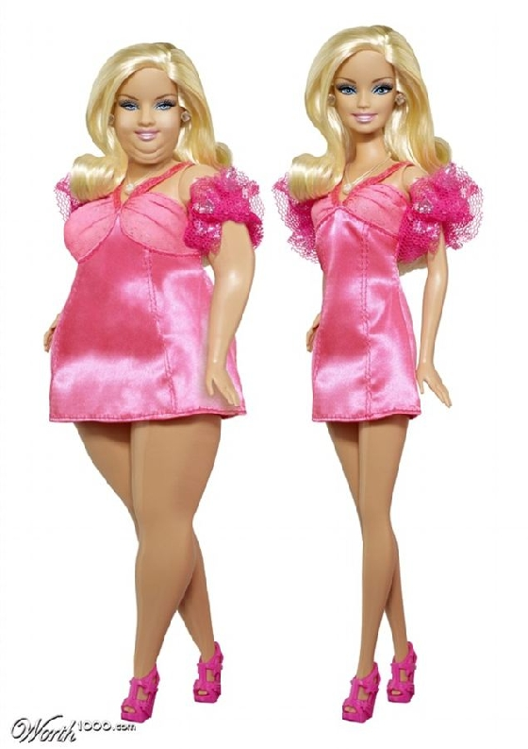  A | B | C
( ) 5. In the reading, talented is closest (最接近) in meaning to
- bad (B) good
( C) happy (D) cute
高雄市立林園高級中學國中部 104學年度第一學期一年級 英語科 第二次段考作答卷
班級： 姓名： 座號：
壹、【聽力測驗，共30分】(1-10題每題1分，共10%)
1. | 2. | 3. | 4. | 5. | 6. | 7. | 8. | 9. | 10
(11-20題每題2分，共20%)：
11 | 12 | 13 | 14 | 15 | 16 | 17 | 18 | 19 | 20
貳、【紙筆測驗，共70分】
一、字彙測驗 (每題1分，共8%) (1-4：課本習作P.23；請依字首提示作答)
1 | 2 | 3 | 4
5. | 6. | 7. | 8

二、看圖，依句意填入適當的字詞。(每格1分，共10%) 課本習作P.24
1  ____________ for me. | 2  ____________ ____________, young men. | 3  _________ _________ your cellphone.
4.  Let’s_________ __________ the bus. | 5.  Please____________ ____________ ____________. | 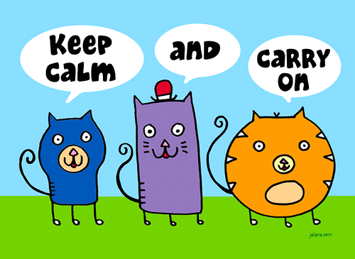

三、選擇 (每格1分，共10%)
1. | 2. | 3. | 4. | 5. | 6. | 7. | 8. | 9. | 10

四、看圖，觀察數字排列，填入適當的英文數字 (每格2分，共8%) 課本習作P.14

1.______________ 2._____________ 3.___________________ 4.____________________

五、讀句子，填入適當的字詞。（每字限填一次）。(每格2分，共10%) 含課本習作8% ,P.23
1._____________ 2._____________ 3.__________________ 4.__________________ 5.__________________
六、依提示回答問題 (每題2分，共10%) 課本習作P.16、P.20、P.26
- Cathy is a girl. She is young and cute. (合併句子) ___________________________________________________
- Don’t close your book.（改為肯定句，並加入 please） ____________________________________________________
- Jenny is a good student.（以祈使句改寫） ____________________________________________________
- cat / favorite pet. / Vicky’s / is / This (句子重組) ____________________________________________________
- from? / are / waitresses / those / Where (句子重組) ____________________________________________________
1. | 2.
七、閱讀測驗： (每題2分，共14%)
1. 2.
1  _______________ | 2  ________________ | 3  ________________ | 4 | 5

高雄市立林園高級中學國中部 104學年度第一學期一年級 英語科 第二次段考解答
班級： 姓名： 座號：
壹、【聽力測驗，共30分】(1-10題每題1分，共10%)
1.  A | 2.  A | 3.  B | 4.  A | 5.  B | 6.  A | 7.  B | 8.  B | 9.  A | 10  A
(11-20題每題2分，共20%)：
11  B | 12  A | 13  A | 14  B | 15  B | 16  A | 17  B | 18  C | 19  A | 20  B
貳、【紙筆測驗，共70分】
一、字彙測驗 (每題1分，共8%) (1-4：課本習作P.23；請依字首提示作答)
run | factory | listen | movie theater
son | robot | trash | hamburger

二、看圖，依句意填入適當的字詞。(每格1分，共10%) 課本習作P.24
1  Wait | 2  Stand up | 3  Turn off
4.  get on | 5.  stand in line

三、選擇 (每格1分，共10%)
1.  B | 2.  B | 3.  D | 4.  D | 5.  B | 6.  C | 7.  B | 8  D | 9.  A | 10  A

四、看圖，觀察數字排列，填入適當的英文數字 (每格2分，共8%) 課本習作P.14

1.____twelve_____ 2.____fifteen__ 3._____seventeen______ 4.______seventy-seven______

五、讀句子，填入適當的字詞。（每字限填一次）。(每格2分，共10%) 含課本習作8% P.23
1.____smart_____ 2. ___voice_____ 3.___hurry_____ 4.__quiet________ 5.____leave_______

六、依提示回答問題 (每題2分，共10%) 課本習作P.16、P.20、P.26
- Cathy is a girl. She is young and cute. (合併句子) Cathy is a young and cute girl.
- Don’t close your book.（改為肯定句，並加入 please） Close your book, please. / Please close your book.
- Jenny is a good student.（以祈使句改寫） Be a good student, Jenny. / Jenny, be a good student.
- cat / favorite pet. / Vicky’s / is / This (句子重組) This cat is Vicky’s favorite pet.
- from? / are / waitresses / those / Where (句子重組) Where are those waitresses from?
1.  C | 2.  A
七、閱讀測驗： (每題2分，共14%)
1. 2.
1_____thin_____ | 2_____short________ | 3_____small________ | 4  B | 5  B

