高雄市立林園高級中學 國中部 104學年度 第 ㄧ 學期 一 年級 英語 科 第 三 次 段考考卷
班級： 姓名： 座號： 本試卷共（4）頁
一、聽力測驗：共30分。
(一) 聽CD，選出聽到的字詞。(每題1分，共5分。)
( ) 1. | (A) building | (B) painting | (C) preparing
( ) 2. | (A) beside | (B) cage | (C) honey
( ) 3. | (A) lake | (B) mountain | (C) island
( ) 4. | (A) training | (B) frisbee | (C) painting
( ) 5. | (A) fruit | (B) vacation | (C) picnic

(二) 聽CD，配合圖片選出最適當的答案。(每題1分，共5分。)
( ) 6. | (A)  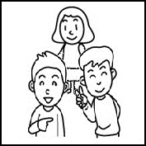 | (B)  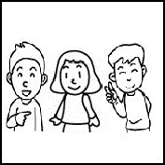 | (C)  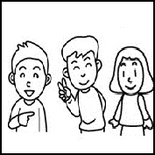
( ) 7. | (A)  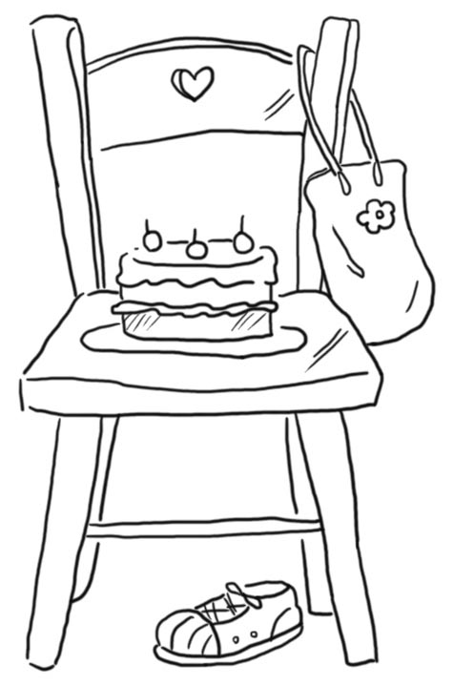 | (B)  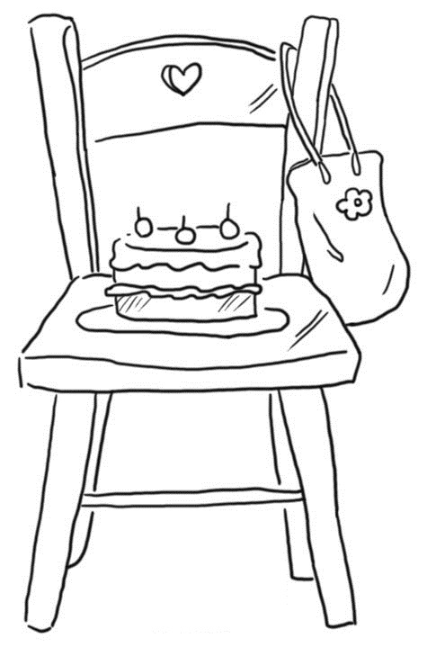 | (C)  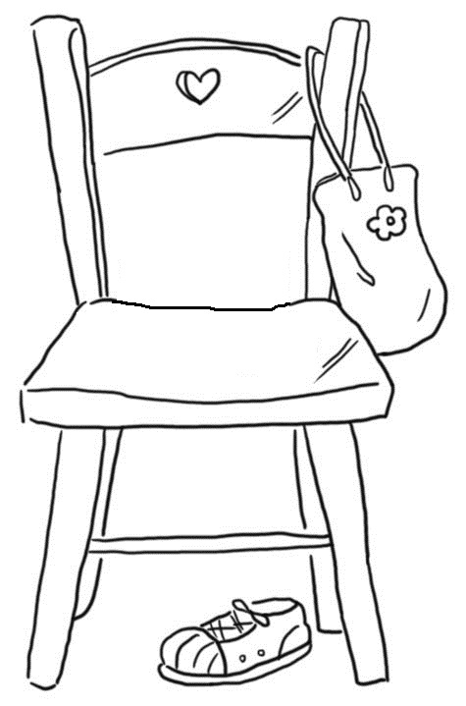
( ) 8. | (A)  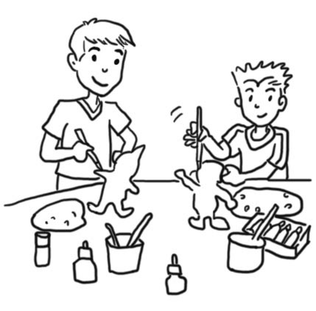 | (B)  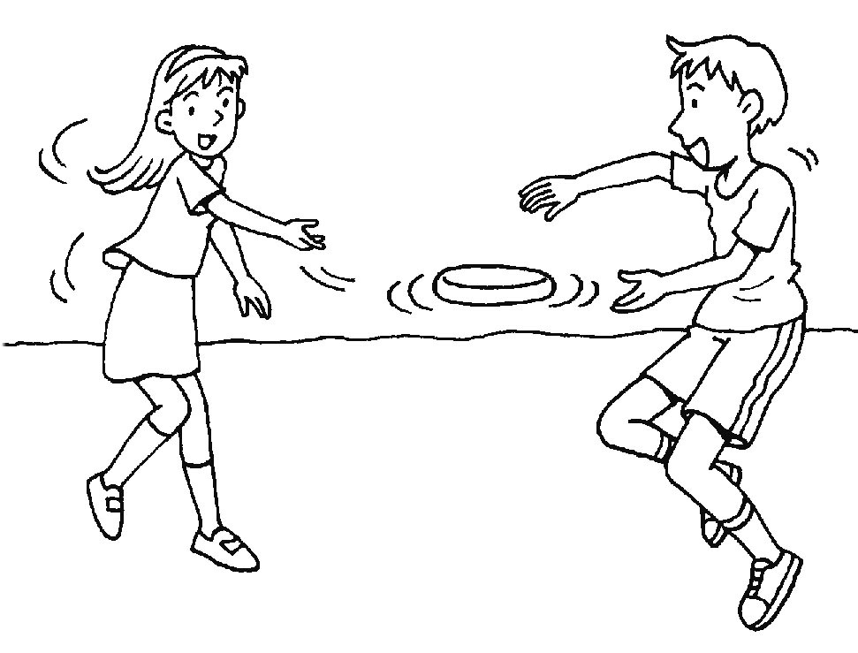 | (C)  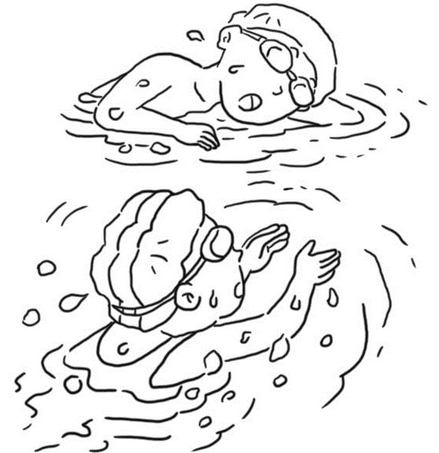
( ) 9. | (A)   | (B)   | (C)  
( ) 10. | (A)  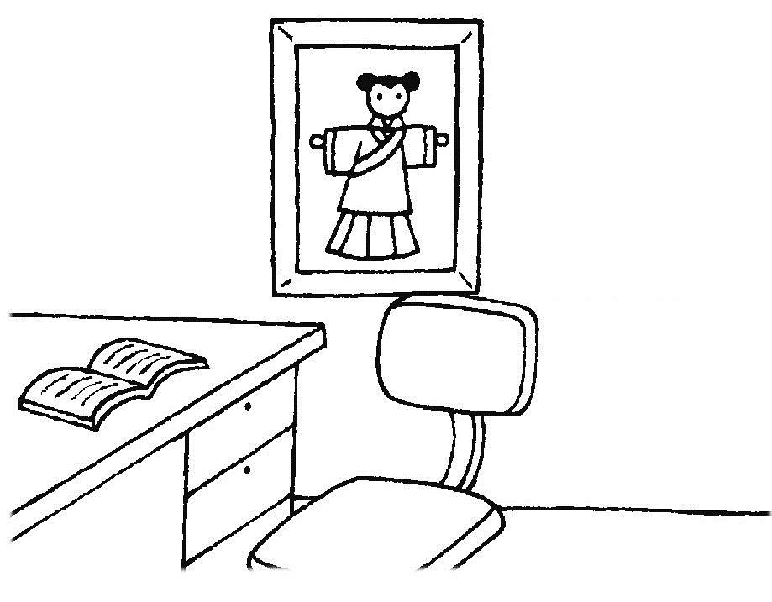 | (B)  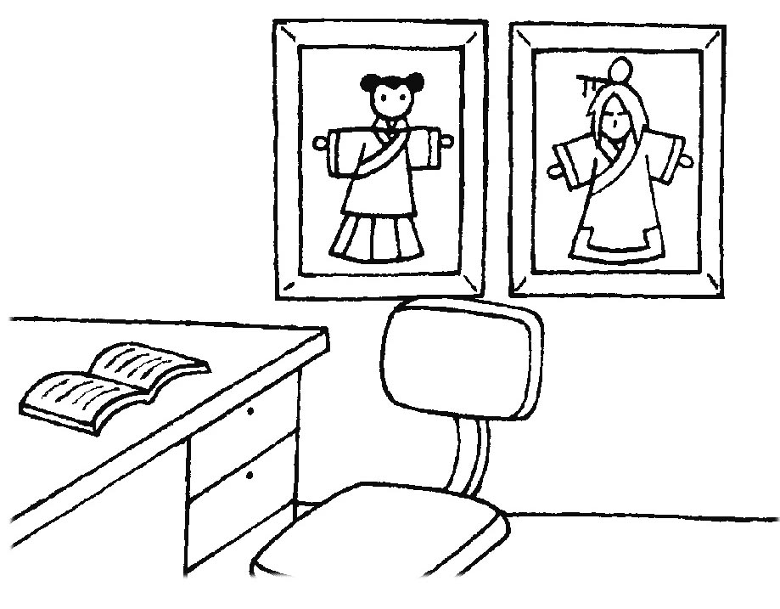 | (C)  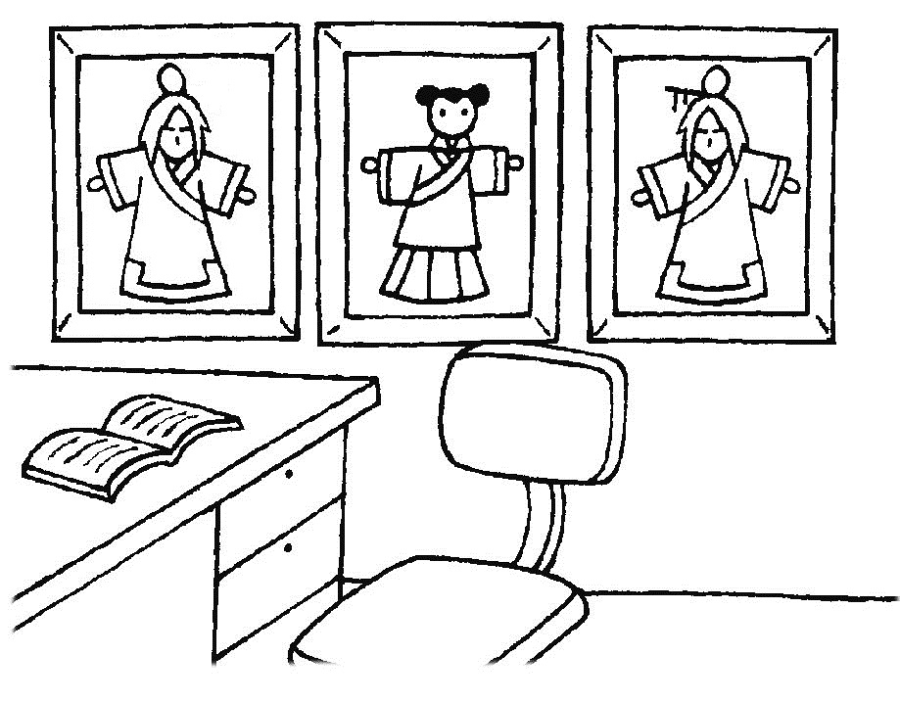

(三) 聽CD，選出適當的回應句。(每題2分，共10分。)
( ) 11. | (A) Let’s play frisbee. | (B) Really? Show me. | (C) Yes. You’re smart.
( ) 12. | (A) It’s in your pocket. | (B) It’s a watch. | (C) It’s special.
( ) 13. | (A) There are a lot of students at school today.  (B) No, there aren’t students at school today.  (C) Yes, there is.
( ) 14. | (A) They are busy. | (B) They are from the USA. | (C) They are talking to their son.
( ) 15. | (A) Oops, I’m sorry. | (B) See you. | (C) Hurry up!
(四) 聽CD中的對話，選出適當的答案。(每題2分，共10分。)
( ) 16. | (A) She’s running over to her friends. (B) She’s singing with her friends. (C) She’s dancing with her friends.
( ) 17. | (A) Yes, there is a monkey in back of the house.  (B) No, there isn’t a monkey in back of the house.  (C) Yes, there are some monkeys in front of the house.
( ) 18. | (A) It’s singing. | (B) It’s sleeping. | (C) It’s shouting.
( ) 19. | (A) There is a house. | (B) There is a lake. | (C) There is a river.
( ) 20. | (A) It is seven fifty. | (B) It is six fifty. | (C) It is seven fifteen.

二. 紙筆測驗：每題 2 分，共35題，總分70分。
(一)字彙選擇
( ) 21. A: Are the girls _____? B: No, they are roller-skating. 【習作p29】
- roller-skating (B) jogging (C) doing (D) sing
( ) 22. Please have your _____. 【習作p34】
(A) busy (B) beside (C) under (D) breakfast
( ) 23. My grandpa’s house is on a _____. He grows(種植) a lot of fruit trees there.
- bank (B) pond (C) hill (D) river
( ) 24. Let’s go to the new _____ near our house. I am hungry. 【習作p40】
(A) restaurant (B) station (C) bank (D) flower shop
( ) 25. The woman is _____ now. She is mopping(拖) the floor(地板). 【習作p28】
(A) hungry (B) great (C) busy (D) late
( ) 26. Mary is _____ the flowers. 【習作p34】
(A) shouting (B) falling (C) watering (D) sleeping
( ) 27. They are _____ a house. 【習作p28】
- building (B) running (C) playing (D) dancing
( ) 28. Oh, no. A woman is _____ from the tall building.
(A) looking for (B) falling down (C) listening to (D) running over to
( ) 29. There are only(只；僅) two people on that _____. 【習作p40】
(A) shop (B) bank (C) lake (D) island
( ) 30. The birds are in the _____. They can’t fly(飛) freely(自由地). 【習作p34】
(A) here (B) cage (C) garden (D) park

(二)文法選擇
( ) 31. The robot is _____ the cellphone and the camera. 【習作p35】
(A) in (B) front (C) between (D) back
( ) 32. A: _____ are Melody and David doing? B: They are playing frisbee. 【習作p29】
(A) How (B) Where (C) Who (D) What
( ) 33. A: Is there a book beside the computer? B: _____
(A) Yes, there is. (B) Yes, there has. (C) Yes, it is. (D) Yes, there are.
( ) 34. Wait for _____, please! It’s dark here. 【習作p31】
(A) I (B) my (C) me (D) we
( ) 35. Look! My dad _____ a beautiful house _____ the dog.
(A) building; with (B) is build; for (C) am building; with (D) is building; for
( ) 36. A: _____ is it there? B: It’s eleven thirty at night. 【習作p36】
(A) What time (B) What (C) Where (D) Who
( ) 37. There _____ a lot of flowers and fruit trees at Wuling Farm. 【課本p104】
- be (B) am (C) is (D) are
( ) 38. A: _____ are your friends doing? B: They’re dancing _____ my room.
(A) Where; in (B) Where; on (C) What; in (D) What; on
( ) 39. A: Is Mr. and Mrs. Brown’s house big? B: Yes, _____ house is big. 【習作p31】
(A) their (B) they (C) them (D) our
( ) 40. A: Are there any people in the station?
B: _____, there aren’t. There aren’t _____ people in the station. 【習作p43】
(A) No ; some (B) No ; any (C) Yes ; some (D) Yes ; any

(三). 克漏字選擇
A. 看圖並閱讀對話後作答。 【習作p32】
Ivan：Hey, Joe. What is that?
Joe：It’s a toy robot, my birthday __41.__.
Ivan：Cool.
Joe：Yeah. It can do many things.
Ivan：Really? Show __42.__.
Joe：OK.
Ivan：__43.__ is it doing now?
Joe：It is __44.__.
Ivan：Wow. How special!
Joe：Listen! It is __45.__ “Happy Birthday to You.”
Ivan：Great.  many 許多的 thing 事情 How special! 真特別啊！
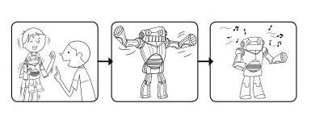

( ) 41. (A) gift (B) house (C) watch
( ) 42. (A) I (B) my (C) me
( ) 43. (A) How (B) What (C) Where
( ) 44. (A) dancing (B) painting (C) swimming
( ) 45. (A) reading (B) doing (C) singing

(四). 閱讀測驗
Ａ.
It’s Sunday afternoon. What are the students of Class 101 doing?

&Sunday 星期日 class 班級 watch 看 game 遊戲 study 讀書

( ) 46. _____ students of Class 101 are watching TV.
(A) 20% (B) 40% (C) 15% (D) 10%
( ) 47. There are 60 students in total in Class 101. ______ students are playing computer games. & in total 總共
(A) 24. (B) 12. (C) 9. (D) 6.
Desk C 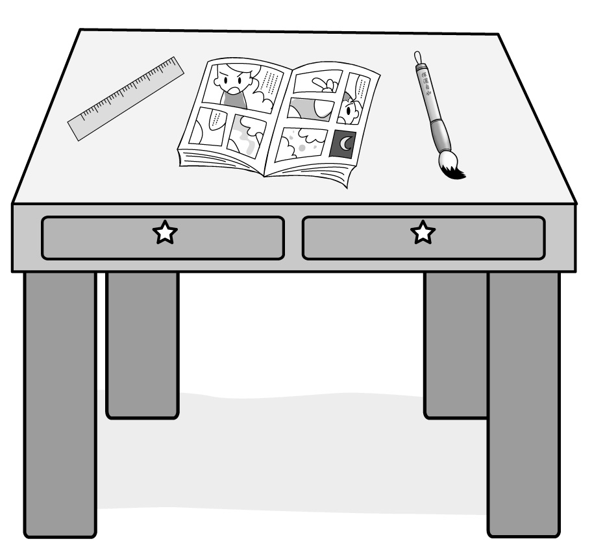 |  | Desk D 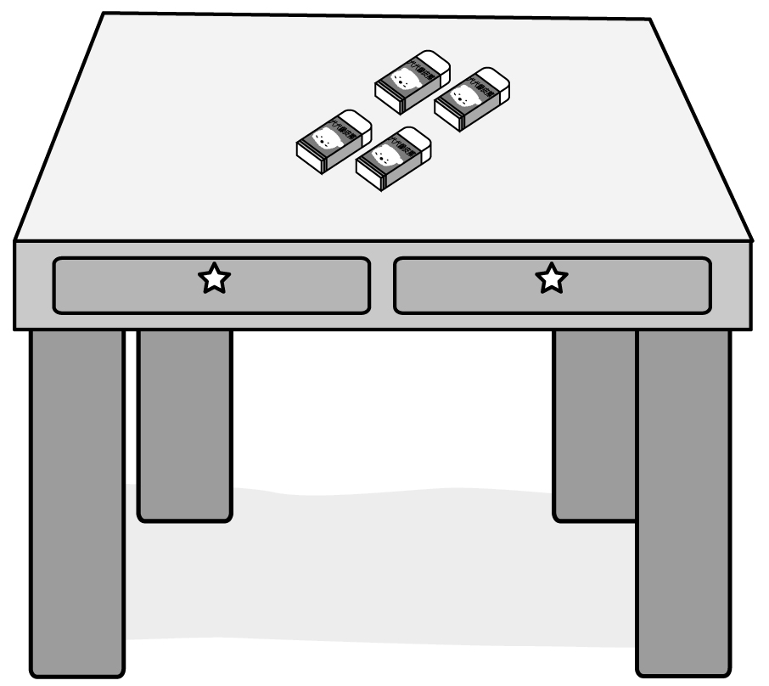
Desk A 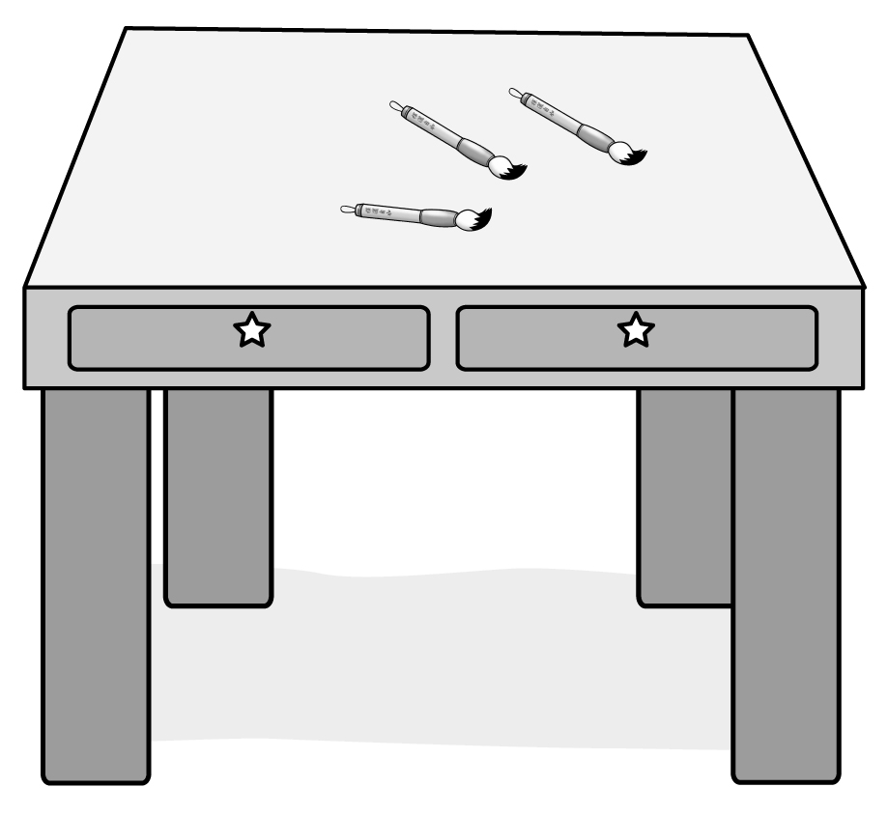 |  | Desk B 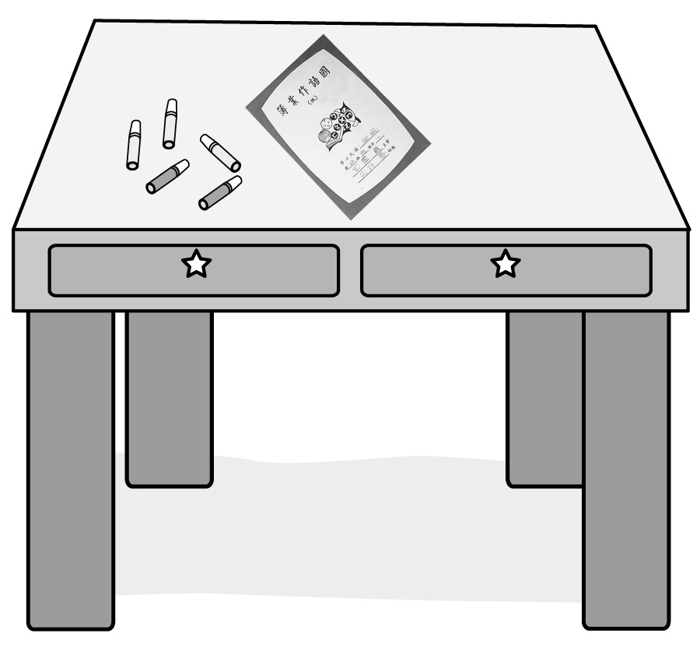
圖1

B.
There are four desks here. Amy’s desk is in back of Meg’s desk. Lily’s desk is beside Amy’s desk, and Henry’s desk is in front of Lily’s desk. Look at Amy’s desk. There are some markers and a workbook on the desk.
 marker彩色筆；workbook練習簿

( ) 48. Which（何者）is Meg’s desk? (請看圖1)
(A) Desk A (B) Desk B
(C) Desk C (D) Desk D

( ) 49. Is there one eraser on Meg’s desk?
(A) No. There are four. (B) Yes, there are. (C) No, there aren’t. (D) Yes, there is.
( ) 50. Are there any erasers on Henry’s desk?
(A) Yes, there are four. (B) Yes, there are five. (C) Yes, there are three. (D) No, there aren’t.
( ) 51. What is there on Lily’s desk?
(A) There are four erasers.
(B) There are a comic book(漫畫書), a brush(水彩筆), and a ruler.
(C) There are three brushes.
(D) There are five markers and a workbook.

C.

A Drawing Class
It’s a drawing class. The students are introducing(介紹) their pictures(圖畫) to the class.
Now it’s Kathy’s turn(輪到Kathy). She is a shy(害羞) girl. And her face is red.
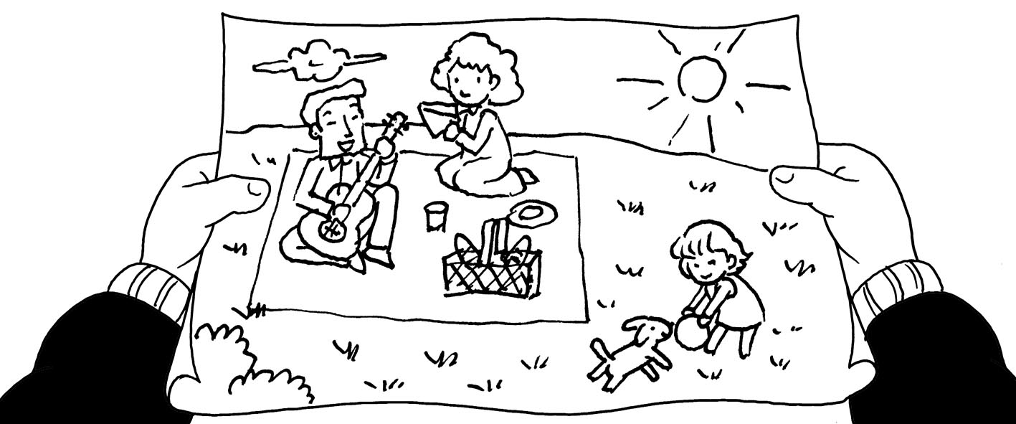
Ms. Wang: Who are you drawing? Please tell us about(關於) them.
Kathy: My… family.
Ms. Wang: Great! What are you doing in the picture?
Kathy: We’re having a picnic in the park.
Ms. Wang: Who is the beautiful woman?
Kathy: My dear mom.
Ms. Wang: What is she doing?
Kathy: She’s preparing food for us.
Ms. Wang: How about the man?
Kathy: He’s my dad. He’s playing the guitar(吉他).
Ms. Wang: Who is the cute girl?
Kathy: Me. I’m playing with my good friend, Cody. He is a smart puppy.
Ms. Wang: Good job! Try and you can do it very well.

( ) 52. Why(為什麼) is Kathy’s face red in the story?
(A) Because(因為) she’s sick(生病). (B) Because she’s very happy.
(C) Because she’s sad. (D) Because she’s very shy.
( ) 53. What is the picture about?
(A) Kathy’s family. (B) Kathy’s class.
(C) Kathy’s birthday. (D) Kathy’s classmates.
( ) 54. What are the people doing in the picture?
(A) They are jogging in the park. (B) They are having a picnic in the park.
(C) They are roller-skating in the parking. (D) They are running in the park.
( ) 55. Which of the following is TRUE? (下列哪個是正確的？)
(A) Cody is drawing pictures. (B) Kathy’s mom is preparing food.
(C) Kathy’s dad is playing with Kathy. (D) Kathy is playing the guitar.

高雄市立林園高級中學 國中部 104學年度 第 ㄧ 學期 一 年級 英語 科 第 三 次 段考答案卷
班級： 姓名： 座號：
一、聽力測驗：共30分。
(一) 聽CD，選出聽到的字詞。(每題1分，共5分。)
1. A | 2. C | 3. B | 4. B | 5. C
(二) 聽CD，配合圖片選出最適當的答案。(每題1分，共5分。)
6. B | 7. C | 8. C | 9. A | 10. C
(三) 聽CD，選出適當的回應句。(每題2分，共10分。)
11. B | 12. A | 13. B | 14. C | 15. A
(四) 聽CD中的對話，選出適當的答案。(每題2分，共10分。)
16. B | 17. A | 18. C | 19. B | 20. A

二、紙筆測驗：每題2分，共35題，總分70分。
(一) 字彙選擇：(每題2分，共20分。)
21. B | 22. D | 23. C | 24. A | 25. C
26. C | 27. A | 28. B | 29. D | 30. B
(二) 文法選擇：(每題2分，共20分。)
31. C | 32. D | 33. A | 34. C | 35. D
36. A | 37. D | 38. C | 39. A | 40. B
(三)克漏字選擇：(每題2分，共10分。)
41. A | 42. C | 43. B | 44. A | 45. C
(四)閱讀測驗：(每題2分，共20分。)
46. B | 47. B | 48. D | 49. A | 50. D
51. C | 52. D | 53. A | 54. B | 55. B
一年級(英文科)第3次段考--答案（年級、科目請標示清楚，謝謝！）
1~5 | ACBBC | 6~10 | BCCAC
11~15 | BABCA | 16~20 | BACBA
21~25 | BDCAC | 26~30 | CABDB
31~35 | CDACD | 36~40 | ADCAB
41~45 | ACBAC | 46~50 | BBDAD
51~55 | CDABB
高雄市立林園高級中學 國中部 104學年度 第 ㄧ 學期 一 年級 英語 科 第 三 次 段考答案卷
班級： 姓名： 座號：
一、聽力測驗：共30分。
(一) 聽CD，選出聽到的字詞。(每題1分，共5分。)
1. | 2. | 3. | 4. | 5.
(二) 聽CD，配合圖片選出最適當的答案。(每題1分，共5分。)
6. | 7. | 8. | 9. | 10.
(三) 聽CD，選出適當的回應句。(每題2分，共10分。)
11. | 12. | 13. | 14. | 15.
(四) 聽CD中的對話，選出適當的答案。(每題2分，共10分。)
16. | 17. | 18. | 19. | 20.

二、紙筆測驗：每題2分，共35題，總分70分。
(一) 字彙選擇：(每題2分，共20分。)
21. | 22. | 23. | 24. | 25.
26. | 27. | 28. | 29. | 30.
(二) 文法選擇：(每題2分，共20分。)
31. | 32. | 33. | 34. | 35.
36. | 37. | 38. | 39. | 40.
(三)克漏字選擇：(每題2分，共10分。)
41. | 42. | 43. | 44. | 45.
(四)閱讀測驗：(每題2分，共20分。)
46. | 47. | 48. | 49. | 50.
51. | 52. | 53. | 54. | 55.

聽力測驗錄音檔
一、聽CD，選出所聽到的字詞。：
1. 《腳本區》My father is building a dog house for Cody.
《題目區》(A) building
(B) painting
(C) preparing
《答案區》A

2. 《腳本區》Honey, what’s this in your pocket?
《題目區》(A) beside
(B) cage
(C) honey
《答案區》C

3. 《腳本區》Mt. Jade is a tall mountain in Taiwan.
《題目區》 (A) lake
(B) mountain
(C) island
《答案區》B

4. 《腳本區》I’m playing frisbee with my dog.
《題目區》 (A) training
(B) frisbee
(C) painting
《答案區》B

5. 《腳本區》They are having a picnic under the cherry blossom trees.
《題目區》 (A) fruit
(B) vacation
(C) picnic
《答案區》C

二、聽CD，配合圖片選出最適當的答案。：
6. 《腳本區》The girl is standing between the two boys.
《題目區》
(A) (B)(C)
《答案區》B

7. 《腳本區》There is a shoe under the chair. But there isn’t a cake on the chair.
《題目區》
(A) (B) (C)
《答案區》C

8. 《腳本區》It’s hot today. The students are swimming.
《題目區》
(A) (B)(C)
《答案區》C

9. 《腳本區》It’s five thirty. Let’s hurry.
《題目區》
(A) (B)(C)
《答案區》A

10. 《腳本區》There are three pictures in the room.
《題目區》
(A) (B) (C)
《答案區》C

三、聽CD，選出適當的回應句。：
11. 《腳本區》I’m training my dog. It’s very smart.
《題目區》 (A) Let’s play frisbee.
(B) Really? Show me.
(C) Yes. You’re smart.
《答案區》B

12. 《腳本區》Where is my cellphone?
《題目區》 (A) It’s in your pocket.
(B) It’s a watch.
(C) It’s special.
《答案區》A

13. 《腳本區》Are there any students at school today?
《題目區》 (A) There are a lot of students at school today.
(B) No, there aren’t students at school today.
(C) Yes, there is.
《答案區》B

14. 《腳本區》What are Mr. and Mrs. Smith doing?
《題目區》 (A) They are busy.
(B) They are from the USA.
(C) They are talking to their son.
《答案區》C
15. 《腳本區》Don’t shout. Mom is sleeping in her room now.
《題目區》 (A) Oops, I’m sorry.
(B) See you.
(C) Hurry up!
《答案區》A

四、聽CD中的對話，選出適當的答案。：
16. 《腳本區》Man: What are you doing now?
Woman: My friends and I are singing.
Question: What is the woman doing?
《題目區》 (A) She’s running over to her friends.
(B) She’s singing with her friends.
(C) She’s dancing with her friends.
《答案區》B

17. 《腳本區》Girl: Look over there! Isn’t there a monkey in back of the house?
Boy: Yes, there is.
Question: Is there a monkey in back of the house?
《題目區》 (A) Yes, there is a monkey in back of the house.
(B) No, there isn’t a monkey in back of the house.
(C) Yes, there are some monkeys in front of the house.
《答案區》A

18. 《腳本區》Man: Look! King Kong is standing on the building.
Woman: What’s it doing?
Man: It’s shouting.
Question: What is King Kong doing on the building?
《題目區》 (A) It’s singing.
(B) It’s sleeping.
(C) It’s shouting.
《答案區》C

19. 《腳本區》Man: Is there a park in front of your house, Kelly?
Woman: Yes, there is a big park in front of my house. And there is a lake in it.
Question: What is there in the big park?
《題目區》 (A) There is a house.
(B) There is a lake.
(C) There is a river.
《答案區》B

20. 《腳本區》Man: It’s seven fifty. Cindy, wake up!
Girl: Oh, no. I’m late.
Man: Wait! I’m sorry. Today is Sunday.
Question: What time is it now?
《題目區》 (A) It is seven fifty.
(B) It is six fifty.
(C) It is seven fifteen.
《答案區》A

