高雄市立林園高級中學 國中部 104學年度 第1學期 2年級第1次段考 英文科 試題卷
班級： 姓名： 座號：
- 本試卷共（ 4 ）頁

第一部分 Listening Comprehension 聽力測驗 （30 %）

- 辨識句意：根據聽到的內容，選出符合描述的圖片或符合圖片的描述。每格1分，共5分
1 | (Ａ) 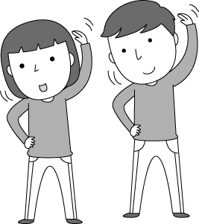 | (Ｂ) 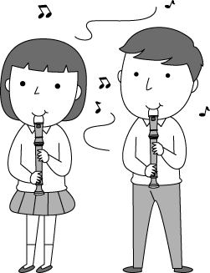 | (Ｃ) 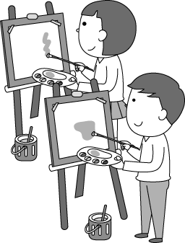
2 | (Ａ) 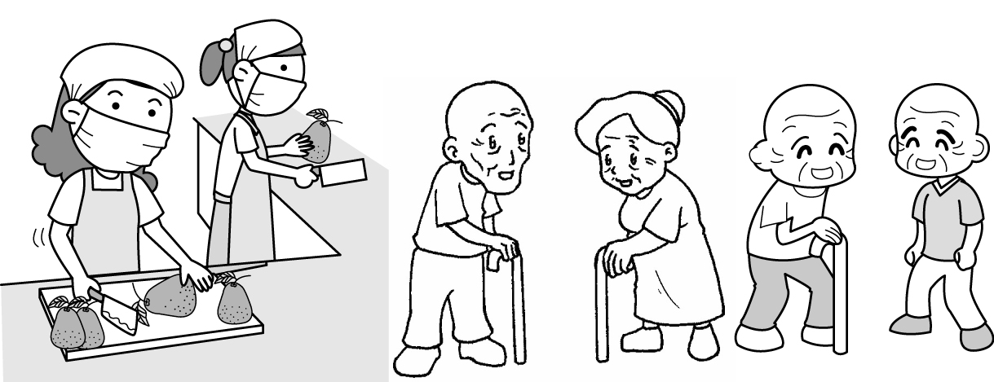 | (Ｂ) 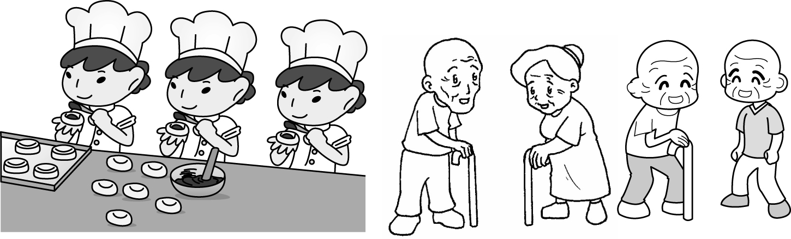 | 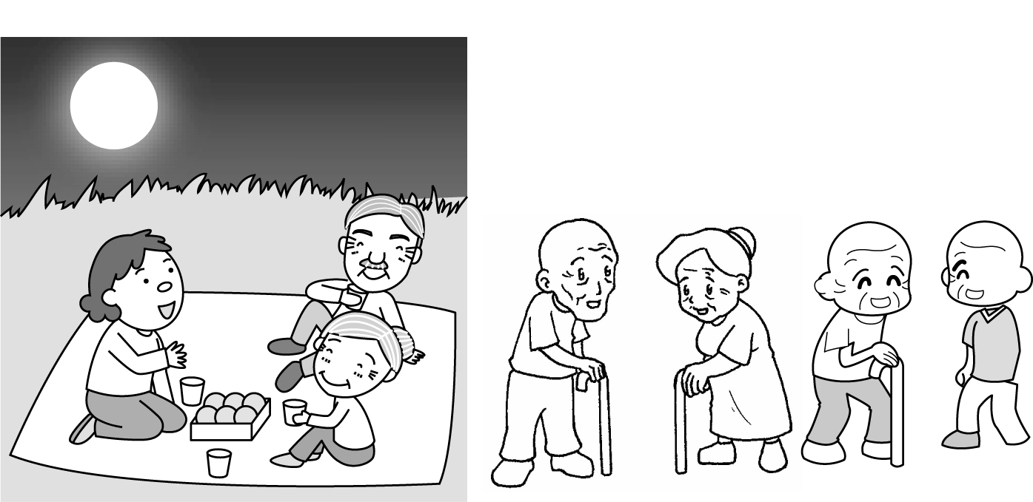  (Ｃ)
3 | (Ａ) 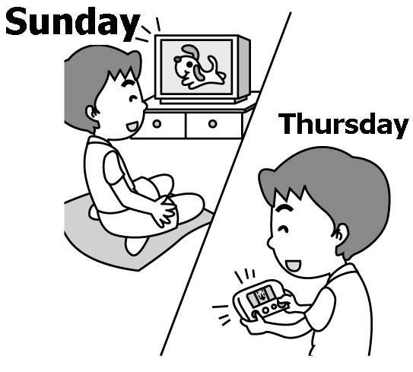 | (Ｂ) 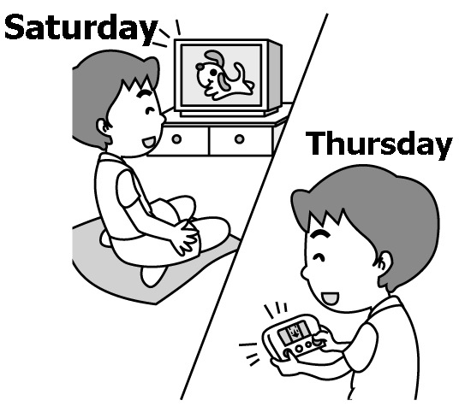 | (Ｃ) 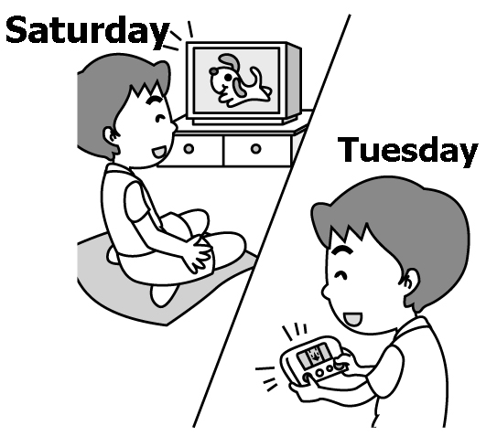
4 | (Ａ) 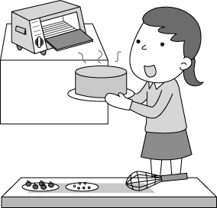 | (Ｂ) 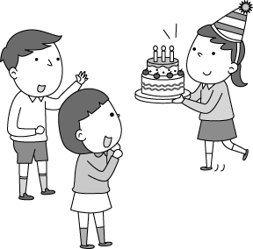 | (Ｃ) 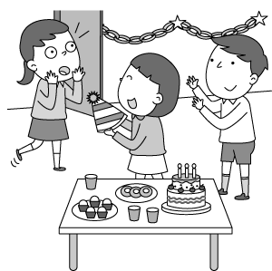
5 | (Ａ) 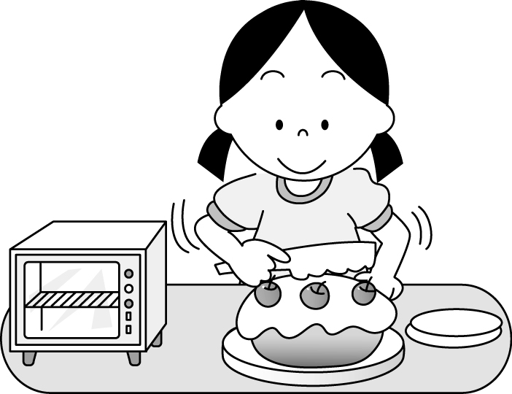 | (Ｂ) 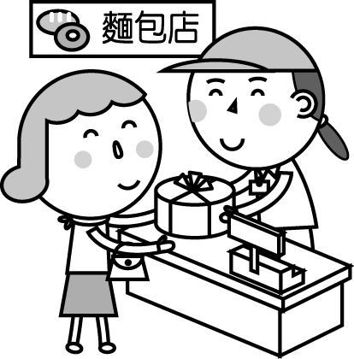 | (Ｃ) 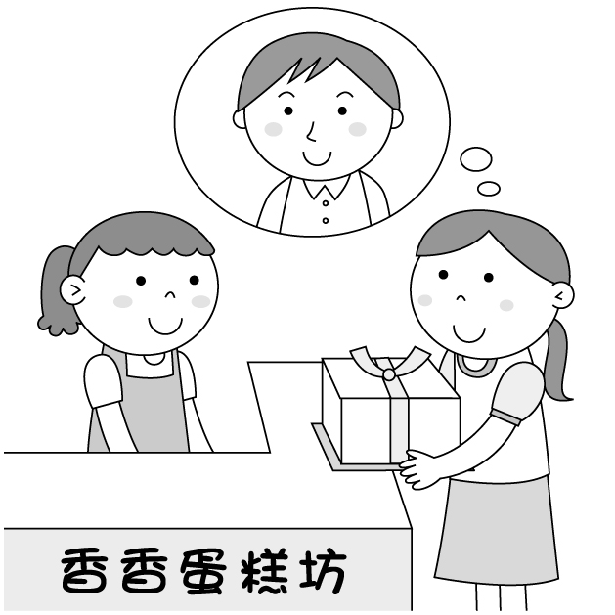  Dad
- 基本問答：根據聽到的內容，選出一個最適合的回應或最適合的問句。每格1分，共5分
- (Ａ) I hope not.
(Ｂ) Good for you.
(Ｃ) It was interesting.
- (Ａ) Peter is my good friend.
(Ｂ) We chatted about our spring vacation.
(Ｃ) Let’s have an interesting chat with him.
- (Ａ) We were poor then.
(Ｂ) We ate pomelos together.
(Ｃ) We fell in love with each other.
- (Ａ) He slept for eight hours yesterday.
(Ｂ) He is never in a sound sleep at night.
(Ｃ) What? He went to bed at nine last night.
- (Ａ) It’s on sale.
(Ｂ) It’s cheap now.
(Ｃ) It’s NT$500.
- 言談理解：根據聽到的內容，選出一個最適合的答案。每格2分，共20分
- (Ａ) Billy didn’t enjoy his vacation.
(Ｂ) Billy visited Japan during his vacation.
(Ｃ) Billy is talking about his vacation plans.
- (Ａ) Gina didn’t like the English class.
(Ｂ) Gina has a different English teacher.
(Ｃ) Gina enjoyed her first day back at school a lot.
- (Ａ) Pigs.
(Ｂ) Tigers.
(Ｃ) Elephants.
- (Ａ) It is sick.
(Ｂ) It is sad.
(Ｃ) It died.
- (Ａ) The man doesn’t have a car now.
(Ｂ) The man sold his car because he didn’t like it.
(Ｃ) The man sold his car because he wanted to buy a new car.
- (Ａ) A cap.
(Ｂ) A robot.
(Ｃ) A pair of shoes.
- (Ａ) Computers and books.
(Ｂ) Only computers.
(Ｃ) Nothing.
- (Ａ) She had a great time dancing and singing.
(Ｂ) She cooked much food.
(Ｃ) She made a card.
- (Ａ) Prison Inn is a bicycle shop.
(Ｂ) Sophia was sick on New Year’s Day.
(Ｃ) Sophia and her family were in Penghu on the first day of the new year.
- (Ａ) She walked Lucky.
(Ｂ) She studied English.
(Ｃ) She practiced basketball.

第二部分 Reading & Writing Comprehension讀寫測驗 （70 %）。

- 文意字彙。每題1分，共5分。
1. Pete, don’t ask your classmates any q ns at this time. Listen to the performer, please.
2. In Taiwan, winter v n lasts（持續）about three weeks.
3. My family loved to have a p c at the park. It was our favorite time.
4. The Wang family are poor, so they usually buy c p things.
5. Linda and I are good friends. We always give p ts to each other on our birthdays.

- 填充題。每格1分，共15分。
1. 寫出下列動詞的過去式
(１) plan →
(２) worry →
(３) hope →
(４) keep →
(５) ask →
- 填入正確的介系詞，不需填字者，請打。
(１) Did you send the book ______ Larry?
(２) Mom, I am hungry. Buy ______ me a hot dog, please.
(３) The boys are making breakfast ______ their parents.
(４) ______ Donation Day, our class gave many toys the kids at the children’s home.

3. 填入正確的所有格代名詞，完成下列對話。
(１) Amy:Are those shoes your brother’s? Ben: No, They are not. are blue, not black.
(２) Jill: Are these Ben and your new toys? Liz: No, they’re not .
(３) Mia: Is that Mr. and Mrs. Chen’s car? Leo: Yes, it’s .
(４) Joy: Jill’s hat is small, and is old. Mom: Okay. Let’s buy some hats tonight.
(５) Sam: I got these beautiful bags from Linda. Ann: Hey, they are not . They are mine.

- 選擇題。每題2分，共18分。
( ) 1. Mark put the chair on the desk, but Andy .
(A) does (B)did (C) doesn’t (D)didn’t
( ) 2. Frank a lot when he was sick last week.
(A) eats and sleeps (B) eat and sleep (C) is eating and sleeping (D) ate and slept
( ) 3. Dujuan typhoon, the Wang family did not go on a picnic on Teachers’ Day.  Dujuan typhoon 杜鵑颱風
(A) Thanks for (B) Because (C)Because of (D) Thanks to
( ) 4. On the Moon Festival, we ate moon cakes, pomelo hats, and karaoke.
(A) made; sang (B) making; sanging (C) are making; sanging (D) make; sing
( ) 5. We can the moon the binoculars from the 91st floor of Taipei 101.
(A) see; with (B) look at; for (C) read; from (D) watch; through
( ) 6. Policeman, come and help, please! .
(A) What happened (B) Something happened (C) It happened something (D) I happened something
( ) 7. The computer game a lot of fun. My students always fun playing it in their free time.
(A) is; have (B) has; are (C) is; are (D) has; have
( ) 8. Nora: Did you have a good time in Japan last week? Lisa: I hope to go there again.
(A) Of course not. (B) You bet. (C) It’s great. (D) Yes, I have lots of fun.
( ) 9. Sophie: Dad, that old man helped us a lot. What can we do? Mr. Wu:
(A) We can visit him and ask for more money. (B) We can do it for him.
(C) We can not do anything for him. (D) We can go thank him in person.

- 翻譯。每題4分，共20分。
  - 他們在中秋節前去了美國。
  - 我買了這件背心給我女兒，因為它很便宜。
  - 由於Mr. Chen，我現在對數學燃起了新希望。
  - 謝謝你們慷慨的捐贈，並且請找一天拜訪我們。


- 閱讀測驗。每小題2分，共12分。

Judy had a busy day today. Her parents went to her grandparents' house because her grandma was sick. Judy took care of her little brother, Joe, at home all day.
Early in the morning, Judy did her homework because Joe was still asleep. Then, Joe got up, and they had sandwiches for breakfast. After breakfast, she cleaned her bedroom, and her brother made a card for their grandma. Later, she made some fried rice for lunch. Her brother enjoyed it very much.
Judy's parents came back home at 6 p.m. They were really happy because she helped them a lot today.

 sick 生病的 asleep 睡覺中

（ ）1. What does it mean? mean 意指
(A) The homework. (B) The breakfast
(C) The card. (D) The fried rice.
（ ）2. Why did Judy take care of her brother at home today?
(A) Her brother was sick. (B) Her parents went to work.
(C) Her parents visited her grandma. (D) Her grandma wasn't home.
（ ）3. Which is true about Judy?
(A) She didn't have breakfast today. (B) She ate a sandwich for lunch today.
(C) She did her homework in the morning. (D) She made a card for her grandmother today.

A year ago, many people dumped buckets of ice water over their hands. It is a little strange, but it’s for a good reason. It’s all part of the Ice Bucket Challenge and it swept over the world in the last August of 2014.

The Ice Bucket Challenge is a challenge game. It is to raise money to fight ALS and make people know more about ALS. Any person can join the game and he or she must dump a bucket of ice water over his or her head. After that, he or she can choose three people to do the same challenge in the next 24 hours. Then, make a video of the challenge and post it to Facebook or YouTube. If he or she fails to finish the challenge on time, he or she should donate money to the ALS Association. Of course, many of them also donate money.

The beginning of the idea of dumping ice water over one’s head to raise money to help the sick is not clear. But because of Pete Frates, people started to donate money to the ALS Association through the challenge. Pete Frates was a baseball player, and he got ALS in 2012. More and more people took the challenge from then on, and it raised more money than before. In 2013, the ALS Association got about $2.8 million in donation; however, they got more than $100 million in donation after the Ice Bucket Challenge started. No matter how much money it is now, it brings much notice to ALS.
 dump 倒 bucket水桶 reason理由 raise money募款 challenge挑戰 ALS漸凍人症 association協會

（ ）1. What does swept over the world mean?
(A) Did some cleaning in the world. (B) Became very popular in the world.
(C) Lived a better life in the world. (D) Helped a family get together.
（ ）2. Why did Pete Frates start the Ice Bucket Challenge?
(A) To collect money for the sick. (B) To spend money on the game.
(C) To cheer for his baseball team. (D) To help people build their home.
（ ）3. Which is true about the Ice Bucket Challenge?
(A) It started from Bill Gates.
(B) People with ALS can share their feelings through the challenge.
(C) The one who takes the challenge can’t donate money.
(D) The challenge wanted to wake people up to know ALS.
高雄市立林園高級中學 國中部104學年度 第1學期 2 年級第1次段考 英文科 作答卷
班級： 姓名： 座號：

第一部份 Listening Comprehension 聽力測驗 （30 %）

- 辨識句意：根據聽到的內容，選出符合描述的圖片或符合圖片的描述。每格1分，共5分
1 | 2 | 3 | 4 | 5

二、基本問答：根據聽到的內容，選出一個最適合的回應或最適合的問句。每格1分，共5分
1 | 2 | 3 | 4 | 5

三、言談理解：根據聽到的內容，選出一個最適合的答案。每格2分，共20分
1 | 2 | 3 | 4 | 5
6 | 7 | 8 | 9 | 10

第二部分 Reading & Writing Comprehension讀寫測驗 （70 %）。

一、文意字彙。每題1分，共5分。
1 | 2 | 3 | 4 | 5

- 填充題。每格1分，共15分。
1. 寫出下列動詞的過去式
( 1 ) | ( 2 ) | ( 3 ) | ( 4 ) | ( 5 )
2. 填入正確的介系詞，不需填字者，請打。
( 1 ) | ( 2 ) | ( 3 ) | ( 4 )
3. 填入正確的所有格代名詞，完成下列對話。
( 1 ) | ( 2 ) | ( 3 ) | ( 4 ) | ( 5 )

- 選擇題。每題2分，共18分。
1 | 2 | 3 | 4 | 5
6 | 7 | 8 | 9
- 翻譯。每題4分，共20分。
1.
2.
3.
4.
- 閱讀測驗。每小題2分，共12分。
1 | 2 | 3 | 4 | 5 | 6

高雄市立林園高級中學 國中部104學年度 第1學期 2 年級第1次段考 英文科 答案卷
班級： 姓名： 座號：

第一部份 Listening Comprehension 聽力測驗 （30 %）

- 辨識句意：根據聽到的內容，選出符合描述的圖片或符合圖片的描述。每格1分，共5分
1 | 2 | 3 | 4 | 5
B | B | C | C | B

二、基本問答：根據聽到的內容，選出一個最適合的回應或最適合的問句。每格1分，共5分
1 | 2 | 3 | 4 | 5
C | B | B | C | C

三、言談理解：根據聽到的內容，選出一個最適合的答案。每格2分，共20分
1 | 2 | 3 | 4 | 5
B | B | A | C | A
6 | 7 | 8 | 9 | 10
C | A | A | C | B

第二部分 Reading & Writing Comprehension讀寫測驗 （70 %）。

一、文意字彙。每題1分，共5分。
1 | 2 | 3 | 4 | 5
questions | vacation | picnic | cheap | presents

- 填充題。每格1分，共15分。
1. 寫出下列動詞的過去式
( 1 ) | ( 2 ) | ( 3 ) | ( 4 ) | ( 5 )
planned | worried | hoped | kept | asked
2. 填入正確的介系詞，不需填字者，請打。
( 1 ) | ( 2 ) | ( 3 ) | ( 4 )
to |  | for | On | to
3. 填入正確的所有格代名詞，完成下列對話。
( 1 ) | ( 2 ) | ( 3 ) | ( 4 ) | ( 5 )
His | ours | theirs | mine | hers

- 選擇題。每題2分，共18分。
1 | 2 | 3 | 4 | 5
D | D | C | A | D
6 | 7 | 8 | 9
B | A | B | D
- 翻譯。每題4分，共20分。
1. They went / to the USA / before / the Moon Festival.
2. I bought this vest / for my daughter / because / it is cheep.
3. Thanks to Mr. Chen, / I now / have new hope / for math.
4. Thank you / for your generous donations, / and visit us someday, / please.
- 閱讀測驗。每小題2分，共12分。
1 | 2 | 3 | 4 | 5 | 6
D | C | C | B | A | D

高雄市立林園高級中學 國中部104學年度 第1學期 2 年級第1次段考 英文科 錄音稿
班級： 姓名： 座號：

第一部份 Listening Comprehension 聽力測驗 （30 %）

- 辨識句意：根據聽到的內容，選出符合描述的圖片或符合圖片的描述。：每格1分，共5分
1.(Ｂ)
解析：音軌：請參考Unit 1 Track A3010631
錄音稿：The students are having music class.
2.(Ｂ)
解析：音軌：請參考Unit 2 Track A3020711
錄音稿：Those women made moon cakes for the old people.
3.(Ｃ)
解析：音軌：請參考Unit 1 Track A3010644
錄音稿：My brother watched TV on Saturday, and played computer games on Tuesday.
4.(Ｃ)
解析：音軌：請參考Unit 3 Track A3030789
錄音稿：The party was a big surprise to the birthday girl.
5.(Ｂ)
解析：音軌：請參考Unit 3 Track A3030782
錄音稿：The little girl bought a cake for her mother.
- 基本問答：根據聽到的內容，選出一個最適合的回應或最適合的問句。：每格1分，共5分
1.(Ｃ)
解析：音軌：請參考Unit 1 Track A3010663
錄音稿：How did you like my talent show?
2.(Ｂ)
解析：音軌：請參考Unit 1 Track A3010672
錄音稿：Isn’t that Peter? What did you chat with him about?
3.(Ｂ)
解析：音軌：請參考Unit 2 Track A3020749
錄音稿：What did you do with Joe last Saturday?
4.(Ｃ)
解析：音軌：請參考Unit 2 Track A3020754
錄音稿：Jack slept in English and history classes. What time did he go to sleep last night?
5.(Ｃ)
解析：音軌：請參考Unit 3 Track A3030825
錄音稿：Excuse me. How much is a pair of gloves?
- 言談理解：根據聽到的內容，選出一個最適合的答案。：每格2分，共20分
1.(Ｂ)
解析：音軌：請參考Unit 1 Track A3010679
錄音稿：G: Did you have fun in Japan, Billy?
B: Yes, it was my favorite time during the winter vacation.
Q: Which is true about Billy?
2.(Ｂ)
解析：音軌：請參考Unit 1 Track A3010681
錄音稿：B: How was your first day back at school, Gina?
G: Not much fun, but I loved my new English teacher’s first class. It was interesting.
B: Good for you.
Q: Which is true about Gina?
3.(Ａ)
解析：音軌：請參考Unit 1 Track A3010690
錄音稿：W: Which do you like, pigs, tigers, or elephants? You like tigers, right?
M: Well, I liked them many years ago, but now I like pigs. I think they are very cute.
W: I see.
Q: What animals does the boy like now?
4.(Ｃ)
解析：音軌：請參考Unit 2 Track A3020762
錄音稿：M: What happened to you, Helen? Are you sick?
W: No, I’m worried about my grandpa. His old friend Lucky can never wake up and he is very sad.
M: The cute dog? I’m sorry for that.
Q: What happened to Lucky?
5.(Ａ)
解析：音軌：請參考Unit 2 Track A3020757
錄音稿：W: I don’t see your car. Where is it?
M: I sold it last month because I needed some money.
Q: Which is true about the dialogue?
6.(Ｃ)
解析：音軌：請參考Unit 3 Track A3030834
錄音稿：M: This cap is my gift, that cup is David’s, and the robot is Jessica’s.
W: Wait! What is my Christmas gift?
M: Don’t worry. The pair of shoes is yours.
Q: What is the girl’s Christmas gift?
7.(Ａ)
解析：音軌：請參考Unit 3 Track A3030843
錄音稿：W: Let’s give the books to those children in the mountains. They don’t have many books at school.
M: Sounds great! We can also give two computers to them. They need them.
W: OK!
Q: What do the man and woman want to give to the kids?
8.(Ａ)
解析：音軌：請參考Unit 3 Track A3030847
錄音稿：W: Dear Kevin,
Thanks to you, I had a wonderful Christmas. I ate great food and I sang and danced a lot. I made the card for you. Maybe I can visit you someday and thank you in person.
Catherine
Q: What did Catherine do on Christmas?
9.(Ｃ)
解析：音軌：請參考Unit 2 Track A3020771
錄音稿：G: I’m Sophia. I didn’t go to school today. Was I sick? No. That was because it was New Year’s Day. We visited Penghu and rode a bike. At night, we had a special dinner at Prison Inn. It was a great day.
Q: Which is true?
10.(Ｂ)
解析：音軌：請參考Unit 1 Track A3010701
錄音稿：G: Yesterday after school, I played basketball with Terry for thirty minutes, and then we walked home together. At home, I listened to English songs and studied for the history test. I walked Lucky after dinner. I really enjoyed the time with him.
Q: What didn’t the girl do yesterday?

