高雄市立林園高級中學 國中部 104學年度 第1學期 2 年級第 3 次段考 (英文 科) 試題卷
班級： 姓名： 座號：
◎本試卷共（ 4 ）
壹：聽力測驗(30%)(每題2分) 根據聽到的內容，選出符合描述的圖片或符合圖片的描述。將答案寫在答案紙上。
1. | 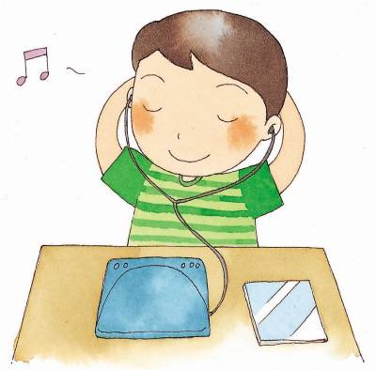  (A) |   (B) | 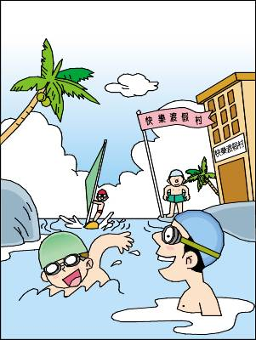  (C)
2. | 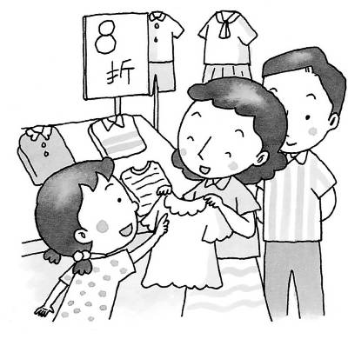  (A) | 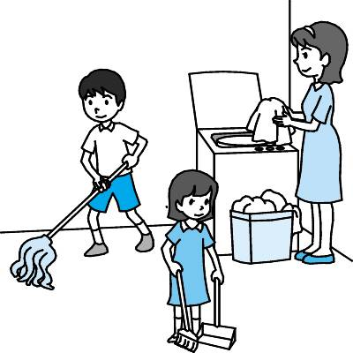  (B) |   (C)
3. | 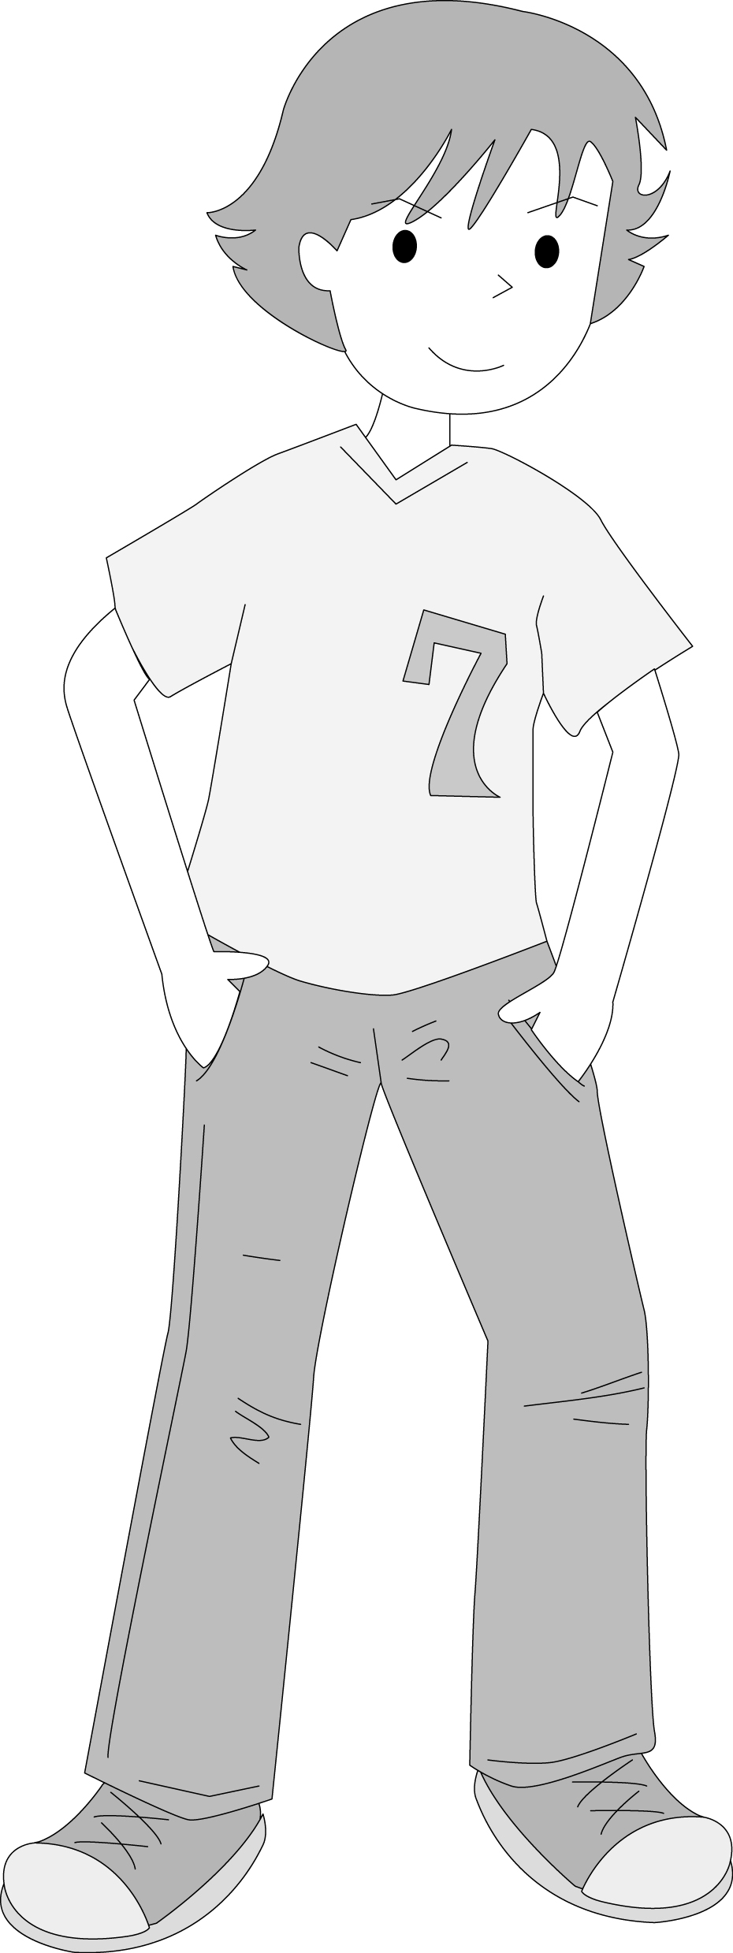  (A) |   (B) |   (C)
4. | 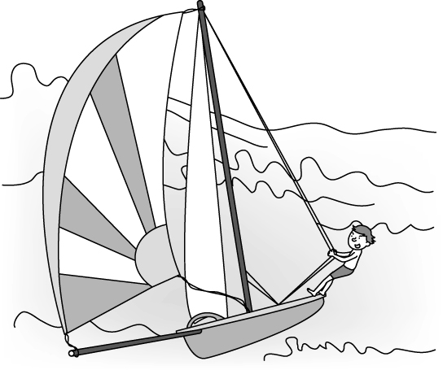  (A) |   (B) |   (C)
5. | 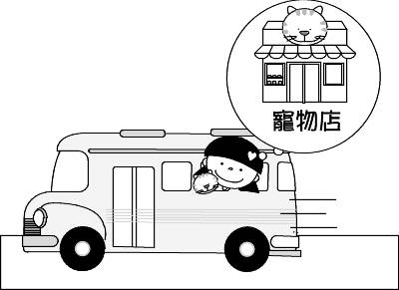
6. | 
7. (Ａ) It is too big for me, so I can’t buy it. (Ｂ) I like the color. It looks pretty on me.
(Ｃ) You can try it on. It’s not expensive.
8. (Ａ) Bee Supermarket is across from the park.
(Ｂ) Before the man and the girl get something to drink, they will go to the park first.
(Ｃ) The man and the girl want to go to the supermarket, so they need to cross the road.
9. (Ａ) A pink shirt. (Ｂ) A purple skirt. (Ｃ) A green skirt.
10. (Ａ) They are going to sing. (Ｂ) They are going to watch birds.
(Ｃ) They are going to take pictures.
11. (Ａ) Ted. (Ｂ) Laura. (Ｃ) Jennifer.
12. (Ａ) Yes, the bank is behind the fire station. (Ｂ) It’s between a shoe store and a park.
(Ｃ) Oh, First Bank is very big.
13. (Ａ) We never take a ship to school. (Ｂ) Jason. He lives far away from the school.
(Ｃ) Wow! Our class can take the MRT to the museum.
14. (Ａ) The man is looking for Kid Toy Shop. (Ｂ) The Fancy Flower Shop is not on Beach Street.
(Ｃ) It will take five minutes for the man to walk to the post office.
15. (Ａ) It’s on Mingming Road. (Ｂ) It’s on Pingping Road. (Ｃ) It’s on Ringring Road.

貮：閱讀評量: (70%)(每題2分)
16. This jacket looks pretty _____ you
(A) for (B) to (C) on (D) in
17. A: The red jacket costs one thousand dollars B: ______ .
(A) The price is cheap. (B) The price is expensive. (C) The price is not bad. (D) Yes, it is wonderful.
18. I spend an hour _____ the report ＝ It takes me an hour _____ the report
(A) doing ; do (B) doing ; doing. (C) doing ; to do (D) to do ; doing
19. 選出不正確的句子
(A) Here are some nice pictures. (B) Here you are. (C) Here comes the bus. (D) Here is it .
20. 選出不正確的句子
(A) Riding on the train is fun. (B) Riding on the train has fun. (C) To ride on the train is fun.
(D) It is fun to ride on the train
21. 選出不正確的句子
(A) I go to my parents’ house by ship. (B) I take a ship to my parents’ house . (C) I go to my parents’ house on a bus.(D) I go to my parents’ house by a taxi.
22. 選出不正確的句子 (A) Linda loves wearing blue jeans. (B) Lisa loves to wear brown pants.
(C) Linda will wear her new dresses to Lisa’s wedding. (D) I love wearing red shorts.
23.A: ______does Jenny usually go there ? B: By taxi.
(A) How (B) What (C) Where (D) Why
24. Taking out the trash won’t_____ you too much time.
(A) take (B) cost (C) spend (D) took
25. Marie enjoys ______ _______.
(A) goes ; surfing (B) going ; hiking. (C) going ; to jog (D) to go ; jogging
26. He _____ at the library late because he missed the bus.
(A) arrived (B) turned (C) drove (D) flew
27. Nora took those beautiful photos with his ______ .
(A) map (B) camera (C) boat (D) plant
28. A: How far is the store ? B:It’s three ______away from here.
(A) lots (B) corners (C) posts (D) blocks
29. A: Where is the store ? B:It’s ______ from the post office.
(A) straight (B) next (C) across (D) between
30. A: How long does it take to fly from here to Taipei ? B: ______.
(A) About fifty minutes. (B) About fifty dollars . (C) About fifty kms. (D) About fifty feet.
There are many different ways to go to school. Some students go to school __31 foot. Some students go to school by bus. Some students ___32. a train to school.
Aaron goes to school in a special way .He lives on a small island(島) in Penghu(澎湖). He gets up at six and takes a ___33 to his school in Magong
(馬公) . He __34_ lots of time getting to school every day. It’s tiring but he is happy because it is a joy for him to learn new thing in school.
31. (A) with (B) on (C)at (D)in
32. (A) fly (B)walk (C) take (D) wait
33. (A) boat (B)car (C) scooter (D) taxi
34. (A)costs (B)spends (C) takes (D) uses
Dear Peter:
How are you doing ?
I’m sorry. I can’t go to your birthday party tonight because my brother __35_ in the hospital, and I’m going to visit him. My mom and I __36_ with him tonight and tomorrow .
I __37_ you five minutes ago, but no one answered the phone. Maybe you __38_ for the party then.
Happy 15th birthday . Kevin
35. (A) was (B) is (C) will be (D) is going to
36. (A) stayed (B)were staying (C) are staying (D)will stay
37. (A)called (B)call (C)am calling (D)will call
38. (A) prepared (B)were preparing (C) are preparing (D) are going to prepare
根據下表的航班資訊、選出正確的答案。
Flight No | From | To | Departure Time | Arrival time | Price
BV229 | Taipei | Hualien | 07: 05 | 07: 40 | NT＄1455
BV627 | Taipei | Kaohsiung | 09: 50 | 10: 40 | NT＄2120
BV655 | Taipei | Penghu | 13: 25 | 14: 20 | NT＄1790
BV851 | Taipei | Kaohsiung | 18: 45 | 19: 35 | NT＄2120
Flight 航班 Departure 出發 Arrival 到達
39. How long does it take to fly from Taipei to Hualien？ (A) About thirty-five minutes.
(B) About forty minutes. (C) About fifty minutes. (D) About fifty-five minutes.
40. Nick will go to Kaohsiung from Taipei next Monday . He wants to get there before noon. Which flight can
he take ？ (A) BV229 (B) BV627 (C) BV655 (D) BV851
41. Jay and his wife are staying in Taipei. They’ll go to Penghu by plane. How much will they spend on the
plane tickets？ (A) NT＄1790 (B) NT＄ 2120 (C) NT＄3580 (D) NT＄4240
We want you
★ Women only: 20-29 part-time : 5 person ★ Pay :NT＄120 an hour
★ Hours: 10:00 a.m---6:00 p.m every weekend.（Sat. Sun.） ★ Free lunch
Please call （02）26170622 0918-411-221 Mr. Chen
42. How much is the pay for a day ？ (A) NT＄790 (B) NT＄ 720 (C) NT＄810 (D) NT＄960
43.How many days a week does one need to work？ (A) two (B) three (C) four (D) five
44. How many hours a week does one need to work？ (A) ten (B) twelve (C) fourteen (D) sixteen
Amy’s Home
WEEKDAY LUNCH BUFFET
12-2 P.M. FROM MONDAY TO FRIDAY ALL YOU CAN EAT
We have delicious main dishes , sald , desserts ,and drinks . Everything is farm fresh .
CHILD （under12）NT＄200 ADULT NT＄ 350

Buffet自助餐 dessert甜點 farm fresh農埸直銷 adult成人 main dishes主菜
45.On what day can you have the weekday lunch buffet？
(A) Sunday (B) Tuesday (C)Saturday (D) weekend
46. What is NOT on the menu for the weekday lunch buffet ？ (A) soup (B) sald (C) dessert (D) drinks
47. John went to the restaurant with his wife and an eleven-year-old son for lunch o n Monday. How much did
it cost ？ (A)NT＄700 (B) NT＄800 (C) NT＄900 (D) NT＄950

Lisa is a junior high school student. She gets up at 6:40 every morning. After breakfast , she usually walks to the bus stop by the park. Many students get on the bus there. The bus comes at 7:15 and it gets to the bus stop near her school at 7:40. Then she walks to school. When Lisa arrives at the school, it’s about 7:50 . She mops the floor of the classroom. It is her work every day. The first class begins at 8:20. So Lisa is never late for her class.

48. How does Lisa go to school every day ？
(A) by train (B) by MRT (C) by car (D) by bus
49.Where does Lisa usually eat breakfast every morning ？
(A) at home (B) at school (C) at the bus stop (D) at the park
50. How does Lisa go to the bus stop by the park？
(A) by taxi (B) by bike (C) on foot (D) by bus

高雄市立林園高級中學 國中部104學年度 第1學期 年級第 次段考 ( 科) 作答卷
班級： 姓名： 座號：

2 年級(英文 科)第3 次段考--答案（年級、科目請標示清楚，謝謝！）
1~5 | B A B A A | 6~10 | C B C B A
11~15 | C B B C C | 16~20 | C C C D B
21~25 | D C A A B | 26~30 | A B D C A
31~35 | B C A B B | 36~40 | D A B A B
41~45 | C D A D B | 46~50 | A C D A C

