高雄市立林園高級中學 國中部 104學年度 第1學期 3年級第1次段考 ( 英文科) 試題卷
班級： 姓名： 座號：
◎本試卷共（ 4）頁
- 聽力測驗:30%

一、字彙配對（選出聽到單字的中文意思）：每題 1分，共 5分
( ) 1. (A) 彩繪 (B) 殺 (C) 行動 (D) 聊天
( ) 2. (A) 狐狸 (B) 蝙蝠 (C) 野獸 (D) 螞蟻
( ) 3. (A) 祕密 (B) 和平 (C) 歌劇 (D) 舞臺
( ) 4. (A) 贏家 (B) 外國人 (C) 行星 (D) 語言
( ) 5. (A) 整齊的 (B) 橫越的 (C) 多彩的 (D) 寂寞的

二、辨識句意（根據聽到的內容，選出正確的圖片代碼）：每題1分，共 5分
( ) 1. (A) 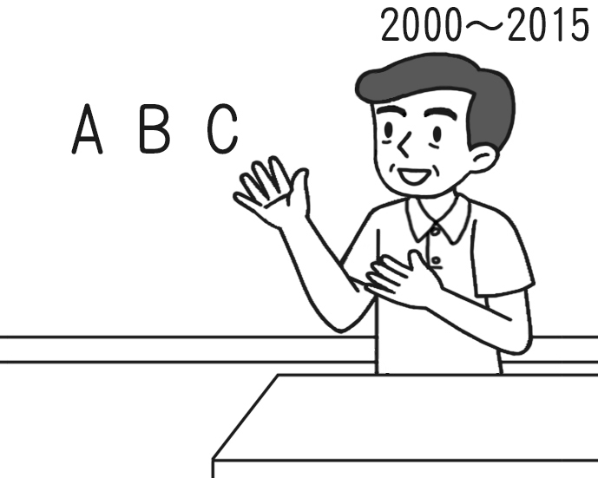 (B) 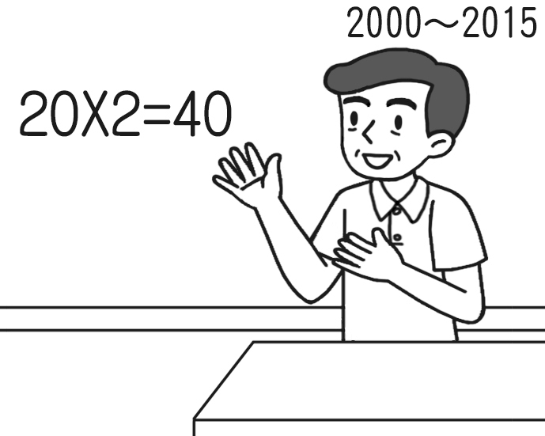 (C) 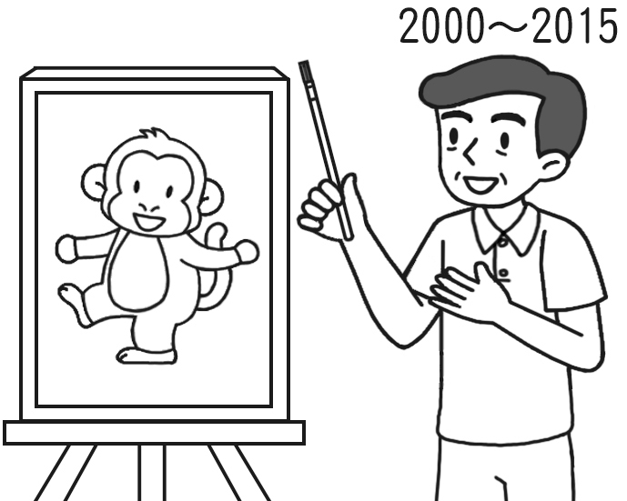
( ) 2. (A) 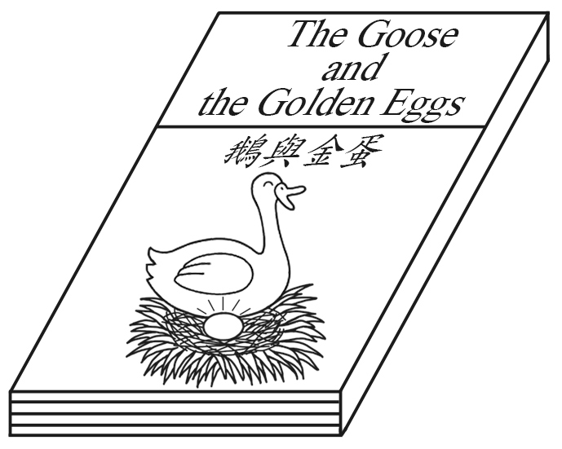 (B) 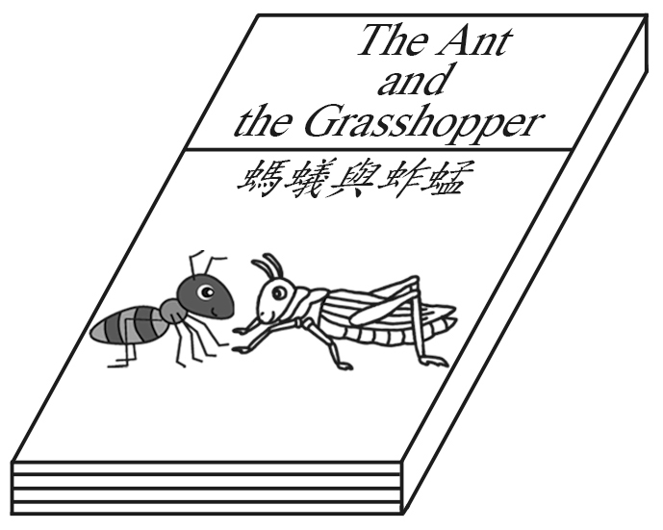 (C) 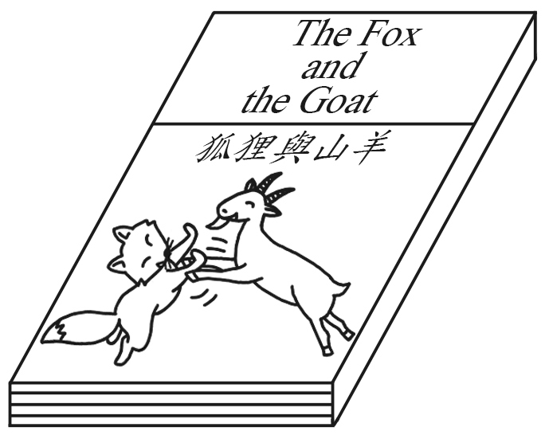
( ) 3. (A) 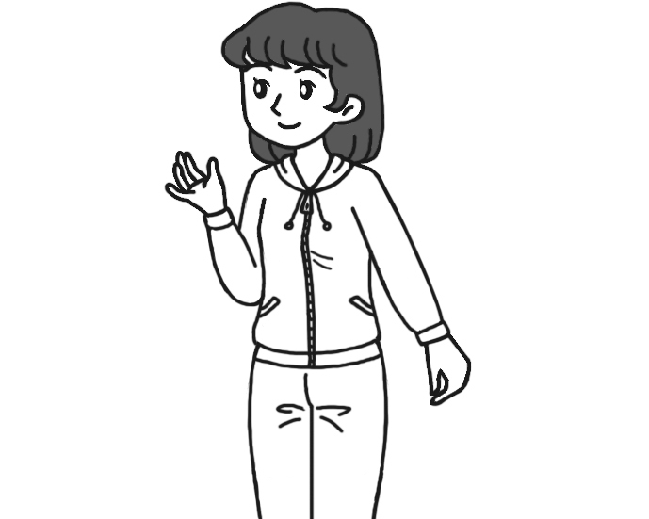 (B) 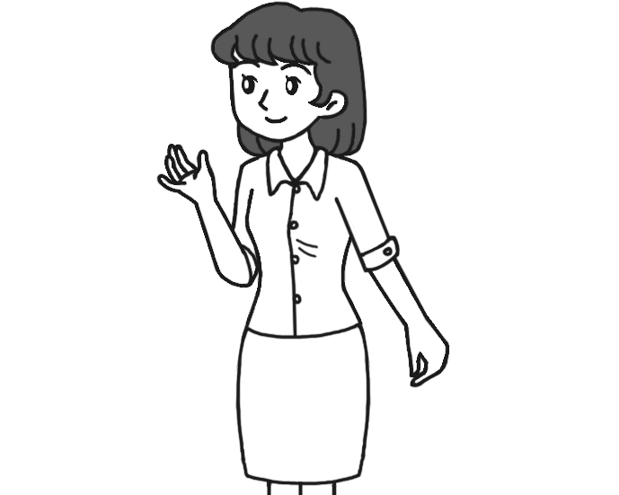 (C) 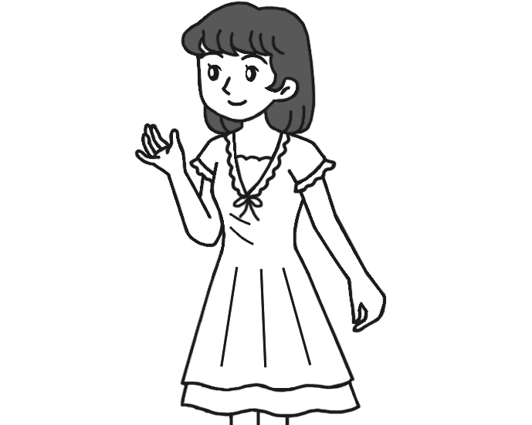
( ) 4. (A) 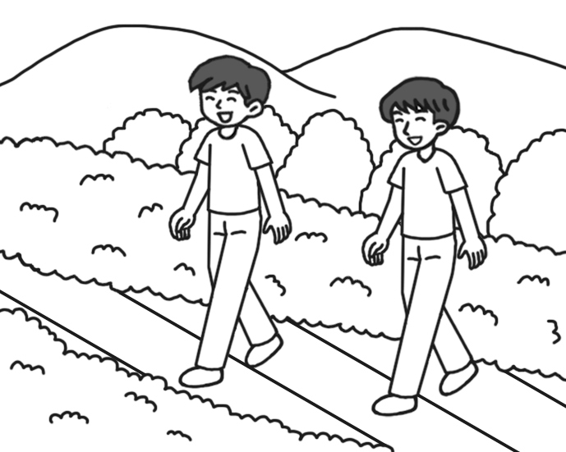 (B) 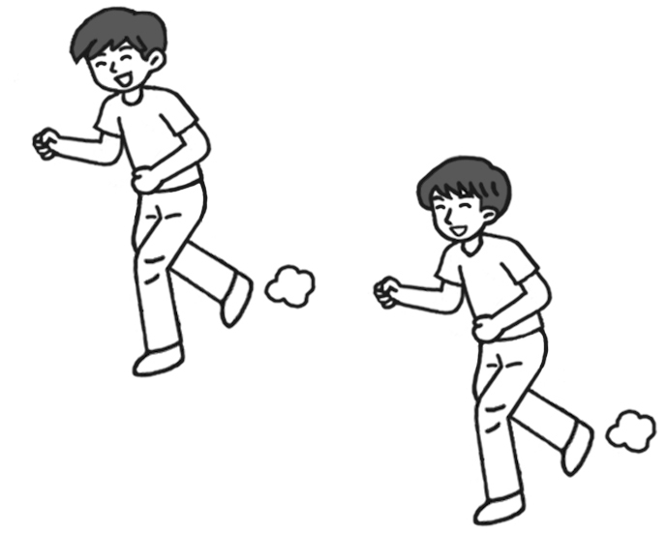 (C) 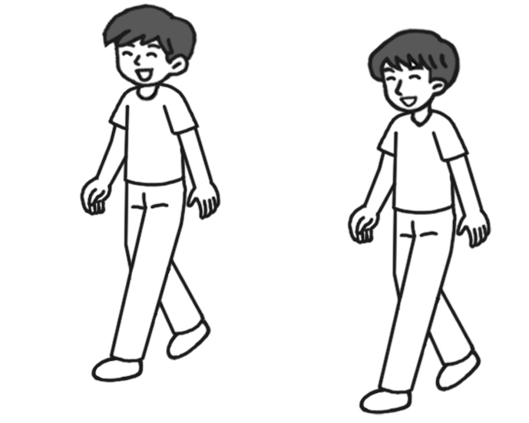
( ) 5. (A) 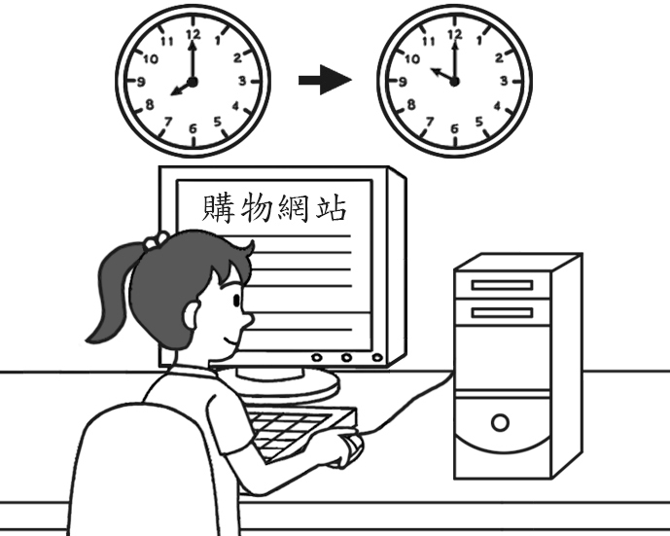 (B) 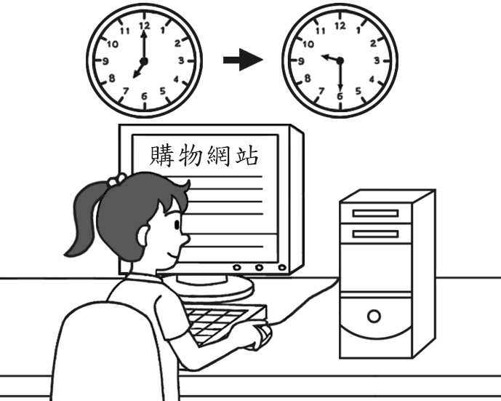 (C) 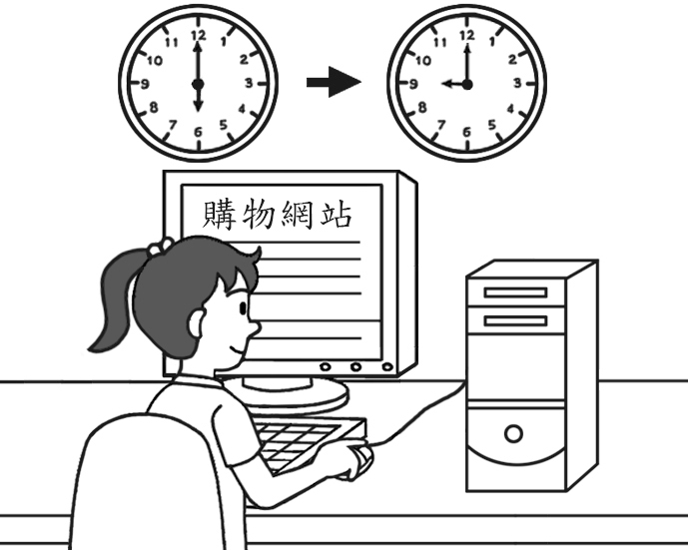
三、看圖回答（根據海報，聽完問題後選出正確的答案）：每題2分，共 10分
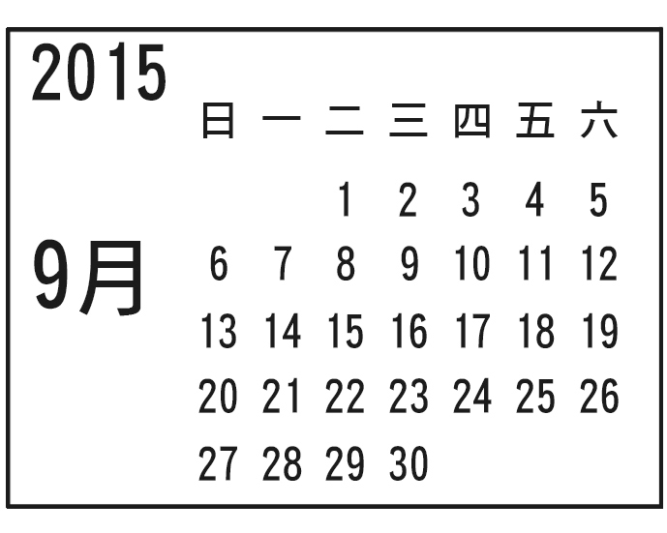
City Museum
Open:Tue.～Fri.9:30 a.m.～5:30 p.m.
Sat.～Sun9:00 a.m.～6:00 p.m.
Special displays for this month:
＊ Old machines from different countries [9/2～9/6]
＊ The most famous painters and their paintings [ 9/8～9/12]
＊ A journey to other artworks [ 9/15～9/18]
＊ The stories of different kinds of dances [ 9/21～9/22]
＊ The histories of different kinds of music [9/24～9/27]
※ For more information, please call (02)2345-4321, go to our website

www.citymuseum.com.tw or mail to
service@citymuseum.com.

( ) 1. (A) On Monday. (B) On Sunday. (C) On Saturday.
( ) 2. (A) Machines. (B) The earth. (C) Art.
( ) 3. (A) A journey to other artworks. (B) The stories of different kinds of dances. (C) The histories of different kinds of music.
( ) 4. (A) The stories of street dance. (B) The stories of jazz music. (C) The stories of movie stars.
( ) 5. (A)  (B)  (C) 

四、基本問答（根據聽到的內容，選出合適的回應）：每題 2分，共 10分
( ) 1. (A) What a great idea! (B) Not yet. But I’ve done most of it. (C) You’ve already done a great job.
( ) 2. (A) He has been an English teacher since 1995. (B) My English has improved.
(C) Using English is suddenly not so difficult for me.
( ) 3. (A) It sounds interesting. (B) It’s exciting, not boring. (C) It’s in October. You can come with me!
( ) 4. (A) You look great in this shirt. (B) It was great. (C) You are tired of eating the same food every day.
( ) 5. (A) That’s a good point! (B) What’s the problem with her? (C) Tell me more.

貳、筆試部份:70%
一、文法：15%
1. ( ) It has been rainy ________ a week. (A) since (B) when (C) while (D) for
2. ( ) I didn’t know John is your sister’s new boyfriend. (A) how (B) that (C) there (D) about
3. ( ) Studying for tests is ______ to Andy. He usually feels _____ with it.
(A) bore; bores (B) bored; boring (C) boring; bored (D) bores; boring
4.( ) There is nothing in the box, ________? (A) is there (B) isn’t there (C) is it (D) isn’t it
5.( ) Jack and Rose have had a pet dog____ (A) in (B) since (C) for (D) around 2000.
6.( ) A: Have you ever been to Japan? B: Yes. ________.
(A) I never (B) I never do (C) I have visited Japan twice. (D) I have never
7.( )Your friends will go to the department store, ________? (A) will they (B) won’t they (C) don’t they (D) are they
8.( ) My teacher isn’t satisfied ________ my homework. (A) with (B) at (C) in (D) to He wants me to write it again. 9.( ) Greg drew the lines on the wall, he? (A) can (B) can’t (C) doesn’t (D) didn’t
10.( ) Helen ________ a cold for one week so she won’t go to Jane’s birthday party.
(A) was having (B) will have (C) has had (D) is having
11.( ) I have_______ Jimmy since I was a junior high school student. (A) knows (B) known (C) knew (D) to know
12.( ) Sitting on the fence isn’t a good way to make true friends, ? (A) is there (B) is that (C) is this (D) is it
13.( ) After eight hours of work, Tom usually feels very ________. (A) tiring (B) to tired (C) tired (D) tires
14.( ) Just keep ______, and you’ll be a good player in the future.
(A) to practice hard (B) practicing hard (C) practiced hard (D) in practice hard
15.( ) Colin: have you played the guitar? Russ: I’ve played it for three years.
(A) How often (B) How soon (C) How long (D) How fast

二、填入符合句意的單字：20%(每題2分)
1.___________ Don’t use your finger to p t at people. It is rude.
rude 粗魯的
2.___________ Do you see the a ts on the table? Someone must put the candy on the table.
3.___________ Angela plans to wear her new u m when she runs in the marathon.
4.____________I haven’t seen him for years. In f t, I can’t even remember his name.
5.____________Helen is a q____k learner（學習者）. She learns things fast.
6.____________You will get into trouble if you don’t tell the t h.
7.____________ Mr. Lewis is from America, and Sakura is from Japan. They are f ers in Taiwan.
8.____________ My English has i ved a lot. I can read longer stories.
9.____________ Sometimes being too g y will make you lose everything.
10.____________ The big house with a beautiful garden b ngs to a rich man.

三、對話：10%(每題2分)
1.( ) Sue: Your music report looks great. ________
Nancy: Well... I asked Rita to help me.
(A) How did you do that? (B) Have you finished it? (C) Where did you get it? (D) How long did it take you?
2.( ) Ted: Where is Alex? Can I talk to him now? Eve: I’m sorry. He to Japan.
(A) is going (B) has gone (C) has been (D) was going
3.( ) Andy: Nice shirt. ________
Diana: Thanks. It cost only $200.
(A) It looks great on you. (B) It’s really a fun run. (C) It makes me feel bad. (D) It’s about 5 kilometers long.
4.( ) Erica: You’re really good at running.
Tony: Well, ________. In fact, I need to practice more to win the game.
(A) get out of here (B) stay away from me (C) I’m very satisfied with myself (D) I’m still training
5.( ) Polly: I like true life stories. We can always learn something from them, can’t we ?
Kenny: Yes, we can. They’re always inspiring.
(A) can we (B) can’t we (C) don’t we (D) won’t we
四、閱讀測驗:10%(每題2分)
In the opera, Legend of the White Snake, Bai Suzhen（白素貞）, a white snake, turns into a woman and falls in love with a handsome young man, Xu Xian（許仙）. They get married and live happily for a short time.
One day, Bai meets Fahai（法海）, a sorcerer. He wants to get rid of all demons and tries to kill Bai. However, Bai is too strong, so Fahai is not able to kill her.
Then Fahai tries to trick Xu into getting Bai to drink a glass of Xiong-Huang wine（雄黃酒）on the Dragon Boat Festival. When demons drink this wine, they will change back to their true shapes. Bai drinks the wine and turns back to a white snake. This scares Xu to death. Bai loves Xu so much that she uses her energy to bring him back to life. He is very thankful and loves her the same as before. After having a baby, Bai becomes even weaker. Then Fahai takes Bai and puts her in a tower.

Legend of the White Snake 白蛇傳 turn into 變成 sorcerer 法師
demon 妖魔 kill 殺死 scare 驚嚇 thankful 感激的

form 外形
Ｃ 1. What is Bai Suzhen’s true form?
(A) A baby. (B) A dragon. (C) A white snake. (D) A beautiful woman.
Ｃ 2. Who is Xu Xian married to?
(A) Fahai. (B) A sorcerer. (C) Bai Suzhen. (D) A young man.
Ｄ 3. When does Bai Suzhen change back to her true shape?
(A) On New Year’s Day. (B) On the Moon Festival.
(C) Five thousand years ago. (D) On the Dragon Boat Festival.
Wendy: Jack wants to join our group. Is that OK?
Mark: Not really. When he was in another group, he wasn’t friendly and didn’t work with his group members well.
Bonnie: He has changed now. He’s a lot nicer and more helpful, isn’t he?
Give him a chance, please.
Ben: Hey, let’s not turn him away.
Mark: OK.

4.________How has Jack changed?
(A) He is not friendly and kind now. (B)He is friendly and kind now. (C)He was friendly and kind .
5.________Are they going to allow Jack to join them? (A) Yes. They decided not to turn him away.
(B) No. They decided to turn him away. (C) Yes. They decided to turn him away.
五、翻譯：15% (每個空格1分)
1.寓言通常用動物教導些生活道理。
______ often ______ animals to ________ _______ for _____.
2明天多雨，是嗎？.
There will _____ a lot of ______ ________, _______ ______?
3. 如果跑者們失去他們的三支旗子，他們就出局了。
_____ the runners _____ their three ______, they are _______ _____ the game.
高雄市立林園高級中學 國中部104學年度 第1學期 3 年級第1次段考 ( 英文科) 作答卷
班級： 姓名： 座號：
壹、聽力測驗:30%
一、字彙配對（選出聽到單字的中文意思）：每題 1分，共 5分
1. D | 2. A | 3. C | 4. B | 5. C
二、辨識句意（根據聽到的內容，選出正確的圖片代碼）：每題1分，共 5分
1. A | 2. C | 3. C | 4. B | 5. A
三、看圖回答（根據海報，聽完問題後選出正確的答案）：每題2分，共 10分
1. A | 2. C | 3. B | 4. B | 5. C
四、基本問答（根據聽到的內容，選出合適的回應）：每題 2分，共 10分
1. B | 2. A | 3. C | 4. A | 5. B
貳、筆試部份:70%
一、文法：15%
1. D | 2. B | 3. C | 4. A | 5. B
6. C | 7. B | 8. A | 9. D | 10. C
11. B | 12. D | 13. C | 14. B | 15. C

二、填入符合句意的單字：20%(每題2分)
1. point | 2. ants | 3. uniform | 4. fact | 5. quick
6. truth | 7. foreigners | 8.improved | 9. greedy | 10. belongs
三、對話：10%(每題2分)
1. A | 2. B | 3. A | 4. D | 5. B

四、閱讀測驗:10%(每題2分)
1. C | 2. C | 3. D | 4. B | 5. A
五、翻譯：15% (每個空格1分)
1.
Fables | use | teach | lessons | life
2
.
be | rain | tomorrow | won’t | there

3.
If | lose | flags | out | of

