高雄市立林園高級中學國中部 104學年度 第1學期 3年級 英語科 第2次 段考試題卷
班級： 姓名： 座號：
本次測驗，試題共有4頁。第一~四大題為聽力測驗，第五~九大題為紙筆測驗。請將答案寫在答案卷上，測驗結束時將答案卷交回。
一、辨識句意（根據聽到的內容，選出正確的圖片代碼）：每題1分，共5分
( ) 1. (A) 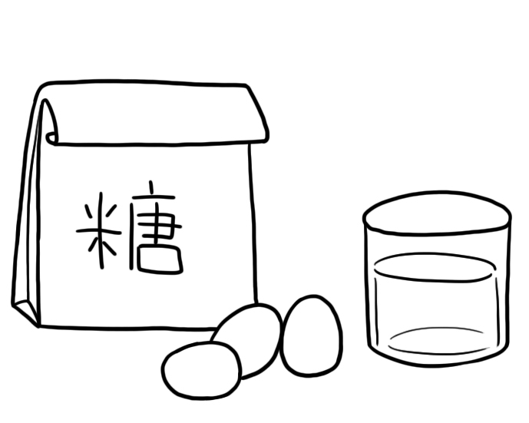 (B) 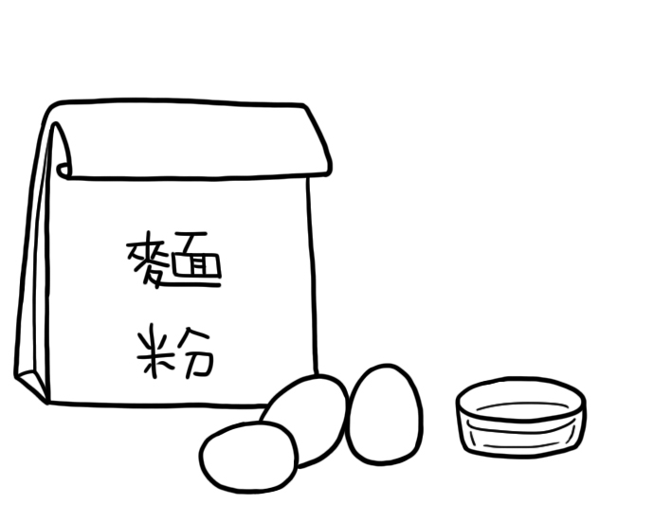 (C) 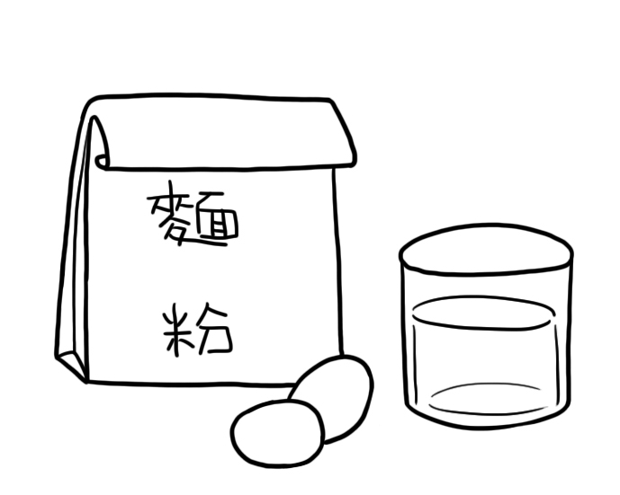
( ) 2. (A) 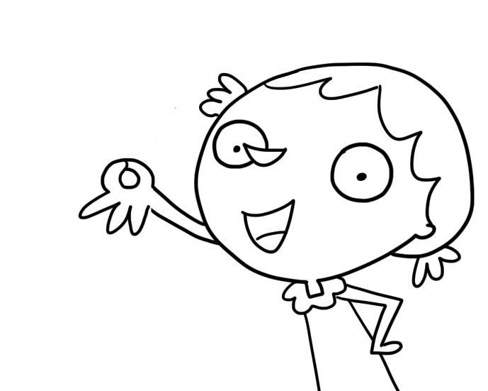 (B) 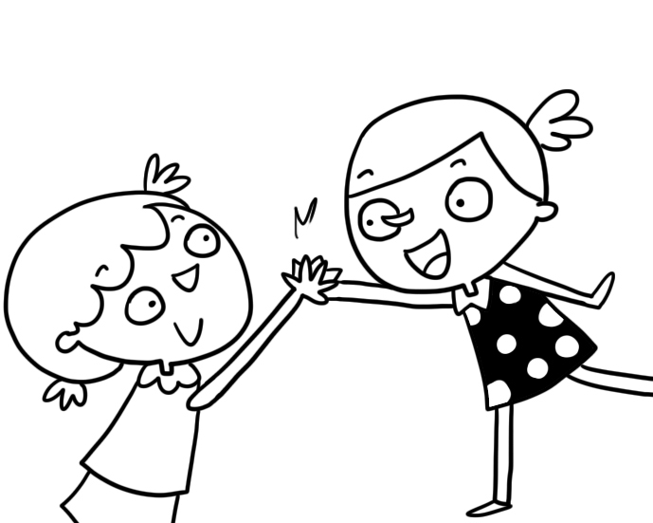 (C) 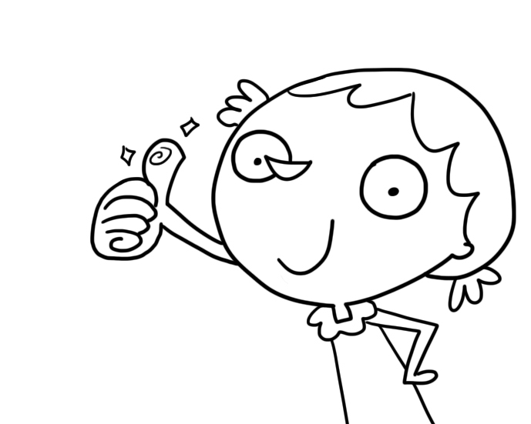
( ) 3. (A) 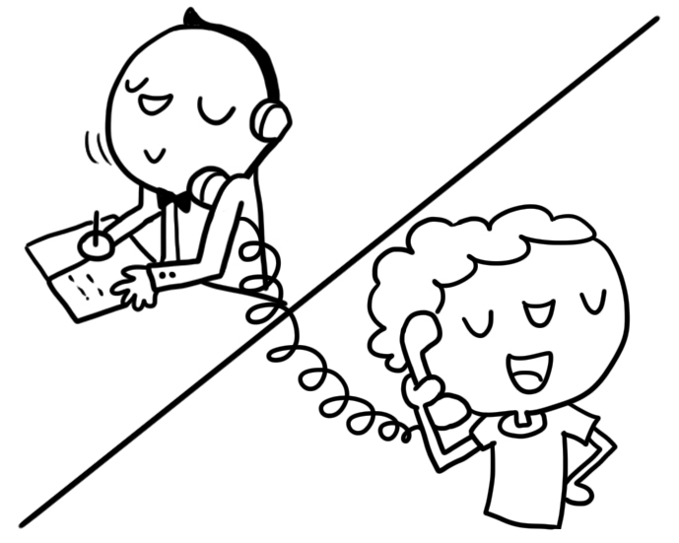 (B) 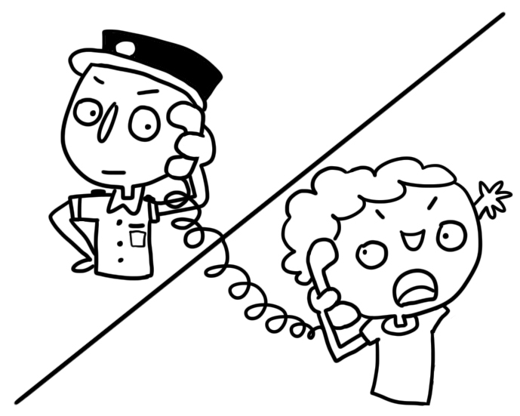 (C) 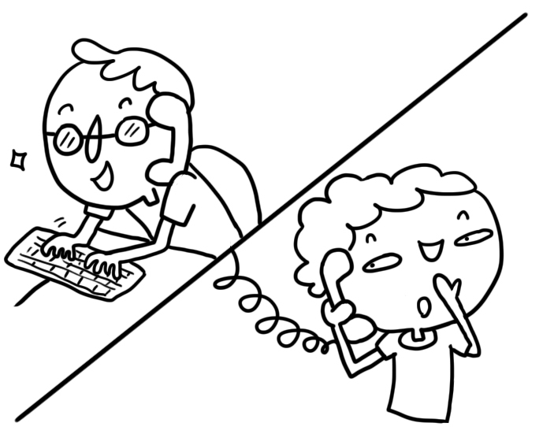
( ) 4. (A) 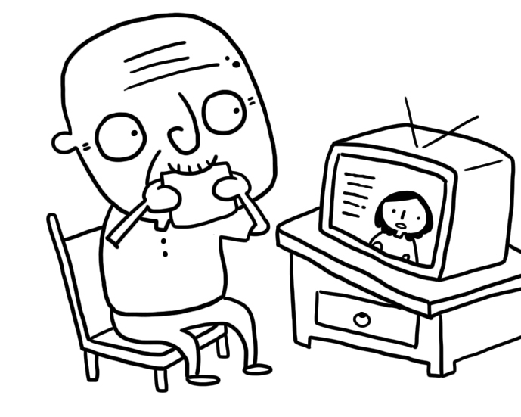 (B) 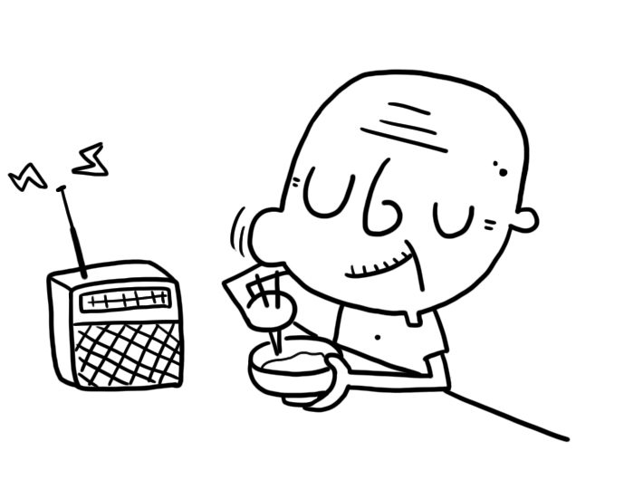 (C) 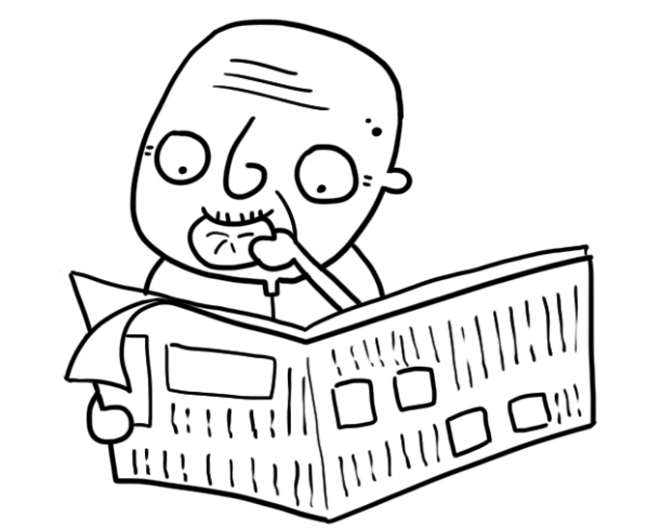
( ) 5. (A) 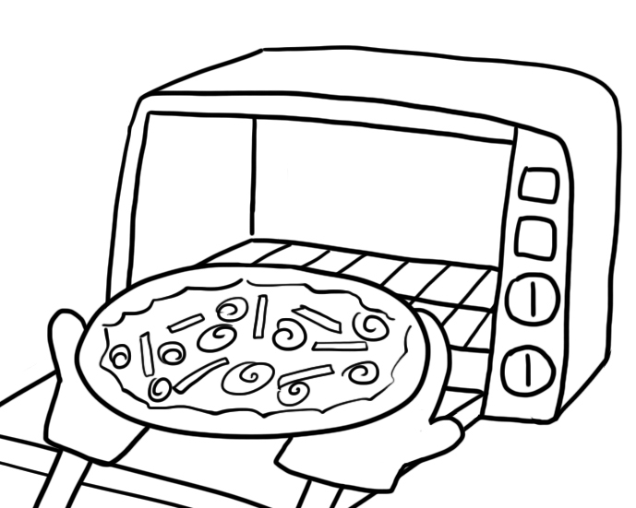 (B) 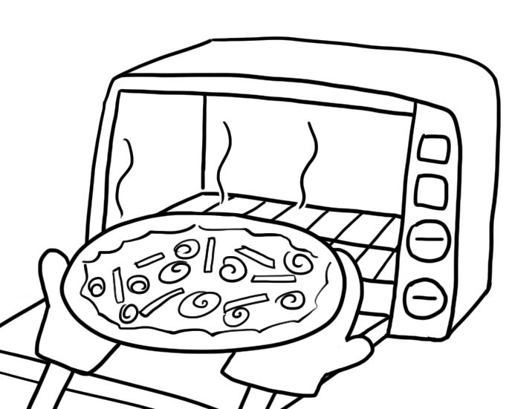 (C) 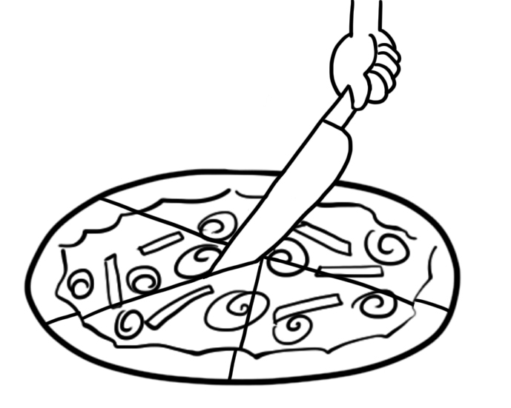
二、基本問答（根據聽到的內容，選出合適的回應）：每題1分，共5分
( ) 1. (A) Don’t worry. I can finish it all.
(B) I like Chinese food, and fried rice is my favorite dish.
(C) Eating too much fried food is not good for your health.
( ) 2. (A) It takes about one hour.
(B) It’s not easy to make a pizza.
(C) It’s about three hundred dollars.
( ) 3. (A) I’m just glad that I won the game.
(B) You need to set up the times for the characters first.
(C) I got a call, and the person said that someone was using my credit card.
( ) 4. (A) First, you have to name all your characters.
(B) All your characters can have a job and a circle of friends.
(C) Don’t worry.You can always tell the characters’ moods from their facial expressions.
( ) 5. (A) Please roll out a thin crust.
(B) Please put on a pair of kitchen gloves.
(C) Please cut the pizza into twelve pieces.
三、言談理解（根據聽到的對話內容與問題，選出正確的答案）：每題2分，共10分
( ) 1. (A) Emily. (B) Steven. (C) Sandra.
( ) 2. (A) It is easy. (B) It is boring. (C) It is difficult.
( ) 3. (A) She will leave first. (B) She has to stay and work. (C) She will leave with the man.
( ) 4. (A) She is sweet. (B) She is the funniest. (C) She is the youngest.
( ) 5. (A) At home. (B) In the park. (C) At the back door.

四、短文辨義（根據聽到的短文內容，敘述正確者寫T，錯誤者寫F）：每題2分，共10分
聽完整篇短文，完成以下五個小題 !
______ 1. Kim met a stranger on the street corner.
______ 2. The man asked Kim for some money to go back home.
______ 3. Kim didn’t give the man any money but took him to the police station.
______ 4. It turned out that the man was a police officer.
______ 5. Kim did not do anything at last.

五、文意字彙：每題1分，共10分
1. Students should r se their hands before they ask questions in class.
2. Although Mary’s watch cost much more than mine, I can’t tell much d ce between them.
3. Being a sports r er is Bill’s dream. He wants to interview Jeremy Lin (林書豪) some day.
4. Jenny had a bad cold and almost lost her v ce last week.
5. Do not forget to put a stamp on the e pe before you mail it.
6. I read a lot of books about Chinese Opera. It is an interesting s t.
7. Pizza is a c n food, a kind of thin bread with toppings.
8. There are a d n eggs next to a pair of kitchen gloves. Leo’s mom will use the eggs to make a cake.
9. Jennifer wouldn’t tell me how much money she left in her bank a t.
10. Turn off the oven when the crust and the cheese begin to t t. Then the pizza is done.

六、配合題 (選出適當的回應句)：每題2分，共10分
1. Ouch! The pan burned my fingers.
A. OK. I’ll make it faster.
B. Great! I’m ready to dig in.
C. Oh, I forgot to put tomato sauce on it.
D. This is David Lin of Ta-Don Company.
E. I told you not to touch the bottom of the pan.
F. She was angry at him for not going to her party.
2. The pizza looks great but tastes strange.
3. Hurry up, or we’ll be late for school.
4. Why did Nina hang up on Jason?
5. May I ask who is calling?

七、文法：每題2分，共20分
1. I want to finish reading the novel today because the book ______ to the library tomorrow.
(A) will return (B) should return (C) should be returned (D) have been returned
2. Grandma takes care of herself _______ well ______ she seldom goes to the doctor.
(A) too ; to (B) enough ; to (C) so ; for (D) so ; that
3. It’s never _______ late _______ start exercising, is it?
(A) too ; to (B) enough ; to (C) so ; for (D) so ; that
4. People use body language to show _______ they feel and _______ they think.
(A) how ; who (B) how ; what (C) why ; where (D) why ; when
5. We aren’t sure ________ Jack failed the test or not.
(A) how (B) when (C) that (D) whether
6. A: The dictionary is useful. Is it expensive?
B: I don’t remember _________.
(A) what happened (B) how to make one
(C) how much it cost (D) when Helen and Jessie are coming
7. Kevin would like to know if Susan ________ to the party tomorrow.
(A) comes (B) came (C) has come (D) will come
8. Steve was ________ short that he ________ join the basketball team.
(A) too ; can (B) too ; could (C) so ; can’t (D) so ; couldn’t
9. Please tell me _________.
(A) what does he do (B) how often they come here
(C) what did they talk about (D) who is the girl in the picture
10. I have no idea _________.
(A)what to do (B) who to talk (C) how to do (D) where to go to

八、克漏字與閱讀測驗：每題2分，共20分
(一)
Apple pies are popular with kids all over the world. Here is a simple way 1. apple pies.  First, prepare the dough and place it 2. the pan.  Second, mix apples, sugar, flour, and vanilla to make the filling. Put the filling in the pie crust. Then bake in the middle of the oven 3. 40~50 minutes. Finally, pull the pan out of the oven and enjoy it!  filling 餡料 vanilla 香草 | 
1. (A) makes (B) making (C) is made (D) to make
2. (A) out of (B) in the center of (C) at the bottom of (D) in front of
3. (A) at (B) on (C) for (D) with

(二)
Dec. 01, 2015
Dear Nicole,
I love Christmas very much. It’s a wonderful season of giving and getting beautiful cards. This card was made by my daughter, Cathy. Do you like it?
This winter we have a lot of snow here, but a friend called me yesterday and said that you are still wearing T-shirts in Taiwan.
How will you celebrate Christmas? Are you going to visit Lisa this year? If so, please say hello to her for me, and tell her that I miss her wonderful cookies!
Sincerely,
Emily
- What should This card look like?
- 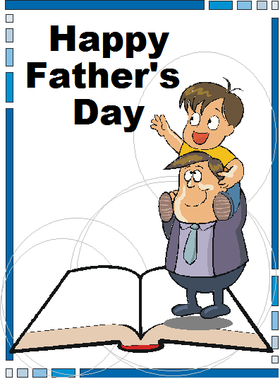 (B) 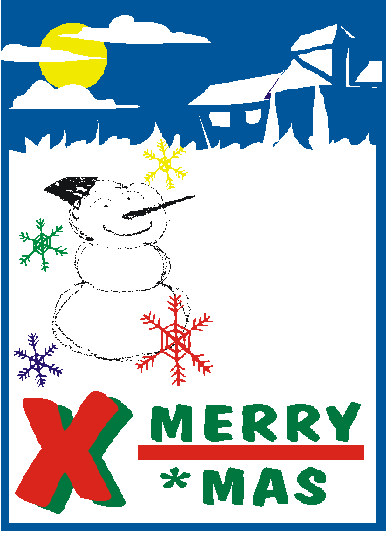 (C)  (D) 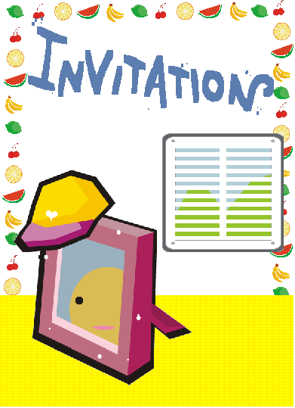
- Who makes delicious cookies?
(A) Nicole (B) Cathy (C) Lisa (D) Emily
(三)
Read Helen’s diary and answer the questions.

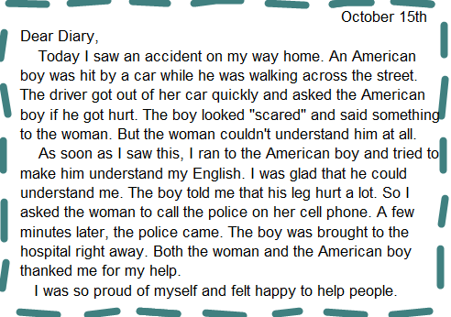

6. The American boy was hit by ___________.
(A) a motorcycle (B) a car (C) a bicycle (D) a police car
7. What does “scared” mean in the first paragraph?
(A) Angry. (B) Careful. (C) Excited. (D) Afraid.
8. Who called the police?
(A) Helen. (B) The woman. (C) The American boy. (D) Nobody.
9. By whom was the American boy taken to the hospital?
(A) The police. (B) Helen. (C) The woman. (D) A taxi driver.
10. Which is true about the story?
(A) The woman could speak English.
(B) The American boy could speak Chinese well.
(C) The American boy wasn’t hurt at all.
(D) Helen helped the American boy because she could speak English.

九、翻譯填空：每格1分，共10分
1. 美式披薩以它的厚餅皮著稱。
American pizza (1) (2) k (3) its thick crust.
2. 要花多少時間才能學會如何玩這款遊戲呢?
How long does it (4) to learn (5) (6) play the game?
3. 那位行員告訴我沒有任何異狀。
The clerk told me there was (7) wrong (8) it.
4. 昨天一直到了傍晚才下大雨。
It (9) rain heavily (10) yesterday evening.

高雄市立林園高級中學 國中部 104學年度 第1學期 3年級 英語科 第2次段考 答案卷
班級： 姓名： 座號：
一、辨識句意（根據聽到的內容，選出正確的圖片代碼）：每題1分，共5分
1. | 2. | 3. | 4. | 5.

二、基本問答（根據聽到的內容，選出合適的回應）：每題1分，共5分
1. | 2. | 3. | 4. | 5.

三、言談理解（根據聽到的對話內容與問題，選出正確的答案）：每題2分，共10分
1. | 2. | 3. | 4. | 5.

四、短文辨義（根據聽到的短文內容，敘述正確者寫T，錯誤者寫F）：每題2分，共10分
1. | 2. | 3. | 4. | 5.

五、文意字彙：每題1分，共10分
1. | 2. | 3. | 4. | 5.
6. | 7. | 8. | 9. | 10.

六、配合題 (選出適當的回應句)：每題2分，共10分
1. | 2. | 3. | 4. | 5.

七、文法：每題2分，共20分
1. | 2. | 3. | 4. | 5.
6. | 7. | 8. | 9. | 10.

八、克漏字與閱讀測驗：每題2分，共20分
1. | 2. | 3. | 4. | 5.
6. | 7. | 8. | 9. | 10.

九、翻譯填空：每格1分，共10分
(1) | (2) | (3) | (4) | (5)
(6) | (7) | (8) | (9) | (10)

高雄市立林園高級中學 國中部 104學年度 第1學期 3年級 英語科 第2次段考 解答

一、辨識句意（根據聽到的內容，選出正確的圖片代碼）：每題1分，共5分
1. C | 2. A | 3. B | 4. B | 5. B

二、基本問答（根據聽到的內容，選出合適的回應）：每題1分，共5分
1. A | 2. A | 3. C | 4. C | 5. B

三、言談理解（根據聽到的對話內容與問題，選出正確的答案）：每題2分，共10分
1. C | 2. A | 3. B | 4. B | 5. A

四、短文辨義（根據聽到的短文內容，敘述正確者寫T，錯誤者寫F）：每題2分，共10分
1. T | 2. T | 3. F | 4. F | 5. F

五、文意字彙：每題1分，共10分
1. raise | 2. difference | 3. reporter | 4. voice | 5. envelope
6. subject | 7. common | 8. dozen | 9. account | 10. toast

六、配合題 (選出適當的回應句)：每題2分，共10分
1. E | 2. C | 3. A | 4. F | 5. D

七、文法：每題2分，共20分
1. C | 2. D | 3. A | 4. B | 5. D
6. C | 7. D | 8. D | 9. B | 10. A

八、克漏字與閱讀測驗：每題2分，共20分
1. D | 2. B | 3. C | 4. B | 5. C
6. B | 7. D | 8. B | 9. A | 10. D

九、翻譯填空：每格1分，共10分
(1) is | (2) known | (3) for | (4) take | (5) how
(6) to | (7) nothing | (8) with | (9) didn’t | (10) until

