高雄市立林園高級中學 國中部 104學年度 第 1 學期 3 年級 英語 科 第 3 次 段考試題卷
班級： 座號： 姓名：
本次測驗，試題共有5頁。第一～四大題為聽力測驗，第五～六大題為閱讀理解測驗。第一~二大題每題1分, 第三~六大題每題2分, 滿分為100分。請用2B鉛筆在答案卡上作答，測驗結束時將答案卡交回。

一、字彙選擇（選出聽到的單字）：每題1分
( ) 1. (A) besides (B) outside (C) beside (D) inside
( ) 2. (A) lap (B) leg (C) late (D) lay
( ) 3. (A) woman (B) man (C) human (D) women
( ) 4. (A) clear (B) green (C) clean (D) unclean
( ) 5. (A) week (B) wet (C) west (D) wait

二、基本問答（根據聽到的內容，選出合適的回應）：每題1分
( ) 6. (A) The world is facing some serious problems.
(B) Most tap water is clean and safe.
(C) Sure, we can all do our share.
( ) 7. (A) Besides, it’s free.
(B) Of course. It’s boiled.
(C) I haven’t heard about it before.
( ) 8. (A) His movies are exciting.
(B) More than five.
(C) Yes, they are super interesting.
( ) 9. (A) Neither do I.
(B) Smoking is not allowed here, either.
(C) Don’t talk when there’s food in your mouth.
( ) 10. (A) Sounds great!
(B) I don’t want to eat hot pot.
(C) No. I want something light.

三、言談理解（根據聽到的對話內容與問題，選出正確的答案）：每題2分
( ) 11. (A) In the movie theater.
(B) In the dining room.
(C) In the library.
( ) 12. (A) Tap water.
(B) Bottled water.
(C) The water from the water machine.
( ) 13. (A) A waitress.
(B) A cook.
(C) A waiter.

P.1
( ) 14. (A) We don’t know. (B) No, he hasn’t. (C) Yes, he has.
( ) 15. (A) The white dress. (B) The pink dress. (C) The blue dress.

四、看圖回答（根據海報，聽完問題後選出正確的答案）：每題2分
Read the table and recycle at the right time.
Things Collected | Time
Paper 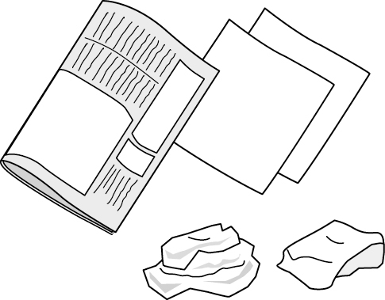 | Tuesday and Thursday:  7 p.m.～8 p.m.
Glass 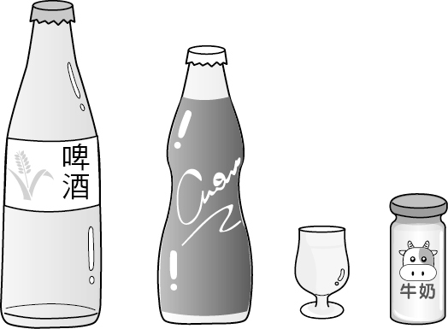 | Tuesday and Thursday:  7 p.m.～8 p.m.
Cans & Plastic bottles 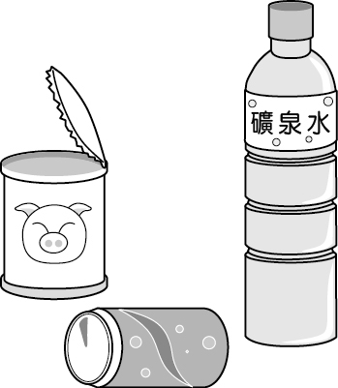 | Monday:  7 p.m.～8 p.m.
Trash 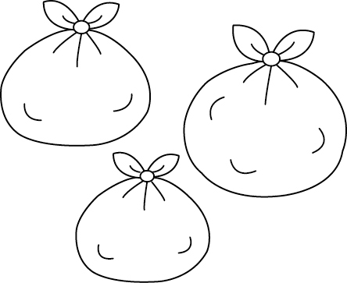 | Every day except Sunday:  7 p.m.～8 p.m.
( ) 16. (A) On Tuesday. (B) On Thursday. (C) On Wednesday.
( ) 17. (A) Paper and glass. (B) Paper and cans. (C) Cans and trash.
( ) 18. (A) Once a week. (B) Twice a week. (C) Every day.
( ) 19. (A) Four days. (B) Six days. (C) Two days.
( ) 20. (A) You can’t take out the trash on Sunday. (B) Plastic bottles are collected once a week.
(C) You can throw away glass and cans on Thursday.

五、單題：每題2分
( ) 21. Jean has good table _____. She doesn’t talk when there’s food in her mouth.
(A) manners (B) salt (C) spoons (D) waiter
( ) 22. The students are _____. They always say “please” to others.
(A) stupid (B) manners (C) boiled (D) polite
( ) 23. John was sick, so he didn’t _____ at the party.
(A) pollute (B) copy (C) create (D) appear
( ) 24. Ken usually buys _____ water at the convenience store.
(A) plastic (B) bottled (C) unclean (D) tap
( ) 25. The pizza _____ we had yesterday was delicious.
(A) who (B) what (C) when (D) X

P.2

( ) 26. The book _____ Mary bought is interesting.
(A) that (B) who (C) what (D) whether
( ) 27. The house in _____ David lives is big.
(A) where (B) who (C) that (D) which
( ) 28. Kevin is dancing with the girl _____ a red dress.
(A) with (B) has (C) have (D) in
( ) 29. 選出含有形容詞子句的句子.
(A) The dog that has two colors is cute. (B) I know that the dog is cute.
(C) We will stay at home if it rains tomorrow. (D) The man in black is very kind.
( ) 30. 選出含有形容詞片語的句子.
(A) I know that you are right. (B) I wash my hands before eating. (C) I know that doctor who wears a hat.
(D) I know that cat with a long tail.
( ) 31. Susan: It takes a lot of practice to be a good artist.
Monica: _____
Susan: I mean you need to work really hard to be good.
(A) I like artists. (B) Are you an artist? (C) What do you mean? (D)Hayao Miyazaki is a great artist.
( ) 32. Jack: Do you know a lot of things around you are made from oil?
Paul: Really? _____
(A) Don’t worry. (B) You’re so sweet. (C) I didn’t know that. (D) I made it last week.
( ) 33. David: I had a bad morning. I had a bike problem and I was late to class.
Richard: Poor you!
David: _____ I forgot to bring my homework and had to do it again at school.
(A) Not at all. (B) That’s not all. (C) I was very happy. (D) I have another question.
( ) 34. Allen: The newspaper says the strong earthquake killed about 30,000 people.
Eric: So many people? _____
(A) How strange! (B) That’s terrible. (C) I don’t like newspapers. (D) Wow, that’s a lot of money.
( ) 35. Dan: Do you know that eating vegetables can make you healthier?
Rick: I’ve always wanted to be healthy.
Dan: Then, _____, you should eat vegetables at every meal.
(A) besides (B) however (C) from now on (D) at the same time
( ) 36. A: There are many cars here. Can you tell me which car is yours?
B: _____
(A) It is the white one with two doors. (B) She is the one with long hair and big eyes.
(C) It is the building next to the department store. (D) He is the one in a brown T-shirt and blue jeans.
( ) 37. A: I have never been to Canada. What about you, Tracy?
B: _____
(A) The weather there is very cold in winter. (B) My brother has been to Canada several times, too.
(C) Neither have I. I heard that it’s a great place to visit. (D) I like France very much. People there are friendly.
P.3
( ) 38. A: Excuse me. Can you tell me where the post office is?
B: _____
(A) She is the girl with big eyes. (B) I can put my money in the post office.
(C) I will go to the post office with my sister. (D) Go along this road, and it is next to the flower store.
( ) 39. A: Leo is the best student in your class. Is that true?
B: _____
(A) Leo runs slowly in my class. (B) I forgot to give Leo my math book. (C) Sure. He is even the best student in our school. (D) So does Helen. She is a beautiful girl in my class.
( ) 40. A: You know how to make seafood pizza, don’t you?
B: _____
(A) Yes, my mom taught me last year. (B) I like seafood very much. It is my favorite food.
(C) The seafood pizza is from the store next to the bank. (D) The seafood pizza is very delicious. I want one.

六、題組：每題2分
Larry and Jack are twin brothers. They have the same hobbies and the same interests. For example, both of them like music. Larry has collected a lot of CDs, and Jack has, 41 . Larry likes to sing popular songs, and 42 does Jack. Larry is good at playing the guitar, and so 43 Jack. Larry does not like to eat vegetables, and 44 does Jack. Larry does not like to exercise, and Jack doesn’t, 45 . Because they are similar in many ways, most of their classmates cannot tell Larry from Jack. It is a lot of fun to have these two twin classmates.
( ) 41. (A) so (B) too (C) either (D) neither
( ) 42. (A) so (B) too (C) either (D) neither
( ) 43. (A) does (B) do (C) is (D) has
( ) 44. (A) so (B) too (C) either (D) neither
( ) 45. (A) so (B) too (C) either (D) neither

Mary and Eric are talking in a coffee shop.
Mary: The speech 46 global warming last week reminds me of Earth Hour. Have you ever heard of it?
Eric: Yes, I have. Earth Hour is a global event 47 is held on the last Saturday of March every year. People turn off all their lights for one hour.
Mary: That’s right. They hope 48 they can create less CO2 to fight global warming.
Eric: I think we should try to use fewer natural resources, especially 49 . For example, we can use the rain water 50 we collect to water our garden.
Mary: That’s so cool! To save our planet, we really should use less power every day.
Eric: I second that idea.

global warming 全球暖化 remind 提醒 event 事件 natural resource 自然資源 second 附議
( ) 46. (A) in (B) about (C) with (D) for
( ) 47. (A) which (B) X (C) who (D) whom
( ) 48. (A) which (B) whom (C) who (D) that
P.4
( ) 49. (A) water and power (B) flowers and trees (C) wind and rain (D) air and sun
( ) 50. (A) where (B) who (C) that (D) for

A rich man lost a piece of gold. He was sure that it was stolen by one of his servants. He called all of his servants together and gave each of them a piece of stick. All the sticks were of the same size. He said, “Here are magic sticks. Every one of you has to take one home and give it back tomorrow. Whoever took my gold away, his stick is going to become longer than the other ones.”
The next day, the servants gave the sticks back to the rich man. One stick was shorter than the others. The rich man said to the servant with the shorter stick, “You are the thief.”

servant 僕人 stick 棒子 thief 小偷
( ) 51. What kind of person is the rich man?
(A) Stupid. (B) Boring. (C) Exciting. (D) Smart.
( ) 52. What is the main idea of the story?
(A) One is happy when he is rich. (B) One is stupid when he is rich. (C) One who has done something bad can’t be found. (D) One who has done something bad will be found.

Kobe Bryant was born on August 23, 1978. He is a famous basketball player for the Los Angeles Lakers of the NBA. He started to play basketball when he was three years old. Some people say that he was born to play basketball because he has won so many awards. At age 34, he became the youngest player in basketball history to reach 30,000 career points. Back in high school, Bryant was once a rap singer. Besides playing basketball, Bryant helps poor children in China with their education and health through his Kobe Bryant Fund. With his shots, Bryant will still bring us joy for many years to come.
award 獎項 reach 達成 career 生涯 rap 饒舌 education 教育 fund 基金
( ) 53. Which basketball team does Kobe Bryant play for?
(A) Miami Heat. (B) Los Angeles Lakers. (C) Chicago Bulls. (D) Houston Rockets.
( ) 54. Which is true about Bryant?
(A) He is good at playing basketball. (B) He sings in a rap group now.
(C) He wasn’t famous until he was 34 years old. (D) He is now a baseball player for the Boston Red Sox.
( ) 55. How does Bryant help the poor children in China?
(A) We don’t know. (B) He teaches them how to play basketball.
(C) He takes them to the USA on vacation. (D) He helps them with his Kobe Bryant Fund.

P.5

高雄市立林園高級中學 國中部 104學年度 第 1 學期 3 年級 英語 科 第 3 次 段考解答

第1~5題 | BACDB | 第6~10題 | CBBAA
第11~15題 | BCACB | 第16~20題 | CABBC
第21~25題 | ADDBD | 第26~30題 | ADDAD
第31~35題 | CCBBC | 第36~40題 | ACDCA
第41~45題 | BACDC | 第46~50題 | BADAC
第51~55題 | DDBAD

