高雄市立林園高級中學 國中部 104學年度 第二學期 1 年級第2次段考 ( 英文 科 ) 試題卷
班級： 姓名： 座號：
◎本試卷共（ 4 ）頁
壹、聽力測驗 30%
一、聽CD，若符合圖意或表格內容的選 A，否則選 B。4 %

1. ＿＿＿  (A) True (B) False  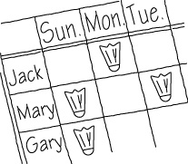 | 2. ＿＿＿  (A) True (B) False  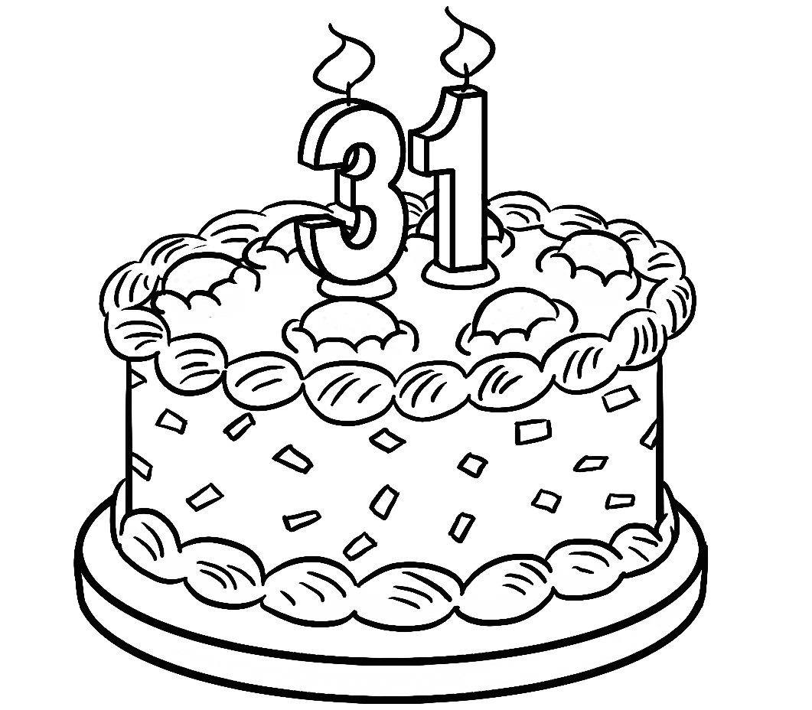 | 3. ＿＿＿  (A) True (B) False  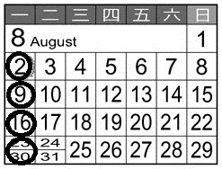 | 4. ＿＿＿  (A) True (B) False  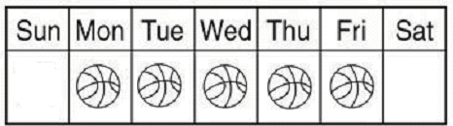
二、基本問答：依據所聽到的內容，選出一個最適合的回應。10 %
1. ＿＿＿
(A) I do. (B) It’s not my pen. (C) We are.
2. ＿＿＿
(A) No, there are two students in front of him.
(B) Yes, there aren’t any students in front of him.
(C) No, there is just one student in front of him.
3. ＿＿＿
(A) No, I have a lot of time this December.
(B) Yes, wish you a Happy New Year.
(C) Yes, my work is over in November.
4. ＿＿＿
(A) You don’t care about me.
(B) It’s good for your health.
(C) Do your homework first,and then we can talk about it.
5. ＿＿＿
(A) About nine o’clock. (B) I seldom go to the gym. (C) I don’t go there on Sundays.

三、言談理解：依據所聽到的對話與問題，選出最適當的答案。10%
1. ＿＿＿
(A) The woman should（應該）practice the guitar every day.
(B) The woman can go to the guitar class with him.
(C) The woman is too busy. She can’t go with him.
2. ＿＿＿
(A) The boy and the girl are brother and sister.
(B) The boy is short of （缺少）money.
(C) Father’s Day is next month.
3. ＿＿＿
(A) On Thursdays. (B) On Wednesdays. (C) On Fridays.
4. ＿＿＿
(A) Every two weeks. (B) Every weekend. (C) Three times a week.
5. ＿＿＿
(A) The girl’s mom only cares about her health.
(B) The girl’s mom only cares about her grades.
(C) The girl’s mom has sleeping problems

四、聽CD中的題組，選出正確的答案。6 %
Question：
(1) ＿＿＿
(A) In a long line in front of the movie theater.
(B) She is with the man and the woman.
(C) At home.
(2) ＿＿＿
(A) It’s almost（幾乎）six.
(B) It’s almost seven.
(C) It’s almost five.
(3) ＿＿＿
(A) The man and the woman are late for the movie at seven.
(B) There are two people in front of Kate.
(C) The man and the woman are in front of Kate.

～聽力測驗結束，請繼續作答～
- 紙筆測驗 70%
- 文意字彙 10%
1.＿＿＿＿＿＿We u y visit our uncle on weekends . 【習作 P.29】
2.＿＿＿＿＿＿Let’s c te Emma’s birthday in my place.【習作 P.24】
3.____________ Brian studies Chinese every W y. 【習作 P.19】
4.____________ They p ce badminton for an hour in the gym every day. 【習作 P.21】
5.____________ A:When is Teacher’s Day ? B: It’s on September t th .【課本 P.63】
6.____________ I have a p m . Let’s ask our teacher for help. 【習作 P.29】
7.____________ September is the n th month of the year.
8.____________ I’m hungry, but I can’t eat. I have a t he now.【課本 P.70】
9.____________ At Happy Junior High School,the students can c se their own clubs.【課本 P.52】
10.___________ Many students are n ed . They have to wear glasses to see things clearly (清楚地).
二、選擇 20%
( ) 1. A：When does your new semester (學期) start? B：Oh. It starts in ＿＿＿.
(A) the month September (B) Tuesday (C) September first (D) Tuesday, September first
( ) 2. Mom hates （討厭）pets. She me have one at home.
(A) always lets (B) never lets (C) lets always (D) lets never
( ) 3. A：＿＿＿ does Nick go to school with every day? B：He goes to school with Ben every day.
(A) What (B) What day (C) Who (D) When
( ) 4. This Thursday is Linda’s ＿＿＿ birthday, and her parents are preparing a party for her.
(A) eight (B) twelve (C) seventeenth (D) twenty-three
( ) 5. A：What day is today ? B：It’s ＿＿＿ Tuesday. 【課本 P.46】
(A) on (B) at (C) in (D) ╳
( ) 6. Cindy：Who homework now? May：Jean .
(A) doesn’t ；does (B) is doing ；is (C) doesn’t do ；don’t (D) do ；does

( Ｃ) 7. A: does Tim go the cram school (補習班)? B: Every day.
(A) How long (B) What day (C) What date (D) How often
( ) 8. A: ________ your father and mother often free ? B: No, they .
(A)Are ；seldom are (B) Are；often are (C) Do ；seldom do (D) Do ；often do
( ) 9. Ruby is an excellent student. , she gets good grades and plays the violin well,too.
(A) No wonder (B) You bet (C) All right (D) For example
( ) 10.Linda： talk in a low voice (小聲地) in a library. Students： .
(A) Always；No problem (B) Always；No way (C) Never；Sure (D) Often；All right

三、填入適當的介系詞，不需要則打 X ：10%
1.It’s too late. Time bed.
2.Your mother cares your health. 【課本 P.76】
3. Father’s Day, Dad is happy about the party..
4. (1) fact, this is also (2) you, honey. 【課本 P.59、 P.70】
5.Let’s meet again this Friday. 【習作 P.27】
6.Don’t worry me. I am fine.
7.I always use my computer least eight hours a day. 【課本 P.76】
8.Staying online too much is bad your eyes.
9.Jim goes to the magic club every Friday morning.

四、克漏字選擇 5 %
My classmate, Robert, is also my good friend. After school, I always play basketball at school, but he (1) . He always (2) home at once（立刻）. His parents have to work until（直到）8:00 every night. So he (3) prepares dinner for his two younger brothers. After all（畢竟）, his brothers can’t (4) care of themselves（他們自己）. (5) , he feeds his dog, Lucky. After that, Robert does his homework and studies. He is helpful to his family.
(1) (A) does (B) doesn’t (C) can (D) can’t
(2) (A) go (B) goes (C) to go (D) is going
(3) (A) never (B) sometime (C) always (D) seldom
(4) (A) take (B) takes (C) to take (D) taking
(5) (A) However (B) Or (C) But (D) Then

背面尚有題目，請繼續作答

五、閱讀測驗 10%
This is Sherry’s schedule（行程表）of a week. Please read it and answer the questions.
(1) Does Sherry always clean her room?
(A) Yes, she always does. (B) No, she seldom does. (C) No, she never does. (D) Yes, she usually does.
(2) How often does Sherry go to church?
(A) Once a week. (B) Twice a month. (C) Twice a year. (D) Once a month.
(3) How often does Sherry have English classes every week?
(A) Eight. (B) Three times a week. (C) Nine. (D) Every day.
(4) When does Sherry have science class?
(A) On the weekend. (B) Once a week. (C) Every Thursday. (D) At three thirty.
(5) Which（哪一個）statement（敘述）is right?
(A) Sherry goes to a beauty shop （美容店）once a month. (B) Sherry has math class twice a week.
(C) Sherry has dinner with her family every Saturday. (D) Sherry has piano class every Monday and Thursday.
六、依提示完成句子 4%
1.Nick does. He understands the school rules. ( 依畫線部分造原問句 ) 【習作 P.21】2%
2.A： ( 依畫線部分造原問句 ) 【習作 P.32】2%
B：My cousin goes to the USA twice a year.
七、整句式翻譯11%
1. 牙醫可解決你的問題，然後你很快就可享用你的午餐了。【習作 P.32】4%
2. 在社團裡，別想太多。就交些朋友以及好好玩樂。【習作 P.21】5%
3. 他們的派對在不同天。【習作 P.27】2%

高雄市立林園高級中學 國中部104學年度 第二學期 1 年級第2次段考 ( 英文科 ) 作答卷
班級： 姓名： 座號：
壹、聽力測驗 30%
一、聽CD，若符合圖意或表格內容的選 A，否則選 B。4 %
1. |  | 2. |  | 3. |  | 4.
- 基本問答：依據所聽到的內容，選出一個最適合的回應。10 %
1. |  | 2. |  | 3. |  | 4. |  | 5.
- 言談理解：依據所聽到的對話與問題，選出最適當的答案。10 %
1. |  | 2. |  | 3. |  | 4. |  | 5.
- 聽CD中的題組，選出正確的答案。6 %
1. |  | 2. |  | 3.

貳、紙筆測驗 70%
一、文意字彙 10%
1. |  | 2. |  | 3. |  | 4. |  | 5.
6. |  | 7. |  | 8. |  | 9. |  | 10.
二、選擇 20%
1. |  | 2. |  | 3. |  | 4. |  | 5.
6. |  | 7. |  | 8. |  | 9. |  | 10.
三、填入適當的介系詞，不需要則打 X ：10%
1. |  | 2. |  | 3. |  | 4. | (1) | 4. | (2)
5. |  | 6. |  | 7. |  | 8. |  | 9.
- 克漏字選擇 5 %
1. |  | 2. |  | 3. |  | 4. |  | 5.
- 閱讀測驗 10%
1. |  | 2. |  | 3. |  | 4 |  | 5.
- 依提示完成句子 4% (全對才給分)
1.
2.
七、整句式翻譯11% (分段給分，請努力作答)
1.
2.
3.
1 年級 ( 英文科 ) 第1 次段考--答案（年級、科目請標示清楚，謝謝！）
壹、聽力測驗
一、 1~5  ( 1分) | BBABA | 二、 1~5  ( 2分) | AACCB | 三、 1~5  ( 2分) | BCCCB | 四、  1~3  ( 2分) | ACB
貳、紙筆測驗
一  ( 1分) | - usually 2. celebrate 3. Wednesday 4. practice 5. twenty-eighth 6. problem 7. ninth  8. toothache 9.choose 10. nearsighted
二  ( 2分) | ABCCD BDADA
三  ( 1分) | 1. for 2.about 3. On 4. (1) In (2) for 5. X 6. about 7. at 8. for 9. X
四  ( 1分) | BBCAD
五  ( 2分) | BABCD
六  ( 2分) | 1.Who understands the school rules？ (全對才給2分 無部份扣分)  2.How often does your cousin go to the USA？ (全對才給2分 無部份扣分)
七 | - The dentist can fix your problem, and then you can enjoy your lunch soon. (一底線1分) 4%  - At the club, don’t think too much. Just make friends and have fun. (一底線1分) 5%  - Their parties are on different days. (一底線1分) 2%

