班級： 姓名： 座號
第一部分 Listening Comprehension 聽力測驗 （30 %）
一.辨識句意: 根據聽到的內容，選出符合描述的圖片或符合圖片的描述 12%
( )1. (Ａ) 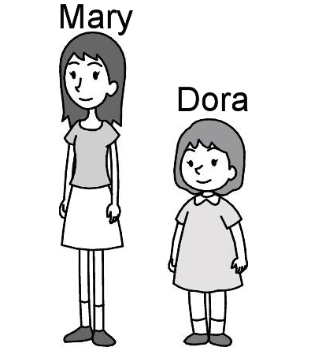 (Ｂ) 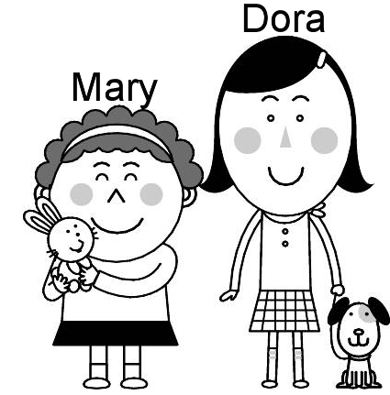 (Ｃ) 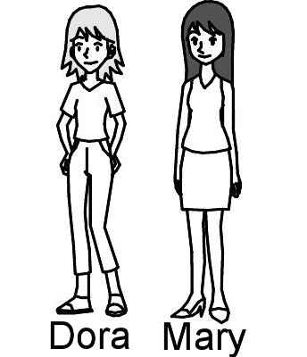

( )2. (Ａ) 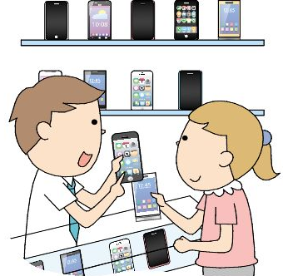 (Ｂ) 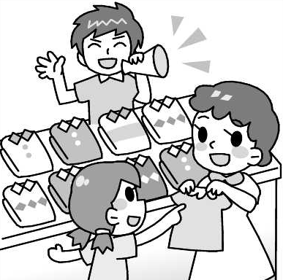 (Ｃ) 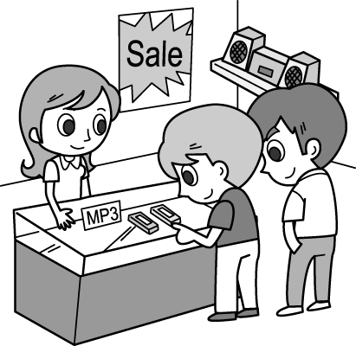

( )3. (Ａ) 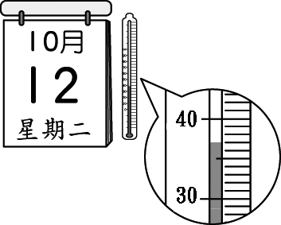 (Ｂ) 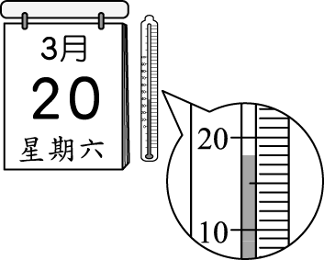 (Ｃ) 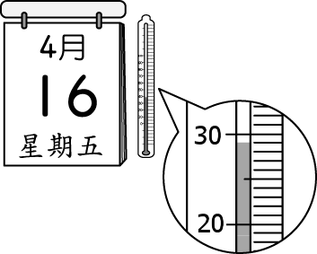

( )4. (Ａ) 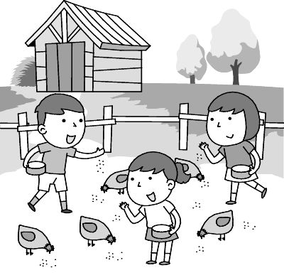 (Ｂ) 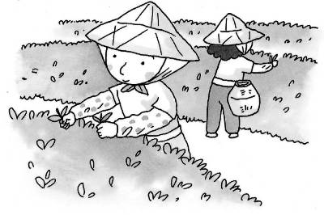 (Ｃ) 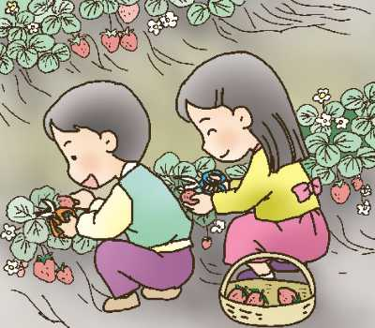
( )5. (Ａ)  (Ｂ) 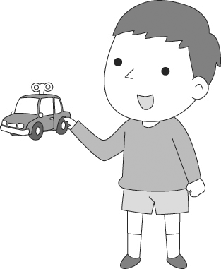 (Ｃ) 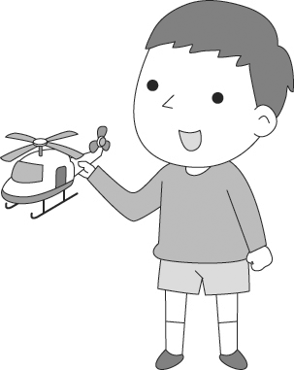
( )6. (Ａ)  (Ｂ) 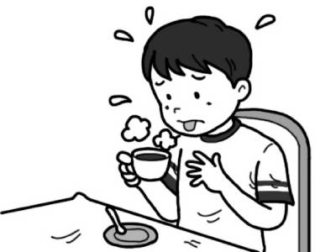 (Ｃ) 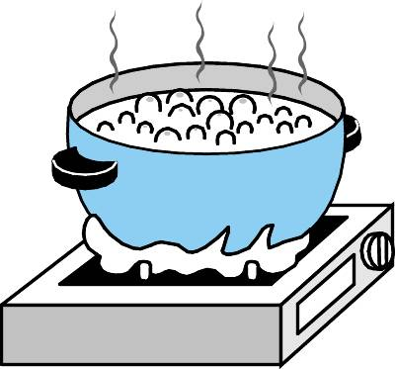
二. 基本問答：根據聽到的內容，選出一個最適合的回應或最適合的問句 12%
( ) 7. (Ａ) I’d like to pay for it for Lisa’s birthday.
(Ｂ) My dad bought it for me last week.
(Ｃ) In cash, please.
( ) 8. (Ａ) Yes, Wang’s Box is a famous shoe store.
(Ｂ) The shoes will cost us a lot of money.
(Ｃ) No, we don’t need any more shoes.
( ) 9. (Ａ) The tomatoes are the most popular.
(Ｂ) You can get many kinds of fruit.
(Ｃ) You can get there on foot.
( ) 10. (Ａ) His farm is far away.
(Ｂ) Let’s go by train. It’s the fastest way.
(Ｃ) It’s a lot of fun for Jason to be a farmer.
( ) 11. (Ａ) I’m happy you like them.
(Ｂ) Strawberries are expensive in this season.
(C ) They are very sour.

( ) 12. (Ａ) I don’t like my dress.
(Ｂ) Thank you. I bought it last week.
(Ｃ) Hurry up. Let’s go inside.
三. 言談理解：根據聽到的內容，選出一個最適合的答案 6%
( ) 13. (Ａ) We don’t know.
(Ｂ) The boy’s.
(Ｃ) The girl’s.
( ) 14 (Ａ) It’s bigger and easy to set up.
(Ｂ) It’s thinner.
(Ｃ) It’s cheaper.
( ) 15. (Ａ) The man doesn’t like fresh watermelon juice.
(Ｂ) The man has a stomachache after he drank the watermelon juice.
(Ｃ) The man was on his way to buy watermelon juice than.
( ) 16. (Ａ) A parking lot is near the night market.
(Ｂ) People can only enjoy food at the night market.
(Ｃ) Garden Night Market is the best night market in Taiwan
( ) 17. (Ａ) She didn’t sleep well.
(Ｂ) She played the guitar all night.
(Ｃ) She couldn’t go to work yesterday.
( ) 18. (Ａ) She didn’t like the food there.
(Ｂ) She got her mom’s call and had to go home soon.
(Ｃ) She didn’t finish her Chinese homework.

第二部分 Reading & Writing Comprehension讀寫測驗 （70 %）
一.選擇題 ，選出最適當的答案 34%
( ) 19. After the heavy rain, vegetables became , so many housewives could not buy a lot.
(Ａ) more and more expensive
(Ｂ) less and less amazing
(Ｃ) cheaper and cheaper
(Ｄ) more and more
( ) 20. Having a wedding in the air than having one at the beach.
(Ａ) has more fun
(Ｂ) are less exciting
(Ｃ) is more fun
(Ｄ) are more interesting
( ) 21. This restaurant sells the best steak in Taipei; you can’t find steak in the city.
(Ａ) more delicious (Ｂ) delicious (Ｃ) most delicious (Ｄ) deliciously
( ) 22. The air in the city is getting because there are too many cars and motorcycles.
(Ａ) bad and bad (Ｂ) worse and worse (Ｃ) worst and worst (Ｄ) better
( ) 23. Smartphones are convenient, and every person in my family has .
(Ａ) it (Ｂ) them (Ｃ) one (Ｄ) those  convenient 便利的
( ) 24. The businessman is good at a 3C shop, and he sometimes enjoys a farmer in
the country for a day.
(Ａ) picking; to be (Ｂ) moving; be (Ｃ) running; being (Ｄ) growing; be
( ) 25. Jay: Mom, can I buy the green MP3 player?
Mom: No. It’s too expensive.
Jay: Oh, Mom, please! I can use some of my pocket money.
(Ａ) Do you have that much money?
(Ｂ) Why not get a cheaper one?
(Ｃ) But it has a nicer color.
(Ｄ) It doesn’t have a case for it.
26-30

Peter visited Taipei 101 with his friend last Sunday. It’s (26) building in Taiwan. They tried and bought some snacks at the supermarket there. Peter’s favorite (27) are chocolate cookies. To him, they are the most (28) cookies of all. Next weekend, Peter will go to Tainan by bus. Taking a bus there is (29) way. No one can imagine what he wants to do in Tainan the most. He wants to (30) different kinds of famous snacks there, like Coffin Bread. Sounds scary, right?

 building 建築物 imagine 想像 coffin 棺材 scary 令人害怕的
（ ）26. (Ａ) tall (Ｂ) the tallest (Ｃ) taller (Ｄ) the least tall
（ ）27. (Ａ) one (Ｂ) ones (Ｃ) other (Ｄ) others
（ ）28. (Ａ) delicious (Ｂ) healthy (Ｃ) best (Ｄ) exciting
（ ）29. (Ａ) cheaper (Ｂ) cheapest (Ｃ) the cheaper (Ｄ) the cheapest
（ ）30. (Ａ) eat (Ｂ) run (Ｃ) sell (Ｄ) own
31-32.
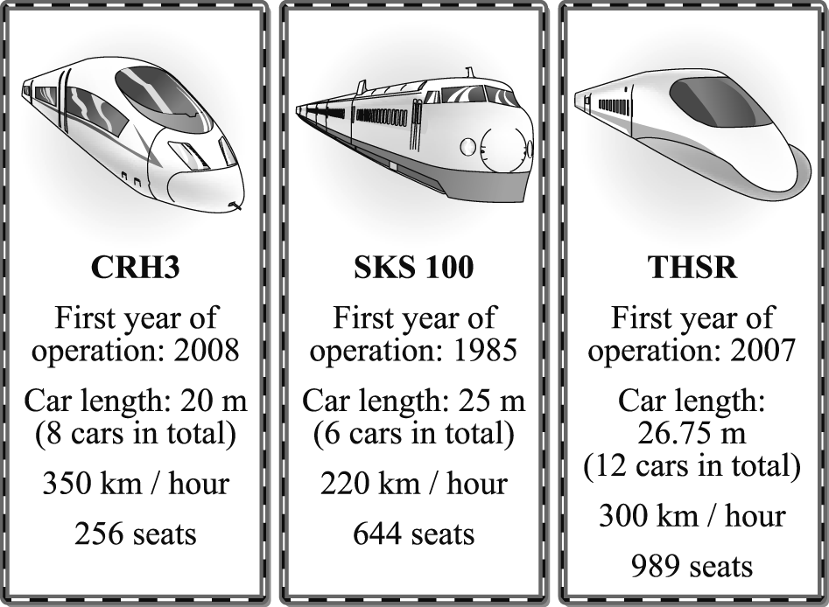
 operate營運 operation 運作 car length 車廂長度 seat 座位
（ ）31. How long is the youngest train? (Ａ) 150 m. (Ｂ) 160 m. (Ｃ) 220 m. (Ｄ) 321 m.
（ ）32. Which is true about the THSR?
(Ａ) It began to operate in 2008.
(Ｂ) Its length is less than 300 m.
(Ｃ) It has more than 900 seats.
(Ｄ) A THSR train has ten cars in total.
33-35
Dear Diary,
Today is Easter. I got up early this morning. After breakfast, my sister and I painted Easter eggs in many different colors, and then we took them to the yard. We hid the eggs everywhere in the yard, and the kids looked for them. Our cousin, Meg, was also there. She looked around the yard and soon found six eggs. After that, we were all tired and hungry. We had a few chocolate eggs and buns. I felt really happy today. It's a lot of fun to celebrate Easter.
Mark

（ ）33. When did Mark paint the eggs?
(A) Before breakfast. (B) After breakfast. (C) During the egg hunt. (D) After the egg hunt.
（ ）34. What DIDN'T Mark do today?
(A) Eat the chocolate eggs. (B) Hide the eggs. (C) Color the eggs. (D) Look for the eggs.
（ ）35. Which is NOT true about Mark's Easter?
(A) He got up early on Easter.
(B) He painted Easter eggs and hid them everywhere in the yard .
(C) He celebrated it with his classmates.
(D) He prepared Easter eggs with his sister.

二.非選擇題 36%
(一)文意字彙 10%
36. A: Can you take the fish out of the r_______or? B: OK.
37. We don’t need to go to school today because it’s a h_____ay.
38. They go to the country every week to e______ce the joy of growing vegetables.
39. Don’t put all your eggs in one b____t.
40. There is somethimg wrong with the camera. I can’t take v_____os with it.
41. Perer is e_____ted because he is going to be a father.
42. The Easter egg hunt is an interesting a_____y on Easter Sunday.
43. They were happy because they won first p____ze yesterday.
44. The radio is more expensive, but its q____y is better..
45. Watermelons grow on the g____d, not on trees.

(二)選出正確答案 ( 注意！寫出前面代號1_2_3才給分 ) 20%
46. The orange one is ( 1. dirty 2. dirtier 3. the dirtiest ) than the white one.
47. The weather is getting ( 1. the hot 2. hotter 3. the hottest ) out here.
48. The elephant is ( 1. big 2. bigger 3. the biggest ) in the zoo.
49. The pink shorts are ( 1.good 2. the better 3. the best ) of the two pairs.
50. These fans are on sale. I want to buy ( 1. one 2. ones )
51. The books ( 1. look 2. looks 3. look like ) heavy, but they’re light.
52. It is ( 1. fast 2. faster 3. the fastest ) to get to the train station by MRT than by bus.
53. The meat duck, but it doesn’t yummy.
( 1. tastes; taste 2. tastes; taste like 3.tastes like; taste)
54. I want to try _____ this Easter, and this way I don’t need to spend time _____eggs.
(1.different something, to boil 2. something different , boiling 3. different things, boiled)
55. The grapes taste ( 1. sweeet 2. sweeter 3. the sweetest ) than the peaches.

(三)中翻英，分段給分 6%
56. 這台新的洗衣機比舊的那一台安靜。
57. 這件紫色的洋裝看起來比灰色的那件漂亮。
58. 這本書是你學習英文最有用的工具。

高雄市立林園高級中學 國中部 104學年度 第2學期 2 年級 英語科 第1次段考 答案卡
◎ 本試卷有58題共 4頁◎ 班級 姓名 座號
第一部份 聽力測驗 1-18題 30%
一. 辨識句意 : 根據聽到的內容，選出符合描述的圖片或符合圖片的描述 ( 1 - 6題 每題2分 12%)
1 |  | 2 |  | 3 |  | 4 |  | 5 |  | 6
二. 基本問答：根據聽到的內容，選出一個最適合的回應或最適合的問句 ( 7-12題 每題2分 12%)
7 |  | 8 |  | 9 |  | 10 |  | 11 |  | 12
三. 言談理解：根據聽到的內容，選出一個最適合的答案 (13-18題 每題1分 6%)
13 |  | 14 |  | 15 |  | 16 |  | 17 |  | 18

第二部分 讀寫測驗
一.選擇題 19-35題 (選出一個最適合的答案) 34% ( 19-35題 每題2分 34%)
19 |  | 20 |  | 21 |  | 22 |  | 23
24 |  | 25 |  | 26 |  | 27 |  | 28
29 |  | 30 |  | 31 |  | 32 |  | 33
34 |  | 35

第二部分 讀寫測驗
二.非選擇題 36-58題 36%
(一)文意字彙 (每題1分 10%)
36 |  | 37 |  | 38 |  | 39 |  | 40
41 |  | 42 |  | 43 |  | 44 |  | 45

(二)選出正確答案 ( 注意！寫出前面代號1_2_3才給分 ) (每題2分 20%)
46 |  | 47 |  | 48 |  | 49 |  | 50
51 |  | 52 |  | 53 |  | 54 |  | 55

(三)中翻英，分段給分 (每題2分 6%)
56
57
58
高雄市立林園高級中學 國中部 104學年度 第2學期 2 年級 英語科 第1次段考 答案
◎ 本試卷有58題共 4頁◎ 命題老師: 李慧真 (分機804)

1 | A | 2 | C | 3 | B | 4 | C | 5 | C | 6 | C

7 | C | 8 | C | 9 | B | 10 | B | 11 | A | 12 | B

13 | C | 14 | C | 15 | B | 16 | A | 17 | A | 18 | B

19 | A | 20 | C | 21 | A | 22 | B | 23 | C
24 | C | 25 | B | 26 | B | 27 | B | 28 | A
29 | D | 30 | A | 31 | B | 32 | C | 33 | B
34 | D | 35 | C

36-40 refrigerator holiday experience basket videos
41-45 excited activity prize quality ground
46-50 22321 51-55 12322
56. The/This new washing machine is quieter than the/that old one.
57. The/This purple dress looks more beautiful/prettier than the/that gray one.
58.The/This book is the most useful tool for you to learn English.

