高雄市立林園高級中學 國中部 104學年度 第二學期 2 年級第2次段考 (英語科) 試題卷
班級： 姓名： 座號：
◎本試卷共（5）頁
第一部分 Listening Comprehension 聽力測驗 （30 %）
- 辨識句意：根據聽到的內容，選出符合描述的圖片或符合圖片的描述。12%
- (Ａ) 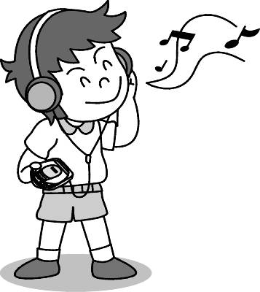 (Ｂ) 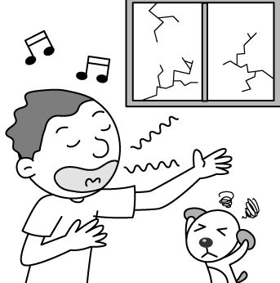 (Ｃ) 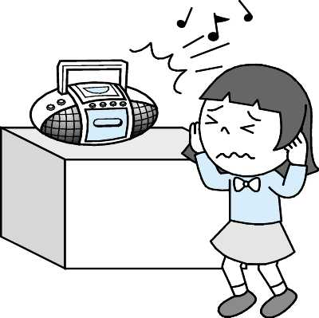

- (Ａ) 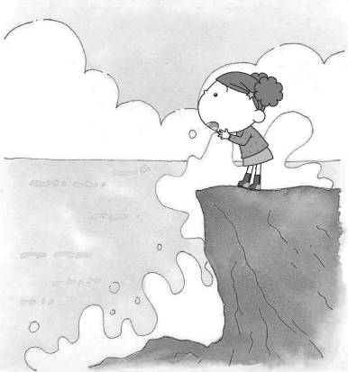 (Ｂ) 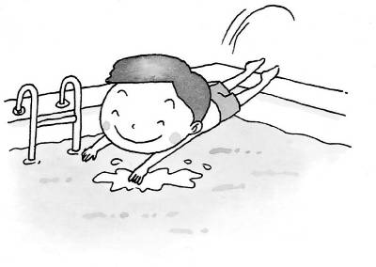 (Ｃ) 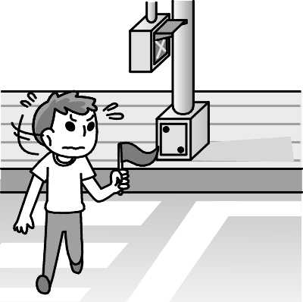

- (Ａ) 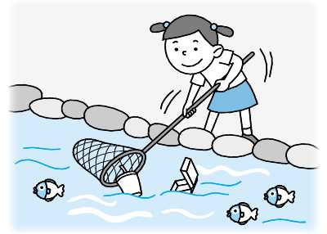 (Ｂ) 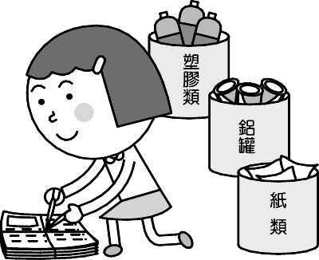 (Ｃ) 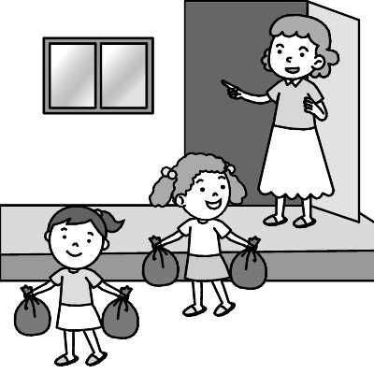

- (Ａ) 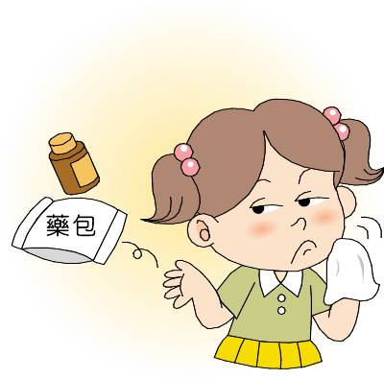 (Ｂ) 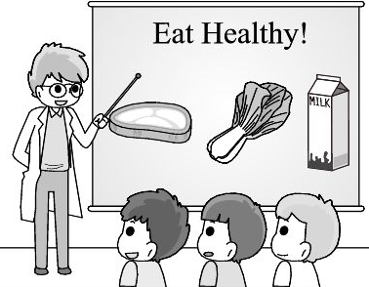 (Ｃ) 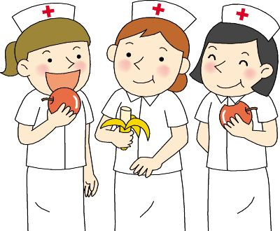

- (Ａ) 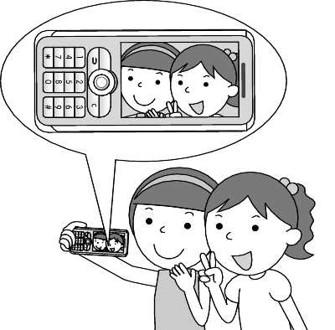 (Ｂ) 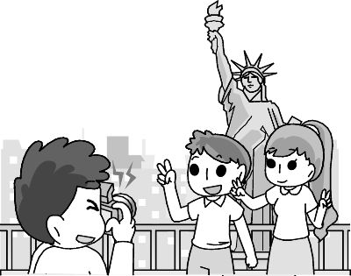 (Ｃ) 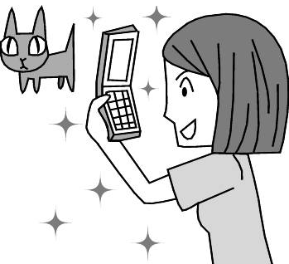

- (Ａ) 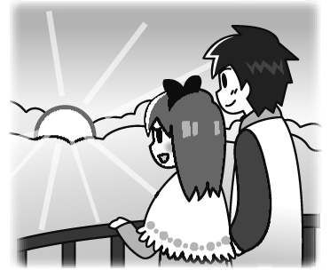 (Ｂ) 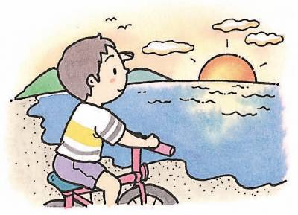 (Ｃ) 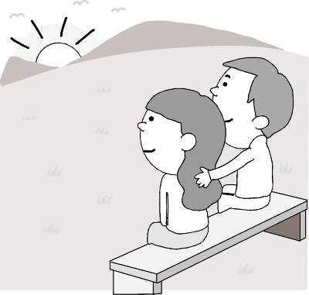

- 基本問答：根據聽到的內容，選出一個最適合的回應或最適合的問句。12%
7. (Ａ) I don’t feel any better.
(Ｂ) Someone broke the windows.
(Ｃ) No, it doesn’t matter with me.
8.(Ａ) He has a terrible stomachache.
(Ｂ) He will be late for his English class.
(Ｃ) He always eats the most slowly of all.
- (Ａ) Shopping bag. I want to be green.
(Ｂ) Using a plastic bag is not kind to our earth.
(Ｃ) Everyone should bring their own bags to the store.
- (Ａ) Mom, can you let me have some free time?
(Ｂ) No, you shouldn’t make me do so much housework.
(Ｃ) Wow! You must be the busiest junior high school student in the town.
- (Ａ) I enjoyed myself and liked the hot spring bath best.
(Ｂ) You can see the beautiful underwater world.
(Ｃ) We were able to watch the sun rise and set.
- (Ａ) How about seven thirty?
(Ｂ) It will be at twelve forty.
(Ｃ) It’s convenient for me to help Jack now.

- 言談理解：根據聽到的內容，選出一個最適合的答案。6%
- (Ａ) The boy didn’t agree with the girl’s parents.
(Ｂ) The boy thought the girl’s parents were right.
(Ｃ) The boy’s parents told him not to go to bed late.
- (Ａ) He needs to find three jobs at the same time.
(Ｂ) He always works over time.
(Ｃ) Because of heavy work, he is becoming weaker and weaker.
- (Ａ) They will turn off the lights for two hours.
(Ｂ) They are talking about how to save their money.
(Ｃ) They want to find out the best way to finish their homework quickly.
- (Ａ) They are reading.
(Ｂ) They are having fun outside.
(Ｃ) They are watching TV at home.
- (Ａ) They are playing volleyball at the beach.
(Ｂ) They are riding a bike to the beach.
(Ｃ) They are cheering someone up.
- (Ａ) Jason’s parents are busy at work.
(Ｂ) Jason hurt himself for the first time yesterday.
(Ｃ) The boy and the girl will try their best to help Jason.

第二部分 Reading & Writing Comprehension讀寫測驗 （70 %）
一.選擇題 ，選出最適當的答案 56%
1. Howard was not ___, so he tripped and fell.
(A) careful enough (B) enough careful (C) carefully enough (D) enough carefully
2. Tony can throw the ball ___ than all the other boys.
(A) far (B) more far (C) farther (D) the farthest
3. It rained ___ last night when I was on the bus home.
(A) strong (B) heavy (C) hard (D) big
4. No one can ___ me wear something I don’t like.
(A) ask (B) make (C) tell (D) help
5. Jeff: Must I finish my homework now, Mom? Mom: No, you ___.
(A) can’t (B) mustn’t (C) don’t (D) don’t need to
6. Winnie: Why didn’t you come to the party last night? Eva: I ___ take care of my brother.
(A) must (B) should (C) had to (D) need to
7. Having some hobbies is a good thing, but still, we ___ spend too much time on those.  hobbies 嗜好
Remember, we will ___ study or work.
  - shouldn’t; have to (B) must; need to (C) can’t; must (D) may; should

8. This morning, I saw you talk to ___ at the street corner.
(A) me (B) you (C) myself (D) yourself
9. Joyce: We should bring our own chopsticks to reduce trash. Emily: ___
(A) I couldn’t agree with you more. (B) I did my best. (C) Good job! (D) What should we do?
10. Michelle: You lost your worksheet again? Eric: Yeah…___
(A) Can you take my place? (B) Sounds nice. (C) Winning isn’t everything. (D) I am in big trouble.

11-15

Mom: Lily, did you see Harry?
Lily: Yes. I saw him 11. out a few minutes ago.
Mom: Well, I'll take out the trash 12. then. The garbage truck is coming.
Lily: Let me 13. it out, Mom. You worked for 8 hours today. You 14. rest.
Mom: But the trash is heavy. Don't you need my help?
Lily: Don't worry. I can do it. Ah, I have to run quickly.
The truck's going to 15. .
Mom: Oh, OK. Thanks, Lily.
 garbage truck 垃圾車
11. (A) to go (B) going (C) goes (D) went
12. (A) yourself (B) himself (C) myself (D) ourselves
13. (A) to take (B) taking (C) take (D) takes
14. (A) should (B) were able to (C) mustn’t (D) don’t have to
15. (A) fall (B) rise (C) lose (D) leave

16-19
On weekends, I like to get up early and go cycling in a big park nearby. It is just a few miles away from my house. Riding on the bicycle, I can feel the breeze softly 17. my face and see leaves dancing with the wind. In spring, I can even see mother birds feeding baby birds. I love nature! I can always enjoy myself there; 18. , one thing really makes me angry. Some pet owners just don’t think they should 19. after their dogs. Please remember to bring pick-up bags if you want to take your dog to the park. Everyone must try their best to keep our environment clean, or we might not be able to live on a healthy and beautiful planet anymore.

 breeze 微風 softly輕柔地 leaves葉子 environment環境

16. “ Go cycling” means ____.
(A) go hiking (B) go recycling (C) go biking (D) go bird watching
17. (A) throwing (B) blowing (C) touching (D) cutting
18. (A) but (B) however (C) or (D) because
19. (A) clean up (B) cheer up (C) hurry up (D) turn off

20-22

Heavy rain washed the land away
I would never forget that 1
When I looked down the muddy river
The terrible sight made me shiver
Many people became homeless
Because some people were careless
We only have one Earth
Think about what it is worth
I used to spend hours
Walking among beautiful flowers
Listening to honey bees
Buzzing around tall trees
Looking at the blue sky
Where wild birds used to fly
Now all this is gone
Because some damage was done
After the trees were cut down
The bare hill became brown

➔

 buzz 嗡嗡叫 wild 野生的 gone 去；不見了 damage 損害 bare 光禿禿的
muddy 泥濘的 sight景象 shiver 發抖 homeless 無家可歸的 careless 草率的 worth 值…的

20. There is one word missing from the poem. What might it be?  poem詩
(A) pay (B) price (C) man (D) day
21. What is the best title of this poem?  title 標題
(A) Song of the Bees (B) Careless Fisherman
(C) Where Has My Beautiful Home Gone (D) Happy Kids in the Mountain
22. Who may be the writer of the poem?
(A) Someone who lives in a big city. (B) Someone who lives on the hill.
(C) The one who cut down the trees. (D) A science teacher.

23-25
eyesbook
Sophia
I cannot stand my sister anymore. She is really MESSY, and I have to
share a room with her. What should I do?
15 minutes ago．Like．Comment



God Mother
You need to talk to your sister and ask her to help you. Nobody wants to live in a messy room. Perhaps you can ask your parents for help. Have them make rules for you and your sister to follow. For example, you can take turns cleaning your room once a week. And maybe you can each have a space for your favorite things. Soon, you will have a clean room.
10 minutes ago．
Sophia likes this. this.

 stand 忍受 perhaps 或許 space空間 take turns 輪流
23. “Messy” means .
(A) funny | (B) strong | (C) clean | (D) dirty
24. What’s Sophia’s problem?
(A) She doesn’t like housework.
(B) Her sister doesn’t ask for help.
(C) Her sister doesn’t clean the room.
(D) She doesn’t have her own room.
25. What did God Mother tell Sophia to do?
(A) Ask her sister not to break rules.
(B) Clean the room together with her sister once a week.
(C) Move to another room.
(D) Let her sister have a space for her favorite things.

26-28
Camp Sunshine


Welcome to Camp Sunshine – the place of sand, sun and blue skies! If you are
looking to create a summer experience to remember, then this is the place. We offer weeklong camps for children aged 6-9, 10-13 and 14-17 all the summer. We provide three healthy meals every day, and several nutritious snacks. Our cabins are new, and we have a new playground. There are many outdoor activities for children: sailing, nature hikes, team sports, rock climbing, swimming and golf. They can also play board games and join drama teams or singing groups. Campers will have a great time! We look forward to seeing your wonderful children this upcoming summer! ( To register, fill out the form, phone our office number, or visit our website. Don’t wait – the places at our camp fill up very early.)



 sand 沙子 offer 供應 provide 提供 nutritious營養的 cabin小木屋 board games桌遊 drama戲劇 camper露營者 look forward to期待 upcoming即將到來 register登記 fill out填寫 form表格
website網頁 fill up 填滿

26.What is the purpose of this ad?  purpose 目的 ad 廣告
- To tell you the cabins, buildings and food at the camp.
- To tell you all about Camp Sunshine.
- To tell you all the activities at the camp.
- To tell you how to register your children for the camp.
27. About the camp, which is NOT true?
- You can go golfing and practice acting at this camp.
- The childrens spend a lot of time outdoors.
- The eight-year-old children go to the camp together with the eleven-year-old ones.
- All the food is provided for the children at the camp.
28.About the camp, which is true?
- The camp is very popular.
- The camp has a new swimming pool and all new cabins.
- This camp runs during the summer and fall.
- The camp is not very busy.

二.非選擇題 14%
(一)Vocabulary文意字彙 8%
1. It was a y late, so we went straight home.
2. I have trouble with math. Can s e please help me?
3. Two years ago, money m t everything to James, but now it doesn’t.
4. Mrs. Chen wants her kids to use money more w y.
5. Jack, you are really green. You never use p c bags when you go shopping.
6. The rain finally stopped, and the b t sun lit up the grassland.
7. Bob: Is it c t for you to buy me a hamburger on your way to school? Brian: Sure!
8. Rosa: Honey, could you help me with the housework? James: No p m!

(二)Translation中翻英，分段給分 6%
1. 你必須記住老師的話，否則你就麻煩了。
2. 我們應該養成隨身攜帶購物袋的習慣。
3. 大聲念出來有助於改善(improve)你的英文。

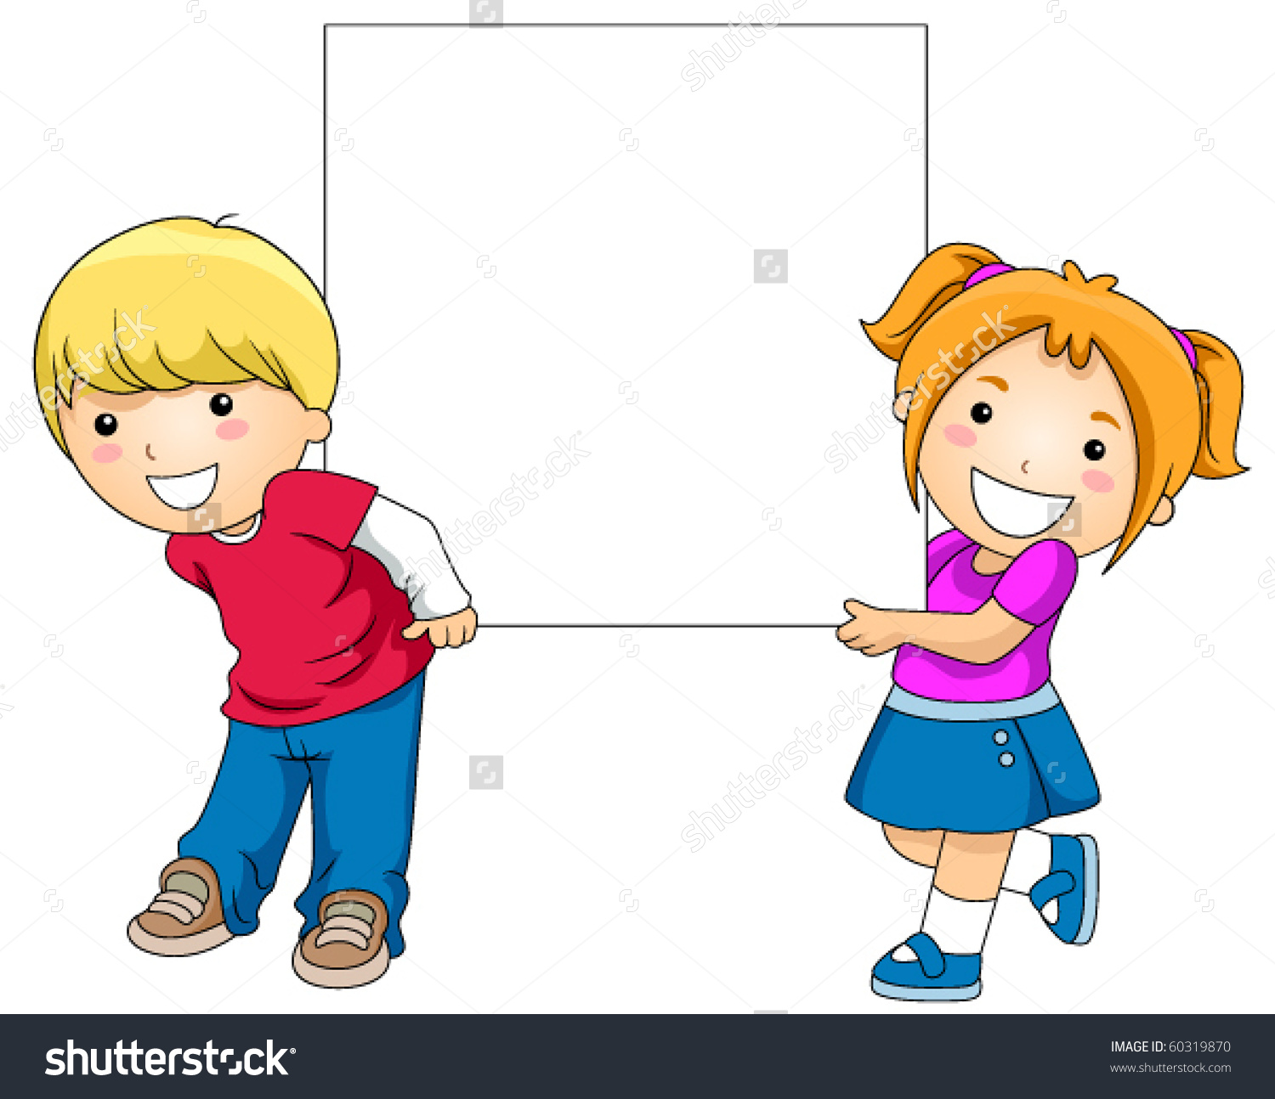

The End!

The End!

 punish 處罰
高雄市立林園高級中學 國中部 104學年度 第2學期 2 年級 英語科 第2次段考 作答卷
◎ 本試卷聽力有18題，讀寫有39題，共 6頁◎ 班級 姓名 座號
第一部份 聽力測驗 1-18題 30%
一. 辨識句意 : 根據聽到的內容，選出符合描述的圖片或符合圖片的描述 ( 1 - 6題 每題2分 12%)
1 |  | 2 |  | 3 |  | 4 |  | 5 |  | 6
二. 基本問答：根據聽到的內容，選出一個最適合的回應或最適合的問句 ( 7-12題 每題2分 12%)
7 |  | 8 |  | 9 |  | 10 |  | 11 |  | 12
三. 言談理解：根據聽到的內容，選出一個最適合的答案 (13-18題 每題1分 6%)
13 |  | 14 |  | 15 |  | 16 |  | 17 |  | 18

第二部分 讀寫測驗 70%
一.選擇題 1-28題 (選出一個最適合的答案) 56% ( 每題2分 )
1 |  | 2 |  | 3 |  | 4 |  | 5
6 |  | 7 |  | 8 |  | 9 |  | 10
11 |  | 12 |  | 13 |  | 14 |  | 15
16 |  | 17 |  | 18 |  | 19 |  | 20
21 |  | 22 |  | 23 |  | 24 |  | 25
26 |  | 27 |  | 28

二.非選擇題 14%
(一)文意字彙 8% ( 每題1分 )
1 |  | 2 |  | 3 |  | 4 |  | 5
6 |  | 7 |  | 8

(二)中翻英，分段給分 6% ( 每題2分 )
1
2
3

高雄市立林園高級中學 國中部 104學年度 第2學期 2 年級 英語科 第2次段考 答案
命題老師: 潘如庸 (分機804)
第一部份 聽力測驗 1-18題 30% (一題2分)
1 | B | 2 | A | 3 | B | 4 | C | 5 | A | 6 | A
(一題2分)
7 | B | 8 | B | 9 | A | 10 | A | 11 | A | 12 | A
(一題1分)
13 | B | 14 | A | 15 | A | 16 | C | 17 | B | 18 | B
第二部分 讀寫測驗 70%
一.選擇題 1-28題 (選出一個最適合的答案) 56% (一題2分)
1 | A | 2 | C | 3 | C | 4 | B | 5 | D
6 | C | 7 | A | 8 | D | 9 | A | 10 | D
11 | B | 12 | C | 13 | C | 14 | A | 15 | D
16 | C | 17 | C | 18 | B | 19 | A | 20 | D
21 | C | 22 | B | 23 | D | 24 | C | 25 | D
26 | B | 27 | C | 28 | A
二.非選擇題 14%
(一)文意字彙 8% ( 每題1分 )
1 | already | 2 | someone | 3 | meant | 4 | wisely | 5 | plastic
6 | bright | 7 | convenient | 8 | problem

(二)中翻英，分段給分 6% ( 每題2分 )
1 | We should make it a habit / to bring a shopping bag with us.
2 | You have to keep the teacher’s words in mind, / or you’ll be in trouble.
3 | Reading out loud / helps (to) improve your English.

錄音稿

辨識句意：根據聽到的內容，選出符合描述的圖片或符合圖片的描述。
1. The boy sings terribly.
2. Don’t go any farther. There’s no road.
3. My mom made me sort the trash.
4. We should eat more fruits to keep healthy.
5. My sisters enjoy taking pictures of themselves.
6. They are watching the sun rise from behind the clouds.
- 基本問答：根據聽到的內容，選出一個最適合的回應或最適合的問句。
7. What’s the matter here?
8. Peter is eating more hungrily than before. What’s the matter?
9. Which do you like, plastic bag or shopping bag?
10. Paul, you must study English in the morning, learn math in the afternoon, and prepare for the science test at night.
11. How was your trip to Green Island, Sophia?
12. What time is convenient for you to help me send the books to Peter, Jack?
- 言談理解：根據聽到的內容，選出一個最適合的答案。
13. G: My parents told me to watch less TV and go to bed early.
B: I couldn’t agree with them more.
Q: Which is true?
14. W: Dear Vincent,
Please take good care of yourself. I don’t think you need to do three jobs at the same time. You
always work busily, you usually skip your meals, and you seldom exercise. Last night you coughed badly again when you were sleeping. I’m worried about you.
Teresa
Q: What isn’t Vincent’s problem?
15. W: We must finish our dinner and homework before eight because there will be no light from eight to ten.
M: Why can’t we turn on the lights for two hours? We’re not so poor for the light.
W: The “ no light for two hours ” event is for our Mother Earth.
Q: What can we know from the dialogue?
16. W: Fighting is really boring to me. It’s not funny at all to watch people fighting with each other.
M: That’s not a true story. Let’s turn off the TV and go out to have some fun.
W: Don’t make me do anything. I’ll read interesting books in my study.
Q: What are they doing now?
17. M: Come on, Sherry. There are only a few miles to the beach. Go faster! We will have fun playing volleyball on the beach.
W: No way! I feel very tired and can’t move any farther.
M: Don’t give up. We’re almost there.
Q: What are they doing?
18. M: Let’s visit Jason in the hospital. He hurt himself again last night because he thought his parents didn’t love him. I’m really worried about him.
W: Me, too. They should spend more time with him, not make money all the time.
M: That’s true. We should help him and make good friends with him.
Q: Which is NOT true about the dialogue?

