高雄市立林園高級中學 國中部 104學年度 第二學期 三 年級 英文 科 第 一 次段考試卷
班級： 姓名： 座號：
本試卷共（ 4 ）頁
壹、聽力測驗（共30分）

一、聽字選圖（聽單字，選出正確的圖片代碼）：每題 1 分，共 5 分
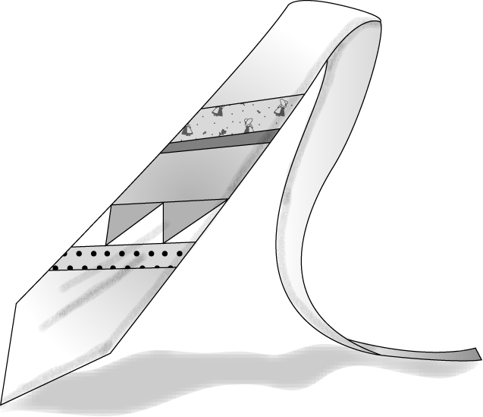
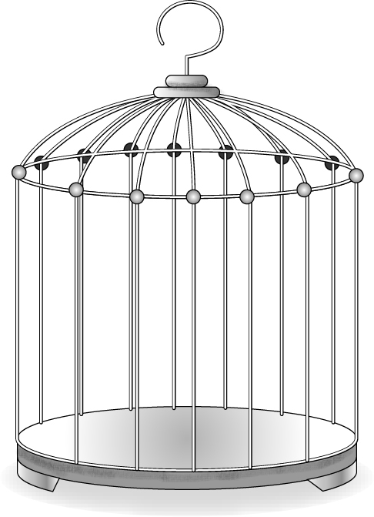
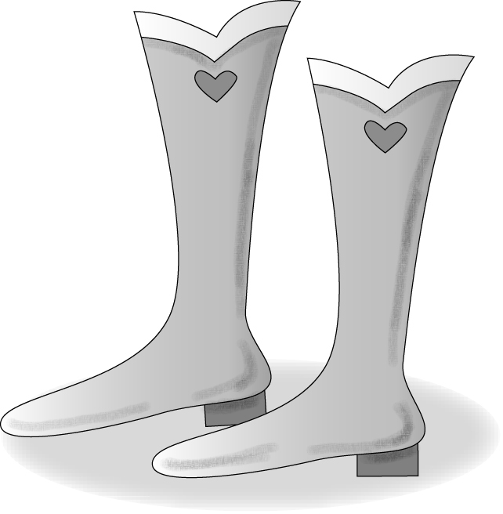
A. B. C.
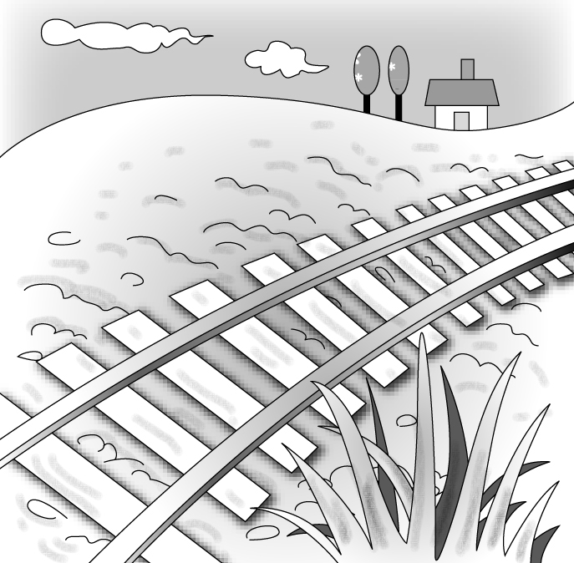
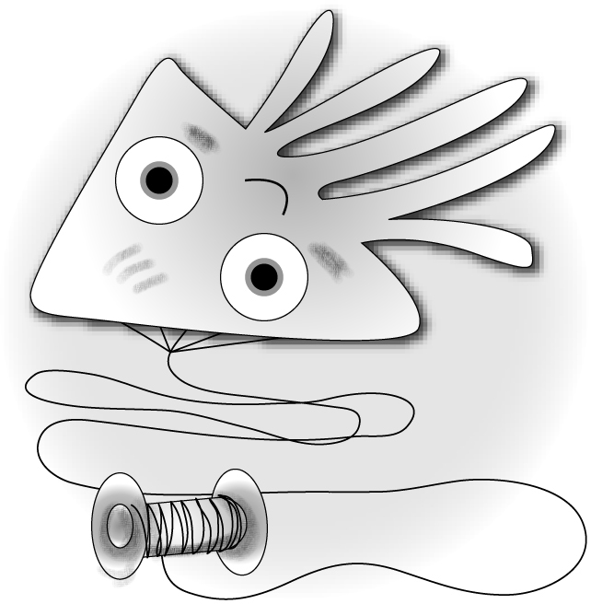
D. E.
答：1. ( ) 2. ( ) 3. ( ) 4. ( ) 5. ( )

二、字彙選擇（選出聽到的單字）：每題 1分，共 5 分
( ) 6. (A) toy (B) tub (C) top (D) tape
( ) 7. (A) list (B) lost (C) least (D) last
( ) 8. (A) slice (B) slide (C) slim (D) sleep
( ) 9. (A) bear (B) below (C) bell (D) belt
( ) 10. (A) minute (B) money (C) miner (D) moment

三、對話選擇（根據聽到的對話內容，選出相符合的答案）：每題 2分，共 10 分
( ) 11. (A) Emily is thinner than Kelly.
(B) Emily wears shorts, not a skirt.
(C) Kelly is heavier than Emily.
( ) 12. (A) The girl isn’t good at math.
(B) The boy bought some comic books last Saturday.
(C) The boy’s comic books were taken away by the girl.
( ) 13. (A) Jeff’s desk was broken, too.
(B) Tom will go to the secondhand store.
(C) Rita won’t go to the secondhand store.
( ) 14. (A) Amy is heavier than before.
(B) Amy doesn’t eat fast food anymore.
(C) The blue jeans look a little big on the boy.
( ) 15. (A) Paul’s mom has slept under the cherry trees.
(B) Paul has seen cherry blossoms in person.
(C) Joyce has seen cherry blossoms in person.

四、短文回答（根據聽到的短文內容與問題，選出正確的答案）：每題 2分，共 10 分
( ) 16. (A) Nancy’s grandmother.
(B) Nancy’s mother.
(C) Nancy’s sister.
( ) 17. (A) Nancy’s grandfather.
(B) Nancy’s grandmother.
(C) Nancy’s mother.
【背面還有聽力試題】
( ) 18. (A) To save both time and money.
(B) To save either time or money.
(C) To save neither time nor money.
( ) 19. (A) Baseball.
(B) Basketball.
(C) Badminton.
( ) 20. (A) In the supermarket.
(B) In the local market.
(C) On the Internet.

貳、紙筆測驗（共70分）
一、字彙測驗（每題1分，共10分）
1. ＿＿＿＿＿＿ This piece of furniture is made of w d. (習作P5)
2. ＿＿＿＿＿＿ The t c is heavier in the city than in the country. (習作P5)
3. ＿＿＿＿＿＿ Look at the mountains and rivers around the city. What a beautiful s e! (習作P5)
4. ＿＿＿＿＿＿ Your pants are so loose. What can you do to h d them up? (習作P10)
5. ＿＿＿＿＿＿ I think the black hat with white d ts fits you better. (習作P10)
6. ＿＿＿＿＿＿ Julia wonders wh se car this is. It looks so new and cool! (習作P10)
7. ＿＿＿＿＿＿ Put on your s kers before you jog. (習作P10)
8. ＿＿＿＿＿＿ To stay healthy, you should make it a h t to exercise every day. (習作P16)
9. ＿＿＿＿＿＿ The Chinese L ern Festival falls on the fifteenth day of the first lunar month. (習作P16)
10.＿＿＿＿＿＿ Don’t forget to p ck a heavy coat before traveling to Canada. It’s very cold there right now.
(習作P16)
二、選填符合句意的動詞片語，並做最適當的變化（每格1分，共6分）：（習作p14）

take off wake up write down

1. Mark: Didn’t you (1) Jolin at six?
Nick: I tried, but I just couldn’t (2) .
2. Son: Dad, I want to (3) my jacket.
Dad: Don’t (4) . It’s getting colder.
3. Julie: Have you (5) the directions to the party for James?
direction 方向
Peter: Not yet. I haven’t had time to (6) .

三、文法測驗（每題2分，共20分）
1.（ ）Is there anyone who has seen ghosts ＿＿＿ person? (習作P6)
(A) in (B) on (C) at (D) for
2.（ ）This picture reminds me ＿＿＿ living in the country with my best friends. (習作P6)
(A) as (B) for (C) at (D) of
3.（ ）Rose: How do you like my new pants?
Sara: They look nice ＿＿＿ you. They go very well ＿＿＿ your shirt. (習作P11)
(A) in; on (B) on; in (C) on; with (D) with; on
4.（ ）October 10 ＿＿＿ Double Ten Day. (習作P11)
(A) also calls (B) also called (C) is also called (D) is also calling
5.（ ）Cathy isn’t free this evening, and Dora isn’t, either. So ＿＿＿ Cathy ＿＿＿ Dora will come to the party tonight. (習作P17)
(A) both; and (B) either; or (C) not only; but also (D) neither; nor
6.（ ）Either you or Grace the boy since he was born, right? (習作P17)
(A) know (B) knew (C) has known (D) knows
7.（ ）Sophie felt sick this afternoon, so she ________ to the doctor. (A) had gone (B) gone (C) went (D) goes
8.（ ）Before Janet picked up her hat, the wind ________ it away. (A) blows (B) had blown (C) has blown (D) blow
9.（ ）I can buy either a hamburger or a sandwich. So I will have ________ of them. (A) none (B) both (C) two (D) one
10.（ ）Both Ellen and Flora ________ for Hokkaido next Thursday. (A) left (B) are leaving (C) is leaving (D) are left
四、克漏字測驗（每題2分，共8分）
Ron: Max, do you know anyone who fixes televisions?
Max: No. Why? Is there anything wrong with yours?
Ron: Yes. There is no sound coming out.
Max: That’s too bad. We can’t live without TV.
Ron: You can say that again. That’s why I want to fix it as soon as possible.
Max: How old is your TV? Why don’t you have a new one instead（代替）? The machine is like us. It has a life, too.
Ron: I guess I (1) it for more than 10 years. But new televisions can be so expensive! I believe that (2) can
last a few more years.
Max: If you need to spend more than half of the price to fix it, then you had better (3) a new one.
Ron: Maybe. But maybe it’s just a small problem. If I can find a great repairman（修理師傅）, it might cost me little
money to fix it.
Max: Why not do some homework online first? Then you can have a better idea.
Ron: I’ve been busy lately. I have no time to shop (4) online (4) in appliance stores.（電器行）
I just don’t want to throw out something that can still be used.

（ ）1. (A) have had (B) had had (C) will have (D) am having
（ ）2. (A) ours (B) theirs (C) mine (D) yours
（ ）3. (A) to buy (B) bought (C) buying (D) buy
（ ）4. (A) both; and (B) either; or (C) neither; nor (D) not only; but also

五、閱讀測驗（每題2分，共10分）
A. Miep Gies isn’t a name most people heard of. However, she played an important part in publishing one of the world’s most famous diaries. Miep Gies lived in Amsterdam in the 1940s. She worked for Anne Frank’s father, Otto Frank. She was a friend of the family, too. The Franks were Jewish. However, after the Nazis controlled their country during World War Ⅱ, being Jewish was a dangerous thing. In 1942, the Frank family hid in a building. For the next two years, Miep Gies and her husband secretly brought the Franks food. In August 1944, someone told the Nazis about the Franks, and they were arrested and sent to the concentration camps. Otto was the only member of the Frank family that didn’t die in the concentration camp. When he went back to Amsterdam after the war, Miep gave him Anne’s diary. Anne Frank：The Diary of a Young Girl was published in 1947. Miep Gies later wrote her own book about Anne. In it, she said that she wasn’t a hero, but she did something to tell us what the real life in the war was.

 Amsterdam 阿姆斯特丹 Jewish 猶太人 Nazis 納粹 arrest 逮捕 member 成員 concentration camp 集中營

（ ）1. Which was true about Miep Gies?
(A) She was a police officer.
(B) She told the Nazis about the Franks.
(C) She worked for Anne Frank’s father.
(D) She was a Jewish.
（ ）2. How did Miep Gies and her husband help the Franks during the World War Ⅱ?
(A) They brought the Franks food.
(B) They sent the Franks to concentration camps.
(C) They wrote a book about the Franks.
(D) They taught Anne how to keep a diary.
背面有題

B. Dear Silvia,
You know what? I went shopping at Mia Department Store this afternoon. It took me about 45 minutes to go there. I wanted to choose a new skirt for my birthday party next week. The skirts there were quite expensive. Each of them cost more than two thousand NT dollars. However, I liked neither long skirts nor short skirts there.
At last, I gave up looking for a skirt. When I started looking for pants, I found a pair of black pants which looked so special. Finally, I bought the black pants, and it cost me only NT$790. It was great, wasn’t it?
Sophia at last 最後

（ ）3. Who went shopping at Mia Department Store this afternoon?
(A) Sophia.
(B) Silvia.
(C) Sophia and Silvia.
(D) We don’t know.
（ ）4. How much did the black pants cost?
(A) NT$790.
(B) NT$970.
(C) NT$2,000.
(D) We don’t know.
（ ）5. Which is NOT true?
(A) Sophia bought a pair of black pants.
(B) The black pants were not expensive.
(C) Sophia bought a new skirt.
(D) The skirts at Mia Department Store were expensive.

六、翻譯﹙每格不限一字，全對才給分。每格1分，共16分﹚
1. 為了避開擁擠的交通，我們搭火車。(課本P6）
(1) the (2) , we took the train.
2. 當我第一次看到它們時，我還以為在下雪，因為我以前從來沒看過任何像那樣的東西。(課本P2﹚
When I first saw them, I (3) it was (4) because I had (5) anything (6) that before.
3. 雖然牛仔褲最早是戶外工人在穿，但是它很快地就受到每個人的歡迎。(課本P19）
Though blue jeans (7) by (8) workers, they soon became (9) everyone.
4. 日本人在臺灣北部種植了大量的油桐樹。(課本P3﹚
The (10) planted a large (11) tung trees in the (12) part of Taiwan.
5. John厭倦收聽廣播，所以他關掉了。
Tired of (13) the radio, John turned (14) .
6. 你到博物館之前，我就已經買票了。
Before you (15) at the museum, I (16) the tickets.
【試題結束】

高雄市立林園高級中學 國中部 104學年度 第二學期 三年級 英文科 第 一 次段考 作答卷
班級： 姓名： 座號：
壹、聽力測驗
一、聽字選圖（聽單字，選出正確的圖片代碼）：每題 1 分，共 5 分
1. | 2. | 3. | 4. | 5.
二、字彙選擇（選出聽到的單字）：每題 1分，共 5 分

6. | 7. | 8. | 9. | 10.
三、對話選擇（根據聽到的對話內容，選出相符合的答案）：每題 2分，共 10 分

11. | 12. | 13. | 14. | 15.
四、短文回答（根據聽到的短文內容與問題，選出正確的答案）：每題 2 分，共 10 分
16. | 17. | 18. | 19. | 20.

貳、紙筆測驗
一、字彙測驗（每題1分，共10分）
1. | 2. | 3. | 4. | 5.
6. | 7. | 8. | 9. | 10.
二、選填符合句意的動詞片語，並做最適當的變化（每格1分，共6分）：（習作p14）
1. (1) | (2)
2. (3) | (4)
3. (5) | (6)
三、文法測驗（每題2分，共20分）
1. | 2. | 3. | 4. | 5.
6. | 7. | 8. | 9. | 10.
四、克漏字測驗（每題2分，共8分）
1. | 2. | 3. | 4.
五、閱讀測驗（每題2分，共10分）
1. |  | 2.
3. | 4. |  | 5.
六、翻譯﹙每格不限一字，全對才給分。每格1分，共16分﹚
(1) | (2) | (3) | (4)
(5) | (6) | (7) | (8)
(9) | (10) | (11) | (12)
(13) | (14) | (15) | (16)
高雄市立林園高級中學 國中部 104學年度 第二學期 三年級 英文科 第 一 次段考 解 答
班級： 姓名： 座號：
壹、聽力測驗
一、聽字選圖（聽單字，選出正確的圖片代碼）：每題 1 分，共 5 分
1. D | 2. C | 3. A | 4. B | 5. E
二、字彙選擇（選出聽到的單字）：每題 1分，共 5 分

6. B | 7. A | 8. C | 9. D | 10. D
三、對話選擇（根據聽到的對話內容，選出相符合的答案）：每題 2分，共 10 分

11. B | 12. A | 13. C | 14. B | 15. B
四、短文回答（根據聽到的短文內容與問題，選出正確的答案）：每題 2分，共 10 分
16. C | 17. B | 18. A | 19. C | 20. A

貳、紙筆測驗
一、字彙測驗（每題1分，共10分）
1. wood | 2. traffic | 3. scene | 4. hold | 5. dots
6. whose | 7. sneakers | 8. habit | 9. Lantern | 10. pack
二、選填符合句意的動詞片語，並做最適當的變化（每格1分，共6分）：（習作p14）
1. (1) wake up | (2) wake her up
2. (3) take off | (4) take it off
3. (5) written down | (6) write them down
三、文法測驗（每題2分，共20分）
1. A | 2. D | 3. C | 4. C | 5. D
6. C | 7. C | 8. B | 9. D | 10. B
四、克漏字測驗（每題2分，共8分）
1. A | 2. C | 3. D | 4. B
五、閱讀測驗（每題2分，共10分）
1. C |  | 2. A
3. A | 4. A |  | 5. C
六、翻譯﹙每格不限一字，全對才給分。每格1分，共16分﹚
(1) To avoid | (2) heavy traffic | (3) thought | (4) snowing
(5) never seen | (6) like | (7) were first worn | (8) outdoor
(9) popular with | (10) Japanese | (11) number of | (12) northern
(13) listening to | (14) it off | (15) arrived | (16) had bought

