高雄市立林園高級中學 國中部 104學年度 第 二 學期 三 年級 英語 科 第 二 次 段考考卷
班級： 姓名： 座號： 本試卷共（5）頁
一、聽力測驗：共30分。
(一) 字彙選擇（選出聽到的單字）：每題1分，共5分
( ) 1. | (A) exercise | (B) exciting | (C) excuse | (D) excited
( ) 2. | (A) entertain | (B) teach | (C) enjoy | (D) enter
( ) 3. | (A) speed | (B) speak | (C) sneak | (D) spell
( ) 4. | (A) block | (B) blanket | (C) black | (D) basket
( ) 5. | (A) afraid | (B) hot | (C) honest | (D) honored

(二) 辨識句意（根據聽到的內容，選出正確的圖片代碼）：每題1分，共5分
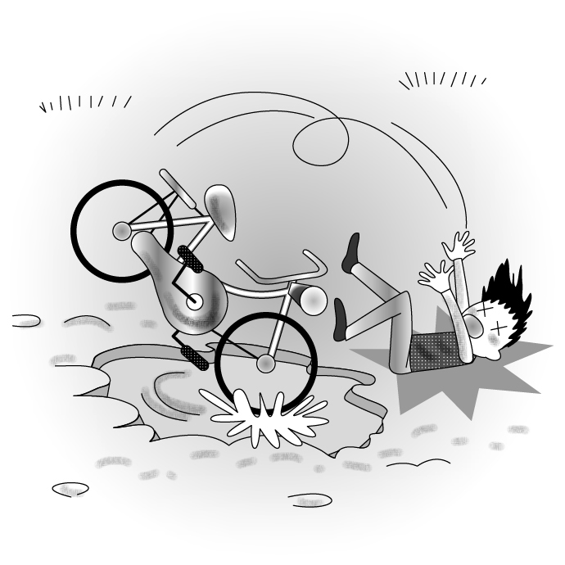
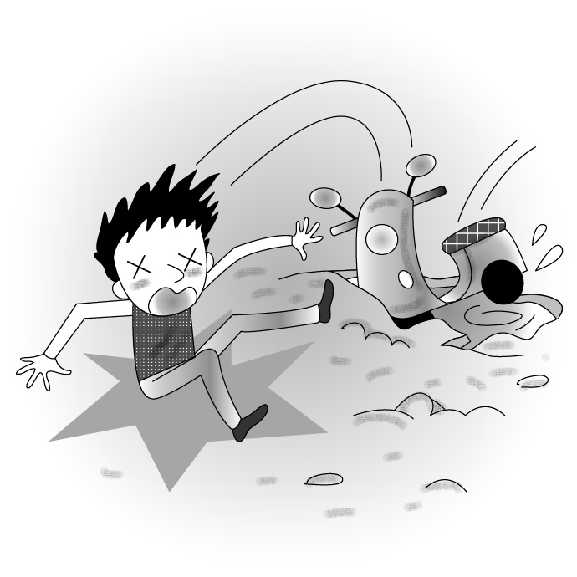
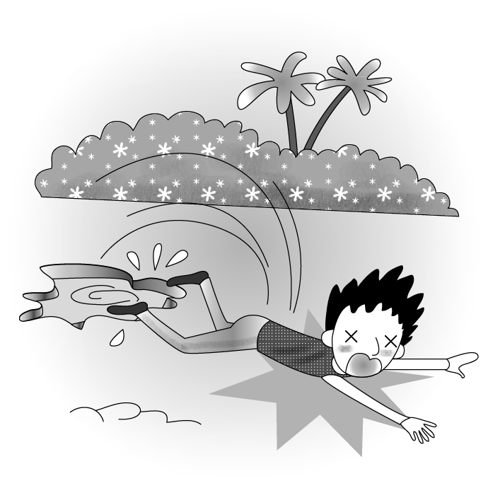
( ) 6. (A) (B) (C)
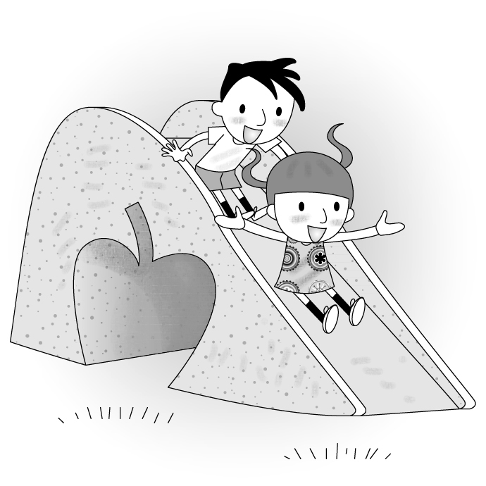
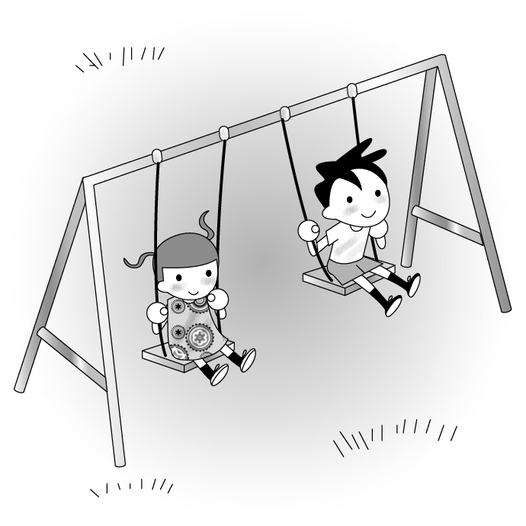
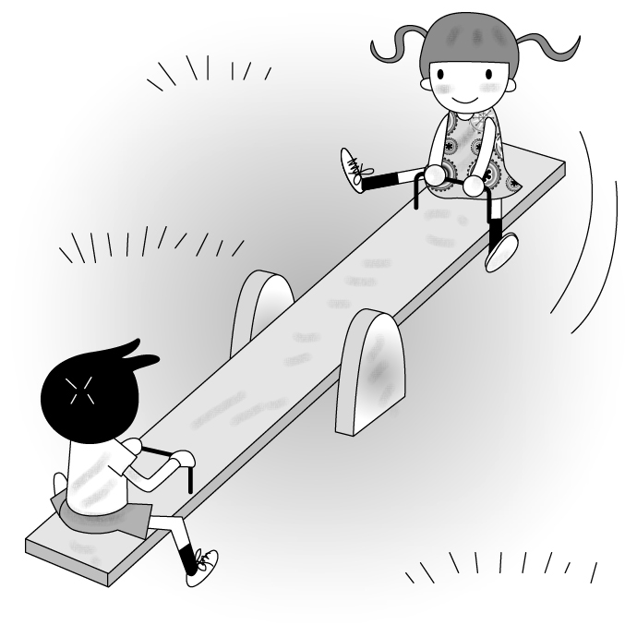
( ) 7. (A) (B) (C)
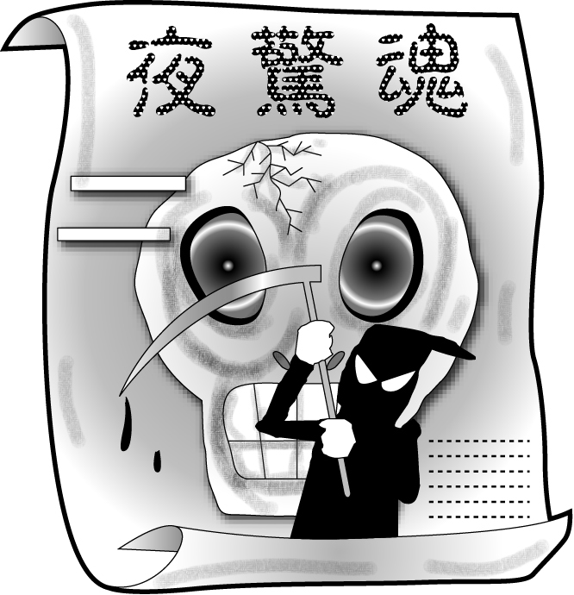
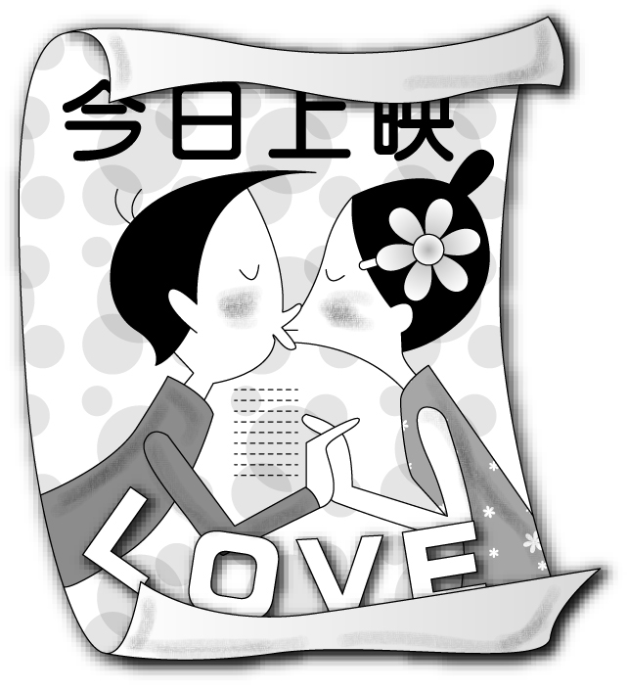
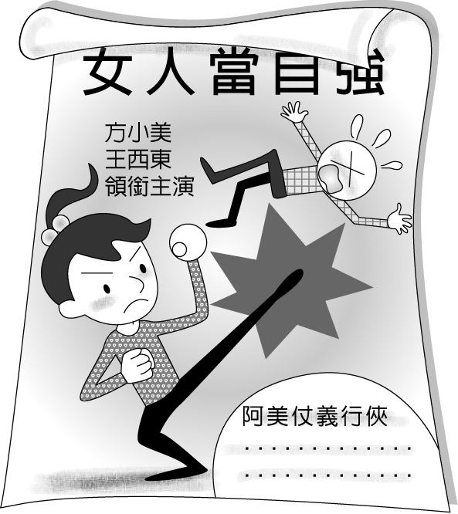
( ) 8. (A) (B) (C)
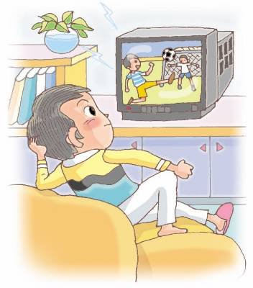
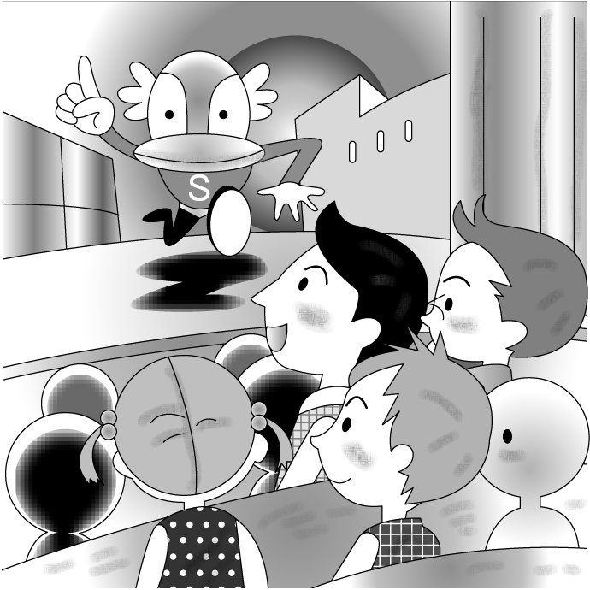
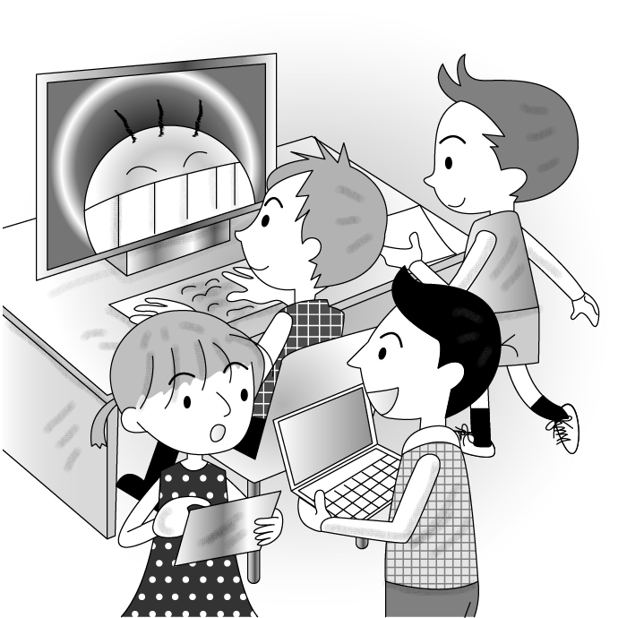
( ) 9. (A) (B) (C)

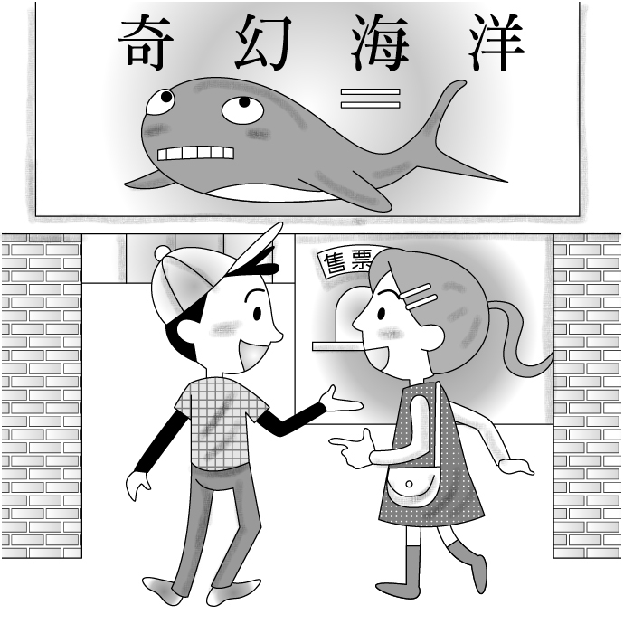
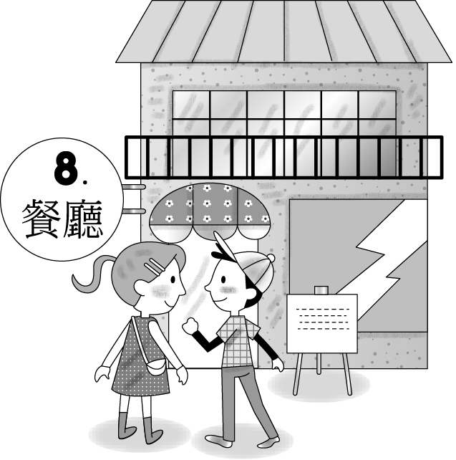
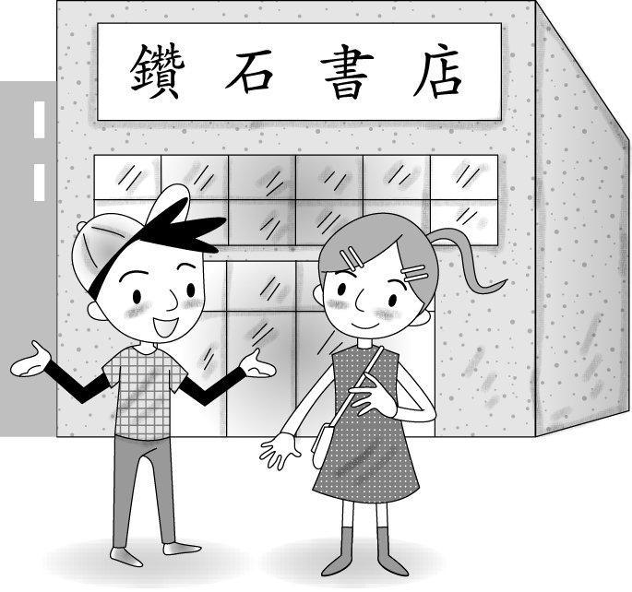
( ) 10. (A) (B) (C)

(三) 基本問答（根據聽到的內容，選出合適的回應）：每題2分，共10分
( ) 11. | (A) It sounds sweet. | (B) It smells fresh. |  | (C) It looks beautiful.
( ) 12. | (A) I like action movies. | (B) This is a love story. |  | (C) I don’t like scary movies.
( ) 13. | (A) They are boring. | (B) I don’t understand love stories. | (C) They are always inspiring.
( ) 14. | (A) He fell down the stairs and got hurt.  (B) He has no interest in dead bodies.  (C) He likes action movies.
( ) 15. | (A) What’s up?  (B) How to make our dreams come true.  (C) Are you ready?

(四) 言談理解（根據聽到的對話內容與問題，選出正確的答案）：每題2分，共10分
( ) 16. | (A) At the gas station. | (B) At the snack bar. | (C) At the box office.
( ) 17. | (A) She was caught in the rain.  (B) She got up late.  (C) She forgot to bring her cellphone with her.
( ) 18. | (A) This Friday. | (B) This Saturday. | (C) This Sunday.
( ) 19. | (A) At the gas station. | (B) At the bookstore. | (C) On the playground.
( ) 20. | (A) She told him how to move ahead in his life.  (B) She told him how to be a doctor.  (C) She told him how to get good grades.

二. 紙筆測驗：每題 2 分，共35題，總分70分。
第一部分：單題(第21-30題，共10題)
( ) 21. Last Friday, I _____ an old friend whom I haven’t seen since we graduated from junior high school.
(A) paid for (B) ran into (C) kept away (D) gave up
( ) 22. Mr. Huang needs a student _____ his work to take out the garbage for him.
(A) finishes (B) finished (C) has finished (D) who has finished
( ) 23. The shopkeeper told Jenny _____ the blue T-shirt had already sold out.
(A) who (B) which (C) that (D) what
( ) 24. Daniel wants to know _____ his cousin and best friend, Bill, can come to his party.
(A) if (B) where (C) what (D) about
( ) 25. The house is on fire, so all of the rooms _____ smoke.
(A) fill with (B) full of (C) are filled with (D) is full of
( ) 26. Gerg: Mary, you don’t look very well. What happened?
Mary: I’m _____ about my English homework. It’s so hard for me.
(A)bored (B) tired (C) worried (D) interested
( ) 27. Kevin told me that the cake from the bakery is delicious, but Linda said it’s too sweet and expensive. I don’t know
_____ .
- who to believe (B) how to believe (C) when to believe (D) whether to believe
( ) 28. There are fewer and fewer indoor spaces that allow smoking. However, there is one great thing that smokers can do,
that is, _____ smoking.
(A) keep (B) stop (C) stay (D) go on
( ) 29. I woke up at five this morning, and I didn’t get back to sleep because I _____ for eight hours.
(A) sleep (B) slept (C) have slept (D) had slept
( ) 30. Sam: Can you tell me _____?
Amy: Yes, there is a supermarket down the street.
(A) why do you like scary movies (B) where I can buy some eggs
(C) why didn’t Jack like action movies (D) when will you go to the movies with us

第二部分：題組(第31-55題，共25題)
(31 ~ 33)
My dear students,
Time really flies. You’re leaving school soon. Before you graduate, I have some important ideas to tell you again. No pains（痛）, no gains（獲得）. (31) how hard the work is, just do it. Hard work leads to success, you know. Teamwork is (32) key to great success. It’s a wonderful experience to get along with your peers（同儕）. Help one another in daily life, and share great ideas with them. It’s much more fun than working alone. Most important of all, build a strong mind and healthy body. Success means nothing (33) good health.
I wish you a bright future.
Your teacher,
Mr. Chen

( ) 31. (A) It is (B) We’re sure (C) No matter (D) People say
( ) 32. (A) no (B) the only (C) a gate (D) another
( ) 33. (A) without (B) with (C) beside (D) above

(34 ~ 36)
A small town has a good chance of starting a good business that can (34) , if it has something special to be proud of. One example is Dahu town of Miaoli, Taiwan. Dahu has been famous for growing strawberries, but the town didn’t start to make lots of money from them until some years ago. As more and more people have visited Dahu for its strawberries, the strawberry farmers have begun to open their farms to the public. At the farms, people can have the fun of
(35) by themselves. People also can buy some things related to strawberries, such as strawberry ice cream and strawberry sausage（香腸）at the stores. The new businesses (36) for those who live in the town, so they can have more time with their family without leaving their hometown for work.

( ) 34. (A) make people healthy (B) make people live longer (C) bring in a lot of food (D) bring in a lot of money
( ) 35. (A) making dishes (B) making ice cream (C) picking strawberries (D) selling strawberries
( ) 36. (A) make a better life (B) make more food (C) make less traffic (D) have lost money

(37 ~ 40)
A kind of ball seaweed（球藻）named Marimo in Japanese is also known as Moss(苔蘚) Balls or Lake Balls in English. Such balls are only found in lakes in the northern hemisphere（半球）. The action of the wave occasionally（偶爾）turns Marimo, so they can maintain（維持）the round shape. They grow very slowly—5 mm bigger each year. You can buy small ones as souvenirs（紀念品）in some aquariums（水族館）. Also, pictures of Marimo are used to make related products such as key rings, notebooks, letter paper, postcards, and so on.

How to take care of Marimo
‧ Grow Marimo in tap water at room temperature（溫度）. In hot weather (above 25°C), they can be placed in the refrigerator, but not the freezer（冷藏室）.
‧ Change the water every one or two weeks.
‧ Keep Marimo away from sunlight. The light inside of the house would be enough for them to grow.
‧ Give them your loving care. Legend（傳說）has it that Marimo would bring the grower happiness and have your dream come true.

( ) 37. What is Marimo?
(A) A ball. (B) A plant. (C) A lake. (D) An animal.
( ) 38. What does the word “ones” mean?
(A) Marimos. (B) Aquariums. (C) Souvenirs. (D) Round shapes.
( ) 39. Which is the right condition(環境) for growing Marimo?
(A) 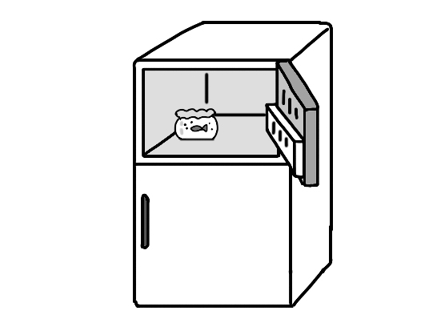 (B)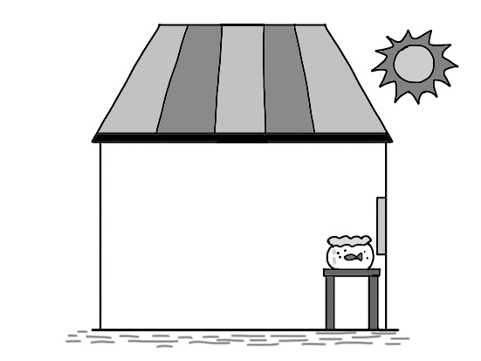 (C)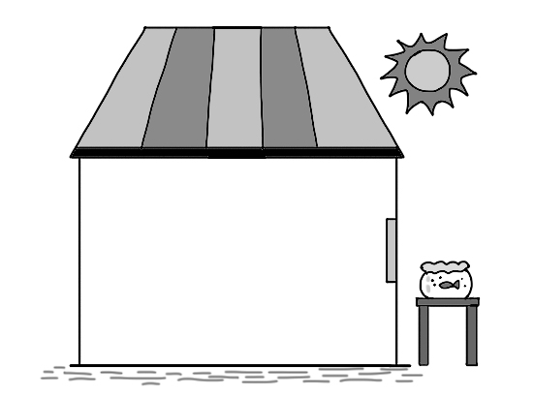 (D) 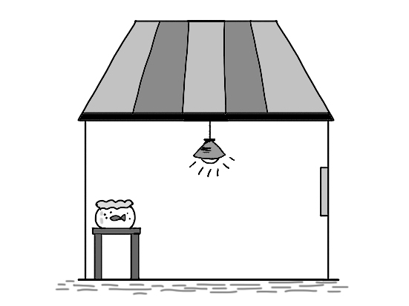
( ) 40. Which is correct?
(A) Marimo can be found all over the world. (B) Marimo grows in lakes.
(C) We can buy Marimo in Australia. (D) Marimo grows from seeds.

(41~44)

( ) 41. What is the ad about?
(A) A speech lesson. (B) An ear clinic（診所）. (C) Business training. (D) A garden.
( ) 42. What might “no more than” want to tell us?
(A) They need more than 12 students (B) They don’t have enough classrooms.
(C) It’s a small size class. (D) They don’t want people to come.
( ) 43. According to the calendar of 2013, what date can you start a new course?
(A) October second. (B) October ninth. (C) October twenty-third. (D) October thirtieth.
( ) 44. Which is NOT true?
(A) It takes one hour to have the lesson each time.
(B) We don’t know how much the tuition（學費）is.
(C) We don’t know how long it will take to finish the course.
(D) It’ easy for people to learn to give a speech effectively（有效率地）.

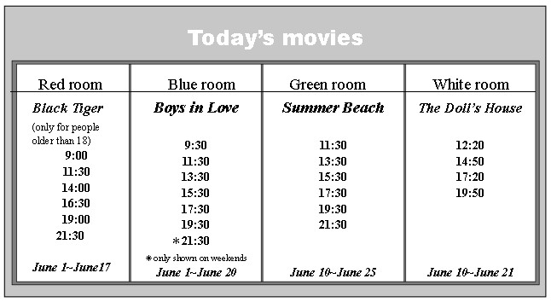
(45~47)

( ) 45. June 23 is Mrs. Wu’s birthday. Her husband is going to take her to see a movie. Which movie can they see?
(A) Black Tiger (B) Boys In Love (C) Summer Beach (D) The Doll’s House
( ) 46. Mary, a junior high school student, went to a movie with her classmates. After the movie, they had lunch at a restaurant near the theater at 11:40. Which movie did they see?
(A) Black Tiger (B) Boys In Love (C) Summer Beach (D) The Doll’s House
( ) 47. Which is true about the movies in the poster?
(A) People cannot see Black Tiger on weekends.
(B) The Doll’s House is not shown in the morning.
(C) Boys in Love is shown six times on weekends.
(D) Of all the movies, Summer Beach is shown the most days.

(48~50)
Weight control is very popular these days. People hope to become thin quickly. Some even take medicine without a doctor’s prescription. But reports show that although many of them do lose weight, they soon gain it back or gain even more.
So how can you safely control your weight? Diet and exercise are the answers. Eat only when you are hungry and eat only food that is good for your health. Never just stop eating; doing so can make you feel even hungrier, and you will eat more. Also, it is better to prepare your own food instead of eating out. And think about changing your lifestyle. For example, turn off the TV and the computer and get some exercise every day. But remember: Don’t be too strict with yourself. Give yourself some time to find the best way to control your weight. * prescription 處方 * instead of 代替

( ) 48. Which is the best title for the reading?
- Medicine for Losing Weight.
- Tips for Losing Weight Quickly.
- Why People Need Weight Control.
- Safe Ways to Control One’s Weight.
( ) 49. According to the writer, what happens to people who take medicine to lose weight?
- Many of them put on weight again.
- They feel unhappy about eating.
- They cannot concentrate on their work.
- Most of them lose too much weight and get sick.
( ) 50. What does Don’t be too strict with yourself mean in the reading?
(A) Eat anything you like when you feel unhappy.
(B) Don’t feel sad if you have spent a lot of money trying to lose weight.
(C) Try to relax by watching TV or playing computer games.
(D) Never try to lose weight in a way that is too difficult.

(51~52)
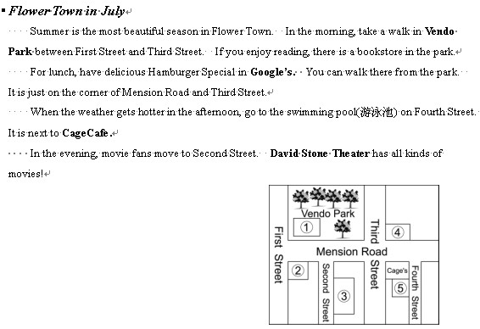
Flower Town in July
Summer is the most beautiful season in Flower Town. In the morning, take a walk in Vendo Park between First Street and Third Street. If you enjoy reading, there is a bookstore in the park.
For lunch, have delicious Hamburger Special in Google’s. You can walk there from the park. It is just on the corner of Mension Road and Third Street.
When the weather gets hotter in the afternoon, go to the swimming pool on Fourth Street. It is next to Cage’s Cafe.
In the evening, movie fans move to Second Street. David Stone Theater has all kinds of movies!
( )51. What is Number 4 in the map（地圖）?
(A) The theater. (B) The bookstore. (C) The restaurant. (D) The swimming pool.
( )52. Who will find this poster useful?
(A) Street vendors. (B) Police officers. (C) People who need jobs. (D) People who visit the town.

(53~55)
Reading is an activity people enjoy a lot in their free time. Some like reading newspapers, and others enjoy novels or comic books. I like reading about the lives of great people. This always gives me a lot of ideas on how to make my own life better.
Great people are remembered not because they were handsome or beautiful, but because they did not give up when their lives were difficult. They used every opportunity to change their lives and make the world better.
One good example is Orville and Wilbur Wright, the two brothers who invented the airplane. The plane has made the world into a small village. Hard work, not good luck, is the reason why the Wright Brothers could invent this convenient machine and become remarkable people. Today we still remember them when we see planes in the sky.
When I feel sad, stories of great people always help me feel better. This is why I enjoy reading about great people’s lives. * opportunity 機會 * invented 發明
( )53. What does "This" mean in the first paragraph?
(A) Being a great person. (B) Reading about the lives of great people.
(C) Living in a special way. (D) Reading newspapers, novels, or comic books.
( )54. Which book might the writer be most interested in?
(A) Michael Jordan: The Man Who Changed Basketball History (B) Ten Books That Have Made Our World Better
(C) Use Every Opportunity to Read in Your Free Time (D) How to Build a Strong Plane
( )55. What does "remarkable" mean in the third paragraph?
(A) Nice and polite. (B) Tall and handsome. (C) Special and famous. (D) Lucky and interesting.
【試題結束】

高雄市立林園高級中學 國中部 104學年度 第 二 學期 三 年級 英語 科 第 二 次 段考答案卷
班級： 姓名： 座號：
一、聽力測驗：共30分。
(一) 字彙選擇（選出聽到的單字）：每題1分，共5分
1. C | 2. A | 3. C | 4. B | 5. D
(二) 辨識句意（根據聽到的內容，選出正確的圖片代碼）：每題1分，共5分
6. A | 7. C | 8. B | 9. A | 10. C
(三) 基本問答（根據聽到的內容，選出合適的回應）：每題2分，共10分
11. B | 12. A | 13. C | 14. A | 15. B
(四) 言談理解（根據聽到的對話內容與問題，選出正確的答案）：每題2分，共10分
16. B | 17. C | 18. B | 19. C | 20. A

二、紙筆測驗：每題2分，共35題，總分70分。
第一部分：單題 (第21-30題，共10題)
21. B | 22. D | 23. C | 24. A | 25. C
26. C | 27. A | 28. B | 29. D | 30. B
第二部分：題組 (第31-55題，共25題)
31. C | 32. D | 33. A | 34. D | 35. C
36. A | 37. B | 38. A | 39. D | 40. B
41. A | 42. C | 43. B | 44. A | 45. C
46. B | 47. B | 48. D | 49. A | 50. D
51. C | 52. D | 53. B | 54. A | 55. C
三年級(英文科)第2次段考--答案（年級、科目請標示清楚，謝謝！）
1~5 | CACBD | 6~10 | ACBAC
11~15 | BACAB | 16~20 | BCBCA
21~25 | BDCAC | 26~30 | CABDB
31~35 | CDADC | 36~40 | ABADB
41~45 | ACBAC | 46~50 | BBDAD
51~55 | CDBAC

聽力測驗錄音檔
一、字彙選擇（選出聽到的單字）：每題 分，共 分
( C ) 1. (A) exercise (B) exciting (C) excuse (D) excited
( A ) 2. (A) entertain (B) teach (C) enjoy (D) enter
( C ) 3. (A) speed (B) speak (C) sneak (D) spell
( B ) 4. (A) block (B) blanket (C) black (D) basket
( D ) 5. (A) afraid (B) hot (C) honest (D) honored
聽力內容：
1. The rain gives us a good excuse to go to the restaurant to eat lunch.
2. Movies entertain us when they make us laugh and cry.
3. I like to see a bad guy sneak up on people and attack them.
4. Once Tony played Superman with a blanket over his shoulders.
5. Jane is honored to give a speech at graduation this weekend.

二、辨識句意（根據聽到的內容，選出正確的圖片代碼）：每題 分，共 分
( A ) 6. (A) (B) (C)
( C ) 7. (A) (B) (C)
( B ) 8. (A) (B) (C)
( A ) 9. (A) (B) (C)

( C ) 10. (A) (B) (C)

聽力內容：
6. George rode into a puddle and fell off the bicycle.
7. John and Mary are playing on the seesaw.
8. Julie is interested in love stories.
9. Movies play an important role in people’s lives.
10. Let’s just wait here at the bookstore.

三、基本問答（根據聽到的內容，選出合適的回應）：每題 分，共 分
( B ) 11. (A) It sounds sweet. (B) It smells fresh. (C) It looks beautiful.
( A ) 12. (A) I like action movies. (B) This is a love story. (C) I don’t like scary movies.
( C ) 13. (A) They are boring.
(B) I don’t understand love stories.
(C) They are always inspiring.
( A ) 14. (A) He fell down the stairs and got hurt.
(B) He has no interest in dead bodies.
(C) He likes action movies.
( B ) 15. (A) What’s up?
(B) How to make our dreams come true.
(C) Are you ready?
聽力內容：
11. How does the rain on the street smell?
12. What kind of movie do you like?
13. Why do you like sports movies?
14. What happened to Bob?
15. What are you going to talk about?

四、言談理解（根據聽到的對話內容與問題，選出正確的答案）：每題 分，共 分
( B ) 16. (A) At the gas station. (B) At the snack bar. (C) At the box office.
( C ) 17. (A) She was caught in the rain. (B) She got up late. (C) She forgot to bring her cellphone with her.
( B ) 18. (A) This Friday. (B) This Saturday. (C) This Sunday.
( C ) 19. (A) At the gas station. (B) At the bookstore. (C) On the playground.
( A ) 20. (A) She told him how to move ahead in his life.
(B) She told him how to be a doctor.
(C) She told him how to get good grades.
聽力內容：
1. Girl: I’d like a bag of popcorn.
Man: Here you are. Would you like something to drink?
Girl: All right. Give me a bottle of soda. How much is it?
Man: The total is 95 dollars.
Question: Where is the girl?
2. Woman: Sorry, I’m late.
Man: I’ve waited for you here for half an hour. Why didn’t you call me first?
Woman: I forgot to bring my cellphone with me.
Question: What’s the woman’s excuse?
3. Boy: I heard that you’ll give a speech at graduation this Saturday.
Girl: Yes. But I’m a little worried.
Boy: Don’t worry. I’m sure you’ll do just fine.
Question: When is their graduation?
4. Girl: It’s fun to play on the seesaw. Let’s play on it again.
Boy: But I’d like to try the slide. Would you like to join me?
Girl: Sure. Let’s go.
Question: Where are the girl and the boy?
5. Boy: What did you tell Johnny?
Girl: I told him how to move ahead in his life.
Boy: It was too serious. Why?
Girl: Johnny’s mom died last month.
Question: What did the girl tell Johnny?
高雄市立林園高級中學 國中部 104學年度 第 二 學期 三 年級 英語 科 第 二 次 段考答案卷
班級： 姓名： 座號：
一、聽力測驗：共30分。
(一) 字彙選擇（選出聽到的單字）：每題1分，共5分
1. | 2. | 3. | 4. | 5.
(二) 辨識句意（根據聽到的內容，選出正確的圖片代碼）：每題1分，共5分
6. | 7. | 8. | 9. | 10.
(三) 基本問答（根據聽到的內容，選出合適的回應）：每題2分，共10分
11. | 12. | 13. | 14. | 15.
(四) 言談理解（根據聽到的對話內容與問題，選出正確的答案）：每題2分，共10分
16. | 17. | 18. | 19. | 20.

二、紙筆測驗：每題2分，共35題，總分70分。
第一部分：單題 (第21-30題，共10題)
21. | 22. | 23. | 24. | 25.
26. | 27. | 28. | 29. | 30.
第二部分：題組 (第31-55題，共25題)
31. | 32. | 33. | 34. | 35.
36. | 37. | 38. | 39. | 40.
41. | 42. | 43. | 44. | 45.
46. | 47. | 48. | 49. | 50.
51. | 52. | 53. | 54. | 55.

