高雄縣立林園高中（國中部）九十學年度第二學期第三次段考英文科考卷
一年級 命題老師：柳文卿
聽力部分
一、選出你所聽到的句子 10﹪
1.（ ） A. There are four seasons in a year. B. Spring is a season.
C. The season is spring. D. Spring is the best season.
2.（ ） A. How many days are there ? B. How many bags are there?
C. How many desks are there? D. How many birds are there?
3.（ ） A. The boys were not good. B. The boys were good friends.
C. The boys and toys were good friends. D. The boys have their hands.
4.（ ） A. She is having a glass. B. She is having red juice.
C. She is wearing a red dress. D. She is wearing red glasses.
5.（ ） A. Our school has computers. B. Teachers come to my school.
C. There were many teachers at my school. D. He teaches computer at my school.
二、聽完A、B、C三句的敘述後，請填上與圖片相符句子的代號。10﹪
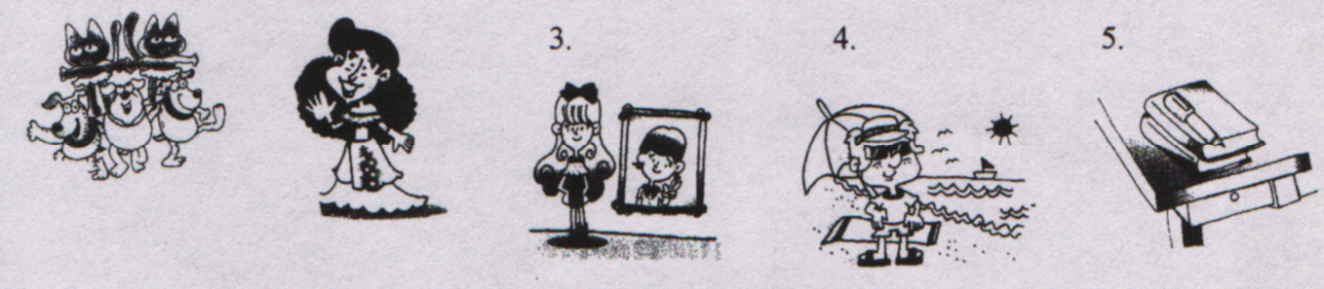
1. 2.

（ ） （ ） （ ） （ ） （ ）
三、根據錄音帶的敘述，將各句子的英文代號填入圖中 10﹪
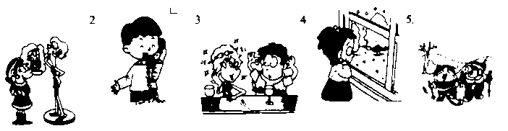
1.

（ ） （ ） （ ） （ ） （ ）
四、聽完錄音帶中的問題後，選出適當的回答。10﹪
1.（ ）A. She wasn’t here this morning. B. I was at school.
. C. This morning was great.
2.（ ）A. I am sorry. B. I teach English..
C. English is in my school.
3.（ ）A. Summer. B. Fall.
C. Winter.
4.（ ）A. Winter is so cold. B. Winter is the fourth season.
C. Yes, I like cold season.
5.（ ）A. My school has English classes. B. English classes are great at my school.
C. Five.
筆試部分
- 字彙測驗：選出或寫出正確的單字 10%
( )1.Please read ____ your teacher. (A) after (B) together (C) alone (D) and
( )2.My mom asked(要求 )me to cut(剪 )my ____ because(因為)it was too long. (A)fingers (B)hair (C) shoes (D) homework
( )3.____ has another beautiful name, “Formosa” (福爾摩沙). (A) America (B)LinYuan (C)Taiwan (D)Japan
( )4.My father or my mother is my ____. (A)friends (B)classmate (C)teachers (D)parent
( )5. Bob and Tom are neighbors(). Their houses are on the same ____. (A)street (B)beach (C)park (D)classroom
- 選擇題 20%
( )1.They ____ after school. (A)usually go home together (B)usually together go home (C)usually studies together (D) are together at home
( )2.This is____ lesson. (A)three (B)the third (C)the three (D)third
( )3.The watch isn’t on the chair now, but it ____ there yesterday. (A)were (B)was (C)are (D)is
( )4.Where ____ your father and mother last Monday? (A)is (B)are (C)was (D)were
( )5._____ is it? It’s summer. (A)What (B)How (C)What season (D)Where
( )6. A: Where were you last Sunday? B:____ (A)At the beach. (B) To school (C)The park was great. (D)We are studying.
( )7.A:____ B: Yes, I was thin, but now I am heavy. (A) You are fine. (B)You are different. (C)We’re the same. (D)That’s too bad.
( )8. What season comes after spring ? (A) Fall. (B) Summer is so hot. (C) Summer does. (D) I like summer very much.
( )9 A: Today is Friday. What day was yesterday? (A) Yesterday was a nice day. (B)Yesterday was June(六月) 6th. (C) Yesterday I was happy. (D)Yesterday was Thursday.
( )10. Who do you live with ? (A) My parents. (B) I live in LinYuan. (C) We live in a big house. (D) I go there with my parents.
- 看圖回答：請依圖片選出最適合的答案 10%
Last Sunday I was in Kenting National Park(墾丁). The park has a beautiful beach in it. I took a lot of pictures (拍照). Look at the picture and answer the question.

( )1. Was it fine last Sunday in Kenting? (A) Fine, thank you. (B) No, it was rainy. (C) Yes, it was.
( )2. Were the girls wearing red shoes? (A) Yes, they were. (B) They have red shoes. (C) Their shoes were good.
( )3. Were boys and girls there? (A)Yes, they were. (B) There are two girls and two boys there. (C) I don’t know (知道).
( )4. Were the girls wearing red shoes? (A) Yes, they were playing basketball. (B) Yes, they were. (C) Yes, they were playing at the beach.
( )5. Was the girl on the chair wearing dark (深色的) glasses? (A) No, she wasn’t. (B) Yes, she was happy. (C) Yes, she was.
- 依提示字造句 10%
  - John / a little heavy / last year
  - David / wearing / new/ jacket
  - Mary / wearing / red dress
  - both / Sue and Ted / classmates / twenty years ago
  - I / not happy / yesterday
- 回答問題：依自己的實際狀況回答 （可簡答）10%
  - How many students are there in you class?
  - Do you like your classmates?
  - Do you study or play with your classmates?
  - How many English classes in a week do you have?
  - Can you have a lot of fun (樂趣 ) in your English classes?

高雄縣立林園高中（國中部）九十學年度第二學期第三次段考英文科答案卷
一年____班 座號____ 姓名_________
聽力部分
一 | 1. | 2 | 3 | 4 | 5 | 二 | 1 | 2 | 3 | 4 | 5
三 | 1 | 2 | 3 | 4 | 5 | 四 | 1 | 2 | 3 | 4 | 5
筆試部分
一 | 1 | 2 | 3 | 4 | 5
二 | 1 | 2 | 3 | 4 | 5 | 6 |  | 7 | 8 | 9 | 10
三 | 1 | 2 | 3 | 4 | 5
四  造句 | 1. |  |  |  |  |  | 2
四  造句 | 3 |  |  |  |  |  | 4
四  造句 | 5
五回答問題 | 1 |  |  |  |  |  | 2
五回答問題 | 3 |  |  |  |  |  | 4
五回答問題 | 5

