高雄縣立林園高級中學附屬國中部九十學年度第二學期第一次段考二年級英語科
範圍：Book IV (Lesson 1 ~ Lesson 2) 命題教師：潘如庸
- 聽力測驗：40%
- 選出你聽到的單字：10%
1. （A）bait （B）bat 2.（A）park （B）pork 3.（A）perk （B）peak
4. （A）burn （B）bun 5.（A）flea （B）flow

- 聽對話，選出適當的答案：10%
1.（A）The girl doesn't like to go with the boy. （B）The girl can't go to the movie. （C）The girl will do her homework.
2.（A）The boy got 98 on the test. （B）The girl studies English every day. （C）They are talking about learning science.
3. They are talking about ____.（A）English tests （B）music （C）news
4.（A）Bob and Mary are going to a party. （B）Mary has to study tonight. （C）Bob has a test on Monday.
5.（A）The girl is a good learner. （B）The boy studies English every day. （C）The boy studies just for the test.

- 聽錄音帶的敘述，若與下表相符則寫「T」，不符則寫「F」：10%
 | School | In Class | After School | Math Test | Free Time
Allen | ABC Junior  High School | Ask questions | Review the lessons | 95 | Swim
Peter | XYZ Junior  High School | Sleep all the time | Study only before the  test | 59 | Play basketball
- 依據錄音帶內容，將下列圖片的正確順序排出來：10%
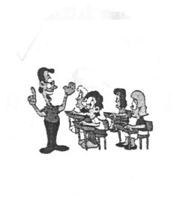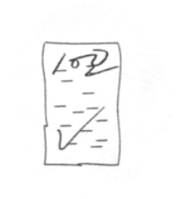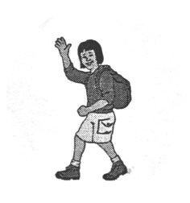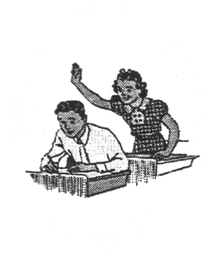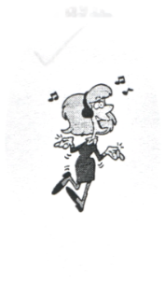
（A） （B） （C） （D） （E）
- 紙筆測驗：60%
- 選出最適當答案完成句子或對話：34%
I ____ one hour a day studying. （A）enjoy （B）spend （C）practice （D）need
2. He watches TTV ____ every night. （A）science （B）English （C）news （D）novels
3. My father is ____. He has no time for this. （A）free （B）busy （C）better （D）afraid
4. I can't do it well, but I'll ____ it. （A）answer （B）follow （C）try （D）join
5. We didn't have a two-day ____ before. （A）cram school （B）weekend （C）news （D）holiday
6. Do you ____ a computer to do your homework? （A）ask （B）open （C）use （D）follow
7. I don’t know how to do it. Can you give me a(n) ____? （A）answer （B）help （C）tip （D）word
8. ____ more, and you'll become heavy. （A）Eat （B）Eating （C）Eatting （D）To eat
9. ____ she ____ stay? （A）Do; have to （B）Does; have to （C）Do; has to （D）Does; has to
10. I need a tip ____ cooking. （A）in （B）of （C）for （D）by
11. Riding bicycles ____ fun. （A）have （B）has （C）are （D）is
12. No one enjoys ____ tests. （A）to do （B）doing （C）t o take （D）taking
13. ____ you afraid of dogs? （A）Do （B）Would （C）Are （D）Be
14. I study a little every day, _______.
- and only before the test （B）not just for the test （C）I preview and review the lesson （D）but I have to
15. A: You did well on the English test, right? B: ____ I got 49. And you? A: Ninety-four.
（A）No. （B）Pretty well. （C）You are right. （D）Sorry.
16. A: I need to talk to you. ____ B: OK.
- Can you give me a minute? （B）Are you free? （C）I am a speaker. （D）Are you listening ?
17. A: Do you have a lot of free time? B: ____
- No, I am free. （B）Yes, but not much. （C）Yes, I spend a lot of time. （D）No, I have many things to do.

- 閱讀測驗：10%

Time 8:00-8:50 9:00-9:50 9:50-10:05 10:10-11:00 11:10-12:00 12:00-12:50 1:00-1:50 2:00-2:50

Class History Math Morning break English PE Lunch Drawing Science

Hi, my name is Henry. This is my class schedule. I have to get up early—at about 6:30. First, I have breakfast. Then, I
ride my bike to school. It takes me 20 minutes to get there. I have four classes in the morning. I like history best. Mr. Lin is
really cool. He knows everything about history. We also get a 15-minute break in the morning. I usually talk to Allen or Peter
at that time. We also eat lunch together, near the football field. I only have two classes in the afternoon. In the science class, we
get to do fun experiments. I am always happy in that class. Drawing is also fun. Our teacher, Miss Wang, is nice. She encourages us
even if our drawing is bad. After school, I spend about an hour doing homework. Then, I go out with my friends.

*history 歷史 *break 休息 *PE 體育 *drawing 繪畫 *schedule 表 *breakfast 早餐
*experiment 實驗 *encourage 鼓勵 *even if 即使

- In the morning, Henry __________.
（A）never eats breakfast （B）gets up before six （C）has four classes （D）has a science class
19. Who are we?
（A）Mr. Lin and Miss Wang. （B）Allen and Peter. （C）The afternoon classes. （D）The students in the class.
20. If a student’s drawing is not good, Miss Wang __________.
（A）gives him an “F” （B）doesn’t encourage him （C）hates him very much （D）is still nice to him
21. Which class does Henry NOT like?
（A）History （B）PE （C）Science （D）Drawing
22. Which one is RIGHT?
  - Every class has 50 minutes. （B）Henry has eight classes a day.
（C）PE comes before English. （D）He’s at school 8 hours a day.

III 看圖回答問題：4%
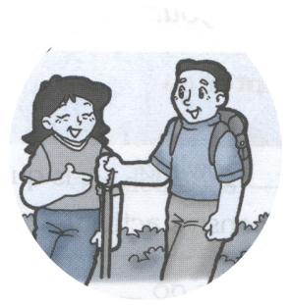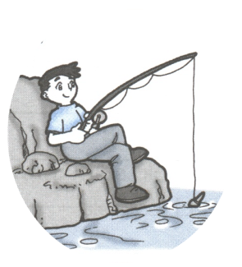
23.What do they like to do on weekends? 24. What is fun for John?

IV 翻譯（英 ＜－＞ 中）：12%
- 我們無法經由補習而學得更多。
- 這個週末我想去看書展（book fair）。
- 媽媽花了30分鐘洗全部的碗盤。
- My friends are going to a baseball game. Can I join them?

二年級英語科答案 by 潘如庸
- Listening 40% （每題二分）
B B B A B
B C B C B
T F F F T
D A B E C
- Writing 60% （1~24 每題二分，25~28每題三分）
B C B C B C C A B C D
D C B A A D C D D B A
23. They like to go hiking. 24. Fishing is fun for him.
25. We can't learn more by going to a cram school.
26. I'd like / want to go to the book fair this weekend.
27. Mother spent 30 minutes washing all the dishes.
28. 我的朋友們要去看棒球賽。我可以加入他們嗎？

