高雄縣立林園高中(國中部)九十學年度第一學期第三次段考二年級英文科試卷
◆紙筆測驗 命題教師：任秋貴
- 填寫適當的動詞形式10%
1.Bob (practice) baseball once a week.
2.Is the typhoon (come) next week?
3.He (put) the present on the desk and went home.
4.Will Tracy hate (have) tests every day? No, she won’t.
5.Study a little every day, and you’ll enjoy (learn)(學習).
- 選擇題20%
1.A: is the flight? B:Once an hour. ①How long ②How often ③When ④How
2.Bill practices basketball .①a day two hour ②a day two hours ③two hour a day ④two hours a day
3.My father me comic books.①never doesn’t buy ②does never buy ③never buys ④never buy
4.Linda plays baseball .①good ②well ③fine ④nice
5.My little brother happy on Sunday.①always is ②always be ③always will ④is always
6.Whyb didn’t you take a taxi ?①to home ②a house ③homely ④home
7.What’s so special Christmas?①of ②in ③about ④between
8.What’s today?①date ②the date ③a date ④in date
9.I’ll be and you’ll be a singer.①a superman ②a Superman ③A Superman ④Superman
10.New Year coming. ①are ②will ③is ④does
- 圖文配合題10%
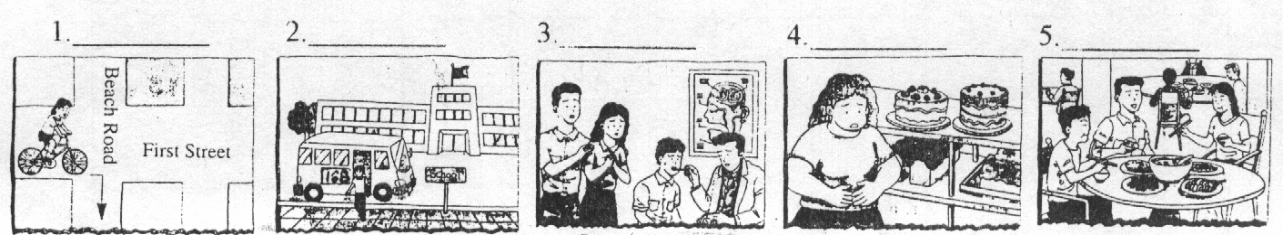
1. 2. 3. 4. 5.

A. There are many delicious cakes in the supermarket, but Mrs. Wang didn’t buy any. She’s too heavy.
B. Every day, Herman takes bus number 168 to the school.
C. Tina rode her bicycle along First Street and turn right on Beach Road.
D. September 5th was Judy’s birthday. They had a big dinner in a restaurant.
E. Brain was sick last night, so his parents took him to the doctor.
- 閱讀測驗10%
Tom is a lazy(懶惰的)student. His math(數學)grades(成績)are very bad. He usually doesn’t do his homework, and Tom’s father always did it for Tom.
One day, Tom’s math teacher talked to him in the classroom. “Tom, you did a god job(表現很好)in your homework. Your answers are right. You got 100 points(分). Did your father did it for you?” asked(問) the teacher. Tom smiled(微笑) at the teacher and said,” Tell you the truth(事實), my father went out last night, so he didn’t have the time to do the homework for me. I did it myself(我自己).”
1.Does Tom’s father always do Tom’s homework? ①Yes, he does. ②No, he doesn’t. ③Not always.
2.Was Tom’s father at home last night?①Yes, he was at home. ②No, he went out. ③We don’t know.
3.Did Tom do his homework last night?①Yes, he did. ②No, he didn’t. ③No, Tom’s father did it..
4.What kind(種類) of the student is Tom?①He is good and smart(聰明). ②He is lazy but smart. ③We don’t know.
5.Whose(誰的)math is bad?①Tom’s math is bad. ②The father’s math is bad. ③The teacher’s math is bad.
五、翻譯10%
- 你曾看過外星人(an alien )嗎？不，從不。
- 你們通常天天有考試嗎？
- 你多久看一次電影？一個月(month)一次。
- Ted的母親喜愛(enjoy)星期六逛街購物。
- 你下週六要去跳舞嗎？

高雄縣立林園高中(國中部)九十學年度第一學期第三次段考二年級英文科答案卷
年 班 號 姓名：
I‧聽力測驗40%
- 將所聽到的字圈起來10%
1. cute cut 2. name class 3.Joe John 4. we wet 5.nice sick
- 仔細聽錄音帶，在下列月曆中圈出你所聽到的日期10%
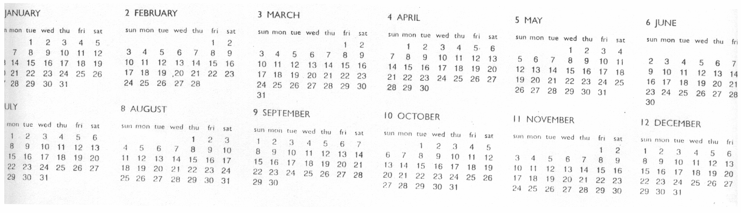

- 聽錄音帶的敘述，若是與表格相符者填T，否則填F10%
1. 2. 3. 4. 5.
- 將下列人物所喜歡的活動以代號填入10%
1. 2. 3. 4. 5.
II‧紙筆測驗60%
- 填寫適當的動詞形式10%
1. 2. 3. 4. 5.
- 選擇題20%
1. 2. 3. 4. 5.
6. 7. 8. 9. 10.
- 圖文配合題10%
1. 2. 3. 4. 5.
- 閱讀測驗10%
1. 2. 3. 4. 5.
- 翻譯10%
1.
2.
3.
4.
5.

