高雄縣立林園高中國中部三年級第二次段考英文考卷(題目卷)
範圍：Book Ⅴ L5～L6 聽 力：26 % 班級：_____年____班 姓名：_____________
命題教師：劉秀雅 筆 試 ：74 % 答 案 請 一 律 寫 於 答 案 紙
.聽 力 題 目 卷 .
Ⅰ. 請依錄音帶的敘述，重組定母，拼出正確的單字。（4%）
1、ttieersn _____________ 2、mmiiccoonnuta _____________ 3、stewa _____________
Ⅱ. 請依錄音帶的敘述，選出你所聽到的單字圖。（4 %）
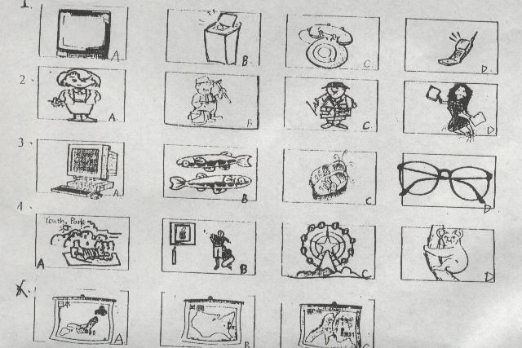
Ⅲ. 聽錄音帶的句子並選擇適當的回應句子。（4 %）
1 . ____ A. Yes , be seated , please. B Yes ,the seat is free. C. No, you sit on the front seat. D. No, it isn’t.
2. _____ A. I’d like Pizza Hut B. I like pizza very much. C. I’d like size 10. D .I’d like a big house.
3. _____A. I park it in a wrong place, and it was towed away. B. My car is much afraid of driving me to work.
C.I don’t like driving my car, and it doesn’t like me, either . D. I like to take the airplane because it is cheaper and faster.
Ⅳ. 聽錄音帶的對話，選出正確的答案。（4 %）
1 . ____ A.In a dress store. B. In a toy store. C. In a computer store. D. In a theater.
2. ____ A. A station near her house. B. A station in front of her house. C. A station between her house and the park. D. A station near her school.
3 . ____ A. Using polite words to every one. B .Showing off all the time. C. Only saying “Thanks” to your friend.
Ⅴ. 以下是Mary昨天步行所經過的地方，箭頭標示行進方向。Mary從家裡出發，經過City Zoo，最後再回到家裡。圖中並標示各點之間步行所需的時間。聽錄音帶裡的敘述，若是與圖的內容相符合寫T，否則寫F。（0 %）
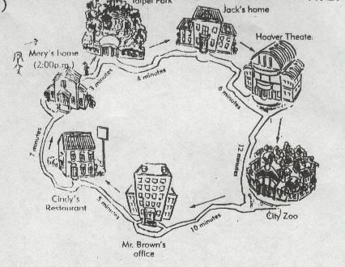

Ⅵ. 聽錄音帶的對話，在人名下的空白處寫上圖中該人物的代號。（6 %）
例如：你聽到……，知道Mark 是在樹下洗車的那位，代號為A,則在Mark下面的空格填上代號A
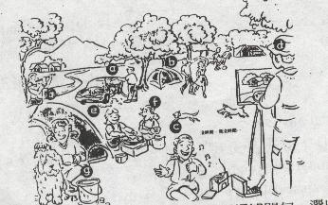

Ⅶ. 看圖回答問題（4 %）
請參考下列地下鐵的地圖，再根據問句，以最短的路程選出最適當的答案。
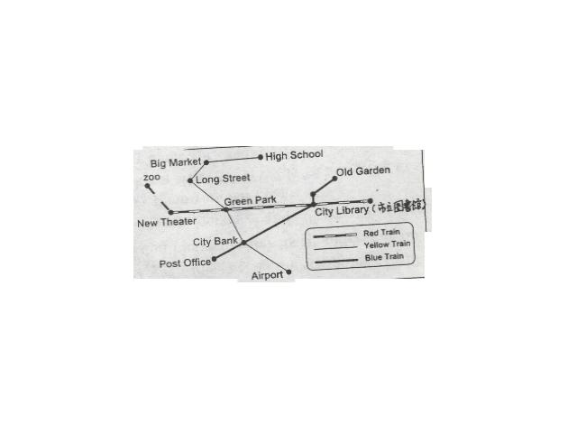

.筆 試 題 目 卷：
- 字彙選擇：請在答案紙上填入正確的答案代碼 12%
Question: | Answer  Code: | Answer  Code: | Answer  Code:
1. Lisa always _________ her friends , so she is not welcome. | A. handsome | AD.體育老師 | CD.中文老師
2. The first ________ of the year is January. | B. sent | AE. ideas | ABC. Criticizing
3. At first, we thought Mr. Lin was an ________ husband. | C. criticizes | BCD.慢跑的藝術 | ABD. ideal
4. What is a PE teacher in Chinese ? | D. 理化老師 | BC .send | ABCD.會話的藝術
5. After I _____ e-mail to my friend , I got an answer the other day. | AB. month | BD. enters
6.Please teach me the art of jogging.  What is the art of Jogging in Chinese? | AC. mouse

- 請在答案紙上填入正確的介系詞 14%
to / about / for / from /up /down /in /on /at / with /of /off / like
  - The world is _________ a small village.
  - The man _________ big eyes is my father.
  - We can learn a lesson ________ the dialogue we just studied.
  - My computer can be linked ______ to your computer.
  - The child is very strange ; she has no interest ________ any toys.
  - Wendy is looking _______ a boyfriend on the computer.
  - Showing __________ is not polite.
- 文法選擇 (請在答案紙上作答) 20%
  - ( ) A teacher who is popular never________ that kind of thing. {A}do{B}does{C}doing {D}did
  - ( ) I , who _______ your friend , can help you with it. {A}am{B}is{C}are{D}be
  - ( ) Susan and the dog ______ are jogging in the park are very cute. {A}who {B}that{C}which{D}whom
  - ( ) Father is going to buy __________ TV. {A} an 80 –inch {B}80-inches{C}a 80-inch{D}an 80-inches
  - ( )Do you know the tall man _______ Chinese in my school ? {A} who teach{B}which teach {C} who
teaches {D}which teaches
  - ( ) Excuse me ?Is this seat _______?{A}take{B}took{C}taking{D}taken
  - ( ) The watch you bought ____yesterday was a fake. {A}it{B}one{C}x{D}which
  - ( ) David knows the song Mary is_______ {A}listened{B}listening{C}listening to it{D}listening to
  - ( ) The shoes _______ are very expensive. {A} that were made in Taiwan{B}that made in Taiwan
{C}makes in Taiwan{D}which makes in Taiwan
10.( ) The girl _____ is my sister. {A}you talked with{B}with that you talked{C}who you talked {D}that
you are talking
- 釋義與完成對話 (請在答案紙上作答) 6 %
1. ( ) A: What special talent do you have ? B:___________
{A} I am not strong enough to play basketball.
{B} I have software to teach me math.
{C} I am very kind. {D} I can sing English songs very well.
2. ( ) Mary’s brother ,who is thirty years old, lives in Linyuan.
{A}Mary lives in Linyuan.{B}Mary has only one brother ,and he lives in Linyuan{C}Mary and her
brother lives in Limyuan {D}Mary has many brothers and one of her brothers lives in Linyuan.
3. ( ) Money is my life.
{A}I like money ,but I don’t think it is very important.{B}Money is the most important thing in my life
for me .{C} I don’t like money at all.{D}I have no money ,and I need money.
- 合併句子 (請在答案紙上作答) 6% 錯一個地方扣一分
  - I saw a boy.
The boy played basketball better than Michael Jordan. ( 請用who /which/that 合併)
  - The trip was very dangerous.
They took the trip last year. ( 請用who /which/that 合併)
  - The story is about a woman.
The woman did many great things. ( 請用who /which/that 合併)
- 閱讀理解 (請在答案紙上作答) 12 %
I like computers very much. Many people who were afraid of computers at first now feel they are easy to use. I remember my first time to go on the Internet . I was so surprised to see so many interesting websites ! Internet really opens a door of knowledge for me.
Every time when I surf the net on the computer , I will add the website which I like into “My Favorite”, so I don’t have to enter its IP address again next time. The websites which I visit most often are www.loxa.edu.tw and www.kimo.com.tw . Both of them are fun and exciting .You may try them yourself , too .
By the way, do you know what “WWW” is ? I am going to ask someone in the Chatting
Room because that’s my homework today !
- add: 加入
- IP address: 網址
- Chatting Room: 聊天室
A. 請根據本文，翻譯出下列4題的中文: (請在答案紙上作答) 10%
1. Internet 2. website 3.surf the net 4.My Favorite
B: 5. WWW 是 World Woman Website, yes or no ?

VII.翻 譯 (請在答案紙上作答) 6 %
- 我要媽媽帶我去世界上任何我想去的地方。_______________________________________
- 請輸入你想要的理想伴侶。_____________________________________________________
.

