高雄縣林園高中國中部第一學期第三次段考一年級英語科
- 聽力測驗 ( 38% , 每題兩分 )
- 聽CD，若是發音完全相同，在空格中寫○，否則寫×。

二、聽CD，根據圖片選出正確的答案。
1. 2.
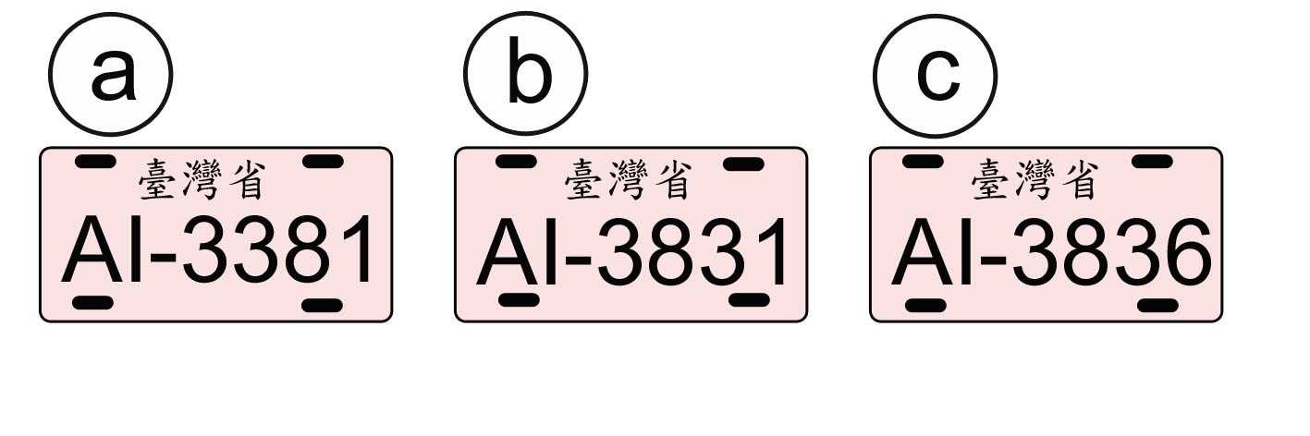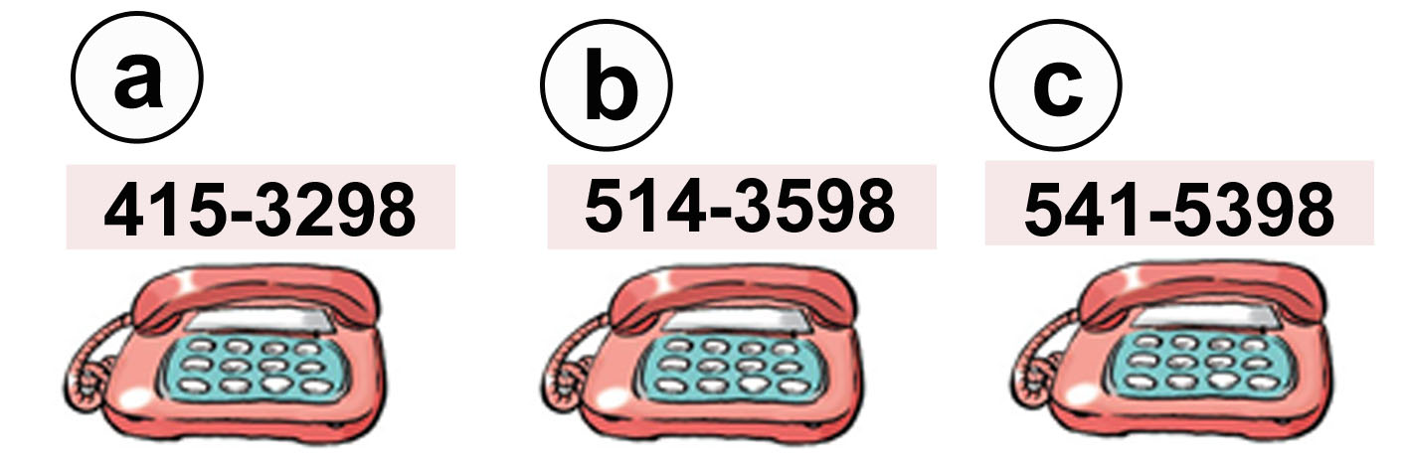

三、聽CD，若是符合圖意寫T，否則寫F。

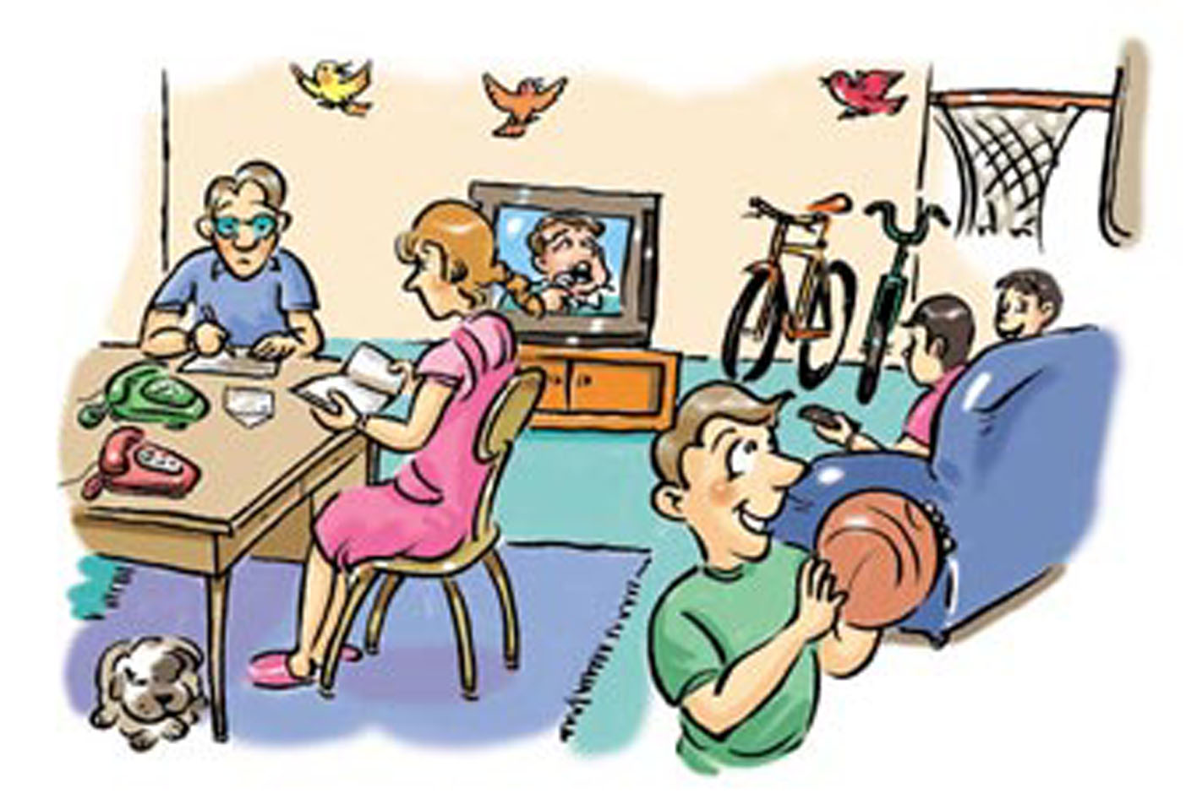

四、聽CD，選出與圖內容相符的句子。
1. 2. 3. 4.
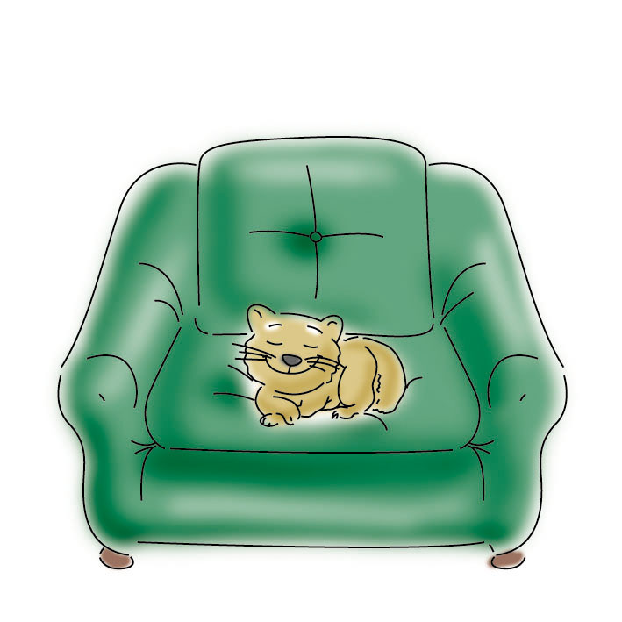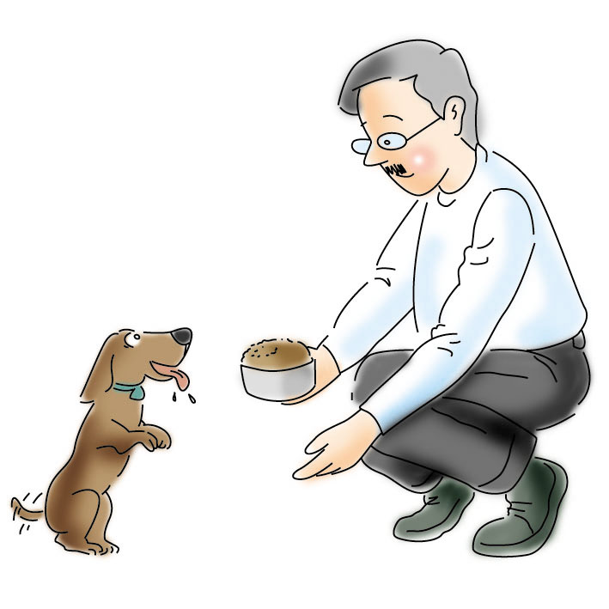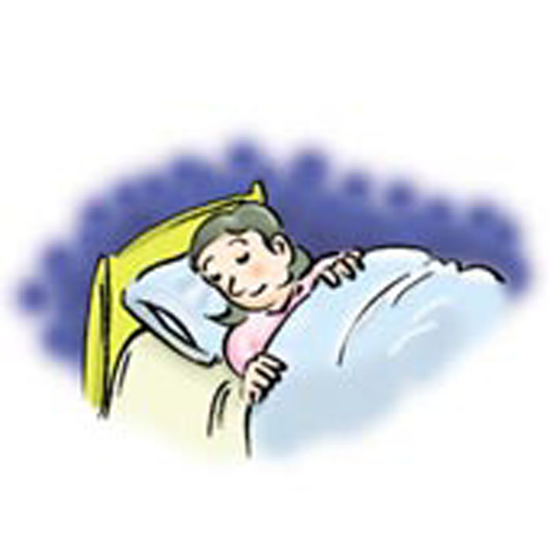

五、選出符合句子或對話情境所描述的圖片。
1. 2. 3.
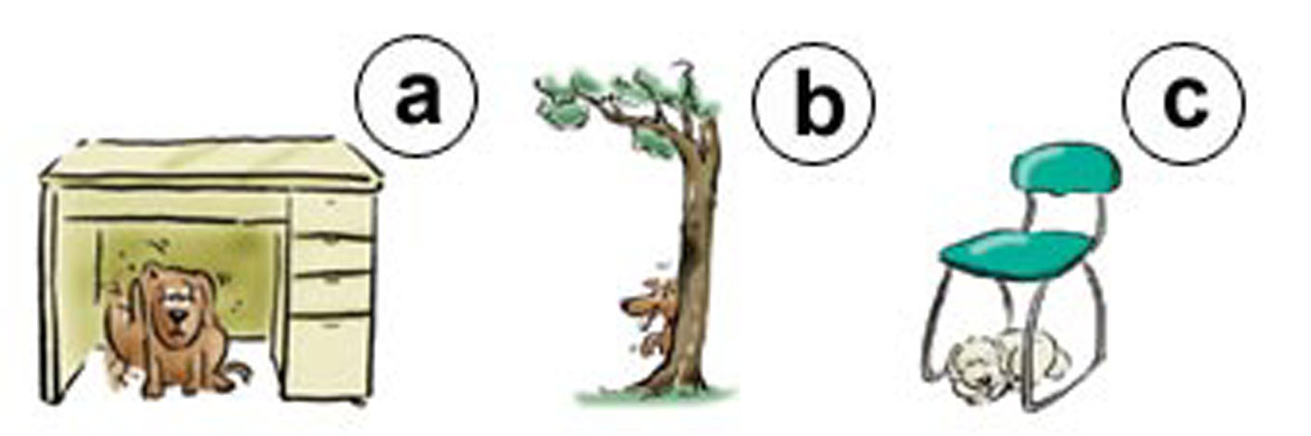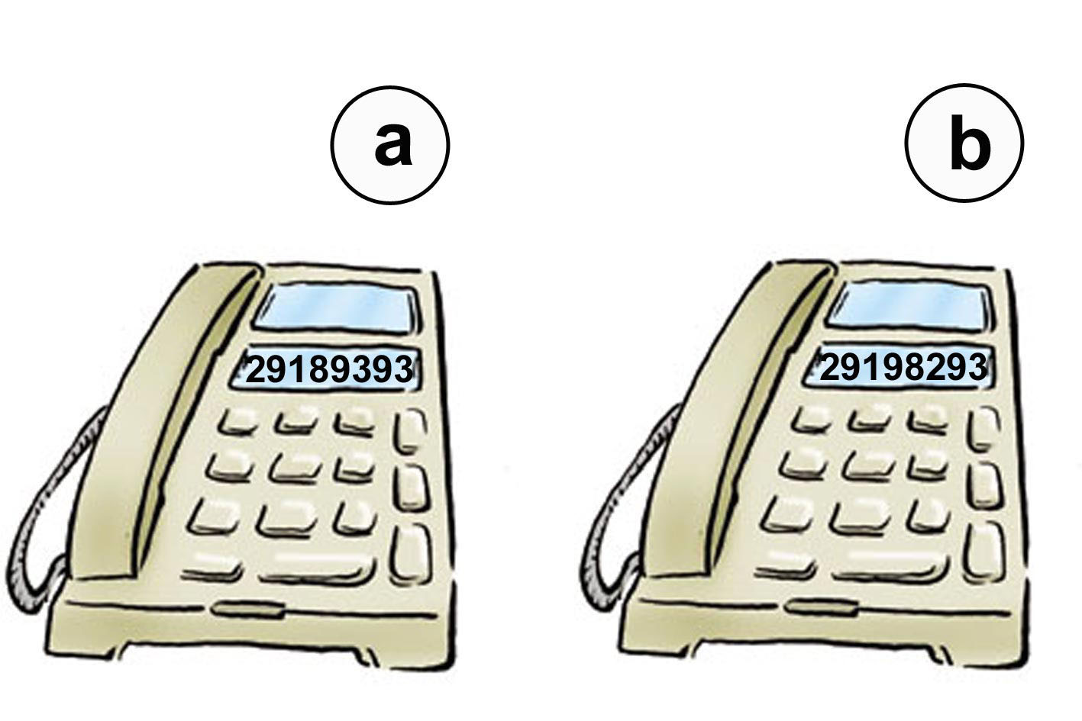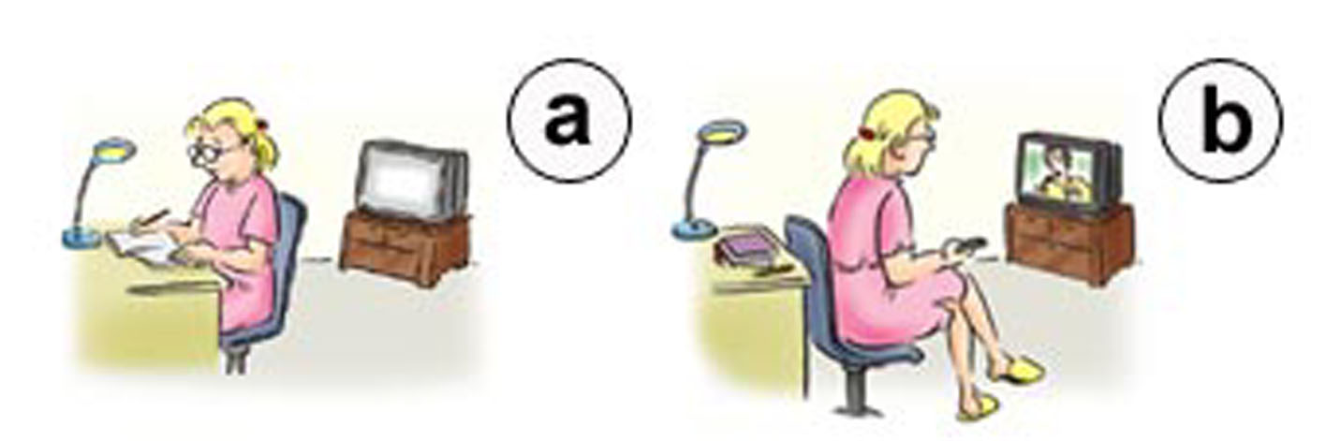

六、聽CD的短文，選出正確的答案。
1.(1)ˉˉ a. In the park.
b. In the living room.
c. In the kitchen.
(2)ˉˉ a. A girl.
b. A woman.
c. Two dogs.

- 筆試（62%）
- 字彙測驗（1~5中譯英，6~10填入適當英文字彙以完成句子）
1.在花園裡 2.放輕鬆。 3.九把椅子 4.在桌上 5.手機號碼
6. Here are three t ts to the zoo（動物園）.
7. This door is locked（鎖上了）. Let's t y that one.
8. My lunch box is in the s g.
9. The p t is too small for the notebook.
10. He's d king the milk.

- 文意選擇（填入代號）
11. Let's call ____. （A）he （B）you （C）she （D）him
12. What's ____ phone number? （A）Sam （B）he （C）his （D）him
13. The turtle（烏龜）is slow, ____ it wins（贏）the game. （A）and （B）but （C）so（D）well
14. Mother: Wake up, Tom. （A）Maybe Tom is sleeping. （B）Maybe Tom is making a wish. （C）Maybe Tom is moving.（D）Maybe Tom is slow.
15. I am on the way home. （A）I am at home. （B）I am going home. （C）I am home. （D）My home is on the way.
16. 甲: Bill, please. 乙: Speaking. （A）Bill's not in. （B）Bill's calling his classmate. （C）乙 is Bill.
（D）甲 needs（需要）Bill's help.
A: 17 are you doing? B: I'm calling Susan.
A: Is she 18 ? B: 19
A: Maybe she's sleeping. B: 20 We（我們）are going to the convenience store.
A: 21 Maybe she's on the way.
17. （A）How （B）Who （C）Where （D）What
18. （A）in home （B）speaking （C）home （D）on
19. （A）Hello? （B）No answer. （C）Wrong number. （D）Yes, she is.
20. （A）I hope not. （B）Wake up, Susan. （C）Wait! （D）It's OK.
21. （A）Forget it! （B）Don't worry. （C）Sorry. （D）How dumb!

- 配合題（答案不得重複）
22. Where's Lucky? A. Wow!
23. Sorry. I forget it! B. I have to go now.
24 .Is Linda in? C. It's me, Linda.
25. What's Father doing? D. Never mind.
26. This is a new watch. E. Thanks.
27. It's 7:15. F. This is she.
28. This is for you. G. Yes, it is.
29. Who is it? H. Washing the dog.
30. Is it beside the bookshelf? I. I don't know.
31. Let's order the pizza（訂比薩）! J. Let me see.
What's the number?

- 翻譯填充
你為什麼又遲到了？ 32 are you late 33 ?
你的鞋在哪兒？是不是在櫃子上？ 34 are your shoes? 35 36 on the rack?
她在樹下餵狗。 She's 37 the dog 38 the tree.
瞧！他來了！ 39 ! He's 40 .
我撥錯號了！ I 41 the wrong number.

高雄縣林園高中國中部第一學期第三次段考一年級英語科解答
- 聽力測驗 ( 38% , 第二大題每題三分，其餘每題兩分 )
一 |  | 1.  X |  | 2.  O |  | 3.  X |  | 二 | 1.  a |  |  | 2.  b
三 | 1.  F |  | 2.  T |  | 3.  F |  | 4.  T |  |  |  | 5.  F |  |  | 四 | 1.  a | 2  c. | 3.  b | 4.  a
五 | 1.  a |  | 2.  a |  | 3.  b |  | 六 |  |  | 1.  a |  |  | 2.  c

- 筆試（62%，1-21每題兩分，22-41每題一分）

1.  in the garden |  | 2.  Take it easy. |  |  |  | 3.  nine chairs |  | 4. on the table  ( on the desk ) |  | 5.  cell phone number
6.  tickets |  | 7.  try |  |  |  | 8.  schoolbag |  | 9.  pocket |  | 10.  drinking
11.  D | 12.  C | 13.  B |  | 14.  A |  | 15.  B | 16.  C | 17.  D | 18.  C | 19.  B |  | 20.  A | 21.  B
22.  I | 23.  D | 24.  F |  | 25.  H |  | 26.  A | 27.  B | 28.  E | 29.  C | 30.  G |  | 31.  J
32.  Why |  |  | 33.  again |  | 34.  Where |  |  | 35.  Are |  |  | 36.  they
37.  feeding |  |  | 38.  under |  | 39.  Look |  |  | 40.  coming |  |  | 41.  have

