高雄縣立林園高中（國中部）九十一學年度第一學期第一次段考英文科考卷三年級
- 答案請寫在答案欄
聽力部分
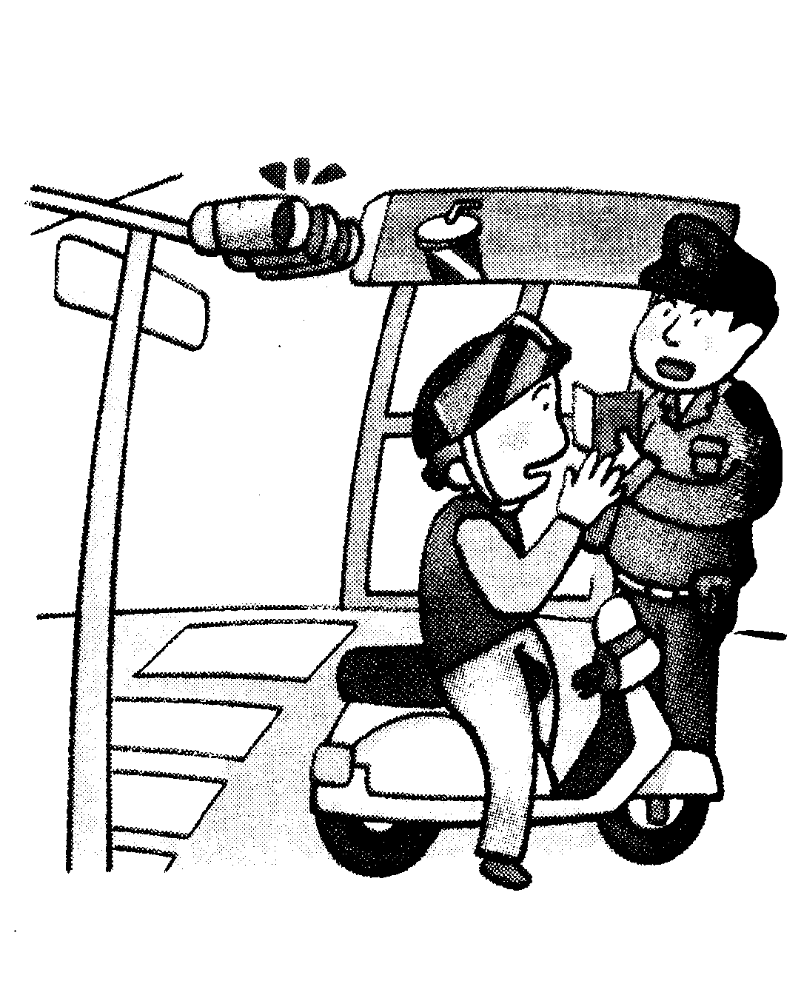
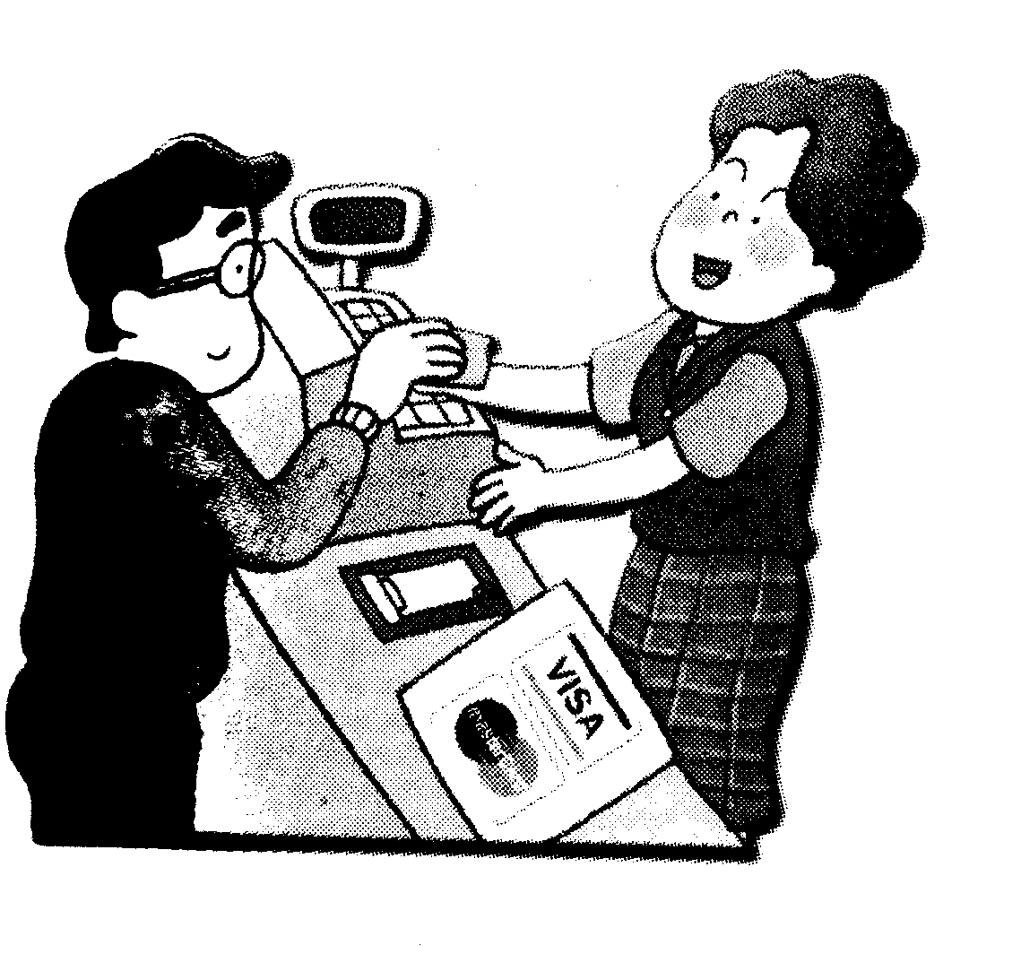
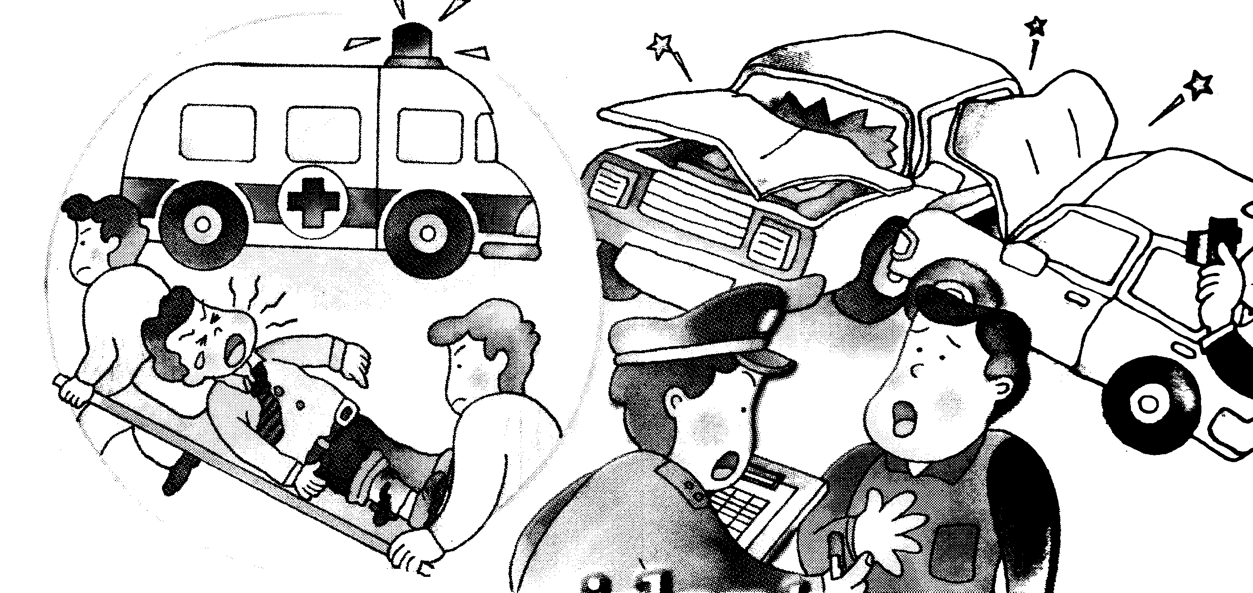
- 聽完A、B、C三句的敘述後，請填上與圖片相符句子的代號 10%
.1. 2. 3.

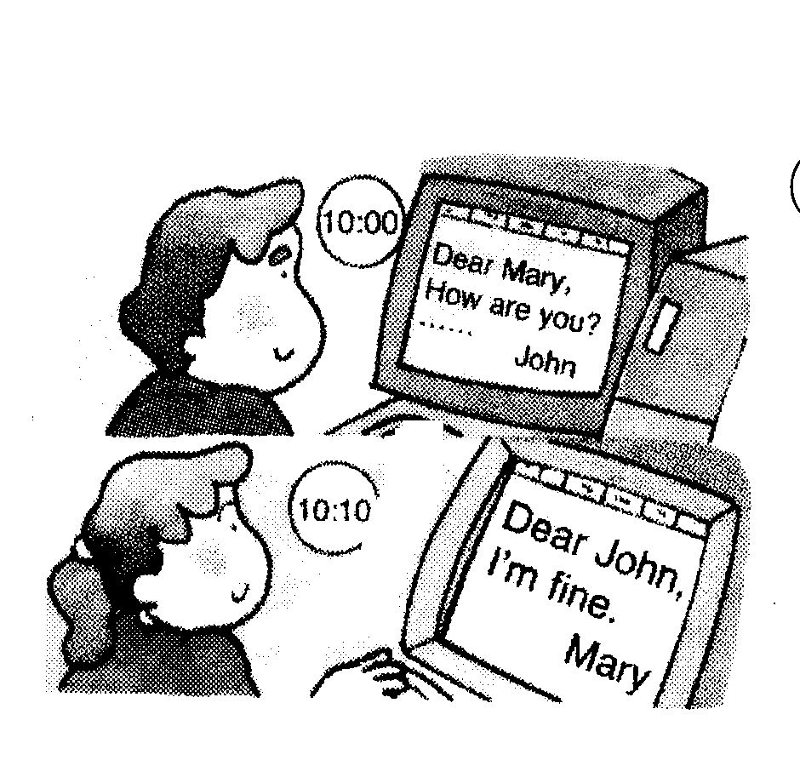
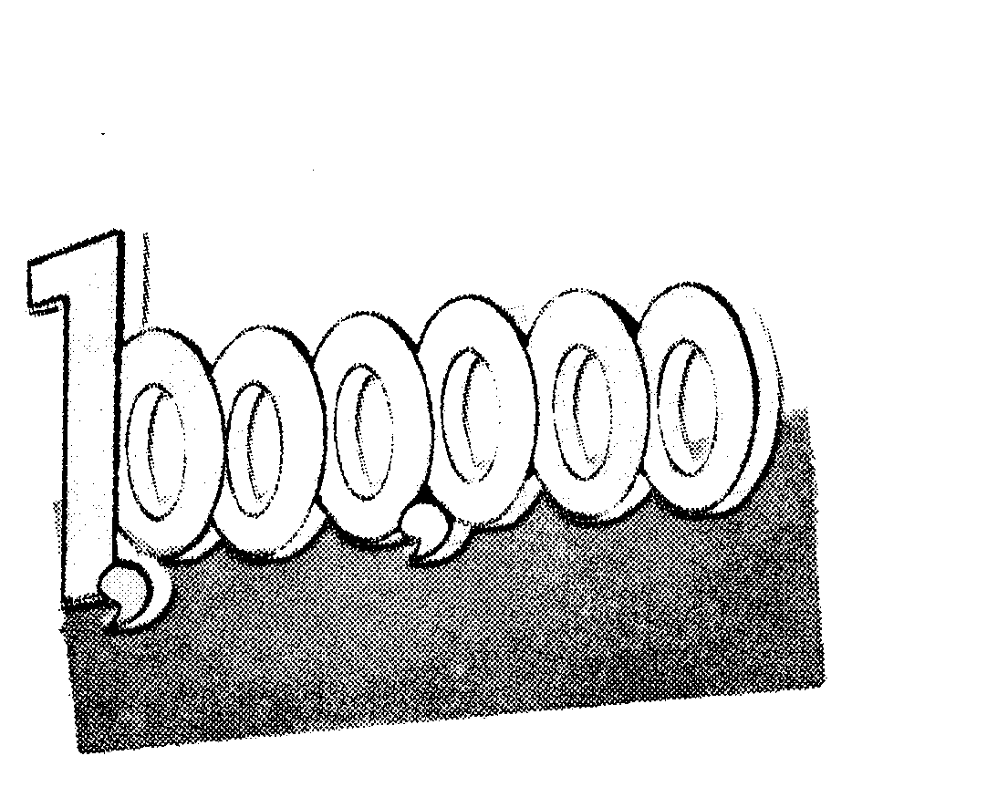
( ) ( ) ( )
4. 5.

( ) ( )
- 依敘述將圖形配對 10% (如第一題圖片剛好配上右邊A圖, 則填上A)
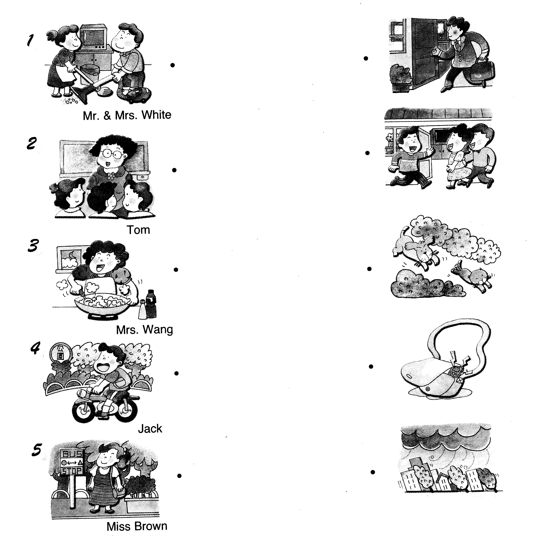
A .

B

C

D

E

三、根據錄音帶的敘述，將各句子的英文代號填入圖中10%
1. ( ) A. In a restaurant. B. Linyuan Senior High School. C. On a bus.
2. ( ) A. She was sick. B. She drove too fast. C. She ate too much food.
3. ( ) A. English is not useful?
B. They are talking about living languages .
C. Spend more time on English, and you will do better.
4. ( )A. Coffee. B. Computer games. C.Homework.
5. ( )A. In Taiwan. B. In America. C. We don’t know.
四、聽錄音帶敘述、選出所描述的圖片 10%
1. ( ) 2. ( ) 3.( ) 4.( ) 5. ( )
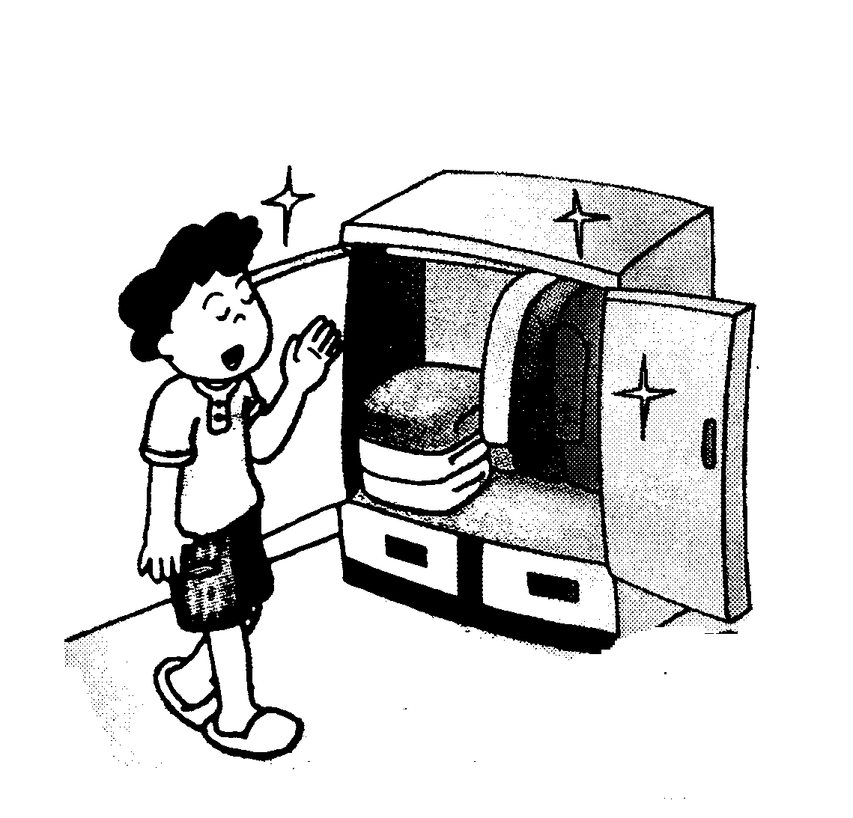
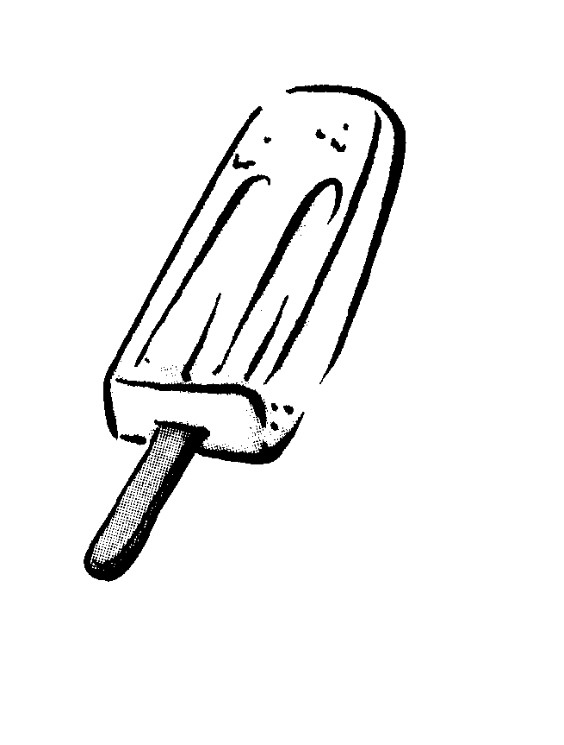
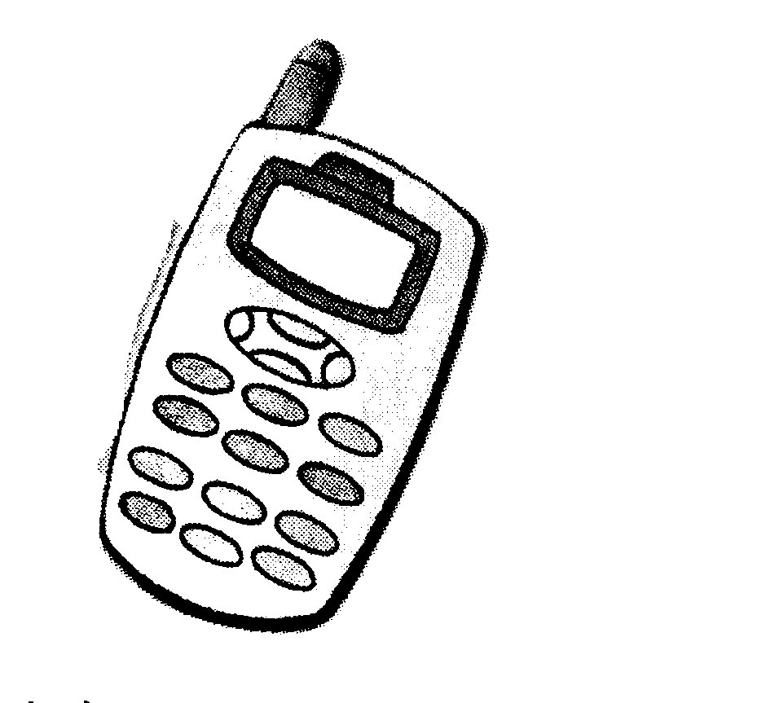
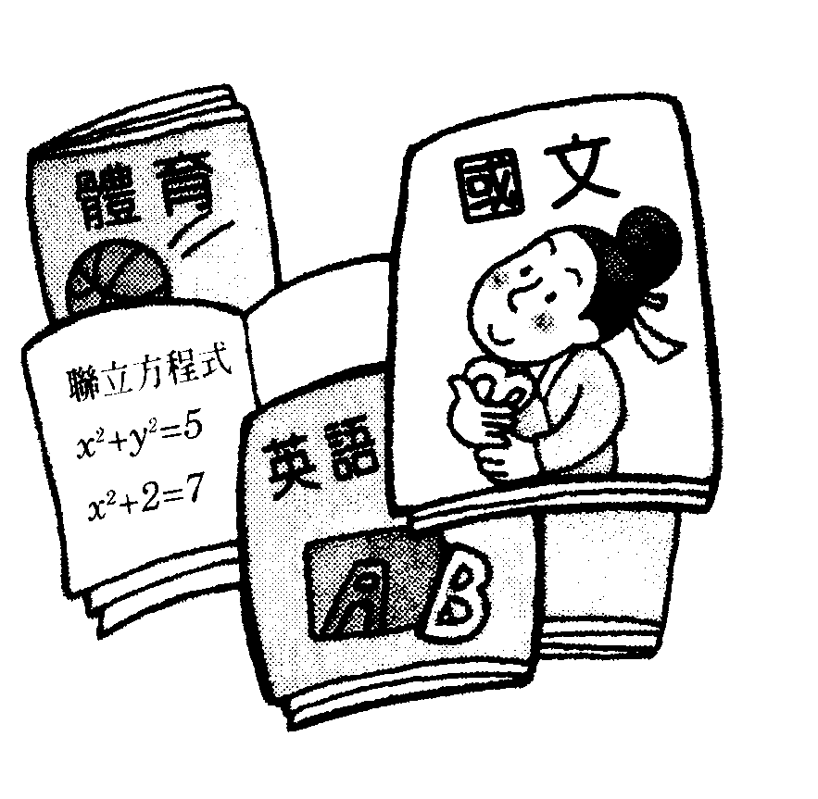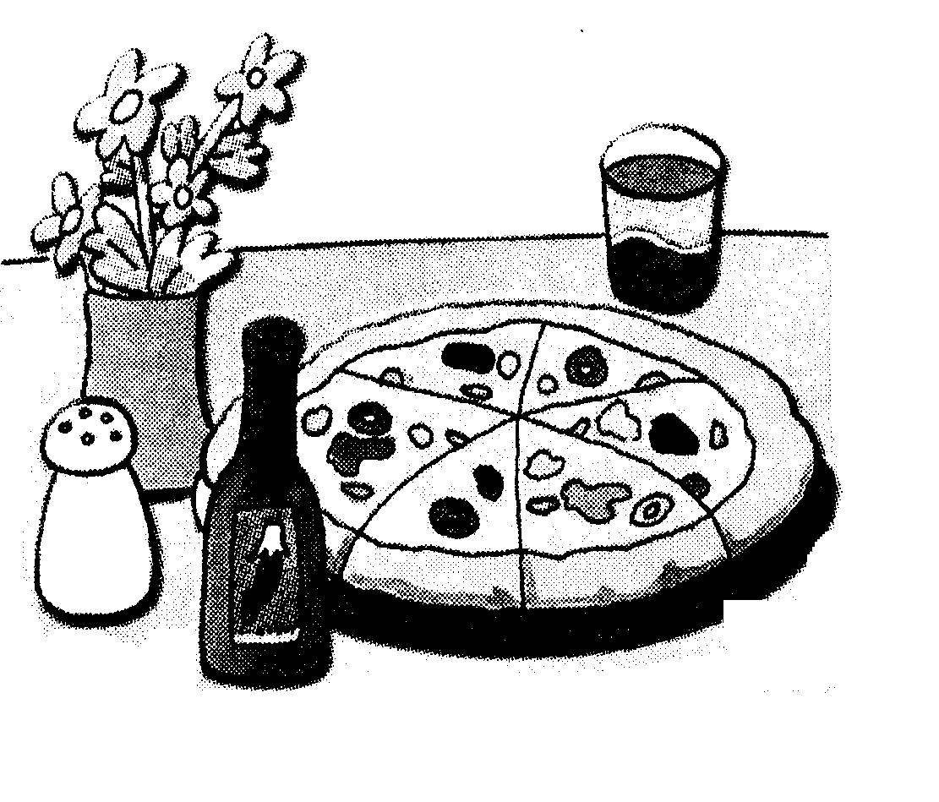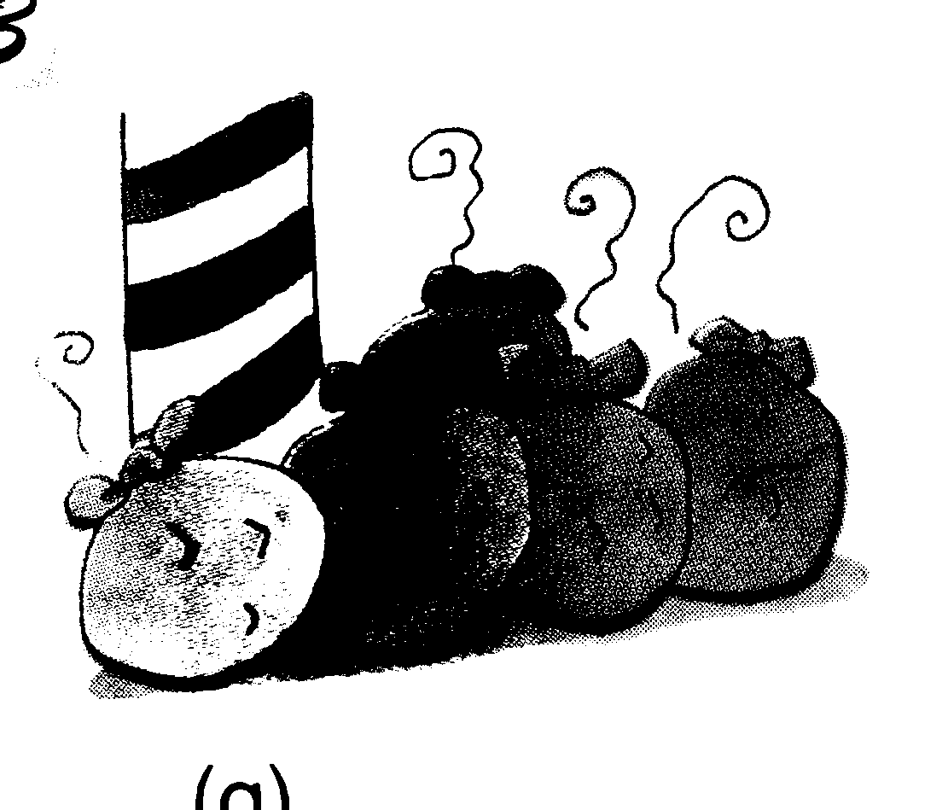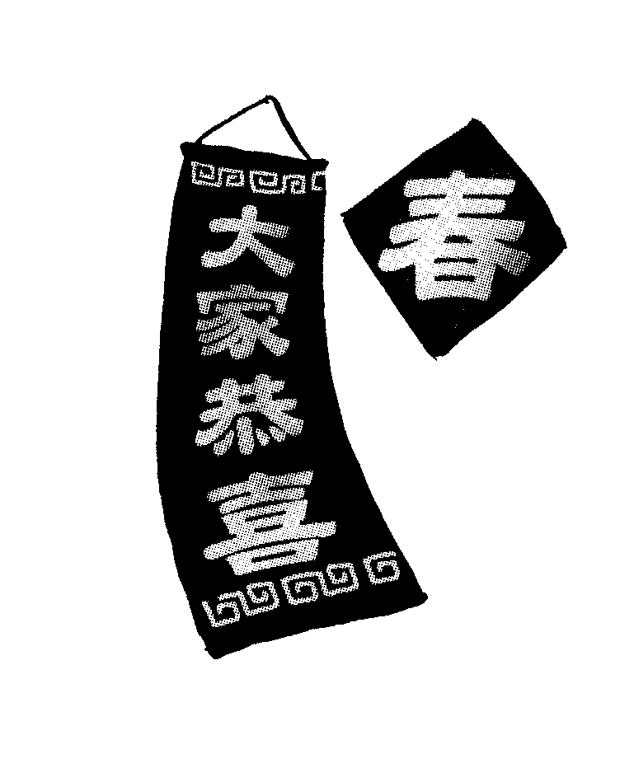
A B C D E F
筆試部分
- 選出適當的單字或片語
1.( ) motorcyclist A. 安全帽 B. 機車 C. 機車騎士
2.( ) village A. 小鎮 B. 村莊 C. 山谷
3.( ) right away A. 對的 B. 右邊 C. 馬上
4.( ) garbage A. 花園 B. 車庫 C. 垃圾
5.( ) A-bian _____ in a poor family. He made up his mind to become an important man, and he made it.
- gave up B. ran out C. shut up D. was born
6.( ) It’s so hot in the room. Can you open the _____ for me. A. closet B. dictionary C. cell phone D. window
7.( ) You should avoid _____. A. swimming B. to swim C. swam D. go to swim
8.( ) Tom bumped into a tree and _____. A. was hurt B. get hurt C. hurt badly D. badly hurt.
9.( ) My grandfather _____ for more than 10 years. A. has died B. has been dead C. died D.dead
10( ) Children should learn to do some housework, like _____ garbage and washing dishes. A. towing away B. taking out C. taking off D. showing off
- 綜合選擇
1.( ) She decided to give up ________ the dessert because she was heavy.
(A) to eat (B) eaten (C) eat (D) eating
2.( ) A: What’s your favorite sport?
B: ________ Baseball─the most exciting one.
(A) The Tigers and the Elephants. (B) What else? (C) Oh, really? (D) I’m not sure.
3.( ) Mr. Su hasn't finished the book ________.
(A) already (B) yet (C) also (D) too
4.( ) A soccer game ________ next week.
(A) will be playing (B) was played (C) will be played (D) is played
5.( ) A: Can I use your telephone? B: ________ It’s over there.
(A) No way! (B) I don’t know. (C) Sorry. I couldn’t follow you. (D) Of course.
6.( ) A: What is April first also called? B: _______
- New Year’s Eve. (B) April Fool’s Day. (C) Double Tenth Day. (D) Children’s Day.

- 依提示作答
  - People eat rice in Taiwan. (改被動) ________________________
  - Alice didn’t make that cake. (改被動) ______________________
  - People all over the world can hear the famous song. (改被動) ________________________
  - 他的錢被警察找到。(翻譯)_________________________
  - 那樣一來，很多意外能被避免。 (翻譯)_________________________
- 請依實際情況來回答問題
  - What can be bought at 7-Eleven ?_____________________
  - What can be seen on your way to school ? ______________________
  - What were you doing at 8:00 yesterday evening ?_______________________
  - When were you born? ____________________
- 短篇閱讀

Contents
To the students……………………………………………1
To the teachers……………………………………………2
Ⅰ. The History of Language……………………………..3
- The Ancient Ages………………………………...7
- The Middle Ages………………………………..15
- The Modern Ages……………………………….19
Ⅱ. The Change and Growth of Language…………………22
- Differences Between Living and Dead Languages…25
- Invention of New Words………………………….30
- Future of Language……………………………….35
Ⅲ.The World of Language: English………………………..39
- Science……………………………………………43
- Business…………………………………………. 48
- Popular Music & Movies………………………… 54
- Video Games & Internet………………………….60

  - content 目錄 ☆ancient 古代

1. ( ) What kind of book is it?
(A) A book about history. (B) A book about Language.
(C) A book about science. (D) A book about the world.
2.( ) On what page can you find the language about business?
  - Page 43 (B) Page 48 (C) Page 54 (D) Page 60
3.( ) How many pages does this book have?
  - Less than 60 pages. (B) 60 pages. (C) More than 60 pages. (D) More than 66 pages.
4.( ) Be careful when you talk on the Internet, or you may make someone unhappy. On what page can you find the language of the Internet?
- Page 19. (B) Page 30. (C) Page 60. (D) Page 1.

………. 請翻到被面填寫答案欄 …………

高雄縣立林園高中（國中部）九十一學年度第一學期第一次段考英文科答案卷
答案欄
三年____班____號 姓名____________

聽力  部分 | 一、  1. |  |  | 2. |  | 3. |  | 4. |  | 5. |  | 二  1. |  | 2. |  | 3. | 4. |  | 5.
聽力  部分 | 三、  1. |  |  | 2. |  | 3. |  | 4. |  | 5. |  | 四、  1. |  | 2. |  | 3. | 4. |  | 5.
筆試部分 | 一、  1. |  |  | 2. |  | 3. |  | 4. |  | 5. |  | 6. |  | 7. |  | 8. | 9. |  | 10.
二、  1. |  | 2. |  |  | 3. |  | 4. |  | 5. |  |  |  | 6.
三依提示作答  1. |  |  |  |  |  |  |  |  |  |  | 2.
3. |  |  |  |  |  |  |  |  |  |  | 4.
5.
四、請依實際情況來回答問題  1. |  |  |  |  |  |  |  |  |  |  | 2.
3. |  |  |  |  |  |  |  |  |  |  | 4.
5.
五短篇閱讀 |  |  | 1. |  |  |  | 2. |  |  |  | 3. |  |  |  | 4. |  |  | 5.

