高雄縣立林園高中（國中部）九十一學年度第一學期第三次英文科段考
（答案請寫在答案卷）
Part I.聽力測驗（20%）
一、聽錄音帶的敘述，選出你所聽到的單字
- (A) English (B) history (C) math (D) science
- (A) space (B) imagine (C) point (D) system
- (A) surprised (B) interested (C) bored (D) impressed
- (A) impossible (B) office (C) pollution (D) air-conditioned
- (A) proud (B) believe (C) tow (D) copy
二、聽錄音帶內容，選出最適合的答案：
I. 選出合適的對話：
- (A) It’s too bad. (B) I’m embarrassed about it.
(C) I’m proud of you. (D) It’s been a history.
- (A) Yes, I’m free today. (B) You can make it!
(C) That’s interesting. (D) No, I’m so surprised.
- (A) Yes. I can’t imagine life without the MRT system now.
(B) My brother saw an accident yesterday.
(C) It’s not quiet in the car.
(D) Yes, it’s a famous brand.
II. 下圖是台北市捷運的價目表，請依這圖表回答錄音帶中的問題：
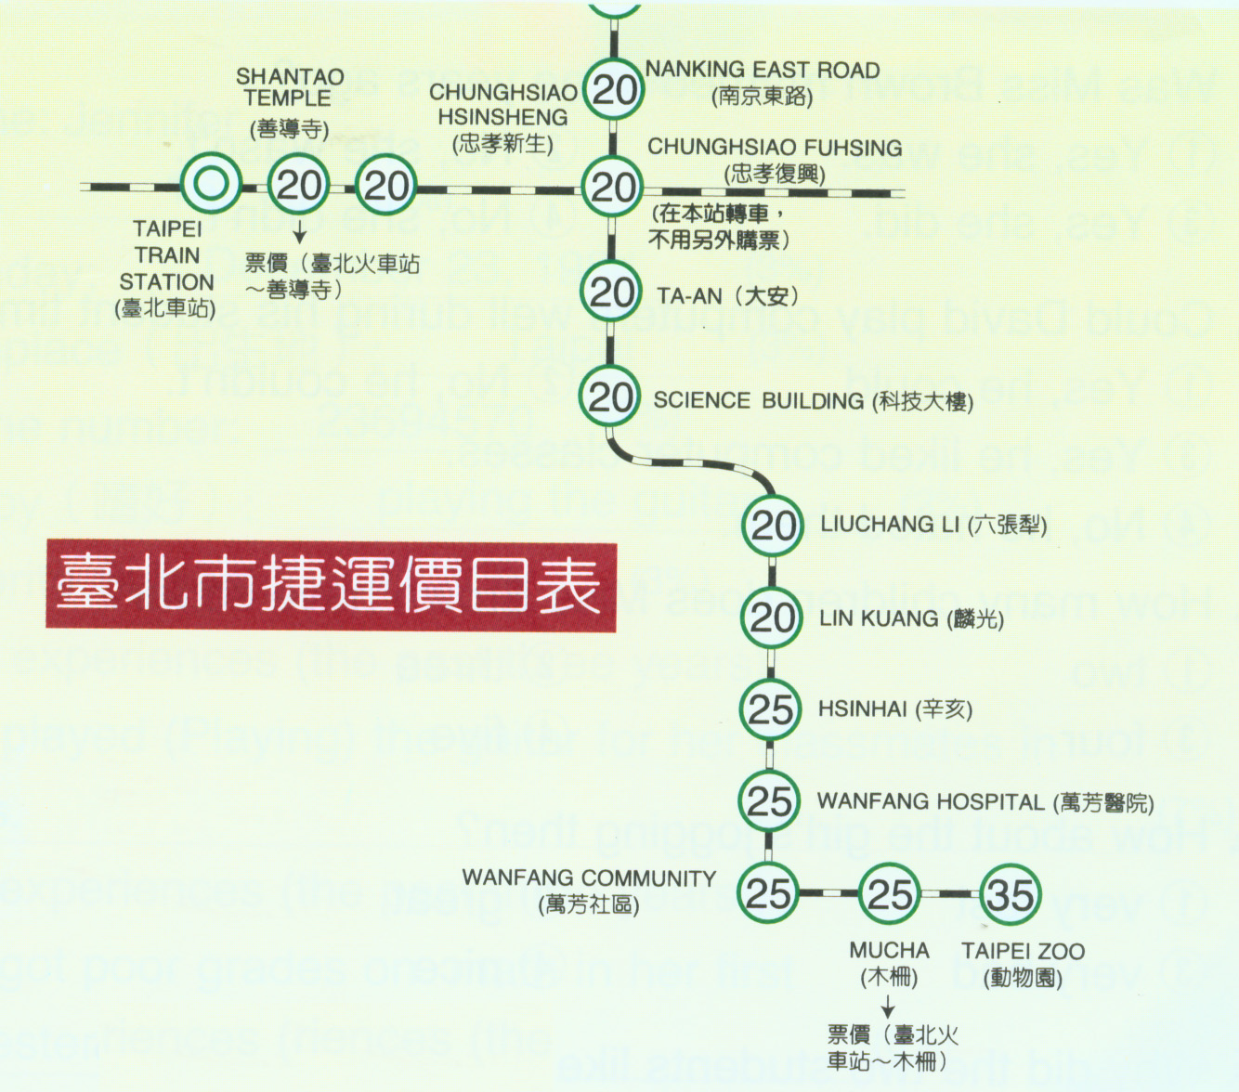
- (A) $20 (B) $25 (C) $30 (D) $35
- (A) 8 (B) 9 (C) 10 (D) 11

Part B 紙筆測驗（80%）
一、字彙（18%，每題2分）
1. There are two s rs in a school year..
2. I can’t s e this problem because it is too hard.
3. At the end of the game, Michael Jordan made a s t , and won the game.
4. Traffic jams is getting more and more s s in the city.
5. 對話 6.乘客 7.十億 8. 吉他 9. 最後

二、文法選擇（20%，每題2分）
（ ）1. Tim fell off the tree and his leg.
(A) break (B) broke (C) broken (D) was broken
（ ）2. An embarrassing experience will .
(A) be never forget (B) never be forget (C) never be forgotten (D) never forget
（ ）3. That’s a movie, and I felt .
(A) boring; boring (B) bored; bored (C) bored; boring (D) boring; bored
（ ）4. Some students waste a lot of time TV.
(A) watch (B) watching (C) watched (D) to watch
（ ）5. That’s your new student, Susan, isn’t ?
(A) it (B) he (C) she (D) that
（ ）6. My sister sports.
(A) interest (B) interest in (C) is interested in (D) interesting to
（ ）7. a parking space in big cities is not easy.
(A) Find (B) To find (C) Found (D) It’s finding
（ ）8. The police officer my car.
(A) has towed away (B) towed away to (C) took away (D) has towed to
（ ）9. I can’t see clearly without my glasses.
(A) put (B) to put (C) wear (D) wearing
（ ）10. Some people a lot of time and money playing computer games.
(A) spend (B) want (C) need (D) take

三、依提示改寫句子（10%，每題2分）
- Tina is reading the letter.
（用Tina is ~~）
Joseph wrote the letter last night.
- Many people died in the accident.
（用關係代名詞合併為一句）~~
The accident happened this morning.
- Susan didn’t make that cake. （改為被動式）
- Taking a hot bath in winter is great. （改為It’s ~~）
- Andy washed the dishes yesterday.
（用Andy’s mother`~~）
His mother made him do it.

四、翻譯（20%，每題4分）
- 已經冷了好幾天了。
- 善用時間的人能多做些事情。
- 在他國中生涯期間曾經有過很多美好和不如億的時光。
- 我們今年六月就要從國中畢業了。
- 我實在等不及那一天的來臨。
五、題組（12%，每題2分）
I.
An old woman opened her window on day and looked out of it. The sun shone brightly. The old woman saw a poor man eating grass 1. her house.
She went out and asked the man, “Why are you eating grass? Are you hungry?”
The man said, “I’m very hungry now. I 2. eaten anything for a long time.”
The woman told him to go to the back of her house, and she went in again. The man smiled and went to the back door of the house.
The old woman opened the door and said to the man, “The grass here is longer.”

- (A) in back of (B) in front of (C) on the roof（屋頂）of (D) far from
- (A) was (B) have (C) wasn’t (D) haven’t
- Which of the following is TRUE?
  - The woman asked the poor man to come into her house.
  - The poor man was very thirsty but not hungry.
  - The woman wanted the man to help her with the grass problem.
  - The poor man had a big meal（餐點）in the woman’s home.
II.
There are too many cars running here and there in big cities. A lot of car drivers do not drive carefully. For example, they drive too fast especially when they are in a hurry（匆忙地）. They run through a red light. Every day in the newspapers we also find many people hurt by drunk（喝醉的）drivers. Take my neighbor for another example. He went out for a party last night. After the party he walked home. While he was walking on the street, a drunk driver hit him from the back. He was badly hurt and sent to the hospital. Now I understand why my parents often say, “Streets are like a tiger’s mouth.” We must be careful when we walk on the streets, especially in the evening.

- What’s the main idea （主旨）of this passage?
(A) I f you drink, don’t drive.
(B) City drivers should not run through a red light.
(C) It’s dangerous to drive in big cities.
(D) Traffic has become a big problem in big cities.
- Which of the following is NOT mentioned （提到）in this passage?
(A) After a party people should not walk home.
(B) Drunk drivers are dangerous drivers.
(C) People walking on the streets may get hit.
(D) Some drivers drive too fast.
- What’s the meaning of “Streets are like a tiger’s mouth.”?
(A) Streets look like the mouth of a tiger.
(B) It’s very dangerous to walk on the streets.
(C) Like tigers, drivers on the streets hurt people.
  - There are tigers eating people on the streets.
高雄縣立林園高中（國中部）九十一學年度第一學期第三次英文科段考（答案卷）
班級：國三 班 座號： 姓名：

Part I.聽力測驗（20%，每題2分）
一、
1. B | 2. A | 3. D | 4. C | 5. B
二、
I’  1. C | 2. A | 3. A | II.  1. B | 2. D

Part B 紙筆測驗（80%）
一、字彙（18%，每題2分）
1. semesters | 2. solve | 3. shot | 4. serious | 5. dialogue
6. passenger | 7. billion | 8. guitar | 9. finally

二、文法選擇（20%，每題2分）
1. B | 2. C | 3. D | 4. B | 5. A
6. C | 7. B | 8. A | 9. D | 10. A

三、依提示改寫句子（10%，每題2分，錯一字扣一分）
1. Tina is reading the letter (that/ which) Joseph wrote last night.
2. Many people died in the accident that/ which happened this morning.
3. That cake wasn’t made by Susan.
4. It’s great to take a hot bath in winter.
5. Andy’s mother made him wash the dishes yesterday.

四、翻譯（20%，每題4分）
1. It’s been cold for so many days.
2. People who/ that use their time well can do more things.
3. There have been many good times and bad times during his junior high school days.
4. We’re going to graduate from junior high (school) this June.
5. I just can’t wait for that day to come.

五、題組（12%，每題2分）
I.  1. B | 2. D | 3. C | II.  1. D | 2. A | 3. B

