高雄縣立林園高中國中部九十一學年度第二學期一年級第三次段考英文科試卷
Part A: Listening (聽力)
I. 聽錄音帶，選出符合圖意的句子: 10%
1. | 2.  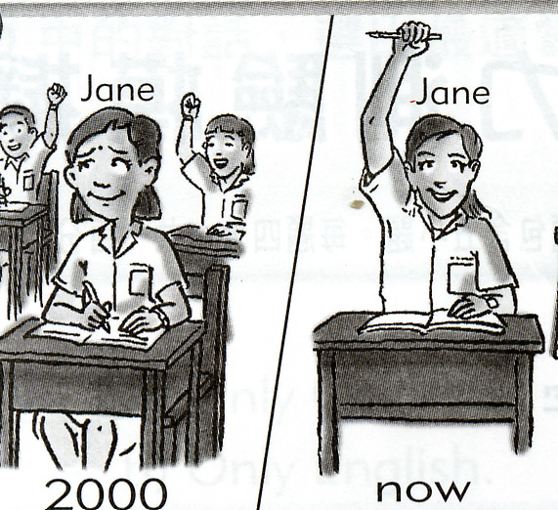 | 3.  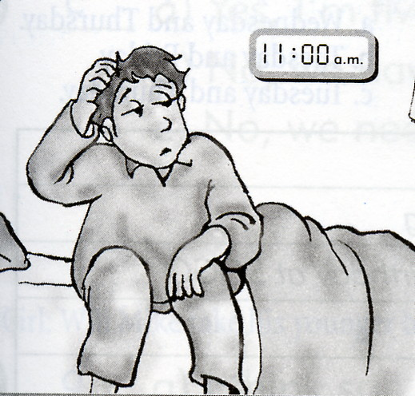 | 4.  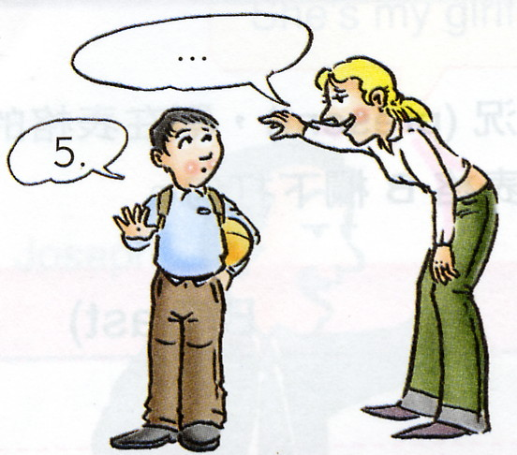 | 5.  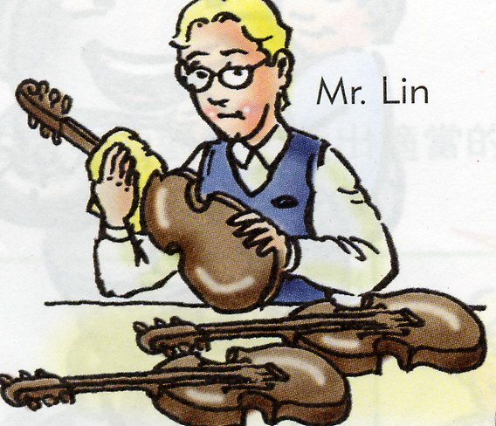
II. 聽錄音帶中的問題，選出最適當的答案:10%
- (A) She likes English. (B) She likes basketball. (C) She likes computers.
- (A) The trees were small before. (B) I was an elementary school student. (C) Yes, it was long time ago.
- (A) It’s a good idea. (B) I think so. (C) Yes, he will.
- (A) I have a meeting with Tom. (B) I’m fine, thank you. (C) She walks to school.
- (A) No, he doesn’t like. (B) Yes, he likes comic book. (C) He likes both.
III. 根據下面的表格內容，簡答錄音帶中的問題:10%
  Billy’s Shopping List
  Item | Unit Price | Quantity
  pizza | NT$500 for one | 2
  coke | NT$25 a bottle | 4
  Mrs. Brown’s Shopping List
  Item | Unit Price | Quantity
  pork | NT$60 a pound | 2
  fish | NT$80 a pound | 3
  Linda’s Shopping List
  Item | Unit Price | Quantity
  ice cream | NT$50 a liter | 1
  pop corn | NT$30 a pack | 4

Part B: Comprehension(筆試)
I. 選出適當的答案填入空格中(10%)
a cup of a pound of two liters of several at least
tough timid enough more quiet

1. Mary’s sister is . She doesn’t talk too much.
brave 勇敢的
2. We have meat for dinner.
3. Alex was a boy six years ago. Now, he’s so brave.
4. Ms. Wang wants lemon tea.
5. I think he has six notebooks.
6. I remember our math teacher, Mr. Ma, was a little . But he was very nice to us, too.
7. students are studying in the classroom after school.
8. A: I have 150 phone cards. B: That’s not a lot. My brother has .
9. They need juice for the picnic.
10. Sally doesn’t have money to buy the book.

II.選擇(20%)
1. Sunday is the day of the week. (A. first B. next C. last D. one)
2. Bruce is very tall now, but he was short .(A. today B. ago C. still D. before)
3. Tom and Mark students. (A. are both my B. my both are C. both my are D. are my both)
4. She likes tennis very much. She is a big . (A. plan B. exam C. fan D. card)
5. we have to speak English in the class? (A. Do B. Does C. Are D. Were)
6. Ted and I classmates three years ago. (A. am B. are C. was D. were)
7. Lucky is one-year-old dog. (A. a B. the C. an D. ×)
8. Which do you , beef or pork? (A. collect B. remember C. prefer D. quantity)
9. meat do you need? (A. How many B. How come C. How much D. How about)
10. What a ! How come you are here? (A. seat B. surprise C. reunion D. world)

III.閱讀測驗(10%)
A. 根據下面的座位表回答下列問題：
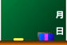
Vince | Tom | Cindy | Adam
Wendy | Mark | Nancy | Richard
David | Linda | Steve | Betty

1. Who are sitting in the first row?
(A) Vince and Wendy. (B) Vince and Cindy. (C) Adam and Betty. (D) Linda and Steve.
2. Who is sitting behind Vince?
behind 在…之後
(A) Tom. (B) David. (C) Wendy. (D) Cindy.
3. Who is sitting right next to Betty?
(A) Steve. (B) Adam. (C) Vince. (D) Mark.

B. 請根據下面對話回答下列問題：
Susan: Hi, Kate! How come you are here?
Kate: I’m here with my friend, Doris. She comes from Canada. She’d like to visit a Chinese elementary school.
Susan: How do you do, Doris?
Doris: How do you do?
Kate: Why are you here?
Susan: I teach music in this school now.
Kate: Really? I can’t believe it! Is our math teacher, Ms. Li still here? I remember she was tough before.
Susan: Yes, she is. But she’s kind now.

- Who is Doris?
A. She’s Kate’s friend. B. She’s Susan’s friend. C. She’s Susan and Kate’s math teacher.
D. She’s Susan and Kate’s music teacher.
 come from 來自
 Canada 加拿大
 kind 親切的
- Who teaches math?
A. Susan. B. Kate. C. Doris. D. Ms. Li.
IV.改寫(10%)
1. They have two cars.(依劃線部分造原問句)
2. I have a brother and a sister. (造原問句)
3. My father has to go to work every day. (改成疑問句)
4. I want coffee, not tea. (請用which造原問句)
5. Mr. And Mrs. Brown are busy. (加入last week)
V.翻譯(20%)
- A:你有幾張郵票？B:至少二千張。
- 一本筆記本是不夠的。
- 他每星期日收看電視上的網球節目。
- 你認為他有時間嗎？
- 真不敢相信我現在是個老師。

高雄縣立林園高中國中部九十一學年度第二學期一年級第三次段考英文科答案卷
Class: Number: Name:
Part A: Listening (聽力)
I.1. C | 2. A | 3. C | 4. B | 5. C | II. 1. B | 2. C | 3. B | 4. A | 5. C
III. 1. Two pounds.

2. Eighty NT dollars a liter.

3. Four bottles.

4. Three liters of ice cream and one pack of pop corn.

5. Three hundred and sixty dollars.

Part B: Comprehension(筆試)
I. 選出適當的答案填入空格中(10%，每格1分)
1. quiet | 2. a pound of | 3. timid | 4. a cup of | 5. at least
6. tough | 7. Several | 8. more | 9. two liters of | 10. enough
II.選擇(20%，每題2分)
1. A | 2. D | 3. A | 4. C | 5. A | 6. D | 7. A | 8. C | 9. C | 10. B
III.閱讀測驗(10%，每題2分)
A.  1. B | 2. C | 3. A | B.  1. A | 2. D
IV.改寫(10%，每題2分，錯1字扣1分)
1. How many cars do they have?
2. How many brothers and / or sisters do you have?
3. Does my father have to go to work every day?
4. Which do you want, coffee or tea?
5. Mr. And Mrs. Brown were busy last week.
V.翻譯(20%，每題4分，錯1字扣1分)
1. A: How many stamps do you have? B: At least two thousand.
2. One notebook is not enough.
3. He watches tennis on TV every Sunday.
4. Do you think he has time?
5. I can’t believe I’m a teacher now.

