高雄縣立林園高中（國中部）九十一學年度第二學期第三次段考英文科考卷二年級
★ 聽力部分 ★30%
一、選出你所聽到的字 10﹪
1.（ ） A. die B. hospital C. examine
2.（ ）A. talking B. speaking C. crying
3.（ ）A. housework B. homework C. hamburgers
4.（ ） A. comfortable B. fashionable C. beautiful
5.（ ） A .legal B. illegal C. single

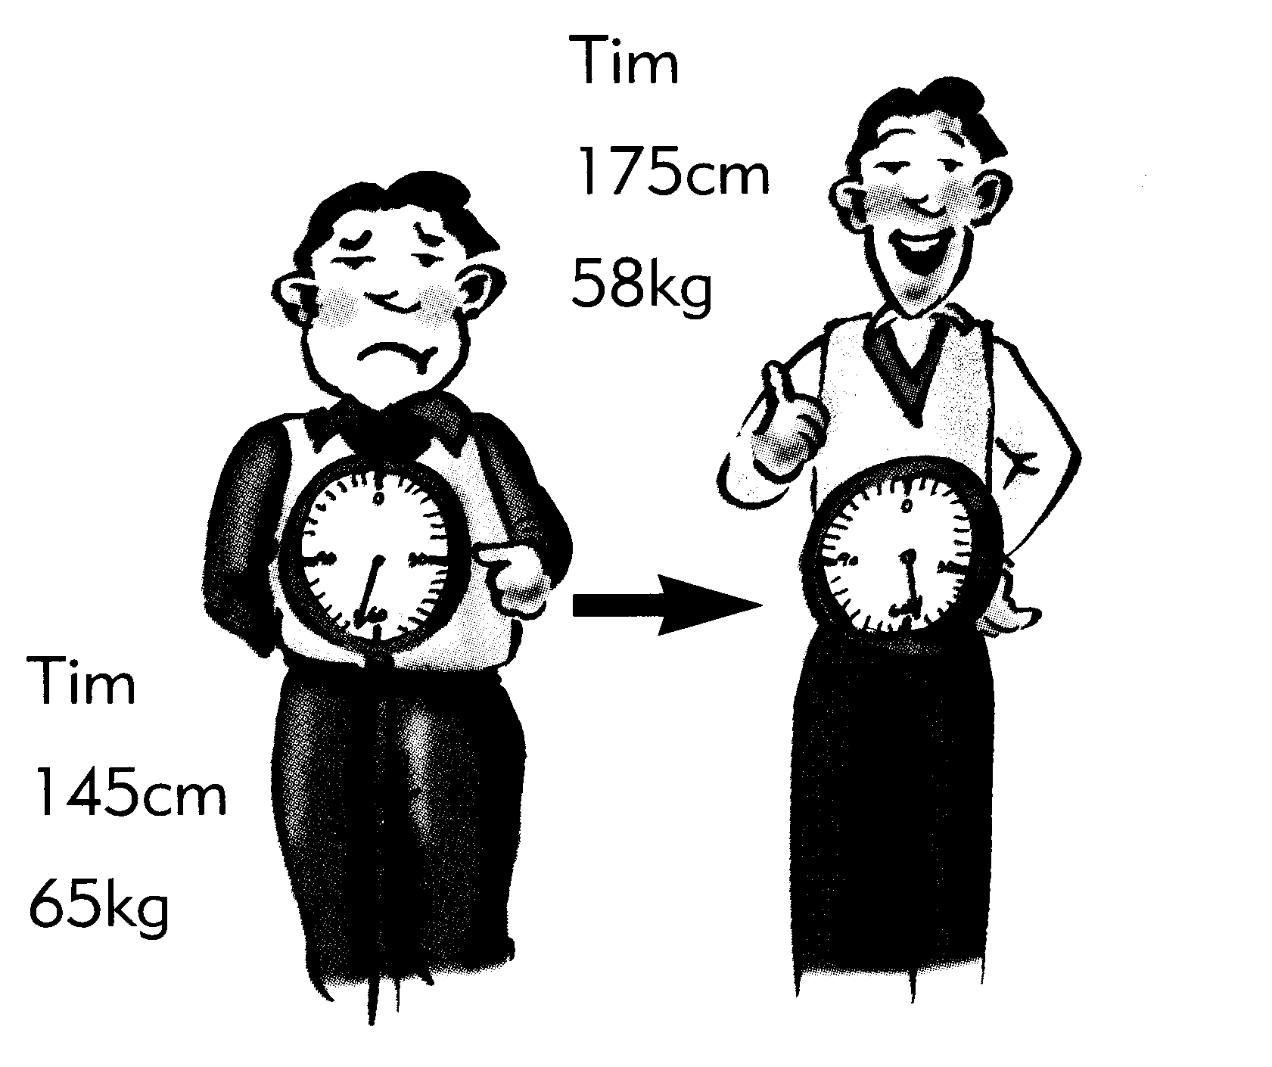
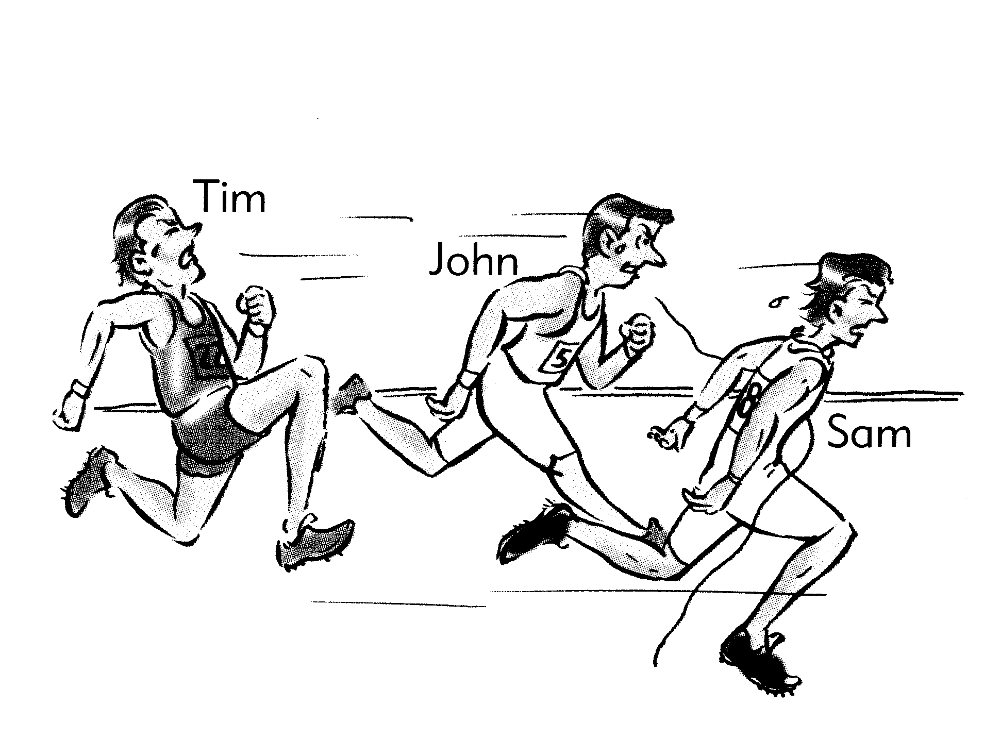
二、聽完A、B、C三句的敘述後，請填上與圖片相符句子的代號。10﹪
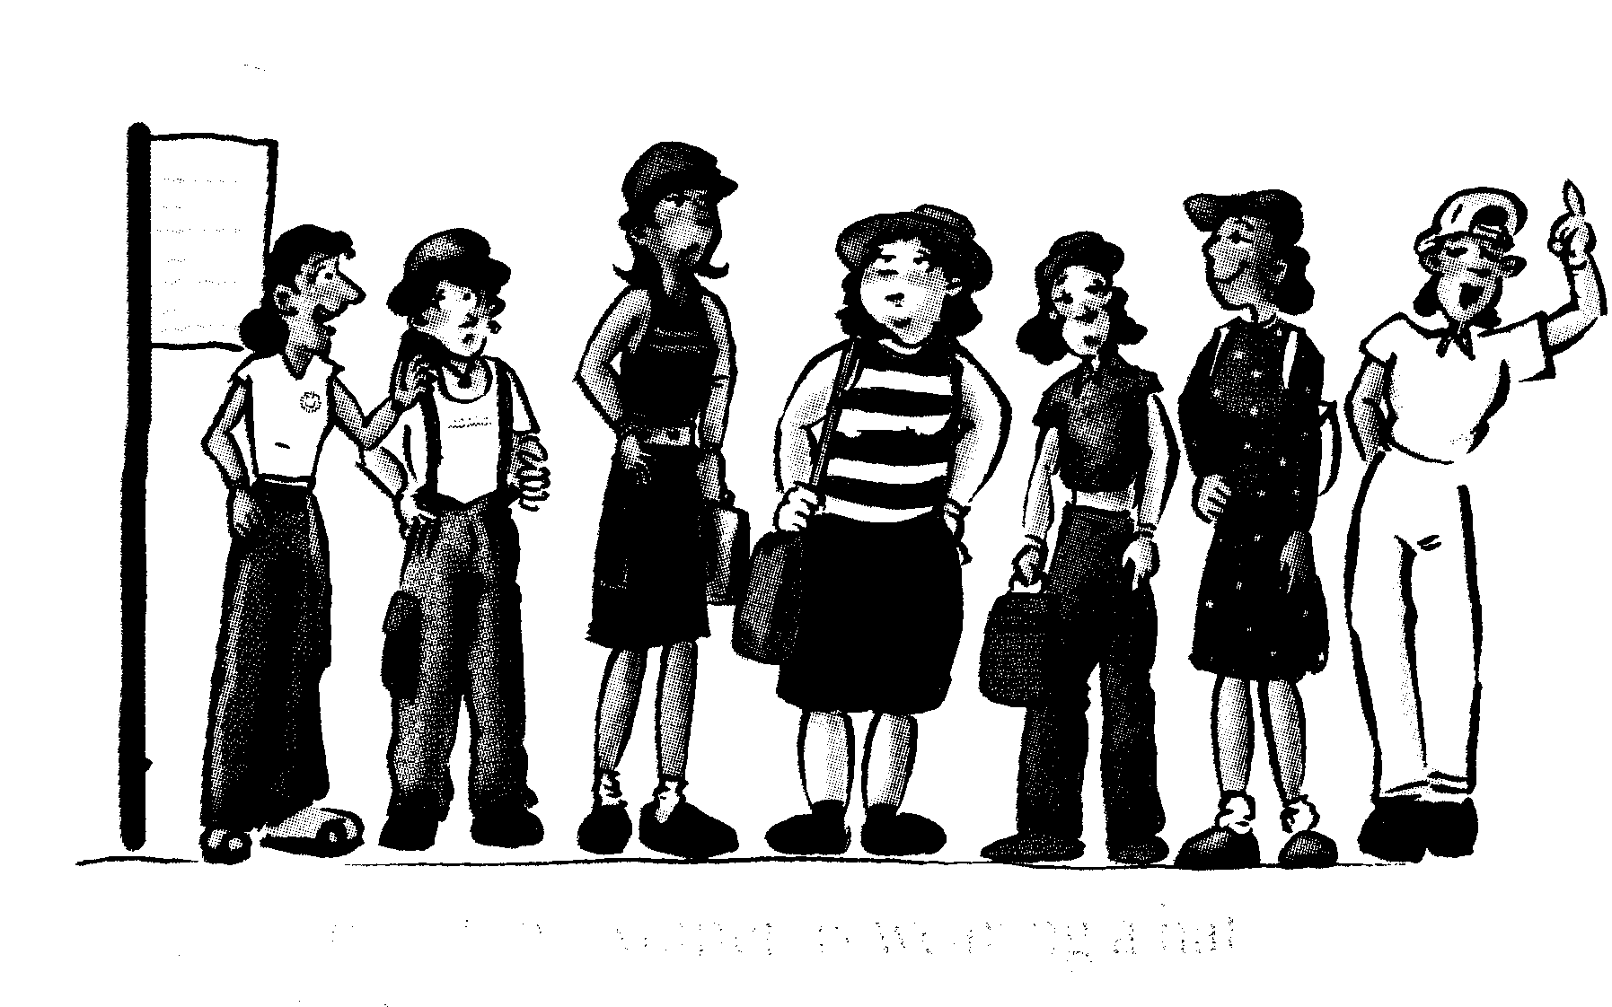

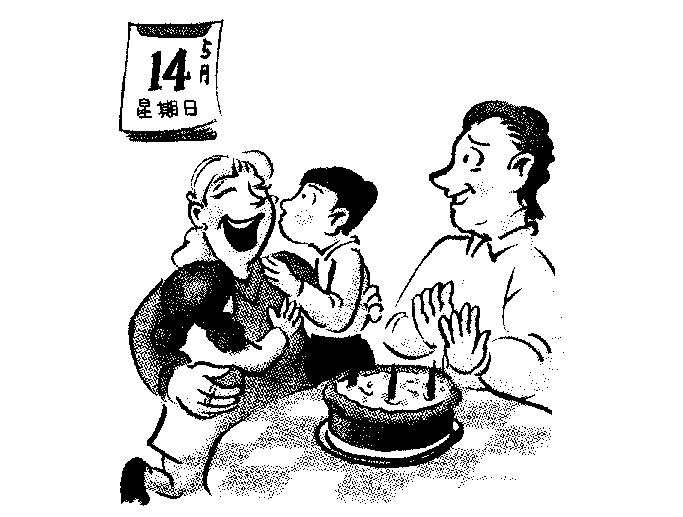
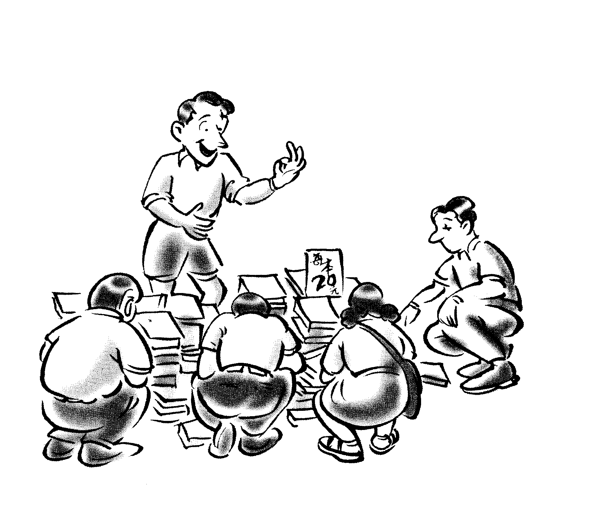

1.（ ） 2.( ) 3.（ ） 4.( ) 5.（ ）

三、聽完錄音帶中的問題後，選出適當的回答。10﹪
1.（ ）A. Peter’s birthday. B. Mother’s Day. C. Teacher’s Day.
2.（ ）A. She spent a lot of money buying the watch.
B. Her new watch is a bad one.
C. She couldn’t go out on Friday.
3.（ ）A. A television. B. A fashionable dress. C. A new pair of glasses.
4.（ ）A. An elephant. B. A cat. C. A rabbit.
5.（ ）A. Doraemon. B. Michael Jordan. C. Our president- A-bian.

- 答案請寫在答案欄
筆試部分
- 選出適當的單字或片語30%
1. In a big department, you can often have the opportunity to see the most _____ skirts. (A) delicious (B) comfortable (C) fashionable (D) elementary
2. I said hello to Jack, but he didn’t _____ me and just walked away. (A) notes (B) notice (C) sell (D) noses
3. Mrs. Ma is getting older and she sees _____ only when she wears her new glasses. (A)clearly (B) carefully (C) coldly (D) sadly
4. It is ____ to drink more milk and take exercise if you want to get taller.
(A) comfortable (B) difficult (C) expensive (D) important
5. Father ____ his car carefully before our long trip to Taipei.
(A) prepared (B) decorated (C) noticed (D) examined
6. Father’s Day is coming. We’ll _____ it in a restaurant. (A) relax (B) have (C) sell (D) celebrate
7. The young man tried to take away my wallet. I took him to the _____ station.
(A) bus (B) gas (C) subway (D) police
8. The restaurant is _____ for its delicious food. That’s why it’s usually full (充滿)of people. (A) afraid (B) proud (C) worried (D) famous
9. In America, you can’t buy medicine without (沒有)your doctor’s _____.
- dictionary (B) envelope (C) prepare (D)prescription
10. It is _____ in Taiwan to drive after you drink a lot; it will do harm to other people. (A) active (B) illegal (C) famous (D) super
11. I like the BMW car very much, but I think the ____ is too high for me. (A) price (B) color (C) business (D) class
12. In Taiwan, children over six years old have to study in _____. There they can learn how to read and how to write. (A) junior high school (B) a computer class (C) a cram school (D) elementary school
13. More and more _____ move to Mainland China (大陸) these years. I think that’s too bad. (A) factories (B) hospitals (C) teacher (D) school
14. Because the parents could not find their lost child, they finally asked the _____ for help. (A) vendors (B) cowboys (C) businessmen (D) police officers
15. Are there _____ chairs for everyone to sit on in this classroom? (A) free (B) funny (C) enough (D) terrible
- 綜合選擇10%
  - My boyfriend bought me this wallet five years ago, but it still looks like _____ .(A) new (B) a new one (C) another new one (D) the new one
  - New cars are much more expensive than old _____. (A) these (B) one (C) ones (D) those
  - 選出錯誤的答案Mother hates _______ .
(A) any illegal things (B) anything illegal (C) somethings illegal (D) all illegal things
4. Many of Danny’s classmates wear long hair, but he _____. (A) hasn’t (B) isn’t (C) won’t (D) doesn’t
- ______ came to see you yesterday. (A) Her one friend (B) Her a friend (C) One friend of her (D) A friend of hers
6. The new dress looks _____ .
- well on her (B) well to her (C) good to her (D) good on her
7. He is _____ to go to senior high school.
(A) so old (B) enough old (C) such an cold boy (D) old enough
8. At the station, we saw many people _____ on and off the buses.
(A) got (B) to get (C) were getting (D) getting
9. Tom practiced English very often; now his English is better than _____.
- I (B) me (C) mine (D) my
10. You should spend more time _____ your homework, or you have more problems.
- do (B) doing (C) to do (D) having done

- 克漏字選擇18%
Mr. and Mrs. Li are shopping from a street vendor at a night market.
Mrs. Li: Look at the dresses. They’re so pretty and fashionable.
Mr. Li: Yes. Which one do you like the best? I will 1. as your birthday present.
Mrs. Li: Hey, how about this red one? 2.
Mr. Li: Sure. Let’s get it. Do you 3.
Mrs. Li: I’d like to buy some tapes and CDs. There they are. Let’s go and get some.
Mr. Li: They’re good singers, and all the songs are not bad. But the price is really low. I think
they’re fakes, and 4. . We had better go to a music store.
Mrs. Li: That’s right. Sometimes cheap things won’t last long.★had better 最好 ★last 持續

1. (A) buy you a ring (B) take you to a nice restaurant
© buy it for you (D) buy you one
2. (A) Does it look good on me? (B) How do I look?
© Do I look all right? (D) What do you think I am?
3. (A) finish shopping (B) need anything else
© decide to hurry home (D) want to try it on
4. (A) it’s illegal to buy them (B) it’s convenient to get them
© I can’t live without them (D) they’re fashionable

Mother’s Day is an important day. 5. is a day when children can show their
love toward their mothers. Many children give flowers to their mothers to make them
very 6. . However, 7. of the people who live near Mrs. Huang’s flower store are poor. The children don’t have any money to buy flowers. 8. Mother’s Day came this year, Mrs. Huang thought of an idea to help them. She asked the children to work one hour for her. They cleaned the windows, swept the sidewalk, and cleaned the floor in the store. Then Mrs. Huang gave each of them flowers to 9. to their mothers. The mothers in Mrs. Huang’s neighborhood all had a happy Mother’s Day this year.

5. (A) Then (B)Which (C) It (D) When
6.(A) afraid (B) easy (C) funny (D) happy
7.(A) most (B) one (C) no (D) much
8.(A) After (B) Before (C) Because (D) Then
9.(A) take home (B) throw away (C) save money (D) make a cake

四、翻譯成英文句子12%
1.天色變的越來越暗。我們必須停止工作，回家了。
2. Jack沒來學校，因為他生病了。
3.對我來說，媽媽不只是雙親之一，也是朋友。

◆ Happy summer vacation!

高雄縣立林園高中（國中部）九十一學年度第二學期第三次段考英文科答案卷
二年____班____號 姓名____________
聽力  部分 | 一、  1. |  |  |  | 2. |  |  |  | 3. |  |  |  | 4. |  |  |  | 5. |  | 二  1. |  |  |  | 2. |  |  | 3. |  |  | 4. |  |  | 5.
聽力  部分 | 三、  1. |  |  |  | 2. |  |  |  | 3. |  |  |  | 4. |  |  |  | 5.
筆試部分 | 一、  1. |  |  |  | 2. |  |  |  | 3. |  |  |  | 4. |  |  |  | 5. |  | 6. |  |  |  | 7. |  |  | 8. |  |  | 9. |  |  | 10.
11. |  |  |  | 12. |  |  |  | 13. |  |  |  | 14. |  |  | 15.
二、  1. |  | 2. |  |  |  | 3. |  |  |  | 4. |  |  |  | 5. |  |  |  | 6. |  |  |  | 7. |  |  | 8. |  |  | 9. |  |  | 10.
三、  1. |  |  | 2. |  |  |  | 3. |  |  |  | 4. |  |  |  |  | 5. |  |  |  |  | 6. |  |  | 7. |  |  | 8. |  |  | 9.
四、
1.
2.
3.

高雄縣立林園高中（國中部）九十一學年度第二學期第三次段考英文答案卷

聽力  部分  每題2 分 | 一、  1. B |  |  |  | 2. C |  |  |  | 3. A |  |  |  | 4. B |  |  |  | 5. B |  | 二  1. B |  |  |  | 2. A |  |  | 3. A |  |  | 4. C |  |  | 5. A
聽力  部分  每題2 分 | 三、  1. C |  |  |  | 2. B |  |  |  | 3. C |  |  |  | 4. A |  |  |  | 5. B
筆試部分 | 一、  1. C |  |  |  | 2. B |  |  |  | 3. A |  |  |  | 4. D |  |  |  | 5. D |  | 6. D |  |  |  | 7. D |  |  | 8. D |  |  | 9. D |  |  | 10. B
11. A |  |  |  | 12. D |  |  |  | 13. A |  |  |  | 14. D |  |  | 15. C
二、  1.B |  | 2. C |  |  |  | 3. C |  |  |  | 4. D |  |  |  | 5. D |  |  |  | 6. D |  |  |  | 7. D |  |  | 8. D |  |  | 9. C |  |  | 10. B
三、  1. D |  |  | 2. A |  |  |  | 3. B |  |  |  | 4. A |  |  |  |  | 5. C |  |  |  |  | 6. D |  |  | 7. A |  |  | 8. B |  |  | 9. A
四、
1. It got darker and darker. We had to stop working and went home.
2. Jack didn’t come to school, because he was sick.
3. For me, Mother is not only a parent but also a friend.

