林園高中92學年度  範圍：L7-L8 & ReviewII  命題教師：劉秀雅 | 國一第三次月考  英語聽力30%  英語筆試70﹪ | 班別：____班  ____號  姓名： | 得分：
Part One：Listening Comprehension聽力（30%）
I、詞彙選擇（4%，每題2分）
( ) 1.(A) little (B) lucky (C) lot (D) library
( ) 2.(A) classmate (B) cloudy (C) cousin (D) concert
II、辨音：（4%，每題2分） 請一律作答在答案紙上
( ) 1.(A) < ɑ > (B) < ε > (C) < e > (D) < υ>
( ) 2 (A) < ɑ > (B) < ɔ > (C) < u > (D) < υ>
III、看圖辨意（5%，每題1分）
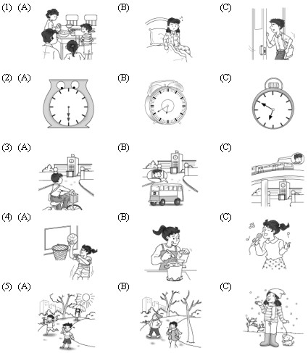
( )

( )

( )

( )

( )

IV、圖文配合（請將錄音帶中所念到的人與他/她喜歡的活動配對，填入代碼，5%，每題1分）
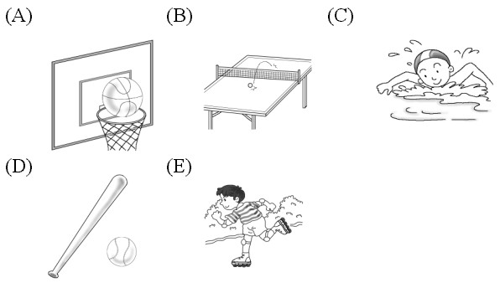

Name | Linda | Linda’s brother | John | Jane | Tom’s brother
Sports | 1 | 2 | 3 | 4 | 5

V、簡短對話（4%，每題2分）
( ) 1.(A)At 10：30 (B)Yes, they do.(C) By school bus.(D)sounds great.
( ) 2.(A)Me ,too. (B)Sounds great.(C)By train.(D)How about you ?
VI、填空（請將錄音帶中所念到的人與他/她喜歡的活動配對，填入代碼，可複選，8%，每題2分）
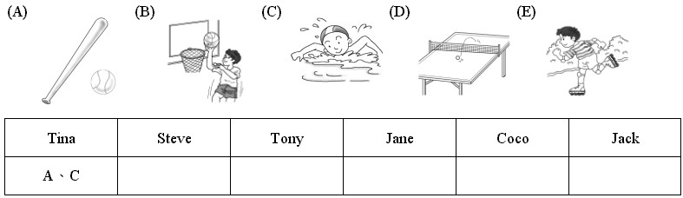

Part Two：Writing Comprehension筆試（70%）
一、文法 ：每題2分 共16分
( ) 1.Lucy likes to _______ music.(A) listen to (B) listens (C) listening to (D) listening
( ) 2.I have ________ time to play baseball.(A) a lots of (B)a lot of (C) lot of (D) many
( ) 3.How about ________ table tennis after school?(A) playing the (B) to play(C) playing (D) plays
( ) 4.________ do the girls go to Taipei?(A) What (B) What’s (C) How’s (D) How
( ) 5.Let’s ________ to the movies.(A) go (B) to go (C) going (D) goes
( ) 6. What movies ________ the boys like?(A) are (B) do (C) is (D) does
( ) 7. My mother ________ a bus to work every day.(A) drive (B) to drive (C) takes (D)to take
( ) 8. Do you want to go to _____ concert?(A) Andy (B) the Andy (C) Andy’s (D) the Andy’s
二、字彙填空：每題2分 共10分
1. We can take the t i outside the airport（機場）home.
2. Many students like to surf the I______t every day.They can know many things（事情） from that.
3. They like to do many activities （活動）after school. They have a lot of h s.
4.You have to s e some money. We want to buy a computer at home.
5.Jack wants to go to Tainan this Sa y.
三、克漏字填空 ：每題2分 共14分
Mary and Tony live in Taipei and they are good friends. Mary gets up very early every morning . She usually(1)g to school on (2) f t. Tony often takes an (3) to school, because it is faster（比較快）than bus. After school,they like (4)t about sports, especially（尤其是）(5)b________, Michael Jordan is their idol. They both love T-shirt（T恤）with (6) n __r 23 on it. They always have a great time (7)t __ __r.
四、對話 ：每題2分 共10分
Ben: Do you like (1) table tennis? Sherry: Yes, I do.
Ben: Me, (2) . Sherry: Do you want to play now?
Ben: Sounds great ! But (3) now. (4) tomorrow.

( ) (1) (A) play (B)plays (C)to playing (D) to play
( ) (2) (A) also (B)and (C)like (D) too
( ) (3) (A) very (B)and (C) too (D) not
( ) (4) (A) Also (B) Often (C) How about (D) Maybe
( ) (5).John: Mother drives me to school every day. Peter: You’re really lucky.
(A) How nice! (B) And you? (C) No, we don’t. (D) Of course.
五、圈出意義不同的字：每題2分 共6分
ex：bus bicycle MRT student
1. cloudy rainy sunny happy
2. noon morning evening spring
3. roller-skating swimming tennis reading
六、在空格內填入am，is，are，have或has：每題1分 共3分
1.Wendy _______ late. 2. I ______ having my lunch now. 3. Robert ________ homework on Monday.
七、將畫底線部分的發音不同者圈起來：每題1分 共3分
ex.： room rain sun
1. money night number 2. sing and moon 3. can long thank

八、是非題：對的句子寫T；錯的寫F每題1分 共4分（注意題號）
1.I am number 5 student. 2.Kathy go home by bus every day.
3.Does Tom likes pizza? 4.I like baseball and dancing.
九、利用所提供的字詞造句：每題2分 共4分（錯一個順序扣一分）
1. train the zoo Harry gets by to _______________________________________________
2. early The boys up get very _______________________________________________

