高雄縣立林園高級中學(國中部)九十二學年度第一學期第一次段考二年級英語科

【聽力測驗】( 30% , 每題2分 )
- Matching （聽CD選出與描述相符的圖片）

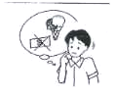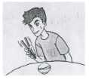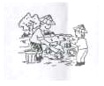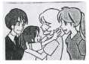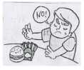
A. B. C. D. E.

- Listen and choose the correct picture.（聽對話，選出正確的圖片）

.
6.  A  B  C | 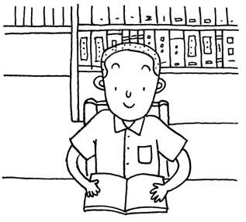 | 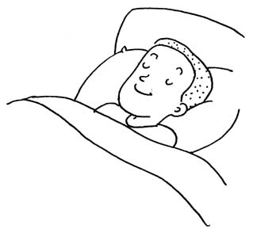 | 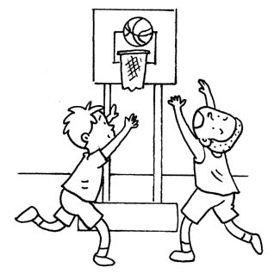

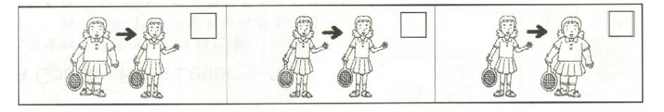

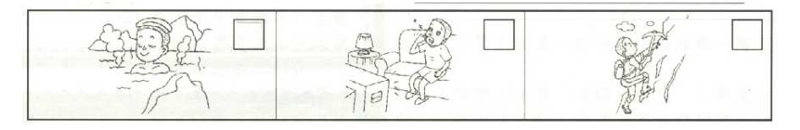

A  B  C  10. | 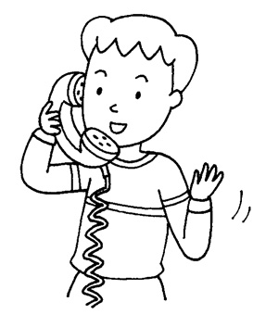 | 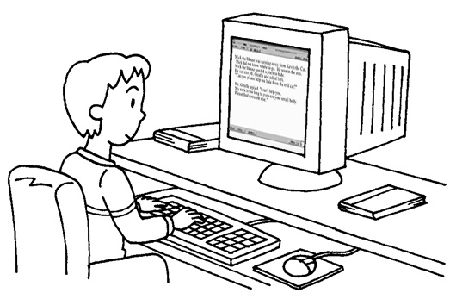 | 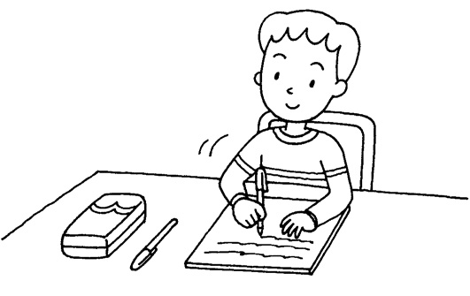

III. Listen and choose the correct answer（聽對話，選出問題的答案）
11. (A) About 10:30. (B) By bus. (C) She was fine. (D) She was late.
12. (A) Jane. (B) Her sister. (C) Her father. (D) Her mother.
13. (A) Be happy. (B) Do exercise every day. (C) Eat less. (D) Don’t get up late.
14. (A) At the National Palace Museum. (B) At a restaurant. (C) At the park. (D) At home.
15. (A) Cooking. (B) Fishing. (C) Eating. (D) Writing.

【筆試】

- 字彙測驗 （16﹪，每題1分）（1~8題,譯成中文，9~16題,選填適合文意之代號）
- 暑假 2.節食 3.生活方式 4.保重 5.隨時 6.爬山 7.種稻 8.在田裡
9. I think I'm too ___. I need to lose five pounds. (A) heavy (B) thin (C) late (D) healthy
10. Peter is his parents' ____. They love him very much. (A) uncle (B) fun (C) treasure (D) daughter
11. She worried very much, and called the police to help ___ her grandma. (A) miss (B) find (C) lose (D) invite
12. Students like to go to Miss Wang's class, because she ___ biology in an interesting way.
- studies (B) learns (C) makes (D) teaches
13. I was ___ a letter from Jane, but it didn't come. (A) expecting (B) writing (C) starting (D) reading
14. May I ___ your computer? I need to e-mail my boyfriend. (A) play (B) use (C) admire (D) see
15. Taipei is my ___. I know everything about it. (A) family (B) school (C) hometown (D) museum
16. Mr. Wu is a great cook. He ___ delicious food. (A) makes (B) eats (C) has (D) takes

- 文法及對話測驗 （24﹪,每題2分）（請依文意,選出一個最佳答案）
17. I ___ a hamburger for my breakfast this morning. (A) eat (B) ate (C) tea (D) eated
18. ___ do you like about the U.S.? (A) How (B) What (C) Why (D) Where
19. I couldn't ___ before, but now I do it every day. (A) swim (B) swam (C) swams (D) swimmed
20. Jogging ___ fun. (A) is (B) has (C) have (D) did
21. He went to the night market, and I ___, too. (A) was (B) did (C) couldn't (D) went
22. The Brown family ___ having dinner now. (A) is (B) was (C) are (D) were
23. We went to Kenting and had ___ fun. (A) very (B) many (C) very much (D) a lot of
24. Tom: Let's go to a movie. May: ___, but I have many things to do.
- OK (B) Too bad (C) I'd love to (D) No way
25. Nancy wasn't very smart, ___
- and she studied hard (B) but she was also beautiful
(C) and she could speak English well (D) but she was friendly
26. Amy: The scenery is beautiful. Bob: ___
- I envy you. (B) Have a nice trip. (C) Yes. I agree. (D) I'm glad you like you like her.
27. Tim: ___ you don’t have room for a couch（沙發）. David: Yes, this is a small room. I really like to have one.
- Too bad (B) How lucky (C) That's nice (D) I'm glad
28. Jack: ___ Helen: I did.
- Did you enjoy it? (B) Who said that? (C) What did you do? (D) Who did he like?

- 克漏字選擇（10﹪,每題2分）（請依文意,選出一個最佳答案）
Last week, my classmates and I took our first 29. to Chiayi（嘉義）.We 30. Mt. Ali（阿里山）. There we saw many people 31. other countries（其他國家）. They 32 the wonderful scenery. 33. my classmates had a good time. We would like to go there again.

29. (A) picture (B) vacation (C) trip (D) class
30. (A) went (B) lived in (C) stayed in (D) visited
31. (A) to (B) from (C) in (D) with
32. (A) admired (B) envied (C) advised (D) knew
33. (A) Both (B) All (C) Everyone (D) A lot

- 閱讀測驗（10﹪,每題2分）（請依文意,選出一個最佳答案）
10/12 Sun. 10/13 Mon. . 10/14 Tue. 10/15 Wed. 10/16 Thurs. 10/17 Fri.
32℃ 34℃ 28℃ 25℃ 26℃ 31℃
34. Today is Wednesday. How was it the day before yesterday?
- It was hot. (B) It was cool. (C) It was warm.（溫暖） (D) It was cold.
35. Brenda was in Ilan for two days and the weather was fine. What days was she there?
- Thurs. and Fri.. (B) Mon. and Tue. (C) Wed. and Thurs. (D) Sun. and Mon.

HISTORY MUSEUM
＊adult 成人 ＊touch 摸
＊Ching Dynasty 秦朝
＊antique 古董
＊park 停車
7, History Rd., Kaohsiung 07-6412059
Open 10:00 ~ 18:00 <Closed on Mondays> 1. No food in the museum.
Ticket Adult : NT$230 2. Don’t take pictures in the museum.
5 ~ 18 years old : NT$100 3. Don't touch the antiques in the museum.
Under 5 years old : Free 4. Be quiet, please.
Parking NT$40
Shows Life in Taiwan
10:30 ~ 11:00 ; 14:00 ~ 14:30
The Ching Dynasty
11:30 ~ 12:30 ; 15:00 ~ 16:00
36. Mr. Lin took his thirteen-year-old son and five-year-old daughter to the museum. He wanted to park his car there. How much did he pay?
(A) NT$470 (B) NT$370 (C) NT$340 (D) NT$730
37. Lisa and Cindy want to know more about the hard life in Taiwan long time ago. What time can they go there?
(A)11:30AM (B)11:00AM (C) 3:00PM (D) 10:30AM
38. Which one is right?
(A) They can get Taiwanese food in the museum. (B) Touching the old things is OK in the museum.
(C) You can't visit the museum on Monday. (D) The museum is in Ilan.

- 翻譯與回答問題（10﹪,每題2分）
39. 一個月前我叔叔和嬸嬸邀我去林園（Linyuan）玩。
40. 我以前常早起做運動。
41. 我沒想到那裡這麼好玩.。
42. 代我問候你父母。
43. Did you ride a bicycle to school yesterday?（據實回答）

高雄縣立林園高中九十二學年度第一學期第一次段考英語科國中部二年級
(答 案 卷)
Class________ No._______ Name____________
聽力測驗 30%（每題2分）
1. | 2. | 3. | 4. | 5.
6. | 7. | 8. | 9. | 10.
11. | 12. | 13. | 14. | 15.

筆試 70%（1~16題每題1分;17~43題每題2分）
1. | 2. | 3. | 4. | 5.
6. | 7. | 8. | 9. | 10.
11. | 12. | 13. | 14. | 15.
16. | 17. | 18. | 19. | 20.
21. | 22. | 23. | 24. | 25.
26. | 27. | 28. | 29. | 30.
31. | 32. | 33. | 34. | 35.
36. | 37. | 38.
39.
40.
41.
42.
43.

高雄縣立林園高中九十二學年度第一學期第一次段考英語科國中部二年級
( 參 考 答 案 )

聽力測驗 30%（每題2分）
1. E | 2. D | 3. B | 4. A | 5. C
6. A | 7. C | 8. B | 9. C | 10. C
11. B | 12. D | 13. C | 14. D | 15. A

筆試 70%（1~16題每題1分;17~43題每題2分）
1. summer vacation | 2. on a diet | 3. way of life | 4. Take care! | 5. any time
6. climb the mountains | 7. grow rice | 8. on the farm | 9. A | 10. C
11. B | 12. D | 13. A | 14. B | 15. C
16. A | 17. B | 18. B | 19. A | 20. A
21. B | 22. C | 23. D | 24. C | 25. D
26. C | 27. A | 28. B | 29. C | 30. D
31. B | 32. A | 33. B | 34. A | 35. D
36. A | 37. D | 38. C
39. My uncle and aunt invited me to Linyuan a month ago.
40. I often got up early and did exercise before.
41. I didn’t expect so much fun there.
42. Say hello to your parents.
43. 略

