高雄縣立林園高中國中部二年級九十二學年度第一學期第三次段考英語科試卷
Part A. 聽力測驗
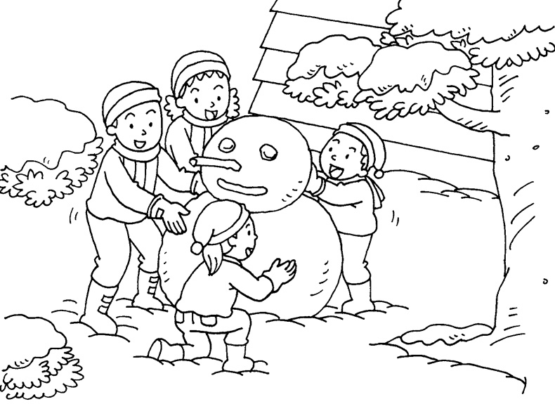
- 請根據圖片，回答錄音帶中的問題。

1. (A) Two. (B) Three. (C) Four.
2. (A) Spring. (B) Summer. (C) Winter.
3. (A) It’s hot. (B) It’s cold. (C) It’s warm.
4. (A) Snow. (B) Rain. (C) Sun.

- 請根據錄音帶中的對話或敘述，選出適合的卡片。
A.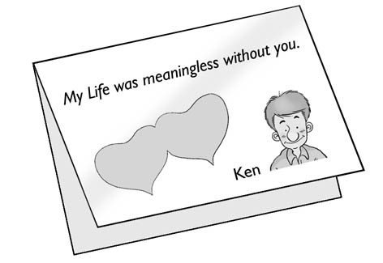 | B.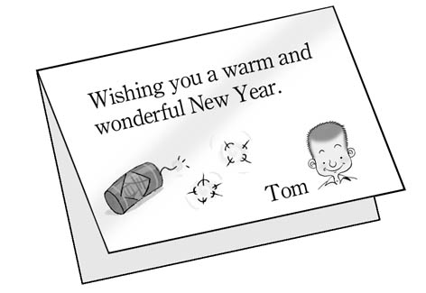 | C.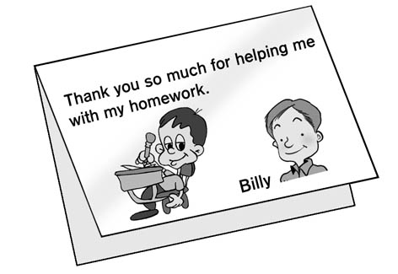 | D.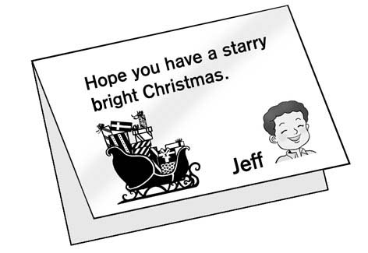 | E.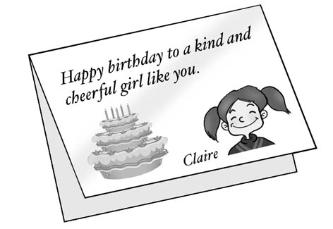

- 聽錄音帶中的問題或句子，選出適當的回答或回應。
  - (A) It’s hot in summer. (B) I like fall. (C) It’s cloudy and windy.
  - (A) Seldom. (B) Two days ago. (C) Yes, but not very often.
  - (A) That’s OK. (B) Thank you. (C) Nothing.
  - (A) It’s sunny. (B) I’m fine, thanks. (C) It’s in winter.
  - (A) That’s nice! (B) I can’t believe it! (C) Great.
  - (A) October 4. (B) November 1. (C) December 6.

Part B. 筆試
I. 填空：填入適當的介系詞，如不需要則打Χ(10%)
1、 I usually get up (1) 6:30 (2) the morning.
2、 We will have a new president（總統） (3) 2004.
3、 I went to a movie (4) last Saturday evening.
4、 My sister likes to go shopping (5) the weekend.
5、 Our school starts (6) September.
6、 Ken had a basketball game (7) a week ago.
7、 The date (8) his letter is April 1, 2002.
8、 I had an exam (9) yesterday.
9、 We have a flag hoisting（升旗典禮） （10） Monday morning.

II.選擇題(20%)
1、 Thanksgiving is in .
(A) October (B) December (C) November (D) September
2、 New Year’s Day is the day of the year.
(A) first (B) second (C) third (D) fourth
3、 Monday is the day of a week.
(A) first (B) second (C) third (D) fourth
4、 How did you your birthday?
(A) celebrate (B) invite (C) thankful (D)
5、A: Can you open the door for me? B: Sure! A:
(A) You’re so nice. (B) You’re welcome. (C) It’s OK. (D) It’s fine.
6、My father fast food.
(A) doesn’t never eat (B) never eats (C) never eat (D) eats never
7、You really helped me .
(A) a lot of (B) a lot (C) lots (D) lot of
8、A: Are you ? B: Yes, we are.
(A) a Canadian (B) Canadian (C) a Chinese (D) Chinese
9、 The English names of the months hard.
(A) do (B) does (C) are (D) is
10、A: The English test is coming soon. Don’t you worry about it? B: Well, .
(A) let’s go (B) we’re always thankful (C) it’s too bad (D) we have to study hard

III. 閱讀測驗(10%)
(A)
Jenny: My birthday is on September 28, the same date of Teacher’s Day!
Tony: Really? That’s interesting.
Jenny: How about you, Tony?
Tony: My birthday is on July 4. Is it a holiday?
Peter: Yes, it’s USA National Day!
Jenny: And you, Peter?
Peter: My birthday is just on Father’s Day this year.
Tony: On August 8?
Peter: No, it’s on the Father’s Day of USA.
Jenny: Let me see. My brother’s birthday is on Thanksgiving.
Tony: And my sister’s birthday is on Christmas!
Jenny: So our birthdays are also some important holidays in some countries!
- What date might（可能） be Peter’s birthday?
(A) June 23. (B) July 24. (C) May 23. (D) August 8.
- When is the birthday of Tony’s sister?
(A) September 28. (B) September 30. (C) December 25. (D) December 24.

(B)
One day Bin Laden went to a fortuneteller（算命師） and asked her “When will I die?” She replied（回答）, “ You will die on an American holiday.” So he asked, “Which American holiday?” And she said, “It doesn’t matter.” “ When you die, it will be an American holiday.”
- Is there an American holiday about Bin Laden?
(A) Yes, we have. (B) No, we don’t. (C) Yes, there is. (D) No, there isn’t.
- What does “ it doesn’t matter” mean?
(A) 這不簡單。 (B) 這不方便。 (C) 這不清楚。 (D) 這不重要。
- Do Americans like Bin Laden?
(A) Yes, they do. (B) No, they don’t. (C) Yes, it is. (D) We don’t know.

IV. 依提示作答及改寫句子（10%）
1、 An officer is standing in front of the police station. （用There is ~改寫）
2、 Jack drinks milk. （加入always改寫）
3、 Lucy doesn’t go to America since（自從） she was born（出生）. （用never改寫）
4、 He plays the violin three days a week. （造原問句）
5、 It’s sunny. （造原問句）

V. 翻譯及回答問題（1～4題中翻英：12%；5～8題回答問題：8%）
1、母親節是在五月的第二個星期日。
2、在袋子裡有一些錢。
3、永遠心懷感恩是感恩節最重要的事。
4、澳洲的聖誕節是在夏天。
5、 Who helped the Pilgrims when they had problems?
6、 What date is the national day of the ROC?
7、 What day is today?
8、 When is your birthday?

高雄縣立林園高中國中部二年級九十二學年度第一學期第三次段考英語科答案卷
二年 班 座號： 姓名：
Part A. 聽力測驗
- 請根據圖片，回答錄音帶中的問題。(8%, 每題2分)
1. | 2. | 3. | 4.
- 請根據錄音帶中的對話或敘述，選出適合的卡片。(10%, 每題2分)
1. | 2. | 3. | 4. | 5.
- 聽錄音帶中的問題或句子，選出適當的回答或回應。(12%, 每題2分)
1. | 2. | 3. | 4. | 5. | 6.

Part B. 筆試
I. 填空：填入適當的介系詞，如不需要則打Χ(10%, 每格1分)
(1) | (2) | (3) | (4) | (5) | (6) | (7) | (8) | (9) | (10)
II. 選擇題(20%, 每題2分)
1. | 2. | 3. | 4. | 5. | 6. | 7. | 8. | 9. | 10.
III. 閱讀測驗(10%, 每題2分)
(A)1. | 2. | (B)1. | 2. | 3.
IV. 依提示作答及改寫句子（10%, 每題2分）
1.
2.
3.
4.
5.
V. 翻譯及回答問題（1～4題中翻英：12%, 每題3分；5～8題回答問題：8%, 每題2分）
1.
2.
3.
4.
5.
6.
7.
8.
高雄縣立林園高中國中部二年級九十二學年度第一學期第三次段考英語科答案卷
二年 班 座號： 姓名：
Part A. 聽力測驗
I.請根據圖片，回答錄音帶中的問題。(8%, 每題2分)
1. C | 2. C | 3. B | 4. A
II.請根據錄音帶中的對話或敘述，選出適合的卡片。(10%, 每題2分)
1. D | 2. A | 3. C | 4. E | 5. B
III.聽錄音帶中的問題或句子，選出適當的回答或回應。(12%, 每題2分)
1. B | 2. A | 3. B | 4. A | 5. B | 6. C

Part B. 筆試
I. 填空：填入適當的介系詞，如不需要則打Χ(10%, 每格1分)
(1) at | (2) in | (3) in | (4) Χ | (5) on | (6) in | (7) Χ | (8) on | (9) Χ | (10) on
II. 選擇題(20%, 每題2分)
1. C | 2. A | 3. B | 4. A | 5. A | 6. B | 7. B | 8. D | 9. C | 10. D
III. 閱讀測驗(10%, 每題2分
(A)1. A | 2. C | (B)1. D | 2. D | 3. B
IV. 依提示作答及改寫句子（10%, 每題2分）
1. There is an officer (standing) in front of the police station.
2. Jack always drinks milk.
3. Lucy never goes to America.
4. How often does he play the violin?
5. How’s the weather?
V. 翻譯及回答問題（1～4題中翻英：12%, 每題3分；5～8題回答問題：8%, 每題2分）
1. Mother’s Day is on the second Sunday of May.
2. There is some money in the bag.
3. The (really) important thing bout Thanksgiving is always thankfulness.
4. Christmas in Australia is in summer.
5. The Indians did. 或 The Indian people did.
6. It’s on the tenth of October. 或 It’s on October 10.
7. Today is Thursday.
8. (略)

