高雄縣立林園高中（國中部）92學年度第三次段考 英語科 一年級
班級____ 座號____ 姓名_____________
壹、聽力測驗﹙每題2分﹚
- 簡短對話：根據聽到的對話，選出正確的答案
（ ）1. Where was Mary last weekend?
（A）She was at the zoo. （B）She was on the beach.
（C）She was at the theater. （D）She was at the basketball court.
（ ）2. Why did Amy go to the airport last Sunday?
- She went there to take the airplane to America.
- She went there to meet her aunt.
- She took some pictures there.
- She went there by MRT.
（ ）3. What didn’t Dave’s uncle bring Dave?
（A）Videos. （B）Stones. （C）Chocolates. （D）Storybooks.
（ ）4. Where was Mark yesterday afternoon?
（A）He was at the zoo. （B）He was at the airport.
（C）He was at the beach. （D）He was in the library.
（ ）5. Where are the two speakers?
（A）They’re at the zoo. （B）They’re at home.
（C）They’re at the airport. （D）They’re at school.
- 猜猜看：根據聽到的敘述，選出最接近描述的答案
（ ）1. （A）A monkey. （B）A bear. （C）A koala. （D）An elephant.
（ ）2.（A）A golden bear. （B）A koala bear. （C）A monkey. （D）A tiger.
（ ）3.（A）A koala. （B）A rabbit. （C）A cat. （D）A hippo.
（ ）4.（A）A tiger. （B）A koala. （C）A bear. （D）An elephant.
- 看圖選擇：根據聽到的內容，選出相符合的圖片
﹙ ﹚1. Look at Picture A. ﹙ ﹚2. Look at Picture B. ﹙ ﹚3. Look at Picture C.
﹙ ﹚4. Look at Picture D. ﹙ ﹚5. Look at Picture E. ﹙ ﹚6. Look at Picture F.
A. B. C. D. E. F.
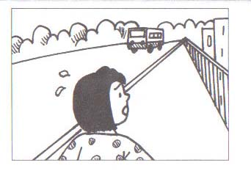
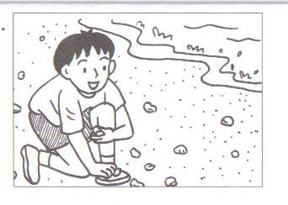
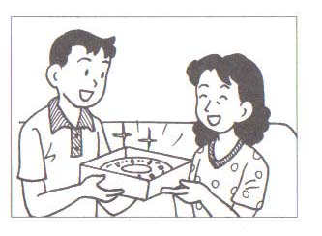
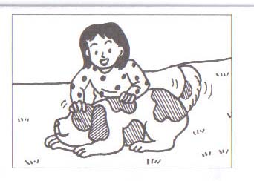
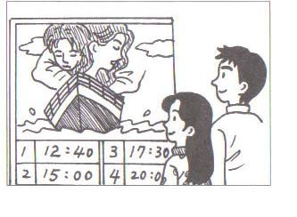
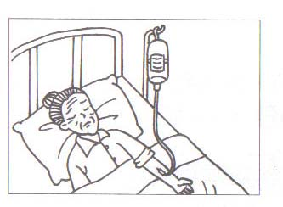

貳、筆試部分﹙每題均2分﹚
一、字彙填空：
1. He g up at 7:30 this morning , so he was late for school.
2. I have a sweet family and both of my p love me very much.
3. Tom b t me a beautiful picture from America.
4. It is great to b the fresh air in the early morning.
5. After m y year is the year of chicken(雞).

二、綜合選擇
﹙ ﹚1. Sherry: _____ delicious fish for us? Lucy: Tina did.
﹙A﹚Who did cook ﹙B﹚Who did you do ﹙C﹚Who cooks ﹙D﹚Who cooked
﹙ ﹚2. During summer vacation, you can go swimming or _____ at home.
- watched TV ﹙B﹚take a trip ﹙C﹚watch TV ﹙D﹚watching movies
﹙ ﹚3. Mary: I’m going to the hospital. Tom: What _____ ?
- in ﹙B﹚for ﹙C﹚by ﹙D﹚on
﹙ ﹚4. It was raining hard. My mother brought _____ .
﹙A﹚an umbrella me ﹙B﹚me an umbrella ﹙C﹚an umbrella with me ﹙D﹚me it
﹙ ﹚5. My brother and I like to collect _____ when we go to the beach.
- fresh air ﹙B﹚beautiful stones ﹙C﹚much money
﹙D﹚interesting books.
﹙ ﹚6. I had a very good _____ at the beach with my family yesterday.
- fun ﹙B﹚time ﹙C﹚food ﹙D﹚song
﹙ ﹚7. All students have to go to school on _____ .
- holidays ﹙B﹚weekends ﹙C﹚weekdays ﹙D﹚summer
﹙ ﹚8. Chris: I played a wonderful game last night. Pete:_____
- Sure you can. ﹙B﹚Can I join you ? ﹙C﹚Really? What’s that?
﹙D﹚Let’s go to the movies.
( )9 .I called your sister last weekend , but she was not home. What _____ your sister _____?
(A) does; do (B) does; does (C) did; did (D) did; do
( ) 10. My father doesn’t want me to have dogs at home. He seems ________ animals.
(A) like (B) to liking (C) to like (D) to hate

三克漏字選擇

Summer Vacation
“ Hey, Anna! Long time no see!” said Jim. “You look happy!”
“I am. I went to an island by boat with my family on my summer vacation.” said Anna. Anna was happy because she and her family had a good time on the island. They found a beautiful beach and swam in the ocean.

“Oh, yes. You went hiking in the mountains, too. You wrote me ﹙1﹚ ,” said Jim. “I ﹙2﹚ it last week.”

“ Yes, I took lots of pictures, too. Let’s look at the pictures tomorrow,” said Anna. “ What did you do on your summer vacation?”

Jim looked sad. He didn’t have a good ﹙3﹚ . He didn’t go to the ocean. He stayed home and went to cram school every day. At cram school, he lost his watch. His mother was unhappy because the watch was ﹙4﹚ . She bought it yesterday.
“ I stayed home on my summer vacation. It was boring” said Jim.
“﹙5﹚ “ said Anna.
﹙ ﹚1. ﹙A﹚a letter ﹙B﹚a gift ﹙C﹚some tea ﹙D﹚some fish
﹙ ﹚2. ﹙A﹚reading ﹙B﹚read ﹙C﹚readed ﹙D﹚reads
﹙ ﹚3 ﹙ A﹚winter vacation ﹙B﹚fun ﹙C﹚weekend ﹙D﹚time
﹙ ﹚4. ﹙A﹚old and cheap ﹙B﹚cheap and dirty ﹙C﹚new and expensive ﹙D﹚beautiful but cheap
﹙ ﹚5. ﹙A﹚That sounds good. ﹙B﹚That’s too bad. ﹙C﹚ It’s wonderful. ﹙D﹚You must be happy.
  - island 島 ★mountains 山 ★cram school 補習班

- 依據題意選填適當的字，並做適當的變化
watch do clean bring happen

1. My father ______ me some storybooks about “Harry Potter” from America last week.
2. What _____ to Tom? He was not at school this morning.
3. Eric didn’t _____ his Chinese homework and this made his teacher angry and asked him to do it during lunch break.
4. My sister and I helped mom _____ the house this weekend.
5. Tom was late for school because he _____ TV very late last night.
- 閱讀理解

2-Day Tour of Hualien
03/07/2004 ﹙Saturday﹚
Morning | - go to Hualien by plane  - early lunch
Afternoon | - go hiking and take photos  - go to Sea World
Evening | - have dinner at a seafood restaurant
04/07/2004﹙Sunday﹚
Morning | - go hiking in Taroko ﹙太魯閣﹚National Park
Afternoon | - free time-a walk on the beach ﹙recommended﹚  - return to Taipei by train
﹙ ﹚1. Who will read this page?
﹙A﹚Pilot﹙飛行員﹚ ﹙B﹚Taxi drivers ﹙C﹚People living in Hualien ﹙D﹚People going to Hualien
﹙ ﹚2. What are the travelers﹙遊客﹚going to do on Saturday afternoon?
- They’re going to shopping in a night market.
- They’re going to eat dinner in a seafood restaurant.
- They’re going to have a early lunch.
- They’re going to go hiking and take pictures.
﹙ ﹚3. When are they going to go hiking in the Taroko National Park?
﹙A﹚Saturday morning ﹙B﹚Saturday evening ﹙C﹚Sunday morning ﹙D﹚Sunday afternoon
﹙ ﹚4. When can people go around and collect beautiful stones and seashells?
﹙A﹚Saturday morning ﹙B﹚Saturday evening ﹙C﹚Sunday morning ﹙D﹚Sunday afternoon
﹙ ﹚5. How are the travelers going to Taipei?
- By train. ﹙B﹚By bus. ﹙C﹚By plane. ﹙D﹚On foot.
- 翻譯
  - 因為昨天雨下很大，所以我整天待在家。
  - 學生們喜歡在午休期間聊天。
  - 猴子們真的很有趣也很可愛。
  - 動物園裡有許多可愛的動物，像無尾熊和猴子。
  - 海很藍，而且空氣很清新。

  - 請將所有答案寫在「背面」答案欄★
高雄縣立林園高中（國中部）92學年度第三次段考 英語科 一年級 答案卷
班級____ 座號____ 姓名_____________
聽力  部分  30% | 一、  1. |  |  |  | 2. |  |  |  | 3. |  |  |  |  | 4. |  |  |  | 5. |  |  |  | 二  1. |  |  |  | 2. |  |  | 3. |  |  | 4.
聽力  部分  30% | 三、  1. |  |  |  | 2. |  |  |  | 3. |  |  |  |  | 4. |  |  |  | 5. |  |  |  | 6.
筆 試  70% | 一、  1. |  |  |  |  |  |  |  |  | 2. |  |  |  |  |  |  |  |  | 3. |  |  |  |  |  |  |  | 4. |  |  |  |  |  | 5.
二、  1. |  | 2. |  |  |  | 3. |  |  |  |  | 4. |  |  |  | 5. |  |  |  |  | 6. |  |  |  | 7. |  |  |  | 8. |  | 9. |  |  |  | 10.
三、  1. |  |  |  | 2. |  |  |  | 3. |  |  |  |  | 4. |  |  |  | 5.
四、  1. |  |  |  |  |  |  | 2. |  |  |  |  |  |  |  |  | 3. |  |  |  |  |  |  |  |  | 4. |  |  |  |  |  | 5.
五  1. |  |  | 2. |  |  |  | 3. |  |  |  |  | 4. |  |  |  | 5.
六
1.
2.
3
4
5

