高雄縣立林園高級中學九十二學年度第二學期第一次段考國中部二年級英語科

【Listening Test】30%
    - Pictures 看圖辨義：聽問題，看圖選答。
（1、2 題請看圖A；3、4、5 題請看圖B）
A. B.
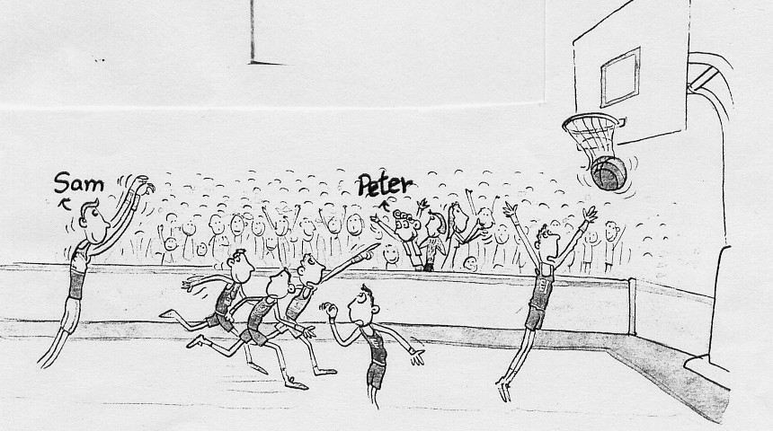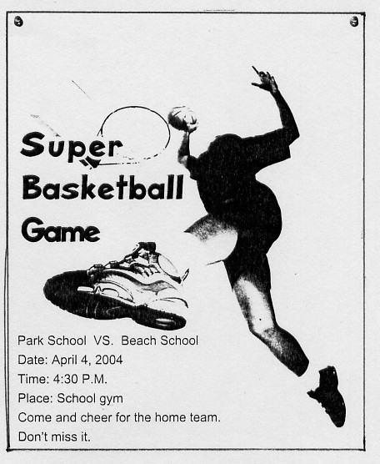

    - T & F 是非題： 6 ~10題的描述根據對話內容，若正確，請寫T；若錯誤，請寫F。
6. They are Internet friends.
7. They both like online games.
8. The boy doesn’t want the girl to go with him.
9. The girl needs to do her homework.
10. The boy’s mother doesn’t like him to play online games.

    - Short Conversations 簡短對話：聽完每一題對話及問題，選出最佳答案。
11. A) A basketball game. B) Their free time. C) Being late.
12. A) The boy went to Taipei. B) The boy is visiting his aunt. C) The boy will have fun with his aunt in Taipei.
- A) The girl called her friend and talked a lot.
B) They both had a happy weekend.
C) The boy went to a basketball camp.
14. A) His mother is sick. B) His job. C) The tests.
- A) He wants to have a date with Linda.
B) He wants to see Linda’s brother.
C) He wants to go to a movie.
【Reading Comprehension Test】70%
I. 字彙測驗：10%
1. You made a s s mistake. You have to apologize for that.
2. Ban is really c y about ENERGY. He has all of their CDs.
3. The b g of the story is good, but I don’t like the end.
4. We’ll have a big c n on our school’s birthday.
5. I’ll never q t playing basketball. It’ll always be my favorite sport.

II. 配合題（從A~N中選出適當回應，填入代號。）：7%
1. Do you like to watch NBA? A. Sure I did.
2. Did you get a good grade in English? B. You can make it.
3. It’s finally the weekend, but I still C. Poor you.
have classes in school. D. That’s very helpful!
4. How can I win the game? E. Not bad!
5. We can have fun tomorrow. F. That’s real!
6. I don’t feel like going out. G. Of course I will.
7. How do you feel now? H. Try to improve your skills.
I. What a great feeling!
J. Congratulations!
K. Nothing. Why?
L. Good luck!
M. Not really!
N. Come on. Everybody’s waiting for you.

III. 文法選擇：7%
1. What do you do ______?
A) in your free B) when you free C) when you have free D) when you have free time
2. Reading English stories ______ fun.
A) are B) will C) is D) maybe
3. John planned ______ every day.
A) to practice to swim B) to practice swimming C) practicing to swim D) practicing swimming
4. Ted is afraid ______.（選出錯誤的答案）
A) speaking English B) to ride a bicycle C) of making mistakes D) he can’t pass the exam
5. Lisa ______ Japan in two days.
A) visited B) will be going to C) is going to visits D) is going to
6. Movie fans spend a lot of time ______ movies.
A) to see B) with seeing C) on D) in
7. Mile’s ankle ______.
A) is hurt B) hurt C) very hurts D) hurted a lot
IV. 克漏字選擇 & 閱讀理解：30%

(I.) One day, a man got lost. He saw an old farmer and a dog sitting in front of a house, so he decided 1.
and 2. directions. But 3. the man got out of his car, he asked, “ 4. , sir. Does your dog bite?” The farmer said, “NO!” Then the man got out of his car, and the dog ran and bit him. The man said, “ I thought you said your dog didn’t bite.” “ That’s not my dog,” the old farmer answered.
* got lost 迷路 * direction 方向 * bite / bit 咬

1. A) stop B) stopping C) to stop D) not to stop
2. A) look at B) ask for C) drive to D) think of
3. A) when B) after C) before D) while
4. A) Sorry B) Excuse me C) Hey D) Come on
5. Does the old farmer’s dog bite?
A) Yes, it does. B) No, it doesn’t. C) We don’t know.

(II.)
Dear Tina,
I won’t be in the class tomorrow. I am going to go hiking with George. He made a plan for his holiday – watching birds in the mountains. Watching birds is a lot of fun for him, you know. And I’d love
to go with him. I can also admire the scenery. Then, we’ll go to the movie, “Cats and Dogs,” in town. Please call me or send me e-mail tomorrow to let me know the homework or the test. I’ll be home about 7:00.
Thanks,
Mary

6. Where won’t Mary go tomorrow?
A) The school. B) The cinema（電影院）. C) The mountains. D) No one knows.
7. What does Mary do?
A) A player. B) A student. C) A girlfriend. D) A singer.
8. What is Mary going to do tomorrow?
A) To watch cats and dogs. B) To make a plan for the holiday.
C) To have a date with George. D) To send e-mail.
9. What do people NOT usually do in the mountains?
A) Hiking. B) Watching birds.
C) Admiring the scenery. D) Seeing a movie.
10. Which one is true?
A) Mary wrote a letter to Tina. B) Mary and George are classmates.
C) Mary will have a holiday, so she can go with George. D) Mary doesn’t like watching birds.

(III.) What does Riva watch on TV this week? Here are her favorite programs:
Mon. | Tue. | Wed. | Thurs. | Fri. | Sat. | Sun.
Let’s Talk English | Sports | Cooking with Linda | HBO  Movie | Discovery | CNN  News | AXN
English is easy. | Enjoy NBA. | Linda makes delicious food. | You’ve Got Mail:  A romantic love story. | How do people make movies in Taiwan? | What’s happening in the world? | A Haunted House: A terrible Japanese movie.
11. On what day does she watch movies?
A) Thursday. B) Thursday and Friday.
C) Thursday and Sunday. D) Thursday, Friday and Sunday.
12. Riva wants to make a cake for her American friend. What program is helpful?
A) Let’s Talk English. B) Cooking with Linda. C) Discovery. D) Sports.
13. From what program can Riva know more about the presidential election（總統選舉）?
A) Sports. B) Discovery. C) CNN News. D) AXN.
14. Which is NOT Riva’s favorite?
A) English. B) Basketball. C) Movies. D) Japanese.
15. Which is true?
A) Riva is afraid of learning English. B) Riva likes basketball.
C) Riva likes fast food. D) Riva likes reading stories.

V. 看圖回答問題：6%
1. What does Elva worry about? 2.Ms. Chen is too heavy. 3. How much beef is Denny going
What does she need to do? to buy?
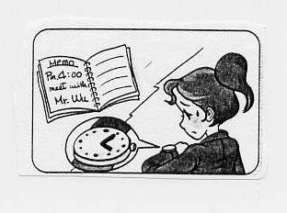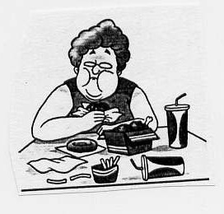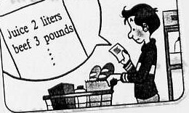

VI. 連貫式翻譯：10%
- 成為一個網球巨星是我的夢想。
- 為了實現這個願望，我每天持續練習。（To….）
- 我的第一場比賽將在明天舉行。
- 贏得這場比賽沒有那麼容易，但我會盡力而為。
- 而我的朋友也會到那裡為我加油打氣。（And ….）

高雄縣立林園高級中學九十二學年度第二學期第一次段考國中部二年級英語科
（（ 答案卷 ）） Class ________ No. ______ Name _______________

【Listening Test】30%
- _______ 2. _______ 3. _______ 4. _______ 5. _______
- _______ 7. _______ 8. _______ 9. _______ 10. _______
11. _______ 12. _______ 13. _______ 14. _______ 15. _______

【Reading Comprehension Test】70%
I. 字彙測驗：10%
- _______________ 2. _______________ 3. _______________ 4. _______________ 5. ________________
II. 配合題：7%
- _______ 2. _______ 3. _______ 4. _______ 5. _______ 6. _______ 7. _______
III. 文法選擇：7%
- _______ 2. _______ 3. _______ 4. _______ 5. _______ 6. _______ 7. _______
IV. 克漏字選擇 & 閱讀理解：30%
- _______ 2. _______ 3. _______ 4. _______ 5. _______
- _______ 7. _______ 8. _______ 9. _______ 10. _______
11. _______ 12. _______ 13. _______ 14. _______ 15. _______
V. 看圖回答問題：6%
1. ___________________________________________________________________________________
2. ___________________________________________________________________________________
3. ___________________________________________________________________________________
VI. 連貫式翻譯：10%
1. ___________________________________________________________________________________
2. ___________________________________________________________________________________
3. ___________________________________________________________________________________
4. ___________________________________________________________________________________
5. ___________________________________________________________________________________

高雄縣立林園高級中學九十二學年度第二學期第一次段考國中部二年級英語科
（（ 參考答案 ））
【Listening Test】30%
1. C B A A A
- F T F T T
11. A B B C C
【Reading Comprehension Test】70%
I. 字彙測驗：10%
- serious 2. crazy 3. beginning 4. celebration 5. quit

II. 配合題：7%
- M A C H I N E

III. 文法選擇：7%
- D C B A D C B

IV. 克漏字選擇 & 閱讀理解：30%
1. C B C B B
6. A B C D A
11. C B C D B

V. 看圖回答問題：6%
1. She worries about being late.
2. She needs to go on a diet. / quit eating fast food. / eat less.
3. He is going to buy three pounds of beef.

VI. 連貫式翻譯：10%
1. To be a tennis superstar is my dream.
2. To realize this wish, I keep practicing every day.
3. My first game will be tomorrow.
4. Winning the game is not so easy, but I’ll do my best.
5. And my friends will cheer for me there.

