高 雄 縣 立 林 園 高 中 9 3 學 年 第 一 學 期 國 中 部 第 二 次 段 考 一 年 級 英 語 科 試 題
班級： 姓名： 座號：

第一部份、聽力測驗：30﹪
一、根據聽到的單字，填入缺少的字母。5％
1. l tter
2. so a
3. th se
4. clo
5. tr

二、選出聽到的字5％
1、（ ） lion  koala  shark monkey
2、（ ） cool  famous  fine cute
3、（ ） voice  movie  place fish
4、（ ） power  powerful  family ruler
5、（ ） maybe  tour bus  next to fish tank

三、選出適當的答句。10﹪
1 | （ ） | ( Yes, they are rulers.   No, it is on the desk.   No, it’s a pencil.
2. | （ ） |  They are from my friends.   It is in the kitchen.   They are under the sofa.
3. | （ ） |  Yes, he is in the living room.   Yes, she is behind the window.   No, she is in front of the door.
4. | （ ） |  No, they are next to the tree.   Yes, they are behind the tree.   Yes, they are on top of the tour bus.
5. | （ ） |  Yes, there are.   No, there isn’t.   No, there is a monkey in my bedroom now.

四、在圖片上方寫出聽到的題號。10﹪
( ) ( ) ( )
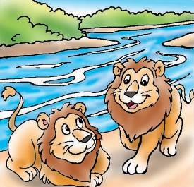
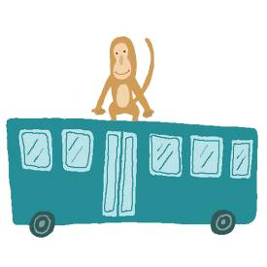


( ) ( )


第二部份、紙筆測驗：70﹪

- 看圖寫出英文單字：10﹪
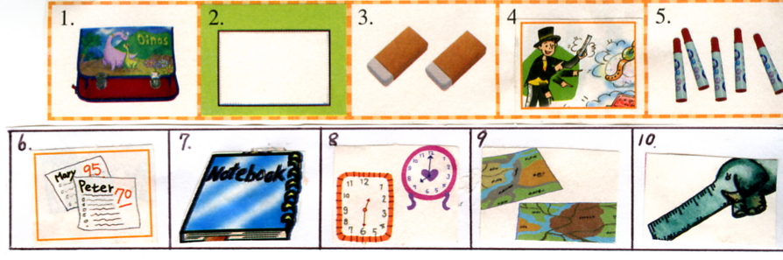

1.It is a __________.
2.That is a __________.
3.These are __________.
4.He is a __________.
5.They are _________.
6.Those are __________.
7.This is a __________.
8.They are __________.
9.They are __________.
10.This is a __________.

- 請依題意選出一個正確或最佳的答案：20﹪
1.There are seven ________ on the table.
（A）cat（B）watches（C）watch（D）dog
2.Look! There is a girl ________.
（A）over（B）on（C）over there（D）under
3.________ a tree in front of your house?
（A）There is（B）Are there（C）Is there（D）Are
4.Isn’ Lucky under your sofa ? B:_____________
（A）Yes, he isn’t.（B）No, he is.（C）Yes, he’s not.（D）No, he isn’t.
5.Where are you , Jane? Oh…_________.
（A）here are you (B) are you there (C) here you are (D) here are she
6.A: I’m a student. B:______? Me, too.
（A）Cool (B) Really (C)How (D)Who
7.It’s nine in the morning _________. You are late.
- now（B）what（C）where（D）great
8.________ your pencil boxes?
（A）Is it （B）Are they (C) Is this (D) Is that
9.I go to school _________ Monday to Friday.
(A) for (B) with (C) at (D) from
10. Are these your comic books?
- Yes, these are. (B) No, these aren’t. (C) Yes, they are. (D) Yes, those are.

- 閱讀測驗：20﹪
(一）
A zoo is a good place. We students like animals very much.
There are lions, tigers, monkeys and elephants.
Elephants are big. Monkeys are cute. Lions and tigers are strong.
We should not give them food.
Maybe the food is not clean.
They will be sick.
We only look at them and love them.
【place-地方 animal-動物 strong-強壯的 should-應該】
【food-食物 clean-乾淨的 sick-生病的】

1.Where is the article（文章）?
（A）At the zoo.（B）In school.（C）On the desk.（D）Under the tree.
2.What isn’t there in the zoo?
（A）Monkeys.（B）Tigers.（C）Telephones.（D）Lions.

3.How do we love animals in the zoo?
（A）Give them food.（B）Play with them.（C）Call them.（D）Look at them.
4.Do students like animals?
（A）Yes, there is.（B）Yes, there are.（C）Yes, he does.（D）Yes, they do.
5.What is not true?
- Elephants are big.（B）Monkeys are cute.（C）Animals are not sick.（D）Tigers are strong.

（二）
My name is Lisa. My family and I are in our new house now. There are three bedrooms, two bathrooms, a living room, a kitchen, and a dining room. There are many beautiful flowers in front of the house. There’s a big tree behind it, too. And a school is next to it.

- Where’s Lisa’s new house?
  - Near a zoo. (B) Next to a school. (C) In front of a garden. (D) Behind a tree.
- There are ________ bathrooms in Lisa’s new house.
  - one (B) two (C) three (D) four
- What is in front of a big tree?
  - A garden. (B) A big tree. (C) A school. (D) Lisa's new house.
- Is Lisa’s house old?
  - Yes, it is. (B) No, it isn’t. (C) Yes, they are. (D) No, they aren’t.
- Where are the beautiful flowers?
(A) On the bed. (B) Behind the tree. (C) In the bathroom. (D) In front of the house.

- 依提示作答：10﹪
1.These are oranges.（改成單數句）
2.There are your teachers in the classroom. (改成疑問句)
3.Yes, yours pens are in the pencil box. （寫出原問句）
4.My mother is in the kitchen..（寫出原問句）
5.Is there a computer on the desk? （否定簡答）

- 連貫式翻譯：10﹪
1.這張照片是給你的。
2.看！在河流附近有三頭大象。
3.在樹下也有一隻大老虎。
4.那些猴子在遊覽車車頂上。
5.哇！他們好可愛啊！

