高雄縣立林園中學九十三學年度第一學期［國中部］一年級英語科單科評量
班級： 座號：
姓名： 得分：
(測驗範圍：第一冊Unit One ~ Unit Three)

- 字彙選擇 (每題2分,共12分)
( ) 1. Five and nine are . (A) fourteen (B) sixteen (C) eleven (D) seventeen
( ) 2. Hurry up (快一點)! We are . (A) stand (B) late (C) sorry (D) happy
( ) 3. A on the computer is an e-mail(電子郵件). (A) paper (B) pencil (C) desk (D) letter
( ) 4. We are Kaohsiung(高雄). (A) for (B) on (C) to (D) from
( ) 5. A: Andy is a magician. B: (A) When? (B) Really? (C) Who? (D) How?
( ) 6. It’s my number. You can call me anytime(隨時). (A) student (B) office (C) game (D) telephone

- 文法選擇 (每題2分,共26分)
( ) 7. Those are my . (A) note books (B) notes books (C) computer games (D) computers games
( ) 8. A: Are you and Polly classmates? B: Yes, are. (A) they (B) we (C) you (D) her
( ) 9. How your friend, Danny ? (A) not (B) am (C) are (D) is
( ) 10. Let’s a movie. (A) look (B) go (C) at go (D) go to
( ) 11. His brother, Andy, is sixteen (A) years (B) year old (C) years old (D) years olds
( ) 12. The cat is so cute. What’s name? (A) its (B) ╳ (C) it’s (D) it is
( ) 13. the classroom are books, desks and chairs. (A) At (B) In (C) On (D) To
( ) 14. Wayne’s mother is office worker. (A) ╳ (B) one (C) a (D) an
( ) 15. She is a student, ? (A) OK (B) right (C) fine (D) great
( ) 16. Those are , not bags. (A) a box (B) boxs (C) boxes (D) box
( ) 17. Ruby is student. (A) very good (B) very a good (C) a very good (D) a good very
( ) 18. you happy to see Jay?(A) Am (B) Are (C) Is (D) Do
( ) 19. A: is that man (男人)? B: He is my grandpa.(A) Who (B) What’s (C) How old (D) How’s

- 克漏字選擇 (每題2分,共16分)

下面為新轉學生 Jenny Wang 的自我介紹，請依題號選擇填入空格中。

(Ａ) name (Ｂ) class (Ｃ) friends (Ｄ) meet

Good morning, Mr. Lee. Good morning, (20) . My English（英文）(21) is Jenny Wang. My(22) call me（叫我）Jenny. I am a student from Japan（來自日本）. Nice to (23) you.

2. 選字填空，並於必要時加以變化：
(Ａ) too (Ｂ) digital (Ｃ) free (Ｄ) telephone
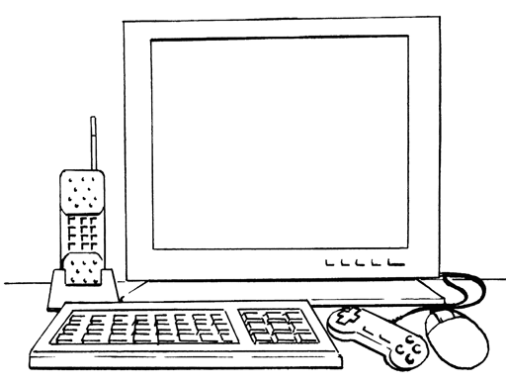

This (24) computer isn’t just a computer. It can be（可以是）a(25) . It can be a TV, (26) . If you buy this computer, these computer games are (27) . Come and buy one now.

- 對話測驗 (每題2分,共16分)
( ) 28. A: How old are your sisters? B: (A) She is thirteen. (B) Twelve and Nineteen. (C) They are not eleven. (D) They are girls.
( ) 29. A: Is that a marker? B: No, a pencil.(A) it’s (B) that (C) it isn’t (D) they’re
( ) 30. A: Your book bag is very cool. B: (A) That’s OK. (B) Oh no. (C) Thank you. (D) Ha! Ha! Ha!
( ) 31. A: Is Miss Chen your friend? B: (A) Yes, he is. (B) Yes, she’s. (C) Yes, she is not. (D) Yes, she is.
( ) 32. A: Are you OK? B: (選不適用的) (A) Very well. (B) I’m very well. (C) That’ OK. (D) Not very well.
( ) 33. A: Sorry, I’m late. B: (A) You’re OK. (B) It’s OK. (C) Are you OK? (D) Thank you.
( ) 34. A: I’m a magician. B: (A) Are you a magician? (B) What are you? (C) Yes, that’s right. (D) Wow! That’s cool.
( ) 35. A: Lily’s father? B: He is a police officer. (A) Who’s (B) What’s (C) How’s (D) How old

- 釋義 (每題2分,共6分)
( ) 36. Jolin: Aren’t those you and Ted’s pictures? Judy: Yes, they’re our pictures. (A) Those are Ted’s pictures. (B) Those are Jolin and Judy’s pictures. (C) Those are Judy and Ted’s pictures. (D) Those are Join and Ted’s pictures.
( ) 37. Susan’s brother, Kenny, is at David’s home.(A) David is at home. (B) Kenny is at David’s home. (C) Kenny isn’t at David’s home. (D) Susan is at David’s home.
( ) 38. Tim: Mark, are you twenty? Mark: No, I’m eighteen. My brother, Jerry, is twenty. (A) Tim is twenty years old. (B) Mark isn’t twenty years old, but Tim is. (C) Mark is not eighteen. (D) Mark’s brother is twenty.

- 重組句子 (每題2分,共6分)
( ) 39.○ I ○ David ○ classmates? ○ and ○ Are
(Ａ)○○○○○ (Ｂ)○○○○○ (Ｃ)○○○○○ (Ｄ)○○○○○
( ) 40.○ play the ○ I ○ computer game. ○ Peter ○ and
(Ａ)○○○○○ (Ｂ)○○○○○ (Ｃ)○○○○○ (Ｄ)○○○○○
( ) 41.○ and ○ They’re ○ Tony’s ○ Tom ○ pictures.
(Ａ)○○○○○ (Ｂ)○○○○○ (Ｃ)○○○○○ (Ｄ)○○○○○

- 閱讀測驗 (每題2分,共18分)
看圖選出正確答案。

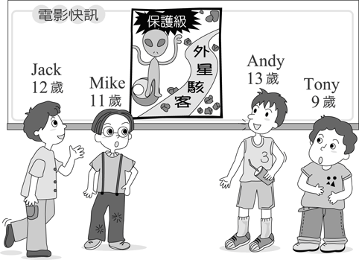

( ) 42. It’s a movie. (Ａ) right (Ｂ) same (Ｃ) police (Ｄ) PG-13
( ) 43. How old is Mike? (Ａ) Nine. (Ｂ) Eleven. (Ｃ) Twelve. (Ｄ) Thirteen.
( ) 44. Only can go see that movie. (Ａ) Jack. (Ｂ) Mike. (Ｃ) Andy. (Ｄ) Tony.

下表為 Tony，Amy，David，Bob 所擁有的物品及數量，請依表格回答問題：

( ) 45. A: Are those comic books? B: Yes. (Ａ) Tony’s (Ｂ) Amy’s (Ｃ) David’s (Ｄ) Bob’s
( ) 46. Only David has（有）a . (Ａ) telephone (Ｂ) notebook (Ｃ) whiteboard (Ｄ) computer
( ) 47. Those markers are . (Ａ) Tony’s (Ｂ) Amy’s (Ｃ) David’s (Ｄ) Bob’s
( ) 48.It is watch. (Ａ) Tony’s (Ｂ) Amy’s (Ｃ) David’s (Ｄ) Bob’s
( ) 49. They are notebooks. (Ａ) Tony and David’s. (Ｂ) Tony’s and David’s. (Ｃ) Tony and Amy’s. (Ｄ) Tony’s and Bob’s.
( ) 50. A: Are those Amy’s pictures? B: (Ａ) Yes, they are. (Ｂ) No, those are David’s. (Ｃ) No, those are not. (Ｄ) Yes, those are.

高雄縣立林園中學九十三學年度第一學期［國中部］一年級英語科單科評量
(測驗範圍：第一冊Unit One ~ Unit Three)

- 字彙選擇 (每題2分,共12分)
A B D D B D
- 文法選擇 (每題2分,共26分)
C B D D C A B D B C C B A
- 克漏字選擇 (每題2分,共16分)
B A C D B D A C
- 對話測驗 (每題2分,共16分)
B A C D C B D B
- 釋義 (每題2分,共6分)
C B D
- 重組句子 (每題2分,共6分)
B C C
- 閱讀測驗 (每題2分,共18分)
1.D B C 2.A D D B B B

