高雄縣立林園高中國中部九十三學年度第一學期第一次段考二年級英文科試題
※※※ 請在答案卷上作答 ※※※
第一部分: 聽力測驗
A. 根據聽到的內容, 選出相符合的圖片 (每題2分)
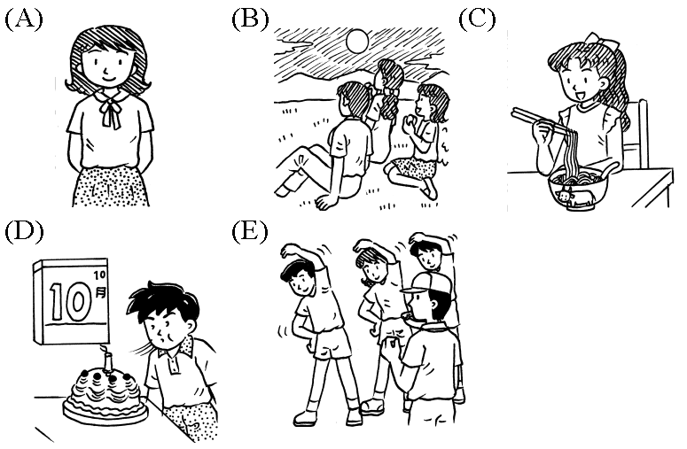
1. ( ) 2. ( ) 3. ( ) 4. ( ) 5. ( )

B. 細讀此表後, 回答下列問題 (約暫停20秒) (每題2分)
John’s School Schedule |  | Mon. | Tue. | Wed. | Thu. | Fri.
08:10~09:00 | 1 |  | History |  | English | Math
09:10~10:00 | 2 | English | Chinese | English | History
10:10~11:00 | 3 | Chinese |  | Math | Math | Chinese
11:10~12:00 | 4 | Math | Art | PE |  | English
( ) 1. (A) Two. (B) Three. (C) Four. (D) Five.
( ) 2. (A) Monday. (B) Tuesday. (C) Wednesday. (D) Thursday.
( ) 3. (A) Math. (B) PE. (C) Art. (D) Chinese.
( ) 4. (A) History. (B) Chinese. (C) Math. (D) English.
( ) 5. Which is true?

C. 根據所聽到的對話內容, 下列各題敘述正確者圈T, 錯誤者圈F (每題2分)
T F 1. Tom and Jenny are going to their teacher’s office.
T F 2. Today is September 28 th.
T F 3. Jenny bought some books for her teacher.
T F 4. Tom’s father’s birthday is in October.
T F 5. Tom’s father likes reading.

第二部分: 紙筆測驗
I. 文意字彙 (每題2分)
1. I am nine years old. I go to e y school.
2. I don’t u d the sentence. Can you translate(翻譯) it for me?
3. Today is October 10th. It’s our N l Day.
4. English is d t for Harry. He never does well on his English tests.
5. Be q t! It’s time for class.

II. 文法選擇 (每題2分)
( ) 1. You look great __________ your school uniform.
(A) on (B) at (C) for (D) in
( ) 2. We can ___________ in the music class.
(A) sing (B) sings (C) to sing (D) singing
( ) 3. There __________ so much __________ every day in school.
(A) are; to learn (B) has; learning (C) is; to learn (D) have; learning
( ) 4. There __________ differences __________ you and me.
(A) is; for (B) are; between (C) has; about (D) have; to
( ) 5. Father’s Day comes ___________ Mother’s Day and Teacher’s Day.
(A) after (B) before (C) on (D) between

III. 對話選擇 (每題2分)
( ) 1. A: Is he an American? B: ___________
(A) Of course I do. (B) They sure are.
(C) I guess so. (D) Come on!
( ) 2. A: ___________ B: It’s January 20th.
(A) What day is today? (B) What time is it?
(C) What date is today? (D) When is the first class?
( ) 3. A: You must be kidding! B: ___________
(A) Thank you. (B) No, I’m serious.
(C) Come on! (D) Really? Why?
( ) 4. A: What’s your favorite holiday? B: ____________
(A) I really like Christmas. (B) It’s my birthday, too.
(C) It’s on Teacher’s Day. (D) I don’t like it, either.
( ) 5. A: I have a problem. B: ____________
- Just go and ask the teacher. (B) Let’s go together.
(C) I’m shy, you know. (D) That’s right.

IV. 克漏字選擇 (每題2分)
A. There are many (1) to enjoy in a year. New Year’s Day (2) first on January 1st. People
(3) until 12 o’clock the night before. Chinese New Year (4) it during winter vacation. Chinese (5) the Dragon Boat Festival by having dragon boat races and eating rice dumplings.
( ) 1. (A) vacations (B) seasons (C) cards (D) holidays
( ) 2. (A) starts (B) comes (C) stays (D) makes
( ) 3. (A) work (B) stay up (C) welcome (D) plan
( ) 4. (A) comes before (B) comes on (C) is after (D) is between
( ) 5. (A) celebrate (B) guess (C) become (D) try

B. Amy: I hate to work with numbers. Math is (1) .
June: (2) I’m good at it. (3) , what’s your favorite class?
Amy: It’s the PE class.
June: PE is OK. (4) , I’m not good at playing sports.
( ) 1. (A) fun (B) excited (C) boring (D) interesting
( ) 2. (A) Not me. (B) You bet! (C) Me, either. (D) I agree.
( ) 3. (A) In that case (B) Really (C) You see (D) By the way
( ) 4. (A) However (B) Let me see (C) By the way (D) In that case

V. 閱讀測驗 (每題2分)
Dear Amy, Friday, February 5th
School will start next Monday. The Lantern Festival is on February 15th this year. It’s a holiday, and it’s my birthday, too. Our cousins will have a party for me on that day. Can you be here in Taiwan then? It will be great if you come back from the USA. Dad and Mom care much about you. We hope everything is OK for you there.
Sincerely,
Judy
( ) 1. When will school start?
(A) On February 1st. (B) On February 5th. (C) On February 8th. (D) On February 15th.
( ) 2. When is Judy’s birthday?
(A) Today. (B) Next Monday. (C) This Friday. (D) On February 15th.
( ) 3. Who will celebrate Judy’s birthday?
(A) Amy. (B) Dad and Mom. (C) Judy’s sister. (D) Judy’s cousins.
( ) 4. Where is Amy?
(A) In the USA. (B) In Taiwan. (C) At school. (D) At a party.
( ) 5. Who is Amy?
(A) Judy’s sister. (B) Judy’s classmate. (C) Judy’s cousin. (D) Judy’s parents.

VI. 翻譯 (每題3分)
1. 在中秋節觀賞滿月是很棒的。
2. 你的牛肉麵來了。
3. 他們常常送彼此生日卡片。
4. A: 你今天必須熬夜嗎？ B: 不，我不必。

高雄縣立林園高中國中部九十三學年度第一學期第一次段考二年級英文科答案卷
第一部分: 聽力測驗
A. 根據聽到的內容, 選出相符合的圖片 (每題2分)
1. ( ) 2. ( ) 3. ( ) 4. ( ) 5. ( )

B. 細讀此表後, 回答下列問題 (約暫停20秒) (每題2分)
1. ( ) 2. ( ) 3. ( ) 4. ( ) 5. ( )

C. 根據所聽到的對話內容, 下列各題敘述正確者圈T, 錯誤者圈F (每題2分)
1. | 2. | 3. | 4. | 5.
T F | T F | T F | T F | T F

第二部分: 紙筆測驗
I. 文意字彙 (每題2分)
1. | 2. | 3. | 4. | 5.

II. 文法選擇 (每題2分)
1. ( ) 2. ( ) 3. ( ) 4. ( ) 5. ( )

III. 對話選擇 (每題2分)
1. ( ) 2. ( ) 3. ( ) 4. ( ) 5. ( )

IV. 克漏字選擇 (每題2分)
A. 1. ( ) 2. ( ) 3. ( ) 4. ( ) 5. ( )
B. 1. ( ) 2. ( ) 3. ( ) 4. ( )

V. 閱讀測驗 (每題2分)
1. ( ) 2. ( ) 3. ( ) 4. ( ) 5. ( )

VI. 翻譯 (每題3分)
1.
2.
3.
4.
高雄縣立林園高中國中部九十三學年度第一學期第一次段考二年級英文科解答
第一部分: 聽力測驗
A. 根據聽到的內容, 選出相符合的圖片 (每題2分)
1. ( E ) 2. ( B ) 3. ( D ) 4. ( A ) 5. ( C )

B. 細讀此表後, 回答下列問題 (約暫停20秒) (每題2分)
1. ( B ) 2. ( C ) 3. ( A ) 4. ( D ) 5. ( B )

C. 根據所聽到的對話內容, 下列各題敘述正確者圈T, 錯誤者圈F (每題2分)
1. | 2. | 3. | 4. | 5.
T F | T F | T F | T F | T F

第二部分: 紙筆測驗
I. 文意字彙 (每題2分)
1. elementary | 2. understand | 3. National | 4. difficult | 5. quiet

II. 文法選擇 (每題2分)
1. ( D ) 2. ( A ) 3. ( C ) 4. ( B ) 5. ( D )

III. 對話選擇 (每題2分)
1. ( C ) 2. ( C ) 3. ( B ) 4. ( A ) 5. ( A )

IV. 克漏字選擇 (每題2分)
A. 1. ( D ) 2. ( B ) 3. ( B ) 4. ( C ) 5. ( A )
B. 1. ( C ) 2. ( A ) 3. ( D ) 4. ( A )

V. 閱讀測驗 (每題2分)
1. ( C ) 2. ( D ) 3. ( D ) 4. ( A ) 5. ( A )

VI. 翻譯 (每題3分)
1. Looking at the full moon on the Moon Festival is great.
2. Here come your beef noodles.
3. They often give each other birthday cards.
4. A: Do you have to stay up today? B: No, I don’t (have to).

