高雄縣立林園中學國中部九十三學年度第一學期第一次段考 三年級 英語科試卷
Part A: Listening Comprehension (30%，每題2分)
- 聽CD的敘述，根據圖片判斷，若是正確寫T，否則寫F。
1. 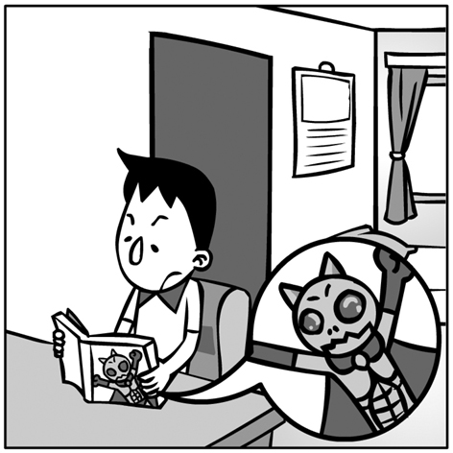 | 2. 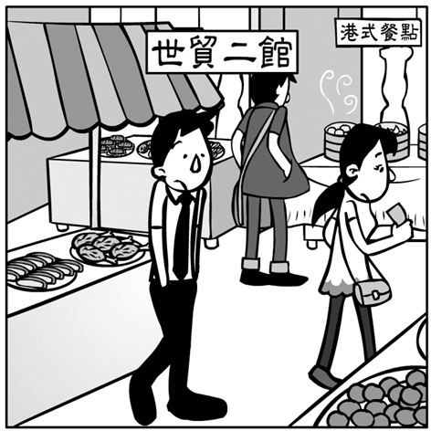 | 3. 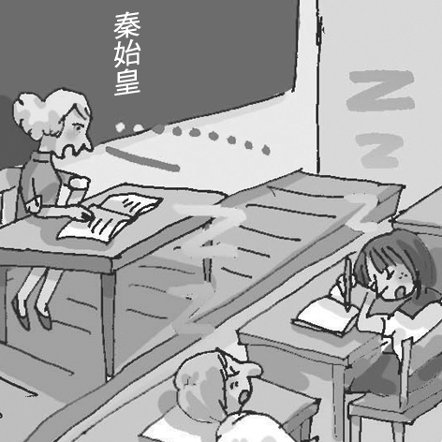 | 4. 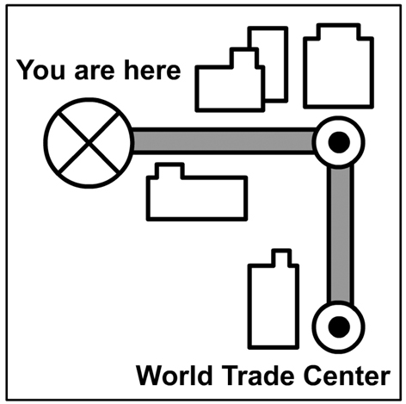
- 聽CD，選出符合圖意的句子。
1.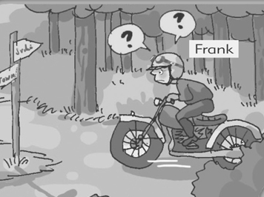 | 2.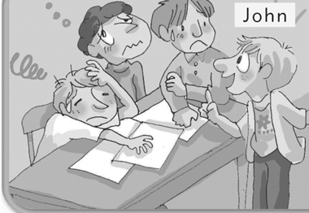 | 3.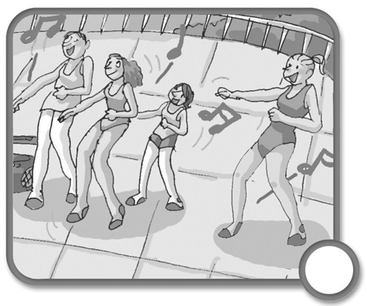 | 4.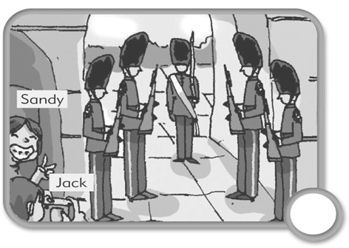 | 5.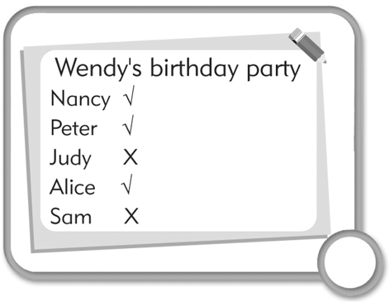 | 6.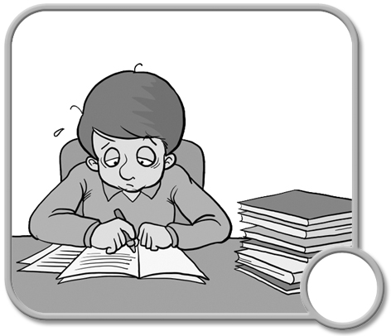
- 選出符合句子或對話情境所描述的圖片。
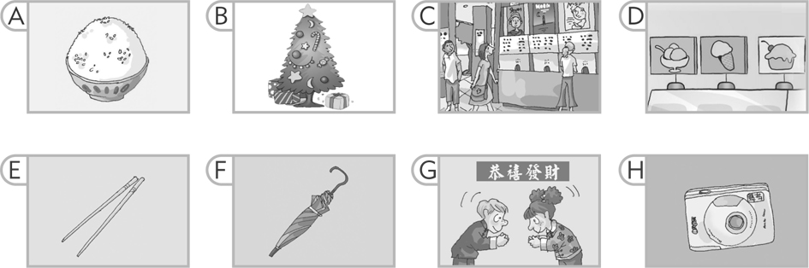
1.
2.
3.
4.
5.

Part B: Writing & Reading Comprehension (70%)
- 字彙&語法測驗(20%，每題2分)：
( )1. When you learn a new language, you need a . You can use it to find the meaning of new words.
(A) dictionary (B) novel (C) chance (D) notebook
( )2. You students come to school before 7:30. (A) will (B) should (C) would (D) can
( )3. People can buy the books or stationery （文具用品） in the .
(A) library (B) bookstore (C) conversation (D) convenient
( )4. When we are in a new place, we use to know the roads and directions.
(A) map (B) MRT (C) bridge (D) trade center
( )5. People can't live water and air in the world.
(A) with (B) not (C) without (D) in
( )6. What kind of do you prefer, climbing mountains or shopping?
(A) music (B) river (C) moment (D) activity
( )7. If you can your time, you can do everything well.
(A) make use (B) get use of (C) be interested in (D) make good use of
( )8. We had a picnic at the that day. And we had a lot of fun.
(A) sale (B) river (C) form (D) night
( )9. My bike yesterday. (A) sold (B) has sold (C) was sold (D) is sold
( )10. The TV show was very . I was with it and didn't want to watch it anymore.
(A) bored; bored (B) boring; bored (C) bored; boring (D) boring; boring
二、對話&釋義(10%，每題2分)：
（ ）1. Some people think good books are treasures to them.
- Some people like treasures more than books.
- Some people think books are more important than treasures.
(C) Good books are important to some readers.
(D) To some readers, treasures are as important as books.
( ) 2. Though the movie theater is very crowded on holidays, young people still like to go there for movies.
- People only see movies on holidays because the theater is crowded.
- Young people don't like to see movies.
- Young people go to the movies because it is very noisy.
- There are lots of people going to the movies on holidays.
( ) 3. Ted's sister has been to Australia.
- Ted's sister has gone to Australia; she isn't here now.
- Ted's sister is in Australia now.
- Ted's sister lived in Australia for a long time.
(D) Ted's sister visited Australia before.
( ) 4. English is spoken in America.
- In America speak English.
- Only English can be understood in the U.S.
- People speak English in America.
(D) People who live in America must speak English.
( ) 5. A: B: I like the special effects.
- How about going to the movies?
- How do you feel about the movie?
- Do you like seeing movies?
- What kinds of movies do you like?

三、將括弧中提示字，以正確形式填入空格中(20%，每題2分，*全對才給分)：
1. The thief (catch) by the police officer last night.
2. Nancy (know) Doris for six years.
3. I took some (excite) pictures when I took a trip to Japan.
4. The English homework must (do) before Friday.
5. John helped his father (wash) the car.
6. This song (sing) by Jay Chou.
7. Mary is surprised at (get) a good grade.
8. Mike is (tire) of fast food.
9. Our school (build) in 1935.
10. (write) an English poem is not an easy job for me.

- 閱讀測驗(10%，每題2分)：
(一)
One day, Mr. White sat next to Mrs. Brown on the train. They both had a long journey to San Francisco in California. However, they did not know each other. Mr. White thought it would be impolite if he did not speak to the woman. Then he began talking to Mrs. Brown, and said, "Do you have a family?"
"Yes, I do. I have a son and a daughter." She answered with a smile.
"It's good." Mr. White said. "Have your son ever smoked?"
"No, He never has. And I never let him smoke, either." Said Mrs. Brown.
"Oh! He's so good. Smoking is bad to our health, just like drinking wine. By the way, did he ever drink?" The man asked.
"Of course not!" He didn't drink even a drop of wine." The woman said.
"I'm so glad of hearing this. I think he must be a very good young man." He said, "How old is he?"
"He is six months old!" Answered the woman.
 journey 旅程 impolite 不禮貌 either 也不 wine 酒 drop 滴 smoke 抽煙
( ) 1. How did they go on their journey? (A) By plane. (B) By car. (C) By train. (D) By truck.
( ) 2. Where were they going? (A) Europe. (B) England. (C) San Francisco. (D) Taiwan.
( ) 3. How many children does Mrs. Brown have? (A) 1. (B) 2. (C) 3. (D) 4.
(二)
Here are the evening programs on four TV channels. Read and answer the questions.
Channel 9 |  | Channel 20 |  | Channel 33 |  | Channel 38
Time | Program | Time | Program | Time | Program | Time | Program
7:00. | Betty's Kitchen | 7:30 | Let's Learn English | 7:00 | American Sports Show | 6:30 | Evening News
7:30 | World News | 8:00 | World News | 8:00 | Music World | 7:30 | Funny Videos
8:00 | Movie: The Rising Star | 9:00 | Sports Today | 9:00 | Animal Show | 8:30 | Porter's Talk Show
program 節目 channel 頻道
( ) 4. At 8:00 p.m., if you want to know about world news, which channel should you watch?
(A) Channel 9.(B) Channel 20.(C) Channel 33.(D) Channel 38.
( ) 5. Steve wants to learn cooking. What time should he watch TV? (A) 7:00. (B) 7:30. (C) 8:00. (D) 9:00.
- 根據提示完成句子(10%，每題2分，*全對才給分)：
  - The Lin family is poor, but they are happy.（用 Though ~ 改寫）
  - I have enough money.
（用 if 合併）
I will buy the computer.
  - Playing on-line games is interesting to some students. (用interested改寫)
（用 since 合併）
  - David began to collect stamps in 1988.
David still collects stamps now.

（合併成一句）
5. Ken is watching his sister.
His sister is roller-blading in the park.

高雄縣立林園中學國中部九十三學年度第一學期第一次段考三年級英語科 答案卷
三年 班 座號： 姓名：

Part A: Listening Comprehension (30%，每題2分)
一、  1. | 2. | 3. | 4. | 二、  1. | 2. | 3. | 4. | 5. | 6.
三、  1. | 2. | 3. | 4. | 5.

Part B: Reading & Writing Comprehension (70%)
一、(20%，每題2分)
1. | 2. | 3. | 4. | 5. | 6. | 7. | 8. | 9. | 10.

二、(10%，每題2分)
1. | 2. | 3. | 4. | 5.

三、(20%，每題2分*全對才給分)
1. | 2. | 3. | 4. | 5.
6. | 7. | 8. | 9. | 10.

四、(10%，每題2分)
1. | 2. | 3. | 4. | 5.

五、(10%，每題2分*全對才給分)
1.
2.
3.
4.
5.

高雄縣立林園中學國中部九十三學年度第一學期第一次段考三年級英語科 解答
三年 班 座號： 姓名：

Part A: Listening Comprehension (30%，每題2分)
一、  1. T | 2. F | 3. F | 4. T | 二、  1. B | 2. B | 3. C | 4. B | 5. B | 6. A
三、  1. C | 2. G | 3. F | 4. D | 5. E

Part B: Reading & Writing Comprehension (70%)
一、(20%，每題2分)
1. A | 2. B | 3. B | 4. A | 5. C | 6. D | 7. D | 8. B | 9. C | 10. B

二、(10%，每題2分)
1. C | 2. D | 3. D | 4. C | 5. B

三、(20%，每題2分*全對才給分)
1. was caught | 2. has known | 3. exciting | 4. be done | 5. wash
6. is /was sung | 7. getting | 8. tired | 9. was built | 10. Writing

四、(10%，每題2分)
1. C | 2. C | 3. A | 4. B | 5. A

五、(10%，每題2分*全對才給分)
1. Though the Lin family is poor, they are happy.
2. I will buy a computer if I have enough money.
3. Some students are interested in playing on-line games.
4. David has collected stamps since 1988.
5. Ken is watching his sister roller-blade / roller-blading in the park.

