林園高中93學年度第一學期國中部第二次段考三年級英語科試題卷 Class____ Number____ Name_______
命題教師 : 王華範
Part I : Listening（聽力）（每題一律2分）
一、選出符合句子或對話情境所描述的圖片代號
1. _________ | 2.________ | 3.________
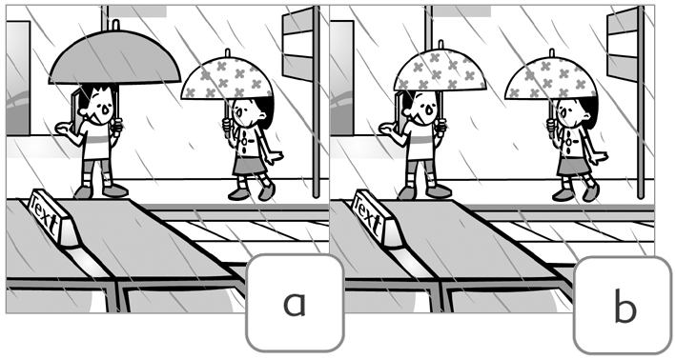 | 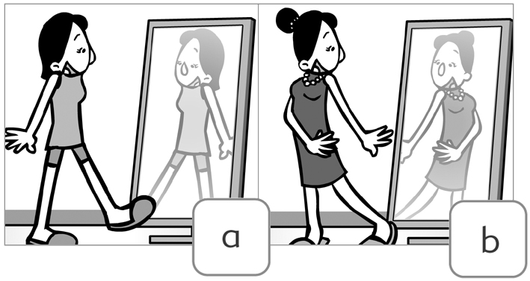 | 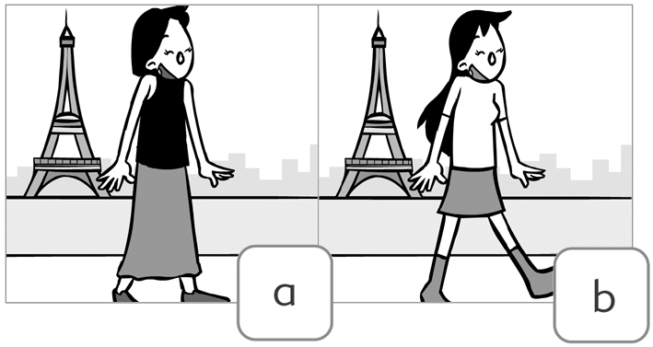
4._________ | 5._________
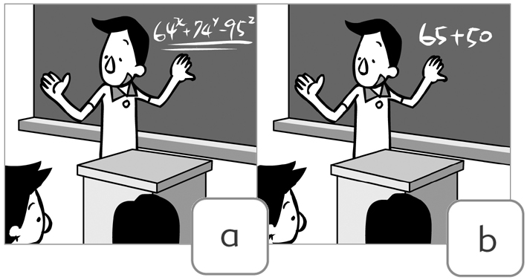 | 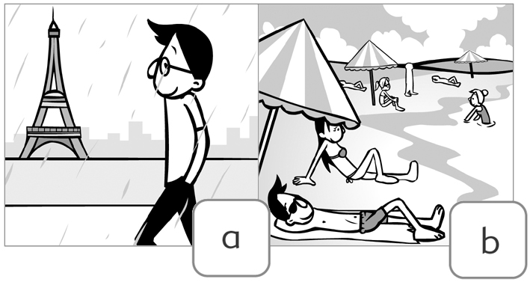

二、聽CD，根據對話選擇圖片或選擇回答
1. ________
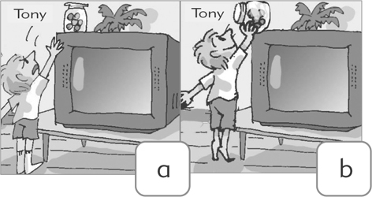
2.ˉ ˉ 3.ˉˉˉˉ
a. The U.S. a. They have to visit King's Cross Station.
b. England. b. They don't need to go to King's Cross Station.
c. Taiwan. c. They'll feel sorry about visiting King's Cross Station.
4.ˉˉˉˉ 5.ˉˉˉˉ
a. In the USA. a. Sweaters
b. In England. b. Gloves
c. In Taiwan. c. T-shirts
三、聽CD，選出符合圖意的句子
1.  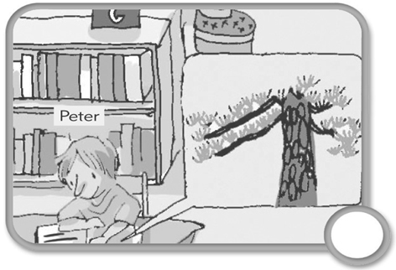 | 2.  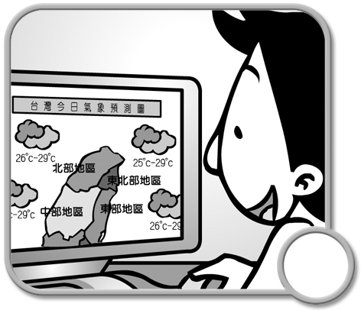 | 3.  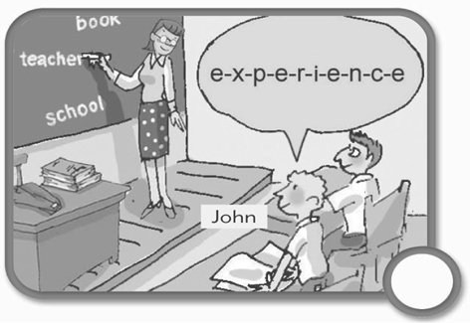 | 4.  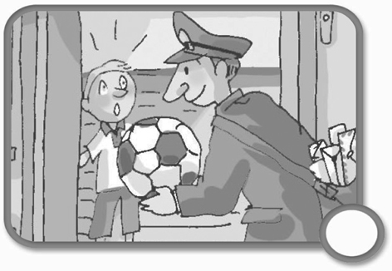 | 5.  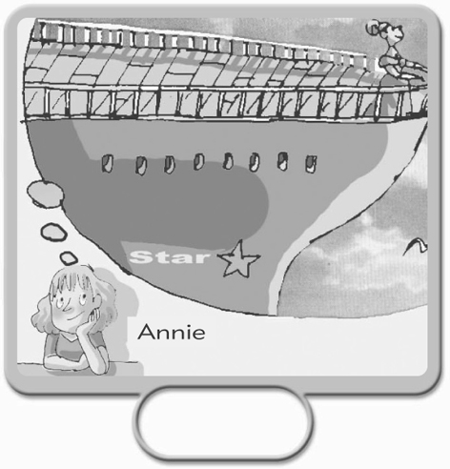
Part II : Comprehension（筆試）
一、字彙測驗：(每題2分，共20分)
- （ ）Take your ˉˉˉˉ coat and gloves. It's very cold in the mountains.
(A) own (B) bored (C) umbrella (D) painful
- （ ）Every time after I finish dinner, I use the ˉˉˉˉ to wash my face.
(A) towel (B) list (C) toothbrush (D) glove
- （ ）A: Have you ever taken a ˉˉˉˉ to Taipei?
B: No, I usually take the train because it's faster.
(A) ship (B) bike (C) bus (D) plane
- （ ）Miss Pan is a ˉˉˉˉ from South Africa. She is kind and friendly.
(A) foreigner (B) body (C) group (D) shop
- （ ）This question is very difficult. It is ˉˉˉˉ my understanding. Please help me.
(A) out (B) above (C) build (D) travel
- （ ）Fish and ˉˉˉˉ are popular food in England.
(A) chips (B) cheers (C) changes (D) chairs
- （ ）Do you know that Easter Day is famous for ˉˉˉˉ eggs? Children love doing this!
(A) saved (B) ordered (C) joined (D) colored
- （ ）When you go to the shopping mall, don’t forget to bring your _______.
(A) towel (B) list (C) ground (D) record
- （ ）May I take your ˉˉˉˉ now?
(A) tips (B)order (C) sunbath (D) waiter
- （ ）I’d like a steak special ______bread
(A) of (B) with (C) in (D) come
二、文法測驗：(每題1分，共14分)
- （ ）A: ˉˉˉˉ is the weather like in Taipei now?
B: It's very hot.
(A) How (B) What (C) Who (D) Where
- （ ）Those are her tomatoes, ˉˉˉˉ?
(A) aren't those (B) are they (C) are those (D) aren't they
- （ ）Betty's hair is ˉˉˉˉ than Linda's.
(A) more longer (B) the longer (C) a lot longer (D) very longer
- （ ）He will show you around when you come, ˉˉˉˉ?
(A) don't you (B) doesn't he (C) won’t he (D) do you
- （ ）Bob changes his study habits, and ˉˉˉˉ Jane.
(A) so does (B) so is (C) neither does (D) neither is
- （ ）Everyone is ready ˉˉˉˉ the picnic this weekend.
(A) To (B) for (C) on (D) with
- （ ）Ken tells me ˉˉˉˉ.
(A) some things funny
(B) funny somethings
(C) funny something
(D) something funny
- （ ）Here ˉˉˉˉ some facts about the hotel.
(A) has (B) is (C) are (D) have
- （ ）Shelly has ˉˉˉˉ as her sister.
(A) more money (B) much (C) as much money (D) money
- （ ）Elephants are animals ˉˉˉˉ two big ears and a long nose.
(A) with (B) have (C) in (D) about
- （ ）I need some books ˉˉˉˉ reading.
(A) to (B) for (C) in (D) with
- （ ）The homework for students ˉˉˉˉ very easy.
(A) are (B) must (C) should (D) is
- （ ）Iverson didn’t see the girl ˉˉˉˉ an umbrella.
(A) with (B) in (C) on (D) is wearing
- （ ）________ came to see you yesterday.
(A) Your one friend (B) One your friend (C) One friend of yours (D) A friend of your
三、對話與完成句子：(每題1分，共6分)
- （ ）Ted: ˉˉˉˉ
Linda: Yes, we do.
(A) We are going shopping, aren't we?
(B) We won't have dinner, will we?
(C) We need to take an umbrella, don't we?
(D) We can't go out, can we?
- （ ）Debbie: Are these jeans yours?
Marvin: ˉˉˉˉ
(A) Yes, they are yours.
(B) Yes, it's theirs.
(C) No, they are mine.
(D) No, they are Peter's.
- （ ）Judy: Aren't you surprised at his report?
Kate: ˉˉˉˉ
(A) No, I am very surprised.
(B) Yes, I am not. It's nothing.
(C) No, I am surprised at it..
(D) Yes, I am. It's great!
- （ ）Monica: I couldn’t catch the bus yesterday.
Gilbert: ˉˉˉˉ
Monica: Let’s leave earlier now.
(A) So could I.
(B) What about you?
(C) Neither can I.
(D) I couldn’t, either.
- （ ）Husband: Can little Sam go to school?
Wife: I don’t think so. ˉˉˉˉ
(A) He’s old enough to go to school.
(B) He’s too young to go to school.
(C) He’s too old to go to school.
(D) He’s too young not to go to school.
- （ ）Lisa: You don’t love me, do you?
Tim: ˉˉˉˉ
(A) Yes, I do. I have another girlfriend.
(B) Yes, I do. You are my only love.
(C) No, I don’t. I don’t have another girlfriend.
(D) No, I don’t. You are my only love.
四、閱讀測驗：(每題1分，共10分)
A. You might be surprised to learn that most food in the United States comes from other countries. Pasta and pizza were brought to America from Italy. Tacos, burritos and many other wonderful dishes came from Mexico. Other popular foods came from China, Japan, and elsewhere. A restaurant menu might have words from many languages. This does not mean there is no such thing as “American” food. It just means that American food has dishes and tastes from the whole world.
pasta通心麵 taco墨西哥薄捲餅 burrito玉米麵餅 dish菜餚 tastes味道
- ( )What is the writer trying to say in the first sentence?
  - Many people think most food in America comes from America.
  - The American food is the most important food in the world.
  - Many people are learning to cook American food.
  - No food in the United States comes from other countries.
2. ( )Which of the following word has the same meaning as “wonderful”?
（A）terrible （B）seafood （C）great （D）happy
3. ( )How many different countries are there in the story?
（A）four （B）three （C）two （D）five
4. ( )What does it mean if food is “popular”?
（A）Many people like it. （B）A lot of people hate it.
（C）It must smell terrible. （D）It looks really beautiful.
B. When you bargain, never let the shopkeeper know how much you want something. Instead, act like you do not care whether you buy it or not. You should also criticize the thing you want to buy. For example, you can say you have seen it at another store for a lower price. Or you could say the style or color is old. Now you know what to do when you bargain. Maybe you will never pay too much for something again. Good luck and happy shopping.
Instead 相反地 act 表現 criticize批評
5. ( )What would you do if you like something?
（A）Let the person in the shop know.
（B）Never tell the person in the shop.
（C）Just buy it right now.
（D）Talk to the shopkeeper for fun.
6. ( )What might happen in the future if you learn how to shop well?
（A）You may not have to pay too much for something again.
（B）You won’t buy anything.
（C）You will borrow others’ money to shop.
（D）You won’t have to talk so much again.
7. ( )What does the underlined word “bargain” mean?
（A）forget to bring money
（B）shop with your husband
（C）ask for a lower price
（D）shop at different stores
C. One afternoon, a cat saw a mouse and started to chase him. The mouse got away by running into his mouse hole. The cat then waited for the mouse to come out. The mouse knew the cat was outside. But, suddenly, he heard barking. He thought a dog had scared the cat away, so he came out. At that moment, the cat caught the mouse. The mouse was surprised. “How can you bark like a dog?” he asked. “In today’s global village,” the cat said, “everyone should speak a second language!”
chase追 hole 洞 global全球的
8. ( )How many animals are written about in this story?
（A）one（B）three（C）two（D）four
9. ( )What did the cat do while the mouse was in the hole?
（A）The cat talked with the dog. （B）The cat ran away.
（C）The cat waited for the mouse. （D）The cat was surprised.
10. ( )What is the main point（主旨） of the article?
（A）The cat catches the mouse.
（B）The mouse is afraid of the cat.
（C）The cat can bark like a dog.
（D）Learning a second language is very important.

五、依照事實回答問題：(每題2分，共10分)（錯一處扣一分）  【一律詳答】  - What does the word “chips” mean in the U.S?  - What did you have for breakfast this morning?  - Which English are we learning, British or American English ?  - How long can most lizards live?  - Which is cheaper, a five-star hotel or a Bed & Breakfast? | 六、翻譯：(每題2分，共10分) （錯一處扣一分）  - 一些語言在說時與用時都不同。  - 你曾經夢想過環遊世界嗎？  - 你的報告進行得怎麼樣了？  - 我不認識那位戴眼鏡的老師。  - 學生們必須認真以通過（pass）基本學力考試（ the Basic Competence Test）。

三年級第二次段考英語科解答卷 命題 : 華範 分機16
【粗框為2分題】
Part I : Listening（聽力）（每題一律2分）
一  1. a | 2. b | 3. b | 4. a | 5. a | 二  1. a | 2. b | 3. a | 4. b | 5. c
三  1. b | 2. a | 3. a | 4. c | 5. b

Part II : Comprehension（筆試）
一、字彙測驗：(每題2分，共20分)
1.A | 2.A | 3.C | 4.A | 5.B | 6.A | 7.D | 8.B | 9.B | 10.B

二、文法測驗：(每題1分，共14分)
1.B | 2.D | 3.C | 4.C | 5.A | 6.B | 7.D | 8.C | 9.C | 10.A
11.B | 12.D | 13.A | 14.C

三、對話與完成句子：(每題1分，共6分)
1.C | 2.D | 3.D | 4.D | 5.B | 6.B

四、閱讀測驗：(每題1分，共10分)
1.A | 2.C | 3.D | 4.A | 5.B | 6.A | 7.C | 8.B | 9.C | 10.D

五、依照事實回答問題：(每題2分，共10分) 【一律詳答】（錯一處扣一分）
1. It (The word) means fries in the U.S.
2. 略
3. We are learning American English.
4. They can live for 15 years.
5. A Bed & Breakfast is cheaper.

六、翻譯：(每題2分，共10分) （錯一處扣一分）
1. Some languages are spoken or used differently.
2. Have you（ever）dreamed about traveling around the world?
3. How’s your report going?
4. I don’t know the teacher with glasses.
5. Students have to study hard to pass the Basic Competence Test.

