高 雄 縣 立 林 園 高 中 93 學 年 度 第 二 學 期 （國中部）第 二 次 月 考 一 年 級 英 語 科 考 卷

命題教師:賴春苑
班級: 姓名: 座號:
(一)、聽力部份：30%

- 選出與聽到的單字不同類別的選項。5%

1.（ ） soup k dumplings l plate
2.（ ） beef k peach l orange
3.（ ） glass k spoon l salt
4.（ ） PE k math l month
5.（ ） green tea k fried rice l beef noodles

- 若聽到的內容與題目相符畫；不符則畫Î。5%

1.（ ）I get up at six thirty.
2.（ ）Helen has math class on Thursdays.
3.（ ）I like oranges, but I don’t like apples.
4.（ ）Which do you like, salad or soup?
5.（ ）The guavas are two for 20 dollars.

選出適當的答句。10%

1.（ ）j They are cheap.
k They are ten for $99.
l It’s 99 dollars.
2.（ ） j We need 10 paper cups and 10 paper plates.
k There are 20 paper cups and 20 paper plates.
l They need 30 paper cups and 30 paper plates.
3.（ ） j The pizza is really good.
k I don’t like French fries.
l I like hamburgers.
4.（ ） j At 7:30 in the morning, I wash my face.
k At 1:00 in the afternoon, I brush my teeth.
l At 9:00 in the morning, I brush my shoes.
5.（ ） j I go to English class on Mondays.
k I like English class, but I don’t like science class.
l I don’t have English class on Mondays.

-1-

四、在圖片上方寫出聽到的題號。10%

(A) ( ) (B) ( ) (C) ( )
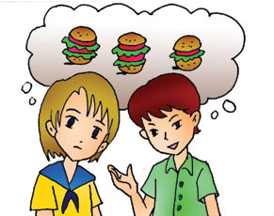
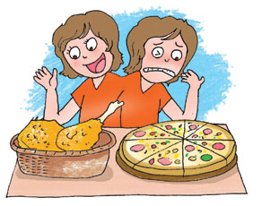
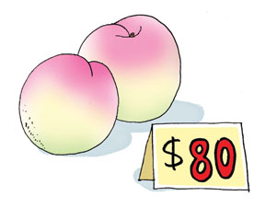

(D) ( ) (E) ( )
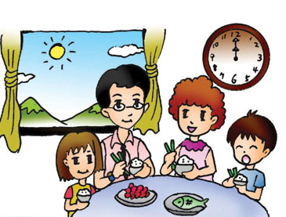
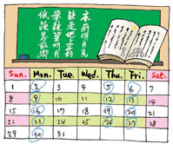

(二)、筆試部分：70%
I.文意字彙：12%

  - This watch is very e_______e. I do not have enough money to buy it.
  - In a s______t, you can buy fruit, food, meat and almost everything you need every day.
  - It is healthy(健康的) to eat b______s after a meal. (餐後)
  - On weekends, there are many people eating at a r_____t.
  - Many people in Taiwan eat s_____s for breakfast.
  - Jenny is good at English. Not me. I like s______l studies better.

II.文法選擇：20%
1.There are three ____ students in my school. (A) thousands (B)thousand (C)thousand of (D) thousands of
2.Lisa: ______ do you make fried rice? Amy: ____ some eggs, rice, salt and ham, and cook everything together.
  - Why; Take (B) How; Take (C) What; To take (D) Which; Taking
3.I can’t eat too much. I ____ .
(A) on diet (B)on a diet (C)go on a diet (D) in a diet
4.We can eat some cake and fruit _____ the picnic.
- on(B) for (C)in (D)at
5.My family _____ a birthday party for me.
(A) plans (B)are planing (C) is planning (D) are planning
6.David,____ quiet! It is not polite (禮貌的) to talk in class.
(A)are (B) be (C) is (D) do
7.Come to my house tonight. I buy a ____ dog. (A) two-month-old(B) two months old (C) two months (D) two-months-old
8.The beef noodles are too hot. Can I order ____ ?
- some drink(B) some tomatoes soup (C) some drinks (D) some tomato soups
-2-

9. We need to drink eight _____ of water every day.
(A) glasses (B)cups (C)bowls (D)glass
10.Peter will ____ with his classmates next Sunday.
(A) go picnic (B) go picnicing (C) go picnics(D) go picnicking

III.克漏字填空:10﹪
Amy is from the U.S.A. But now she is teaching English here in Taiwan. She is pretty __(1)__ tall. She likes the food in Taiwan. But she can’t use chopsticks __(2)__. In America, people use forks and k__(3)__ when eating. She likes cooking. Today she wants to make an apple pie because (因為) the apples are __(4)_ sale. Her pies are very delicious. All of her friends like her pies very __(5)__.

IV.閱讀測驗：10%
Tea, please!
We have many kinds of tea in Taiwan, 1ike green tea, black tea, jasmine tea, Oolong tea or pearl milk tea, but do you know which one is the most popular. Bingo! Pearl Milk Tea. When many foreigners come to Taiwan, their friends always ask them to try it first and they like it a lot. When they go back, they even miss it and want to try it again. Pearl Milk Tea is from the city, Taichung, served hot and cold. Its first name is boba milk tea. It is because there are some giant round balls in it besides milk, tea, and sugar. At first sight, some people like it but some maybe hate it. When you enjoy it, you need a wide straw to suck up the giant round balls. Now, even if you are in Taipei, Kaohsiung, New York or Tokyo, you can enjoy it. It is that famous. Do you like it?

Kind種類 popular受歡迎的 foreigner外國人 serve供應 because因為 giant巨大的
besides除之外 at first sight初見 maybe也許 hate討厭 suck吸飲

1. Where is Pearl Milk Tea from?
  - Taipei （B）Taichung (C) Kaohsiung （D）New York
2.From the passage, how many kinds of tea can you find?
    - Five. （B）Three . （C）Four. （D）I don’t know.
3.What will those foreigners miss when they go back?
- Taiwan. （B）Their friends. （C）Pearl Milk Tea.（D）Taipei 101 mall.
4.Boba in the passage means
(A) a beautiful woman. （B）a small marble. （C） the giant round balls.（D）milk tea.
5.You need _________ to suck up the giant round balls in the milk tea.
(A) a fork （B）a spoon （C）a wide straw （D） chopsticks

VI.依提示作答及翻譯：18%
    - My mother gets up at six every morning.（造原問句）2%
    - I need twenty apples and peaches. （造原問句）2%
    - The guavas are ten for $99. （造原問句）2﹪
    - 你要哪一樣,炸雞或披薩。3%
    - 下次試試我的炒麵。3%
    - 看!河裡有許多魚。3%
    - 我妹妹正在和麥克講電話。3%

高 雄 縣 立 林 園 高 中 93 學 年 度 第 二 學 期 （國中部）第 二 次 月 考 一 年 級 英 語 科 答 案 卷

班級: 姓名: 座號:

聽力部份：30%
一、選出與聽到的單字不同類別的選項。5%
1.（ ）2.（ ）3.（ ）4.（ ）5.（ ）
二、若聽到的內容與題目相符畫；不符則畫Î。5%
1.（ ）2.（ ）3.（ ）4.（ ）5.（ ）

三、選出適當的答句。10%
1.（ ）2.（ ）3.（ ）4.（ ）5.（ ）
四、在圖片上方寫出聽到的題號。10%
A.（ ）B.（ ）C.（ ）D.（ ）E.（ ）
筆試部分：70%
I. 文意字彙：12%
1 | 2 | 3 | 4 | 5 | 6

II.文法選擇：20%
1.（ ）2.（ ）3.（ ）4.（ ）5.（ ）
6.（ ）7.（ ）8.（ ）9.（ ）10.（ ）

III.克漏字填空:10﹪
1 | 2 | 3 | 4 | 5

IV.閱讀測驗：10%
1.（ ）2.（ ）3.（ ）4.（ ）5.（ ）

V.依提示作答及翻譯：18%(1-3題, 毎題 2 分; 4-7題, 每題 3 分)

1

2

3

4

5

6

7

高 雄 縣 立 林 園 高 中 93 學 年 度 第 二 學 期 （國中部）第 二 次 月 考 一 年 級 英 語 科 答 案 卷

班級: 姓名: 座號:
聽力部份：30%
一、選出與聽到的單字不同類別的選項。5%
1.（ 3 ）2.（ 1 ）3.（ 3 ）4.（ 3 ）5.（ 1 ）
二、若聽到的內容與題目相符畫；不符則畫Î。5%
1.（ x ）2.（ o ）3.（ x ）4.（ o ）5.（ x ）

三、選出適當的答句。10%
1.（ 2 ）2.（ 3 ）3.（ 3 ）4.（ 2 ）5.（ 1 ）
四、在圖片上方寫出聽到的題號。10%
A.（ 5 ）B.（ 3 ）C.（ 4 ）D.（ 1 ）E.（ 2 ）
筆試部分：70%
I. 文意字彙：12%
1 expensive | 2 supermarket | 3 bananas | 4 restaurant | 5 sandwiches | 6 social

II.文法選擇：20%
1.（ B ）2.（ B ）3.（ C ）4.（ D ）5.（ D ）
6.（ B ）7.（ A ）8.（ C ）9.（ A ）10.（ D ）

III.克漏字填空:10﹪
1 and | 2 well | 3 knives | 4 on | 5 much

IV.閱讀測驗：10%
1.（ B ）2.（ A ）3.（ C ）4.（ C ）5.（ C ）

V.依提示作答及翻譯：18%(1-3題, 毎題 2 分; 4-7題, 每題 3 分)

1 What time does your mother get up every morning?

2 How many apples and peaches do you need?

3 How much are the guavas?

4 Which do you want, fried chicken or pizza?

5 Next time try my fried noodles.

6 Look! There are many fish in the river.

7 My sister and Mike are talking on the telephone.

