高雄縣立林園高級中學(國中部) 九十三學年度第二學期 第三次段考 一年級英語科試卷
命題教師:陳佳慧 一年 班 號 姓名：

(注意:請將答案填入答案卷中，繳卷時僅交答案卷即可)
I.聽力測驗(共20分)
（1）聽問句，選出適當的答句(每題2分，共10分)
1.（ ） ① She never go swimming after school.
② She always does her homework after school.
③ Yes, she always go jogging after school.
2.（ ） ① I usually go home by MRT.
② I never go home by car.
③ I usually go home at 6 p.m.
3.（ ） ① No, I wasn’t.
② No, we aren’t.
③ Yes, I was tired.
4.（ ） ① She wasn’t in the hospital.
② She was in the museum.
③ She is in the train station.
5.（ ） ① Yes, I was in the U.S.A.
② I wasn’t in Taiwan.
③ I was in Japan.
（2）若聽到與圖片相符的打○，不符的畫×(每題1分，共5分)
1. 2. 3.




4. 5.
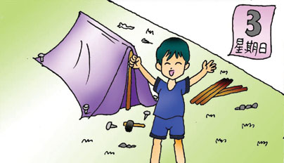
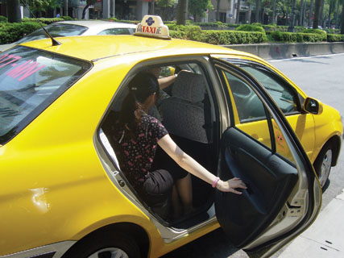

（3）寫出與錄音內容相符的圖片代號(代號為A, B, C, D, E) (每題1分，共5分)
A. B. C. D. E.
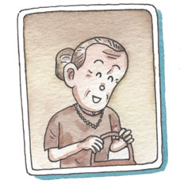
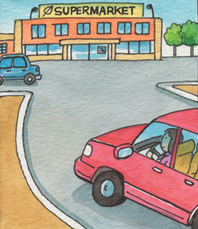
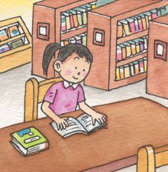
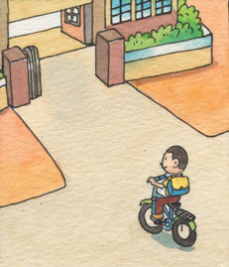
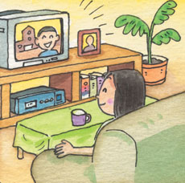

1. |  | 2. |  | 3. |  | 4. |  | 5.

II.文意字彙(每題1分，共10分)
Which club(社團) do you like to j n in?
We need to buy some fruit and food（食物）for the picnic. Let's go s g.
My grandfather often goes m n climbing, so he's still healthy(健康).
Don't leave（留下）the little boy at home a e. It's very dangerous（危險的）.
A: What time is it ? B: It's a y nine o'clock now.
Mother's day is on the s d Sunday of May(五月)
Amy's mom and dad often takes her to go skiing. She has very good p ts.
My brother often goes h g on Sundays.
I don't think Mom will（將會）let you go outside. She looks a y now.
I got（收到）many birthday c s from my friends this year.

III.文法選擇(每題2分，共20分)
（ ）Your brother was still here hour ago. (Ａ) two (Ｂ) an (Ｃ) a (Ｄ)×
（ ）Let's get off the next stop. (Ａ) at (Ｂ) × (Ｃ) in (Ｄ) on
（ ）How much the taxi fare? (Ａ) be (Ｂ) are (Ｃ) is (Ｄ) does
（ ）Here the train. (Ａ) come (Ｂ) comes (Ｃ) coming (Ｄ) to come
（ ）I have two . You can use my card. (Ａ) bus card (Ｂ) buses card (Ｃ) bus cards (Ｄ) buses cards
（ ）Zax: Were you nervous? Selina: No, I . (Ａ) isn't (Ｂ) weren't (Ｃ) am not (Ｄ) wasn't
（ ）My teacher always walks to school, Mike also goes foot. (Ａ) and; on (Ｂ) but; on (Ｃ) or; with (Ｄ) and; with
（ ）My grandpa when he's free. (Ａ) always listen to CDs (Ｂ) often watches TV (Ｃ) goes mountain climbing always (Ｄ) goes never swimming
（ ）He doesn't like fishing . (Ａ) very well (Ｂ) on time (Ｃ) on the way (Ｄ) at all.
（ ）Were you in China ? (Ａ) right now (Ｂ) the day after tomorrow (Ｃ) three months ago (Ｄ) next year

IV.對話與釋義(每題2分，共10分)
（ ）Sam: Oh, no. I don't have any money with me. David: I have five hundred dollars. It's enough.
(Ａ) I can't hear you.
(Ｂ) We can go on foot.
(Ｃ) You're right.
(Ｄ) Don't worry.
（ ）Hebe: Ella: My boyfriend's picture. Isn't he handsome?
(Ａ) What about your boyfriend?
(Ｂ) What are you looking at?
(Ｃ) Is it your boyfriend's album?
(Ｄ) Are you listening to CDs?
（ ）Jolin: What days do you go swimming? Jay: (Ａ) In my free time. (Ｂ) On weekends. (Ｃ) In the afternoon.
(Ｄ) At about five o'clock.
（ ）Coco: Where were your parents last night? Lily:
(Ａ) We were at the church.
(Ｂ) My parents was in the hospital.
(Ｃ) They are in the museum.
(Ｄ) They were at home all night.
（ ）It was May's first day of school, and she was nervous. (請選出意思相同者)
(Ａ) It's easy for May to be nervous.
(Ｂ) May was nervous on her first day of school.
(Ｃ) May looks nervous in the picture.
(Ｄ) May was nervous when she was at school.

V.閱讀測驗(每題2分，共20分)
(1)以下是Charlene老師班上學生所寫的便條，請依其內容回答下列問題


I wasn’t beautiful before, but now I’m pretty. I like to help people.
Angel
I was short and fat, but I am thin and tall now.
Tony

I was ugly, but now I’m handsome now. My classmates think I’m often angry. I don’t think so. Terry
I was nice, but now I am not cute at all. I don’t like my friends.
Cathy

（ ） Who was sweet before?
[ Word Bank ]
fat胖 thin瘦 ugly醜
(Ａ) Sherry. (Ｂ) Tony. (Ｃ) Cathy. (Ｄ) Terry.
2.（ ）Terry doesn't think he is often .
(Ａ) afraid (Ｂ) nervous (Ｃ) worried (Ｄ) angry
3.（ ） Isn't Tony short and fat?
(Ａ) Yes, he isn't. (Ｂ) No, he is. (Ｃ) Yes, Tony is. (Ｄ) No, he isn't.

(2)下表為 Cathy 的行程表，請看表回答問題
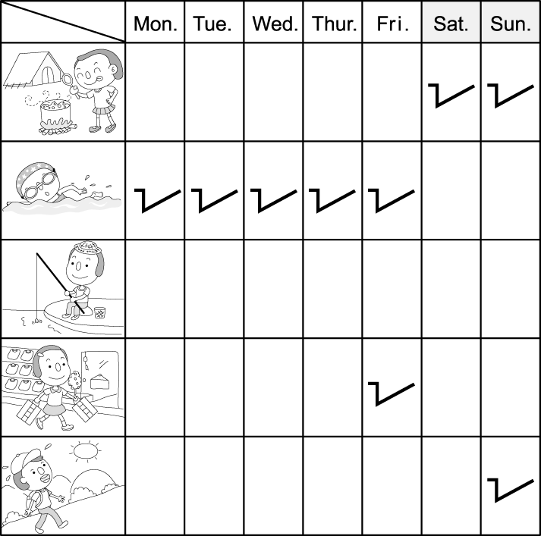
4.（ ） What does Cathy usually do on weekends? She often . (Ａ) goes hiking (Ｂ) goes camping (Ｃ) plays basketball (Ｄ) plays tennis
5.（ ） What does Cathy do after school? She always . (Ａ) go shopping (Ｂ) studies math (Ｃ) goes swimming (Ｄ) plays the piano
6.（ ） Cathy goes fishing in her free time. (Ａ) always (Ｂ) usually (Ｃ) sometimes (Ｄ) never

(3)請依下面地圖填入正確地點之選項代號
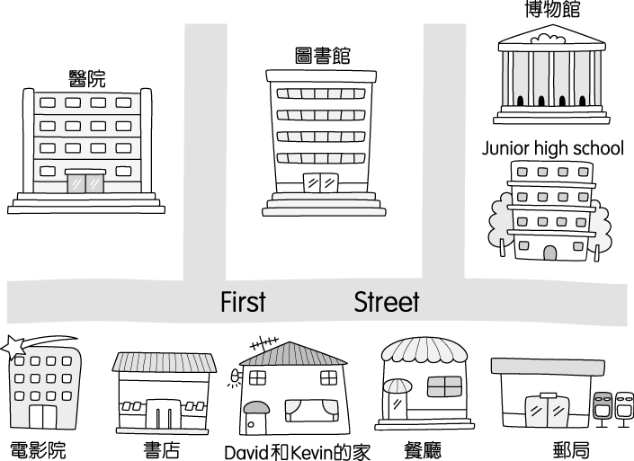
[ Word Bank ]
live 住 between在…之間 across from對面
end盡頭 street街 convenient 方便的
選 項 代 號
(Ａ) post office (Ｂ) museum
(Ｃ) bookstore (Ｄ) library (Ｅ)hospital
David and Kevin live in a big city. Their house is between a (7) and a restaurant. Next to the restaurant is a (8) . David and Kevin's school is right across from it. The (9) is behind the school. At the end of the street is a (10) . It's really convenient to live in a big city.

VI.翻譯(每題4分，共20分)
1.What does Tom usually do when he's free?（以「他經常去露營」詳答）

2.Sara often goes to church by taxi.（依畫線部分造原問句）

3.Kevin 需要從市立圖書館借些VCD。

4.上星期三我媽媽很生氣。

5.她哥哥總是得第一。

高雄縣立林園高級中學(國中部) 九十三學年度第二學期 第三次段考 一年級英語科答案卷
命題教師:陳佳慧 一年 班 號 姓名：

I.聽力測驗(共20分)
（1）聽問句，選出適當的答句(每題2分，共10分)
1 |  | 2 |  | 3 |  | 4 |  | 5
（2）若聽到與圖片相符的打○，不符的畫×(每題1分，共5分)
1 |  | 2 |  | 3 |  | 4 |  | 5
（3）寫出與錄音內容相符的圖片代號(每題1分，共5分)
1 |  | 2 |  | 3 |  | 4 |  | 5
II.文意字彙(每題1分，共10分)
1 |  | 6
2 |  | 7
3 |  | 8
4 |  | 9
5 |  | 10
III.文法選擇(每題2分，共20分)
1 |  | 2 |  | 3 |  | 4 |  | 5
6 |  | 7 |  | 8 |  | 9 |  | 10
IV.對話與釋義(每題2分，共10分)
1 |  | 2 |  | 3 |  | 4 |  | 5
V.閱讀測驗(每題2分，共20分)
1 |  | 2 |  | 3 |  | 4 |  | 5
6 |  | 7 |  | 8 |  | 9 |  | 10
VI.翻譯(每題4分，共20分)
1
2
3
4
5
高雄縣立林園高級中學(國中部) 九十三學年度第二學期 第三次段考 一年級英語科答案卷
命題教師:陳佳慧 一年 班 號 姓名：

I.聽力測驗(共20分)
（1）聽問句，選出適當的答句(每題2分，共10分)
1 | 2 | 2 | 1 | 3 | 1 | 4 | 2 | 5 | 3
（2）若聽到與圖片相符的打○，不符的畫×(每題1分，共5分)
1 | × | 2 | ○ | 3 | ○ | 4 | ○ | 5 | ×
（3）寫出與錄音內容相符的圖片代號(每題1分，共5分)
1 | D | 2 | E | 3 | B | 4 | A | 5 | C
II.文意字彙(每題1分，共10分)
1 | join | 6 | second
2 | shopping | 7 | parents
3 | mountain | 8 | hiking
4 | alone | 9 | angry
5 | already | 10 | cards
III.文法選擇(每題2分，共20分)
1 | B | 2 | A | 3 | C | 4 | B | 5 | C
6 | D | 7 | A | 8 | B | 9 | D | 10 | C
IV.對話與釋義(每題2分，共10分)
1 | D | 2 | B | 3 | B | 4 | D | 5 | B
V.閱讀測驗(每題2分，共20分)
1 | C | 2 | D | 3 | D | 4 | B | 5 | C
6 | D | 7 | C | 8 | A | 9 | B | 10 | E
VI.翻譯(每題4分，共20分)
1 | He usually goes camping when he’s free.
2 | How does Sara often go to church?
3 | Kevin needs some VCDs from the city library.
4 | My mother was very angry last Wednesday.
5 | Her brother always wins first prize.

