林園高中九十三學年度第二學期國中部英語科單科評量一年級考卷
命題教師:尤信貿 一年 班 號 姓名：

（ ）A: Hey! Do you Jack? B: The new classmate in your class? A: Yes.(Ａ)draw (Ｂ)remember (Ｃ)listen (Ｄ)exercise
（ ）A: What do you like? B: I like koalas(無尾熊). (Ａ) animal (Ｂ) dinner (Ｃ) rope (Ｄ) party
3. ( ) I miss the bus. I have to wait for the _______ one. (A)under (B)next (C)behind (D)some
（ ）The pencil is too short, Please give(給) me one. (Ａ) enough (Ｂ) another (Ｃ) hungry (Ｄ) same
（ ）We can see many animal shows in a . (Ａ) host (Ｂ) circus (Ｃ) museum (Ｄ) restaurant
（ ）Jack's mom is in the hospital(醫院). His sister is . (Ａ) hungry (Ｂ) sick (Ｃ) smart (Ｄ) tired
（ ）Today is Dad's birthday. And Mom is making a cake for him. (Ａ) sick (Ｂ) same (Ｃ) busy (Ｄ) smart
（ ）Alex often has dinner with his family at this . (Ａ) circus (Ｂ) museum (Ｃ) restaurant (Ｄ) breakfast
（ ）You can some drinks before eating. (Ａ) catch (Ｂ) order (Ｃ) jump (Ｄ) listen
（ ）Sara and her parents go to the movies . (Ａ) together (Ｂ) later (Ｃ) o'clock (Ｄ) really
11.（ ）It's late the show. (Ａ) at (Ｂ) for (Ｃ) in (Ｄ) on
12.（ ）Mike loves the ball games . (Ａ) very (Ｂ) pretty (Ｃ) much (Ｄ) so very
13.（ ）Can the monkey ride a bike, ? (Ａ) too (Ｂ) right (Ｃ) OK (Ｄ) all right
14.（ ）What time Tony go to school? (Ａ) do (Ｂ) does (Ｃ) can not (Ｄ) doing
15.（ ）Mark his teeth every morning. (Ａ) brush (Ｂ) brushing (Ｃ) brushes (Ｄ) brushs
16.（ ）The Wang family dinner now. (Ａ) is having (Ｂ) having (Ｃ) has (Ｄ) are having
17.（ ）Amy's brother is tall handsome. (Ａ) with (Ｂ) or (Ｃ) and (Ｄ) but
18.（ ）Vicky has for lunch. (Ａ) a noodle (Ｂ) beef noodle (Ｃ) fried noodles (Ｄ) some noodle
19.（ ）What soup do you like to ? (Ａ) drinks (Ｂ) having (Ｃ) has (Ｄ) eat
20.（ ）I need salt to make fried rice.（選不適用） (Ａ) many (Ｂ) some (Ｃ) little (Ｄ) much
21.（ ）Lisa wants . (Ａ) tomatos soups (Ｂ) tomatos soup (Ｃ) tomatoes soup (Ｄ) tomato soup
22.（ ）A: B: The movie “Cats and Dogs”is.
(Ａ) What time is the movie?(Ｂ) What's on TV?(Ｃ) Is it time for the movie?(Ｄ) What's wrong?
23.（ ）Ted: You're late, Amy. Amy: I miss（錯過）the bus.
(Ａ) What are you doing?(Ｂ) What do you do?(Ｃ) What's wrong with you?(Ｄ) What time is it?
24.（ ）A: It's six o'clock. We're late for the show. B: No hurry. The show is at seven.
(Ａ) It's still early for the show.(Ｂ) It's late now.(Ｃ) My watch is slow.(Ｄ) What time is it by your watch?
25.（ ）Amy: Ouch! Bob: Amy: I cut my hand and it hurts(痛).
(Ａ) That's right.(Ｂ) Are you OK?(Ｃ) It's all right.(Ｄ) Is it OK?
26.（ ）A: My brother is sick. He's in the hospital（醫院）now. B:
(Ａ) See you later.(Ｂ) Oh, no! He's crying.(Ｃ) I'm sorry to hear（聽到）that.(Ｄ) That's too late.
27.（ ）A: B: Take some salt, rice, eggs, and chicken. Then cook everything together.
(Ａ)Can you make fried rice?(Ｂ)How do you make fried rice?(Ｃ)Do you like to eat fried rice?(Ｄ)What do you like to eat?
28.（ ）Mom: Mark, you look tired. Why not ?
(Ａ) play for another hour (Ｂ) take a break (Ｃ) take a look (Ｄ) go to the movies
29.（ ）A: What days do you have PE class? B: I have PE class .
(Ａ) next time (Ｂ) today (Ｃ) at 6:30 p.m. (Ｄ) on Mondays and Wednesday
30.（ ）I have social studies class .
(Ａ) every Tuesday and Thursday (Ｂ) in Friday mornings (Ｃ) Mondays and Wednesday (Ｄ) at Saturday
31.（ ）I'm a little thirsty(口渴). Let's some .
(Ａ) order; drinks (Ｂ) orders; drink (Ｃ) ordering; drinks (Ｄ) orders; drinks
32.（ ）I only want some fruit(水果) for lunch. I'm .
(Ａ) in a diet (Ｂ) in diet (Ｃ) on diet (Ｄ) on a diet
33.（ ）I like piano class, but .
(Ａ) my cousin doesn't like(Ｂ) my sister likes art class(Ｃ) Amy likes it, too(Ｄ) Cathy likes fried rice
Judy: Sam, what day is today? Is it Saturday?
Sam: No, it's Sunday.
Judy: Do you have the time?
Sam: It's eight forty.
Judy: Oh, no. I want to go to a ball game with Ken.
Sam: What time is that game?
Judy: It's at nine o'clock.
Sam: Don't worry. You can go by taxi. It will only takes you ten minutes.
（ ）(34) What's the day today?
(Ａ) Tuesday. (Ｂ) Thursday. (Ｃ) Saturday. (Ｄ) Sunday.
（ ）(35) What does“Do you have the time?”mean?
(Ａ) Do you have free（空閒）time?(Ｂ) What time is it?(Ｃ) Is time money?(Ｄ) How old are you?
（ ）(36) There are minutes left（剩餘）to the ball game?
(Ａ) 10 (Ｂ) 15 (Ｃ) 20 (Ｄ) 25
（ ）(37) Can Judy go to the game on time（準時）by taxi?
(Ａ) Yes, she can.(Ｂ) No, she can't.(Ｃ) No, she can't go.(Ｄ) Yes, he can go.
Hi, my name is Mike. I am a junior high school student. I can play basketball. I often play with my classmates. My father is from the U.S.A. He's an English teacher at our school, and so is my mother. They often go jogging on Sunday. My brother, Jack, can play basketball, too. He also likes to play tennis. Both my brother and I ride bicycles to school.

（ ）(38) Mike and Jack are .
(Ａ) classmates (Ｂ) sisters (Ｃ) brothers (Ｄ) cousins
（ ）(39) Jack's father and mother often .
(Ａ) go swimming (Ｂ) go jogging (Ｃ) do sit-ups (Ｄ) sing and dance
（ ）(40) What sport can Mike and Jack play?
(Ａ) Tennis. (Ｂ) Baseball. (Ｃ) Dodge ball. (Ｄ) Basketball.
（ ）(41) Mike often plays basketball with .
(Ａ) his brother (Ｂ) his students (Ｃ) Jack (Ｄ) his classmates
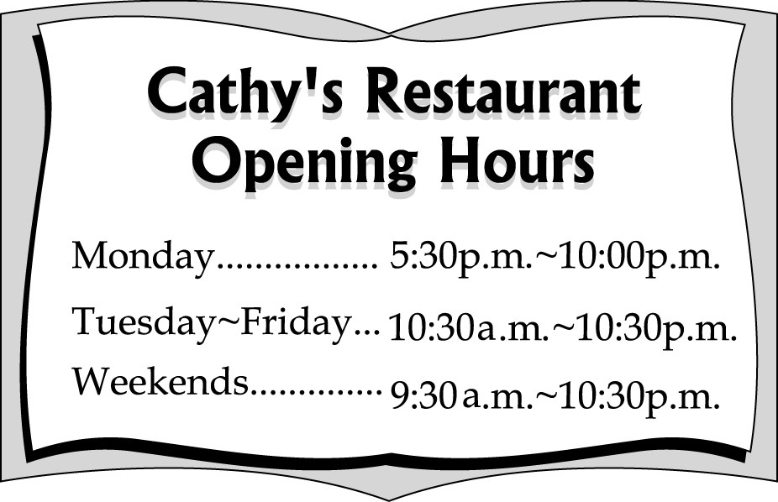
（ ）(42) What times does Cathy's Restaurant open on Thursday?
(Ａ) 5:30 p.m. (Ｂ) 10:00 a.m. (Ｃ) 10:30 a.m. (Ｄ) 10:00 p.m.
（ ）(43) What day does Cathy's Restaurant only open at night?
(Ａ) Monday. (Ｂ) Wednesday. (Ｃ) Friday. (Ｄ) Saturday.
（ ）(44)How many hours does Cathy's Restaurant open on Sunday?
(Ａ) 11. (Ｂ) 12. (Ｃ) 13. (Ｄ) 14.
（ ）(45)When can you go to Cathy's Restaurant?
(Ａ)At 10:00 a.m. on Wednesday. (Ｂ)On Saturday afternoons. (Ｃ)At 10:30 a.m. on Monday. (Ｄ)At 8:00 a.m. on Sunday.
（ ）(46)What time does Cathy's Restaurant close on Sunday?
(Ａ) 10:00 p.m. (Ｂ) 10:20 p.m. (Ｃ) 10:30 a.m. (Ｄ) 10:30 p.m.
Dear Andy,
How are you doing? Today we (47) three new classmates. Nancy (48) from Japan. She's fourteen years old. She (49) short hair and her eyes are very pretty. Tony is from Japan, too. He is good-looking（好看的） (50) he is not tall. Dave is only twelve years old. He's from the U.S., so his English is very good. Do you have new classmates in your class?
Lisa
（ ）(47)(Ａ) have (Ｂ) are (Ｃ) having (Ｄ) want
（ ）(48)(Ａ) come (Ｂ) goes (Ｃ) comes (Ｄ) runs
（ ）(49)(Ａ) with (Ｂ) has (Ｃ) in (Ｄ) and
（ ）(50)(Ａ) and (Ｂ) but (Ｃ) or (Ｄ) with
林園高中九十三學年度第二學期（國中部）單科評量一年級英文科答案

1 | B | 2 | A | 3 | B | 4 | B | 5 | B | 6 | B | 7 | C | 8 | C | 9 | B | 10 | A
11 | B | 12 | C | 13 | A | 14 | B | 15 | C | 16 | D | 17 | C | 18 | C | 19 | D | 20 | A
21 | D | 22 | B | 23 | C | 24 | A | 25 | B | 26 | C | 27 | B | 28 | B | 29 | D | 30 | A
31 | A | 32 | D | 33 | B | 34 | D | 35 | B | 36 | C | 37 | A | 38 | C | 39 | B | 40 | D
41 | D | 42 | C | 43 | A | 44 | C | 45 | B | 46 | D | 47 | A | 48 | C | 49 | B | 50 | B

