高 雄 縣 立 林 園 高 中 九 十 三 學 年 度 第 二 學 期 （國中部）第 二 次 月 考 二 年 級 英 文 科 考 卷
班級: 姓名: 座號:
Part A----Listening Comprehension Section（聽力測驗）30﹪ 命題教師：李慧真老師
一、看圖選擇 : 每題2分，共10分
說明 根據圖片與聽到的內容，選出正確的答案。
1. 2. 3. 4. 5.
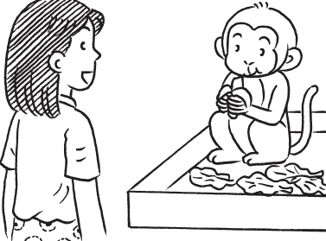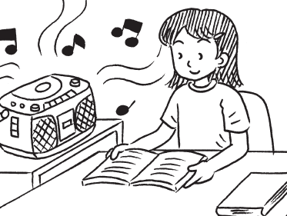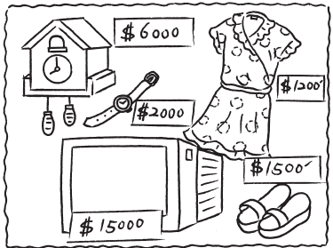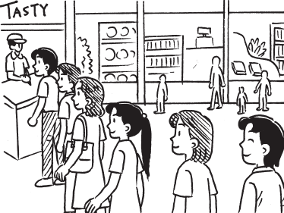

Live on以…為食 noisy吵鬧的 practice練習 relexed放鬆 dress洋裝
stand in line for為….排隊站著 tasty美味的
二、短文回答 : 每題2分，共10分
說明 根據聽到的短文內容回答相關問題。
( ) 1. Why do people like to keep pets?
(A) They have much time, and don’t know what to do. (B) They think pets are beautiful to look at.
(C) They want to sell pets to make money. (D) They feel alone and have no friends.
( ) 2. What can’t dogs do for people?
(A) They can’t cook a nice meal. (B) They can’t watch sheep on the farm.
(C) They can’t find out people in the snow. (D) They can’t lead the way.
( ) 3. How can a dog find out a man in the snow?
(A) A dog can see well. (B) A dog is good at smelling.
(C) A dog can listen to strange sounds. (D) A dog is good at running.
( ) 4. Which is NOT true?
(A) Dogs have been man’s favorite pets for a long time. (B) Dogs can’t save people’s lives.
(C) Dogs are man’s best friend. (D) Dogs can do a lot of things for people.
( ) 5. What is the best topic (標題) of the reading?
(A) Keeping a Dog As a Pet (B) The Kinds of dogs
(C) Our Best Friends—Dogs (D) Our Favorite Dogs
lonely寂寞的
save解救
It’s said that據說 have been一直是 guide dog導盲犬
三、聽句辨義 : 每題2分，共10分
說明 根據聽到的對話內容，敘述正確者勾選T；錯誤者勾選F。
□T □F 1. They both love staying at a shopping mall.
□T □F 2. Nancy hates loud music because it makes her crazy.
□T □F 3. Vivian will buy the green shirt. It’s cheaper.
□T □F 4. Jean’s birds can talk and sing beautiful songs.
- T □F 5. The Sogo Department Store is Paul’s favorite place for shopping.
building建築物

Part B----Basic-skill Testing（紙筆測驗）70﹪
- 文意字彙（Test for vocabulary）：10﹪
1.Listening to music can help us forget our t s.
2.The j_____l sound of music makes us happy.
3.T ds of basketball fans went to the ball game yesterday.
4.There is a cross（十字架）on the roof of the c h.
5.The f________p between Nancy and Alice is strong.
__________________6. My pet, Lucky, is hungry now. I’ll bring him some s_____s.
__________________7.When the cat’s away, the m______e will play.
__________________8.Tony is as b_____e as a lion.
__________________9.Music becomes an important part of their l_____s.
__________________10.Excuse me. Where’s the fitting room（試衣間）？ I’d like to try the red s_____r on.
二.文法測驗 （Test for grammar） 20﹪
1.How much do the clothes____？
（A）spend（B）cost（C）take （D）pay
2.Tom’s shirt is _____than mine.
（A）the cheapest（B）much cheapest（C）very cheapest（D）the cheaper
3.We don’t have to _____ time finding out Tom’s telephone number.
（A）spend（B）cost（C）take（D）pay
4.Some parents only make their children _____ all the time.
（A）to study（B）study（C）studying（D）studied
5._____ you _______ Mary is wrong.
（A）Both~and（B）Not only~but also（C）As~as（D）Either~or
6.We can’t go shopping ______ money.
（A）as（B）with（C）of （D）without
7. A: I won’t go on a picnic.
B:_____.
（A）Say！（B）Not bad.（C）Why?（D）Why not?
8.Wendy is not as fat as Mary, but she is a little fatter than Coco.
（A）Wendy is the fattest.
（B）Mary is the thinnest.
（C）Coco is the thinnest.
（D）Coco is fatter than Mary.
9. Of the two boys, Peter is the noisier（吵鬧的）.
（A）Peter is noisier than the other boy.
（B）Peter is the noisiest of all the boys.
（C）Peter is much noisier than any other two boys.
（D）Peter is as noisy as the other boy.
10.Jay is a student, and so am I.
（A）Jay is a student, but I’m not.
（B）Jay is a student, and I do, too.
（C）Either you or I am a student.
（D）Both Jay and I are students.

三.文法改錯（Test for the correct use of the words） 10﹪
（每題只錯一個地方，請直接將正確用法寫在答案欄上）
例如：I like eat fast food.
答案請寫to eat或eating
1.My good friends listen me when I feel sad.
2.Taipei 101Mall has one hundred stores, include bookstores, video stores, and restaurants.
3.My rabbit, Snow Ball, likes to eat grasses and vegetables.
4.Dong is so nice, he’ll probably make lot of friends.
5.Joan is the smart girl in school.
6.Excuse me. Can you help me taking the heavy bag.
7.I am strong than you are！
8.The man became happily.
9.Mary bought some books from exercise.
10.I like doing homework quiet.
四.閱讀測驗 （Test for reading） 20﹪
Linyuan Bookstore
Anniversary Sale!! May 8 ~ May 20
Open Tue. ~ Sun.
General Price Sale
Comic Books NT$300 each 20% off
Story Books NT$200 each 30% off
Dictionaries NT$500 each 40% off
CDs NT$300 each 30% off
Cards NT$25 each（buy one, get one free）

anniversary週年慶 20% off 八折
Heidi and Coco are at the Linyuan Bookstore on May 12.
1.Heidi bought two CDs and four comic books. How much did she pay for them?
（A）NT$480
（B）NT$920
（C）NT$1200
（D）NT$1380
2.Coco paid two hundred dollars for cards. How many cards did she get?
（A）8
（B）12
（C）16
（D）20
3.Which is the most expensive, a comic book, a dictionary, or a story book？
（A）a comic book
（B）a dictionary
（C）a story book

What is a good way to celebrate Mother’s Day？ It’s a tradition in America that sons and daughters wear a flower on Mother’s Day. The flower is pink if your mother is still alive, and white if she is not.
Maybe you know what your mother likes best. You could take her out for a meal, or give her a gift of beautiful flowers. However, it is more important just to be with your mother on her special day. Even better, tell her how much you care about her every day－not just once a year！

tradition傳統 alive活著 dead死亡
4.What should children do more than once a year?
（A）Buy flowers for themselves.
（B）Celebrate Mother’s Day.
（C）Wear pink and white flowers.
（D）Tell their mothers how much they love them.
5.What do we know about a girl if she is wearing a white flower on Mother’s Day?
（A）We know her mother is dead.
（B）We know her mother has a daughter.
（C）We know her mother likes white flowers.
（D）We know her mother is well.
6.What is the writer mostly talking about?
（A）Pink and white flowers.
（B）How to be a good son or daughter.
（C）Differently holidays in America.
（D）What kind of present to give your mother.
Skip：Wow！Look at that skateboard, Pete.
Pete：It’s a beauty alright. Imagine if we each had one.
Skip：That would be awesome！But I only have twenty-three dollars. I don’t have enough money.
Pete：Don’t worry. I have twenty dollars. Maybe we can buy the skateboard together and share it.
Skip：Ok. Let’s buy it！
Daniel：Be careful. Sometimes sharing isn’t that easy.
Pete：You said it. But what should we do?
Daniel：We’ll divide up the days of the week. Pete can have the skateboard on Monday, Wednesday, and Friday. Skip can have it on Tuesday, Thursday, and Saturday.
Skip：Wait a minute！Today is Sunday. Who gets the skateboard on Sunday？
Daniel：Well, since it was my idea, I do.

suggest建議
7.What does “awesome” in line three mean?
（A）terrible （B）trouble （C）sad （D）great
8.Which is true?
（A）The skateboard costs twenty-three dollars.
（B）Skip can have the skateboard on Wednesday.
（C）Daniel suggests Pete and Skip buy the skateboard together.
（D）Skip and Pete buy the skateboard together.
9.What does the sentence “You said it.” in line seven mean?
（A）Pete agrees with Daniel.
（B）Pete doesn’t like Daniel’s idea.
（C）Pete doesn’t understand what Daniel is talking about.
（D）Pete wants to share the skateboard with Daniel.
10.Who gets the skateboard on Sunday？
（A）Pete（B）Skip（C）Daniel（D）Nobody
五.課文習作專區：中翻英 （Test for reading in the textbook and workbook） 10﹪
1.天空上的雲很漂亮。
2.妳戴這頂帽子很好看。
3.George跑起來像一匹馬。
4.有些學生一直隨身攜帶CD播放機。
5.寵物需要你的愛和幫助，你必須好好照顧他們。

（國中部）第 二 次 月 考 二 年 級 英 文 科 答案卷
Part A----Listening Comprehension Section（聽力測驗）30﹪
一、看圖選擇 : 每題2分，共10分
1 | A | 2 | C | 3 | B | 4 | C | 5 | D
二、短文回答 : 每題2分，共10分
1 | D | 2 | A | 3 | B | 4 | B | 5 | C
三、聽句辨義 : 每題2分，共10分
1 | T | 2 | F | 3 | T | 4 | F | 5 | F
Part B----Basic-skill Testing（紙筆測驗）70﹪
- 文意字彙（Test for vocabulary）：每題1分10﹪
1. | troubles | 2. | joyful | 3. | Thousands | 4. | church | 5. | friendship
6. | snacks | 7. | mice | 8. | brave | 9. | lives | 10. | sweater
- 文法測驗 （Test for grammar）每題2分 20﹪
1. | B | 2. | B | 3. | A | 4. | B | 5. | B
6. | D | 7. | D | 8. | C | 9. | A | 10. | D
三.文法改錯（Test for the correct use of the words） 每題1分 10﹪
（每題只錯一個地方，請直接將正確用法寫在答案欄上）
1. | listen to | 2. | including | 3. | grass | 4. | lots | 5. | smartest
6. | take | 7. | stronger | 8. | happy | 9. | about | 10. | quietly
四.閱讀測驗 （Test for reading）每題2分 20﹪
1. | D | 2. | C | 3. | B | 4. | D | 5. | A
6. | B | 7. | D | 8. | D | 9. | A | 10. | C
五.課文習作專區 （Test for reading in the textbook and workbook）每題2分 10﹪
1.The clouds in the sky are beautiful.
2.The hat looks good/great on you.
3.George runs like a horse.
4.Some students bring a CD player with them all the time.
5.Pets need your love and help, and you have to take good care of them.

