高雄縣立林園高級中學國中部 一 年級 英語 科第三次段考考卷 題目卷
範圍： L7~Review 3 班級： 姓名： 座號：
壹、Listening Test (聽力測驗)
一、True or false (根據下圖以及聽到的句子，正確的寫T，錯誤的寫F) 10%
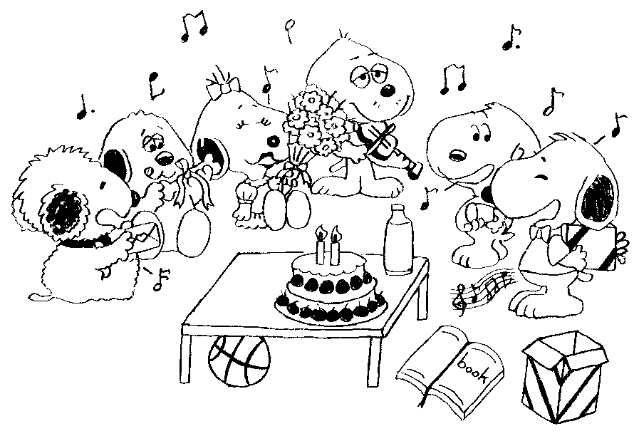

1. _________ 2. _________ 3. _________ 4. _________ 5. _________

二、Listen and match (聽CD的句子，填入正確的代號) 10%

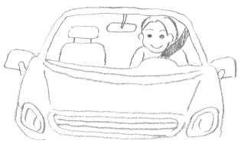 |  | 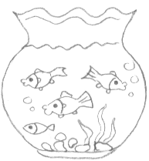 |  | 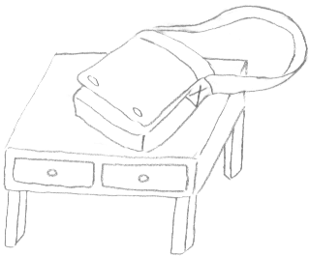 |  |  |  | 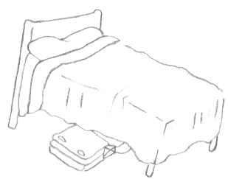
1. |  | 2. |  | 3. |  | 4. |  | 5.

三、Conversation (根據聽到的對話及題目，選正確的答案) 10%
1. (A) It’s 000-11822. (Ｂ) It’s 000-11922.
2. (A) Yes, she is. (Ｂ) No, she isn’ t.
3. (A) They are eating a hot dog. (Ｂ) They are washing a dog.
4. (A) Yes, they’re behind the brushes. (Ｂ) No, they’re in front of the brushes.
5. (A) He’s watching his phone. (Ｂ) His watch is slow.

貳、Comprehension Test (紙筆測驗)
一、Choose (選擇) 20%
1. A: Where are the boys playing? B: ___________.
(A) With a basketball (B) Under the table (C) To the school (D) from the USA
2. A: ______ is Ted doing in his room? B: He’s eating lunch. (A) What (B) Where (C) Who (D) Why
3. A: This jacket is too small for me. B: Well, ______ this one. (A) run (B) try (C) turn (D) drink
4. A: Hello? May I speak to May? B: ______ May speaking. (A) She is (B) I am (C) This is (D) There is
5. Let’s ______. (A) calling (B) call he (C) call she (D) call him
6. Our favorite players are over there. Let’s ______.
(A) cheering for them (B) give them big hand (C) give them a big hand (D) me give them a big hand
7. They are having fun ______ their classmates. (A) in (B) with (C) to (D) up
8. There are ______ in my bag. (A) shoe (B) shoes (C) a shoe (D) a shoes
9. A: Uh-oh. I am late. B: _______ Your watch is too fast.
(A) Take it easy. (B) Nice to meet you. (C) I have to go now. (D) You’re welcome.
10. A: What’s Bob doing? B: ___________
(A) He’s make a cake. (B) Yes, he’s making a cake. (C) No, he’s making a wish. (D) He’s making a wish.

1 《背面有題》

二、Match (配合題，從A到G中選出適合的答句) 5%

( ) 1. Where’s Sam from?
( ) 2. Where is Sam?
( ) 3. May I speak to Sam?
( ) 4. Sorry, I am late.
( ) 5. Maybe there’s a bomb over there.

A. She’s at home.
B. I hope not.
C. Never mind.
D. Speaking.
E. He’s from Japan.
F. Yes, I am Sam.
G. He’s beside the door.

三、Reading (閱讀測驗) 6%
Jill got an e-mail from her classmates, Mary.
Jill, I call you several times, but no answer. Are you at home now? Today is Jeffery’s birthday. Let’s go to his party with your cat, Mimi. I am on the way to your home. I hope you are ready when I am there. Don’t forget your present!
Mary
got 收到 e-mail 電子郵件 several times 幾次 ready 準備好了

1. Jill got an e-mail from Mary. Why?
(A) They’re going to Jill’s party. (B) They’re going to Mary’s party.
(C) They’re going to Jeffery’s party. (D) They’re going to Mimi’s party.
2. What does there mean? (此處的there是什麼意思?)
(A) Jeffery’s party (B) Mary’s home (C) Jill’s home (D) We don’t know.
3. “Don’t forget your present” means (表示) _________
(A) “Open the present.” (B) “Go to the party with your present.”
(C) “Go to the party with your parents.” (D) “Put the present down.”

四、Vocabulary (文意字彙) 10%
1. Three and five is e t.
2. You are s t. You solve (解決) this hard (困難的) question (問題).
3. This is a w g number. Jacky’s phone number isn’t 3838-338.
4. A: One t t for the 7:30 game, please. B: Yes, sir.
5. There are two big p ts on my jacket.

五、Rewrite the words or the sentences (改寫)
I. (將括號中的字做適當變化，不限字數) 5%
1. I am _________( swim ) at school.
2. John is _________ ( turn off ) the TV.
3. There are two _________ ( watch ) on the table.
4. Peter _________ (drive) to your home now.
5. Doris is _________ (drink) milk.

II. (依提示作答) 12%
1. What are you doing? ( you 改成Peter，並做適當變化 )
2. I sit on the chair. ( 改成現在進行式 )
3. My phone number is 8899-888. ( 依畫線部分造原問句 )
4. Mr. and Mrs. Li are at home. ( 依畫線部分造原問句 )

六、Translate (翻譯) 12%
1. 桌上的牛奶太冰了。
2. 花園裡有一台公用電話。
3. 有三隻又大又漂亮的魚在魚缸裡。
4. 我的朋友們正在房間裡餵貓咪們。

2

高雄縣立林園高級中學國中部 一 年級 英語 科第三次段考考卷 答案卷
範圍： L7~Review 3 班級： 姓名： 座號：
壹、Listening Test (聽力測驗)
一、True or false (根據下圖以及聽到的句子，正確的寫T，錯誤的寫F) 10%
1. | 2. | 3. | 4. | 5.

二、Listen and match (聽CD的句子，填入正確的代號) 10%
1. | 2. | 3. | 4. | 5.

三、Conversation (根據聽到的對話及題目，選正確的答案) 10%
1. | 2. | 3. | 4. | 5.

貳、Comprehension Test (紙筆測驗)
一、Choose (選擇) 20%
1. | 2. | 3. | 4. | 5. | 6. | 7. | 8. | 9. | 10.

二、Match (配合題，從A到G中選出適合的答句) 5%
1. | 2. | 3. | 4. | 5.

三、Reading (閱讀測驗) 6%
1. | 2. | 3.

四、Vocabulary (文意字彙) 10%
1. | 2. | 3. | 4. | 5.

五、Rewrite the words or the sentences (改寫)
I. (將括號中的字做適當變化，不限字數) 5%
1. | 2. | 3. | 4. | 5.

II. (依提示作答) 12%
1.
2.
3.
4.

六、Translate (翻譯) 12%
1.
2.
3.
4.

