高雄縣立林園中學國中部一年級94學年度第一學期英文科單科評量
範圍：第一課~第五課
一.字彙選擇 20%
1. One and four are ____.
(A)two (B)three (C)four (D)five
2. Johnson and Sarah are ___________. They have（有）two sons（兒子）, Peter and Tom.
(A) teacher and student (B)husband and wife (C) brother and sister (D) father and daughter（女兒）
3. A：_______ the door, please. I feel cold（冷）.
B：Okay.
A：Thanks.
(A)Cut (B)Open (C)Close (D)Pick up
4.Jerry, ______ the candles and make a wish.
(A)put down (B)blow out (C)pick up (D)sit down
5.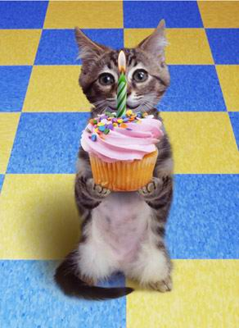 It is a cute____.
(A)computer (B)cat (C)puppy (D)coach
6.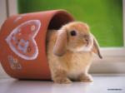 This is my pet, Lucky. She’s a ____.
(A)rabbit (B)waiter (C)shopkeeper (D)nurse
7.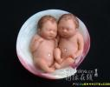 A: What are they? B: They’re ____.
(A)cats (B)puppies (C)babies (D)cakes
8. 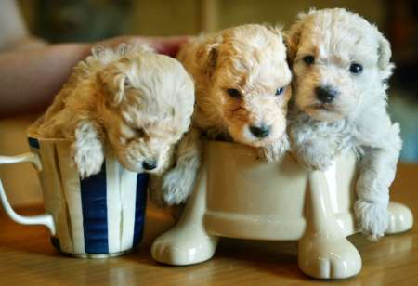 They are _____.
(A)salespersons (B)puppies (C)computers (D)teachers
9.Mr. Wang teaches（教）baseball. He is a baseball_____.
(A)coach (B)mailman (C)worker (D)doctor
10.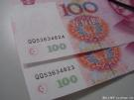 It’s_____.
(A)a lunch box (B)a book (C)a bomb (D)money
二.文法選擇 20%
11. Peter：Sue, ______is my brother, Mark.
Sue：Nice to meet you, Mark.
(A) this (B)that (C)it (D)she
12.A：____________? B：Bill White.
(A) How are you？ (B)What’s your name？ (C)How do you do？ (D)What’s that？
13. A：______ come in. B：I’m taking a bath.（洗澡）
(A)Isn’t (B)Don’t (C)Please not (D)Not
14. A: Look here, everybody. ________
B: Cheese.
(A) Don’t move. (B) Stand up. (C) Sit down. (D)Say” cheese.”
15. A: Are those your bags? B:_______.
(A)Yes, their are. (B)No, those are my bags. (C) I don’t know. (D) Yes, they are.
16.A: Sorry I’m late.（遲到） B: ____________
(A)Nice to meet you. (B)How do you do? (C) Thank you. (D)It’s all right.
17. Miss Li is my English teacher. ______ is very nice.
(A)He (B)She (C)It (D)They
18. Linda and Helen are students. _______ schoolbags are very heavy（重的）.
(A)She (B)They (C)Her (D)Their
19.______name is Nancy. I ____ a student.
(A)She, is (B)My, am (C)He, is (D)Your, are
20.A：________ are you from？ B：We are from Taiwan.
(A)Who (B)How (C)Where (D)What
三.文法改錯（每題只有一個錯誤，找出錯誤即可，不用訂正）
21. You are a student. I is a student, too.
（A） （B） （C）
22. Is this your cat.
（A） （B）（C）
23. Ann and Helen are teacher.
（A） （B） （C）
24. This’s my book, and that’s your book.
（A） （B）（C）
25.I amn’t a baseball fan, but my father is.
（A） （B） （C）
26. She sister, Betty, is my classmate.
（A） （B） （C）
27. We are good friend.
(A) (B) （C）
28. Those aren’t Helen’s boxs. They are mine.
（A） (B) （C）
29. They cats are Spot and Lucky.
(A) (B) (C)
30. my father is a baseball coach.
(A) (B) （C）
四.閱讀測驗 20%
（一） Heidi’s Family Tree
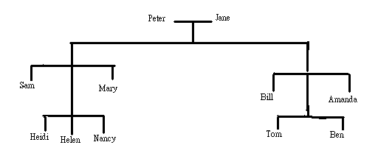
（31）Who is Heidi’s father? (A)Sam (B)Bill (C)Peter (D)Tom
（32）Who is Bill’s mother？ (A) Amanda (B)Helen (C)Jane (D)Mary
（33）Who is Tom’s cousin? (A)Helen (B)Ben (C)Bill (D)Peter
（34）Who is Helen’s sister？ (A)Mary (B)Jane (C)Nancy (D)Amanda
（35）Who is Tom’s brother？ (A)Ben (B)Bill (C)Sam (D)Peter
（二）
Hi, my name is Alice. Today is my birthday. We have （有）a birthday party at McDonald’s. My father gives（給）me a puppy. My mother gives me a big cake. My classmates, Peter and Susan, give me a basketball. And my sister, Sue, gives me a computer book. How nice！
I make a wish, “ I want to be a basketball player or（或）a computer engineer. I cut the cake and have a good time.
（36）What’s the writer’s（作者） name?
(A)Peter (B)Sue (C)Susan (D)Alice
（37）Who is Sue?
(A)Peter’s sister (B)Susan’s classmate (C)Alice’s sister (D)Alice’s classmate
（38）What gift（禮物）does Sue give?
(A) a computer book (B)a puppy (C)a basketball (D)a big cake
（39）Where is the birthday party?
(A)At Alice’s home.（家）(B) At McDonald’s. (C)At Peter’s home. (D) At school.
（40）Is Alice happy?
(A)No, she is angry.（生氣） (B)No, she is not happy. (C)Yes, she’s. (D)Yes, she is happy.
（三）

Good morning. I’m Sam Brown. Welcome to TVBS. I’m in South Africa. Look！There are （有） an elephant（大象） and her baby over there. She’s waiting for her friends. Elephants like（喜歡）friends. They are so cute. I like elephants, and you?
（41）What is Sam Brown ?
（A）A singer. （B）A reporter. （C）A salesperson. （D）A diplomat.
（42）Where is Sam Brown?
（A）He’s in America.（B）He’s in Panama.（C）He’s in Canada.（D）He’s in South Africa.
（43）Are elephants cute?
（A）Yes, they are.（B）Yes, it is.（C）No, they aren’t.（D ）No, it isn’t.
（44）Do elephants like friends?
（A）Yes, they like Sam Brown.（B）Yes, they like friends.（C）No, they don’t like friends.（D）No, they don’t like Sam Brown.
（45）Does Sam Brown like elephants?
（A）Yes, he likes elephants.（B）Yes, he likes tigers.（老虎）（C）No, he likes elephants. （D）No, he likes tigers.
（四）
 | Susan | Nancy | Peter | Tom
brother or sister | 1 brother | 1 brother&1 sister | 2 brothers&1 sister | 2 brothers&2 sisters
cousin | 2 cousins | 3 cousins | 1 cousin | 4 cousins
job（工作） | singer | diplomat | teacher | coach
from | USA | Canada | Germany | Japan
（46）Who is from Germany?
（A）Susan （B）Nancy （C）Peter （D）Jane
（47）Who is a singer?
（A）Susan （B）Nancy （C）Peter （D）Jane
（48）Tom has（有） ______ cousins.
（A）one （B）two （C）three （D）four
（49）Where is the coach from?
（A）The USA . （B）Canada. （C）Germany. （D）Japan.
（50）Who has one brother and one sister?
（A）Susan （B）Nancy （C）Peter （D）Jane

高雄縣立林園中學國中部94學年度第 一學期一年級單科評量英文科答案
1 | D | 6 | A | 11 | A | 16 | D | 21 | B | 26 | A | 31 | A | 36 | D | 41 | B | 46 | C
2 | B | 7 | C | 12 | B | 17 | B | 22 | C | 27 | C | 32 | C | 37 | C | 42 | D | 47 | A
3 | C | 8 | B | 13 | B | 18 | D | 23 | C | 28 | C | 33 | A | 38 | A | 43 | A | 48 | D
4 | B | 9 | A | 14 | D | 19 | B | 24 | A | 29 | A | 34 | C | 39 | B | 44 | B | 49 | D
5 | B | 10 | D | 15 | D | 20 | C | 25 | A | 30 | A | 35 | A | 40 | D | 45 | A | 50 | B

