高雄縣立林園高級中學國中部 二 年級 英語 科第三次段考考卷
範圍：L7~Festival 班級： 姓名： 座號：

- 聽力測驗30%
一、 根據錄音內容，與圖片相符的寫Ｔ，不符的寫Ｆ(10%)
(１)  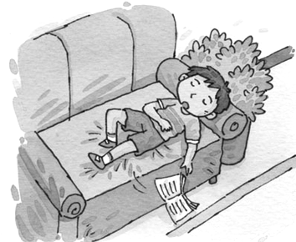  （ ） | (２)  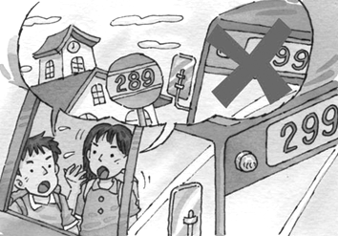  （ ） | (３)  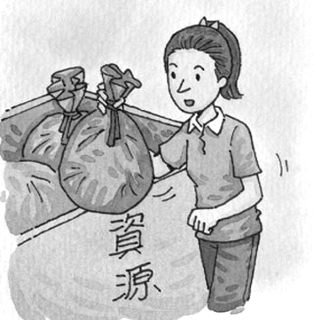  （ ） | (４)  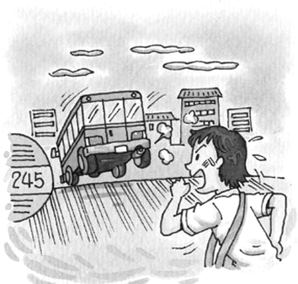  （ ） | (５)  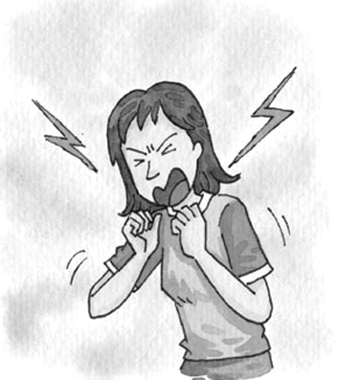  （ ）

二、根據錄音內容，在空格中填入相符的題號10%
Ex.  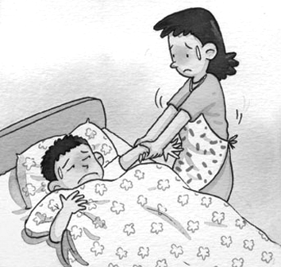 | (Ａ)  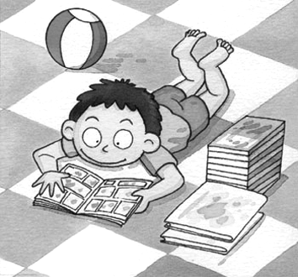  （ ） | (Ｂ)  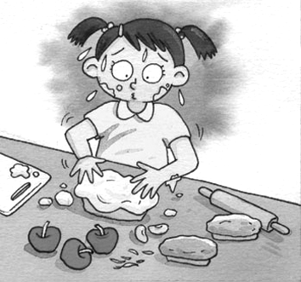  （ ） | (Ｃ)  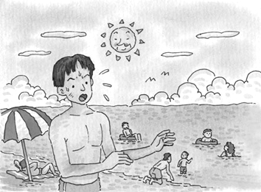  （ ）
(Ｄ)  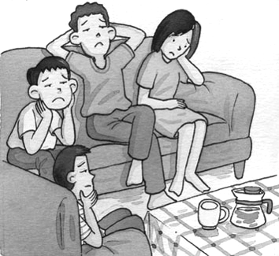  （ ） | (Ｅ)  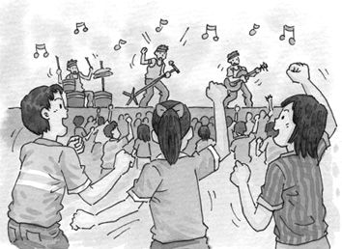  （ ）

三、根據錄音內容選出適當的答句10%
1、 (Ａ) I enjoy to play video games. (Ｂ) I hate to enjoy vacations.
(Ｃ) I enjoy doing housework. (Ｄ) I don’t like to do it fast.
2、 (Ａ) No, I like shopping. (Ｂ) Yes, shopping is fun. (Ｃ) No, things are very cheap.
(Ｄ) Yes, I have no money.
3、 (Ａ) Yes, it is easy for me. (Ｂ) No, I can not do it. (Ｃ) I tried my best.
(Ｄ) I did not come on time.
4、 (Ａ) Yes, I think so. (Ｂ) Yes, I am exciting. (Ｃ) I think surfing is exciting.
(Ｄ) I think reading is boring.
5、 (Ａ) I like to. (Ｂ) TV is not good for children. (Ｃ) She hates to look at it.
(Ｄ) Yes, she does.

- 紙筆測驗70%
四、文意字彙10%
1、Cathy ran away from home. It was really a big h e to her family.
2、Linda likes baseball very much, and she also c ts a lot of baseball cards.
3、Jack is in bed with a high f r. He needs to see a doctor.
4、That is an i g TV show. Everyone likes it very much.
5、Parents give children red e es on Chinese New Year.
6、There are many c e stores around here.
7、You still can’t play the piano well, so you need more p e .
8、The player s es beautifully（優美地）on the ice.
9、There is t h everywhere（到處）. Let’s clean it up.
10、Put a s p on the letter before mailing(郵寄) it.

五、語法選擇24%
1、Carol will go shopping tonight, but Leo . (Ａ) won’t (Ｂ) will (Ｃ) isn’t (Ｄ) doesn’t
2、Playing video games great fun. (Ａ) are (Ｂ) is (Ｃ) has (Ｄ) have
3、I forgot my umbrella, so I was all wet because of the rain. (Ａ) to bring (Ｂ) bringing
(Ｃ) brought (Ｄ) brings
4、Why you come to school yesterday? Were you sick? (Ａ) weren’t (Ｂ) didn’t
(Ｃ) doesn’t (Ｄ) won’t
5、Is there anything wrong your leg? (Ａ) with (Ｂ) for (Ｃ) from (Ｄ) on
6、My cousin likes in his free time. (Ａ) to go to bowl (Ｂ) to go bowling
(Ｃ) going to bowl (Ｄ) go bowling
7、How much should I pay the tickets? (Ａ) from (Ｂ) by (Ｃ) for (Ｄ) with
8、David is good at e-mails. (Ａ) writes (Ｂ) wrote (Ｃ) writing (Ｄ) write
9、A: You want a hamburger, a small fries and a coke. What do you want? B: That’s all. Thanks.
(Ａ) kind (Ｂ) back (Ｃ) else (Ｄ) messy
10、You’ll receive it three days. (Ａ) of (Ｂ) on (Ｃ) at (Ｄ) in
11、Polly went to bed late last night, and she feels now. (Ａ) asleep (Ｂ) sleep (Ｃ) sleeping
(Ｄ) sleepy
12、A: What is your sister going to wear tonight? B: (Ａ) She’s wearing a beautiful dress now.
(Ｂ) She plans to wear the reindeer suit. (Ｃ) The Santa girl suit looks strange on her.
(Ｄ) She won’t wear jeans tonight.

六、克漏字選擇 10%
Students, you (１)１(１))(１) have an entrance exam in May. Now I have (２)２(２))(２) to tell you.
First, remember to make good use of your time. Don’t waste time watching TV or (3) video games.
Second, take care of your health. Don’t go to bed late. (4) can help you learn better.
Third, don’t give up easily when making mistakes.
Last, you have to believe in (5) .
Best wishes for everyone of you.
1、(Ａ) are going (Ｂ) will (Ｃ) can (Ｄ) don’t
2、(Ａ) important anything (Ｂ) important something (Ｃ) anything important
(Ｄ) something important
3、(Ａ) play (Ｂ) playing (Ｃ) plays (Ｄ) played
4、(Ａ) Getting enough sleep (Ｂ) Feeling sleepy (Ｃ) To fall sleep (Ｄ) Get enough sleepy
5、(Ａ) yourselves (Ｂ) ourselves (Ｃ) myself (Ｄ) themselves

七、閱讀測驗16%
(一)
Sam had a store on Market Road in Tainan City. He sold men’s clothes, and he always had one young man to help him. He thought he could pay less to young men than to older ones. Almost all the young men work for him for only a few months because enjoyed seeing girls come into their store, but not many came.
1、Sam’s store didn’t sell . (Ａ) skirts (Ｂ) jeans (Ｃ) shirts (Ｄ) sweaters
2、Who are“they” in line 3? (Ａ) Shoppers. (Ｂ) The old men. (Ｃ) Sam.
(Ｄ) The young men Sam hired.
3、Why did Sam have young men to help him? (Ａ) Shoppers liked young man. (Ｂ) Young men were good-looking. (Ｃ) The old men didn’t like Sam. (Ｄ) He paid less money to young men.
4、No young men worked for him very long because . (Ａ) they got little money from Sam
(Ｂ) few girls came to the store (Ｃ) they liked the country more (Ｄ) they didn’t like to work with Sam

(二)
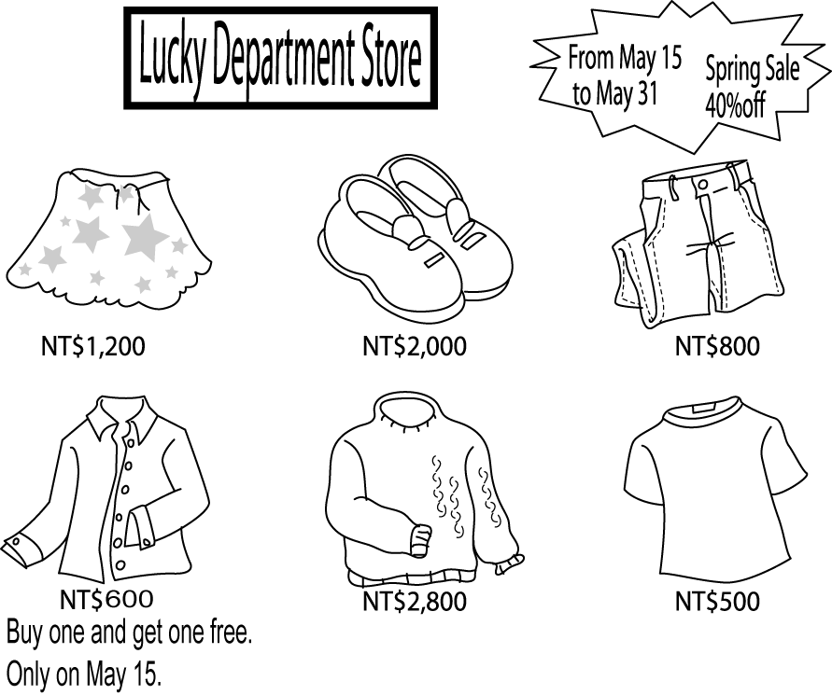
last 持續
1、Amy went to the department store to buy a skirt and jeans. She went there on the morning of May fifth. How much should she pay?
(Ａ) NT$ 800. (Ｂ) NT$ 1,000. (Ｃ) NT$ 1,200. (Ｄ) NT$ 2,000.
2、Molly only has eight hundred dollars. She wants to buy two shirts for her brothers. What date can she go to the department store?
(Ａ) May fifteenth. (Ｂ) May twentieth. (Ｃ) May twenty-fifth. (Ｄ) May thirty-first.
3、How much will Molly get back after she buys the shirts?
(Ａ) NT$ 100. (Ｂ) NT$ 200. (Ｃ) NT$ 300. (Ｄ) NT$ 400.
4、 How many days will the sale last? (Ａ) 14. (Ｂ) 15. (Ｃ) 16. (Ｄ) 17.

八、翻譯10%
- 我弟弟因為吃太多而肚子痛。 (…so…)
2、或許我們放學後可以一起上網。
3、冬天早起是非常困難。 (Getting…….)
4、明天你要吃什麼當午餐呢？ (..will…)
5、快一點！我們快遲到了。

高雄縣立林園高級中學國中部 二 年級 英語 科第三次段考答案卷
範圍：L7~Festival 班級： 姓名： 座號：

- 聽力測驗30%
一、 根據錄音內容，與圖片相符的寫Ｔ，不符的寫Ｆ(10%)
1. | 2. | 3. | 4. | 5.
二、根據錄音內容，在空格中填入相符的題號10%
A. | B. | C. | D. | E.
三、根據錄音內容選出適當的答句10%
1. | 2. | 3. | 4. | 5.
- 紙筆測驗70%
四、文意字彙10%
1. | 2. | 3. | 4. | 5.
6. | 7. | 8. | 9. | 10.
五、語法選擇24%
1. | 2. | 3. | 4. | 5.
6. | 7. | 8. | 9. | 10.
11 | 12
六、克漏字選擇 10%
1. | 2. | 3. | 4. | 5.
七、閱讀測驗16%
(一)
1. | 2. | 3. | 4.
(二)
1. | 2. | 3. | 4.
八、翻譯10%

1.

2.

3.

4.

5.

