高雄縣立林園高級中學國中部94學年度第二學期 一年級 英語 科單科評量題目卷
測驗題形：Listening Test 共50題選擇題 班級： 姓名： 座號：

I. 單題選擇
1. Mr. Jones sometimes goes to work by taxi. He is a cook.
Question: What can Mr. Jones do?
(A) He can drive a taxi. (B) He can cook. (C) He can teach.
2. Woman: Can you feed the dog for me?
Man: Yes, of course.
Woman: Can you wash it for me?
Man: No, I can’t.
Question: Which one is true?
(A) The man can feed the dog. (B) The man can wash the dog. (C) The man can wash the woman.
3. They have fifteen baseballs.
Question: How many baseballs do they have?
(A) Thirteen. (B) Fifty. (C) Fifteen.
4. A: How much is the lemon tea? B: It’s twenty-seven dollars.
(A) (B) (C)
5. A: What time is it now? B: It’s half past five.
(A) It’s 12:05. (B) It’s 4:30. (C) It’s 5:30.
6. A: What time do you have PE class? B: I have PE class at three fifteen.
(A) 3:00 (B) 3:15 (C) 3:50
7. Woman: What do you do on Sunday?
Man: I play tennis.
Woman: What else?
Man: I play the violin.
Question: Which one is true?
(A) The man loves music only. (B) The man loves sports only. (C) The man loves sports and music.
8. Woman: Where is your cousin?
Man: She’s in America now.
Woman: What is she doing there?
Man: She is teaching math in a college.
Question: What does the man’s cousin do?
(A) She is a college student. (B) She is a math teacher in college. (C) She teaches American history in college.
9. Woman: What a beautiful flower, Bill! Is it for me?
Man: Well, sorry, Sally. It’s for my mom. Today is her birthday.
Question: What is the flower for?
(A) It’s for Bill’s mother’s birthday. (B) It’s for Sally’s birthday. (C) It’s for Bill’s birthday.
10 . Tom: What time does your mother get home, Tony?
Tony:______.
Question: What does Tony say?
(A) She goes to work at 9:00 every day. (B) She is a housewife. (C) She gets home at 5:30 in the afternoon.

II. 題組
A.
Frodo is a junior high school student. He has to study history, English, Chinese and PE at school. PE is his favorite. He enjoys doing exercise very much. He swims every Monday, Wednesday and Friday morning. He eats a lot of junk food, but he is not heavy. He looks slender and energetic. He also likes to play computer games. He usually goes to Sam’s home every Saturday morning to play computer games.
11. What’s Frodo’s favorite class at school?
(A) PE (B) art (C) history
12. When does Frodo swim?
(A) Monday, Tuesday and Friday (B) Tuesday and Thursday (C) Monday, Wednesday and Friday
13. What does Frodo do on Saturday?
(A) He plays the piano. (B) he plays computer games. (C) He swims.
14. What does Frodo look like?
(A) He doesn’t look heavy. (B) He looks heavy because he eats a lot. (C) He is slender and looks sick.
15. Does Frodo eat a lot of junk food?
(A) Yes, he does. (B) No, he doesn’t. (C) We don’t know.
B:
Boy: What is it?
Girl: It’s a new computer.
Boy: It’s small and light.
Girl: Yes, it is. It’s a present from my uncle.
Boy: Is it very fast?
Girl: Yes, it is. It’s beautiful, too.
16. Which one is true?
(A) The boy has a new computer. (B)The computer is big and heavy. (C) The computer is fast.
17. Which one is true?
(A) The computer is a present from the girl’s father. (B) The computer is a present from the girl’s uncle.
(C) The computer is a present for the girl’s uncle.
C
Girl: Hello? Is this Sam?
Boy: Speaking.
Girl: Sam, I have three tickets to a ball game tonight. Let's go to the ball game.
Boy: Sorry. I have to clean my room tonight.
Girl: Well, never mind. Where is Andy? He is a big fan, too.
Boy: I don't know. He is not at home.
Girl: Do you have his cell phone number?
Boy: Yes. It's 0931-284-967.
Girl: Thanks. Bye.
18. What is the girl going to do?
(A) She is going to clean her room.
(B) She is going to call Andy.
(C) She is going to play baseball with Andy.
19. Where is the girl going tonight?
(A) She is not going anywhere.
(B) She is going to school.
(C) She is going to the ball game.
20. Why can't Sam go with the girl?
(A) He doesn't like the ball game.
(B) The girl doesn't want him to go.
(C) He has to clean his room.
21. What's Andy's cell phone number?
(A) It's 0931-284-976.
(B) It's 0931-284-967.
(C) It's 0913-284-976.
D.
Boy: Hi, Mary, are you free this afternoon?
Girl: Yes, I don't need to go to school this afternoon. What's up?
Boy: Today's Jane's birthday. I am going to her party.
Girl: Great! I'd like to join you. When does the party begin?
Boy: It begins at two o'clock and ends at four thirty.
Girl: Great! I don't want to miss it. Where are you going now?
Boy: I'm going to buy a present for her.
Girl: I think she needs a new dress.
Boy: Do you know her size?
Girl: Yes, I do. I go shopping with her every weekend.
Boy: Ok. Let's go.
22. Where are the boy and girl going?
(A) To see the movies. (B) To go to school. (C) To buy a present.
23. Is Mary free this afternoon?
(A) Yes, she is. (B) No, she isn't. (C) She is busy this afternoon.
24. What do they buy for Jane's birthday present?
(A) Chocolate. (B) A dress. (C) Jewelry.
25. Why does Mary know Jane's size?
(A) They are sisters. (B) They go shopping together every weekend. (C) Mary is Jane's mother.
26. When does the party begin?
(A) It begins at 5:00. (B) It begins at 4:30. (C) It begins at 2:00.
E.
Amanda: What food do you like, Ted?
Ted: I like the sandwich. Do you also like the sandwich, Amanda?
Amanda: No, chocolate is my favorite.
Ted: What about you, Peter? Which do you like, the sandwich or chocolate?
Peter: I like both. but my favorite is junk food.
Amanda: Yes, he has hamburgers and coke every day. And he watches TV and eats hot dogs every night!
Ted: No wonder! You look heavy! Do you exercise?
Peter: No, I don't like exercise.
Ted: Come on! You have to take care of your health. Let's go play basketball!
27. Who likes chocolate only?
(A) Ted. (B) Amanda. (C) Peter.
28. What food does Ted like?
(A) The sandwich. (B) Chocolate. (C) Both.
29. What does Peter do every night?
(A) He studies and eats hot dogs. (B) He watches TV and eats hot dogs. (C) He exercises and watches TV.
30. Why is Peter heavy?
(A) He likes junk food, but he doesn't exercise. (B) He eats too much chocolate. (C) He likes junk food, and he exercises.
31. What sport does Ted want to play with Peter?
(A) Baseball. (B) Basketball. (C) Tennis.
F
Hi, My name is Lilly. I have a little sister, Grace. She is four years old. Every Friday, I have to take care of her when my parents go to visit my grandmother. My grandmother is eighty years old, but she is still healthy and happy. Every Saturday night, my grandmother plays the piano and my family sing together at seven o'clock. And we go on a picnic every Sunday. We enjoy it.
32. How old is Grace?
(A) She is seven. (B) She is eighty. (C) She is four.
33. When do Lilly's family sing together?
(A) At seven every Sunday night. (B) At four every Saturday night. (C) At seven every Saturday night.
34. What can Lilly's grandmother do?
(A) She can take care of her sister. (B) She can play the piano. (C) She can smoke.
35. When do Lilly's family go on a picnic?
(A) On Sundays. (B) On Saturdays. (C) on Fridays.

III. 進階題
A. Julie: Vivki, what do you want for lunch?
Vicki: I want fish and vegetables. And you, Julie?
Julie: I don't want to eat lunch. I am on a diet.
Vicki: On a diet?
Julie: Yes, i'm too chubby.
Vicki: No, you're not.
Julie: You look thin, Vicki. Do you exercise ever day?
Vicki: Yes, I do. I go jogging for thirty minutes and jump rope for twenty-five minutes every day.
Julie: I see. I can eat lunch, but I need to exercise.
Vicki: That's right!
36. What does Vicki want for lunch?
(A) Fish and apple tea. (B) She doesn't want to eat lunch. (C) Fish and vegetables.
37. Why doesn't Julie want to eat lunch?
(A) She wants to lose weight. (B) She wants to keep a diary. (C) The meal tastes bad.
38. How long does Vicki exercise every day?
(A) Fifty minutes. (B) Fifty-five minutes. (C) Thirty minutes.
39. What exercise does Vicki do every day?
(A) To go jogging and jump rope. (B) To play basketball. (C) To swim.
40. What does it mean when Julie says "I see"?
(A) It means " I understand." (B) It means "I see you exercise." (C) It means "I see you eat lunch."
B. Boy: What are you going to wear for the party?
Girl: I'm going to wear a pink dress. What about you?
Boy: I don't know. I'll go to the department store and look.
Girl: When will you go?
Boy: I'll go at sax o'clock.
(*)
Girl: Bob, look at that white shirt over there.
Boy: How much is it?
Girl: It's one thousand dollars.
Boy: That's too expensive. I want to try on the purple shirt.
Girl: Wow! It looks good on you. How much is it?
Boy: It's five hundred dollars. And I'll buy it.
41. What is the girl going to wear for the party?
(A) A pink dress. (B) A white dress. (C) A purple shirt.
42. When will the boy go to the department store?
(A) At six thirty. (B) At six. (C) On Saturday.
43. How does the boy think about the white shirt?
(A) It's too expensive. (B) It's not pretty. (C) It's too large.
44. How much is the purple shirt?
(A) It's one thousand dollars. (B) It's five hundred dollars. (C) It's five thousand dollars.
45. Which one will the boy buy?
(A) The pink shirt. (B) The white short. (C) The purple shirt.
C.



  $50 | 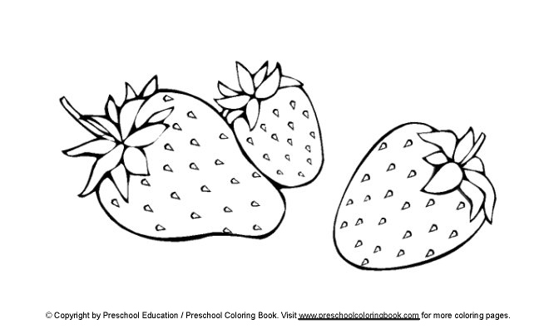    five /$99
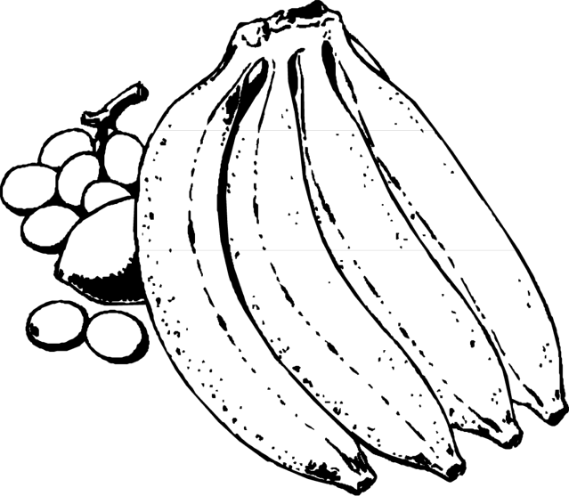  $45 | five /$79
    $15 | five /$79
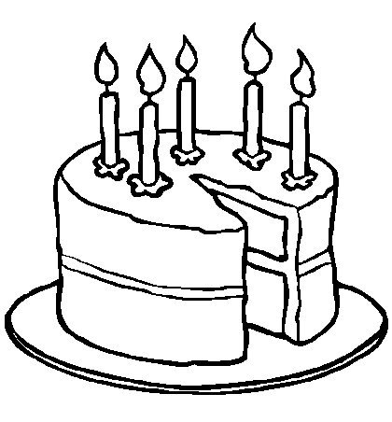  $280 |   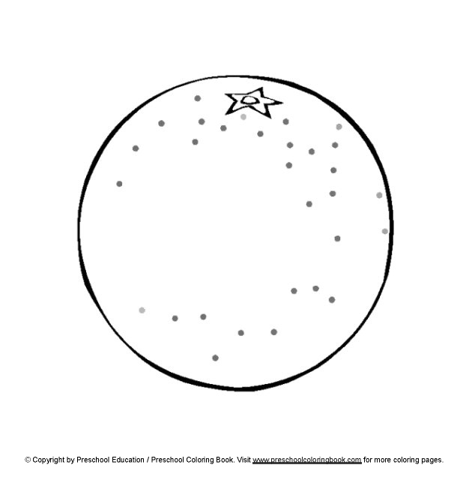  ten /$99
$320 | ten /$89

46. How much is a pizza?
(A) They're five for 99 dollars. (B) There's a pizza. (C) It's 280 dollars.
47. Can they buy paper plates at this shop?
(A) No, they don't need paper plates.
(B) No, they can't.
(C) They don't want paper plates.
48. Can they buy ten apples for 99 dollars?
(A) They’re ten apples for 99 dollars. (B) Yes they can. (C) No, they can't.
49. How much is a cake?
(A) Three hundred and twenty dollars. (B) Ten for eighty-nine dollars. (C) Very cheap.
50. How much are a hamburger and ten peaches?
(A) They're 129 dollars. (B) They're 208 dollars. (C) They're 158 dollars.

英文單評 一年級 答案
1 | B | 2 | A | 3 | C | 4 | A | 5 | C | 6 | B | 7 | C | 8 | B | 9 | A | 10 | C
11 | A | 12 | C | 13 | B | 14 | A | 15 | A | 16 | C | 17 | B | 18 | B | 19 | C | 20 | C
21 | B | 22 | C | 23 | A | 24 | B | 25 | B | 26 | C | 27 | B | 28 | A | 29 | B | 30 | A
31 | B | 32 | C | 33 | C | 34 | B | 35 | A | 36 | C | 37 | A | 38 | B | 39 | A | 40 | A
41 | A | 42 | B | 43 | A | 44 | B | 45 | C | 46 | C | 47 | B | 48 | C | 49 | A | 50 | B

