高雄縣立林園高中國中部九十四學年度第二學期第一次段考二年級英語科
命題教師：潘如庸

I. Listening Comprehension 聽力測驗 （３０%）
（I）根據聽到的內容，依序標出圖片的代號，不可重複。
(Ａ) (Ｂ) (Ｃ) (Ｄ) (Ｅ)
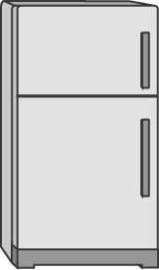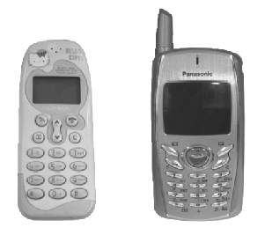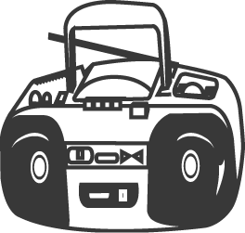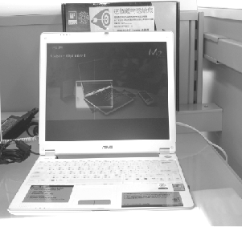

（II） 根據聽到的題目，選出適當的答句。
(1) (Ａ) I like to go swimming. (Ｂ) No, I like romantic movies. (Ｃ) What’s it about?
(Ｄ) Stephen Chow’s movies are funny.
(2) (Ａ) Sorry, I don’t have a telephone. (Ｂ) Yes, it’s a book about cell phones. (Ｃ) Of course! (Ｄ) Sure, here you are.
(3) (Ａ) Let’s go to Warner Village. (Ｂ) I love the popcorn. (Ｃ) This is the biggest theater in town. (Ｄ) I’ll get tickets.
(4) (Ａ) It’s very popular. (Ｂ) Yes, I like the story very much. (Ｃ) What’s it about? (Ｄ) Yes, I bought something.
(5) (Ａ) I love popcorn. (Ｂ) I want to study. (Ｃ) My home is more comfortable than outside.
(Ｄ) Yes, I want to watch TV.

（III）根據以下表格，仔細聽題目，選填正確代號

選項代號 | brand | price | size | weight | Sales  (a day) | Functions
(A) | Ericsson | NT$6,800 | 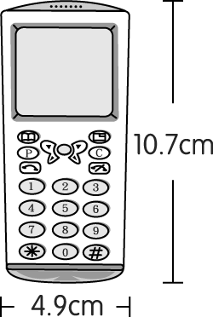 | 65g | 25 | *Taking pictures  *Surfing the Net
(B) | Motorola | NT$5,500 | 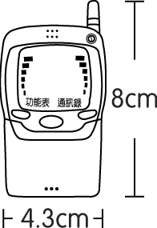 | 79g | 20 | *Playing games  *Sending messages
(C) | BenQ | NT$6,000 | 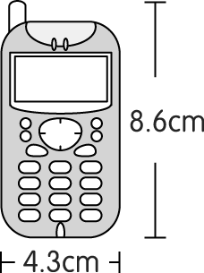 | 68g | 30 | *MP3 player  *Taking pictures
(D) | Nokia | NT$4,000 | 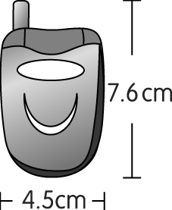 | 70g | 18 | *English-Chinese dictionary  *With Bluetooth

*聽力測驗結束，請翻到背面繼續作答。加油！

II. Reading Comprehension 閱讀測驗 （６０%）
(I) Vocabulary Test（10%）
請從A、B、C、D四個選項中選出與”Test Word”中的單字「意義最接近」或「意義最相關」的選項。
 | Test Word | A. | B. | C. | D.
Example | student | park | room | school | theater
1. | give away | stop | lend | distribute | put
2. | kid | fun | child | guy | kitten
3. | I got it. | I see. | I caught it. | I took it. | I know you.
4. | comedy | yard | carefully | trend | laughter
5. | director | doctor | actor | poster | adult

(II) Grammar Test（10%）
（請根據題意選出最適當答案）
- When Mother knew Jack didn’t do his test ___, she became ___.
(A) good; angry (B) well; angrily (C) good; angrily (D) well; angry
- Of all the books, which one do you like ___?
(A) more (B) best (C) well (D) better
- A: ___ is this jacket? Is it ___, Linda? B: No, it’s not mine.
(A) Who; hers (B) Whose; hers (C) Whose; yours (D) Who’s; yours
- I’ll try my best ___ be late.
(A) not to (B) don’t (C) don’t to (D) not
- A: Do you have a blue pen? B: No, but I have some black ___.
(A) one (B) ones (C) pen (D) it

(III) Cloze（22%）
（請根據文意選出最適當答案）
A: Hey, Doris. Do you know we have the second theater in town now?
B: Yes. My sister just went there last night. She said its 1 was very big, so she could see every scene clearly.
A: Why not 2 this weekend?
B: Good idea! I’m thinking about watching the movie Brokeback Mountain there, too.
scene 場景
A: Brokeback Mountain?
B: Don’t tell me you don’t know that movie! It might be 3 movie in the world now. Its 4 is about US$760,000,000 in America.
A: Really? What’s the movie about?
B: It’s a story about love between two cowboys.
A: Sounds 5 . Let’s book the tickets right now.

1. (A) poster (B) design (C) seat (D) screen
2. (A) check it out ourselves (B) go to the other theater (C) find a better one (D) follow your sister
3. (A) famous (B) the most famous (C) more famous (D) famouser
4. (A) price (B) ticket (C) box office (D) money
5. (A) interest (B) interested (C) interesting (D) interestedly

There is a report in the newspaper about Japanese women. Today, in Japan, 6 than 50% of their women are still unmarried by 30. It says that 7 all of them stay with their parents. They 8 no rent, do no housework, and come and go 9 . They are the most 10 consumers in Japan because all their money is under their control. They know how to enjoy their lives 11 more than their male co-workers.
unmarried未婚 rent房租 consumer消費者
control 控制 male co-worker男性同事

6. (A) many (B) much (C) more (D) less
7. (A) more (B) almost (C) most (D) even
8. (A) pay (B) spend (C) take (D) use
9. (A) away (B) carefully (C) freely (D) slowly
10. (A) successful (B) important (C) convenient (D) careful
11. (A) far (B) many (C) little (D) very

(IV) Reading Skills Test（18%）
（請根據文意選出最適當答案）
Credit Cards
Credit cards are getting popular because they are convenient to use. However, they bring some people much trouble when they don’t use them wisely. Some people overspend money by using credit cards. When they use credit cards, they don’t feel they’re spending real money. They forget they still have to pay the credit card companies days later. So, they use all their money and sometimes they even borrow money from banks. At last, they can’t earn enough money to pay the banks back and bring problems to their family. People really need to be more careful when using credit cards.
wisely明智地 overspend超支 companies公司 earn賺

- What is the passage mainly about?
(A) The problems that credit cards bring. (B) Credit cards are very convenient.
(C) How to use credit cards wisely. (D) Using real money is better than using credit cards.
- Why do people like credit cards?
(A) They do not have to pay. (B) Credit card companies will pay for you.
(C) You can use them everywhere . (D) They are convenient.
- What problem do credit cards bring?
(A) Overspending. (B) Convenience to use them.
(C) Too many credit card companies. (D) More families have trouble.
- What might be the writer’s advice about credit cards?
(A) Don’t shop with credit cards. (B) Keep only one card.
(C) Get a card from a better bank. (D) Think twice before using the card.


Easter is a spring holiday. It’s always on a Sunday. Christians go to church on Easter Sunday. They go at sunrise. They 1.
sing, pray and think about a new life after death. It’s a happy day.
2.
Flowers, chicks, eggs and rabbits are all signs of Easter. They are signs of new life. They are happy that winter is over. In some cities, people show their new clothes in an “Easter Parade.” 3.
Little children believe in the Easter Bunny. The Easter Bunny has many baskets. He will put colored eggs and candy in them. Then he hides the baskets. Today, children still hunt for the baskets on Easter morning. They also color eggs and have a game of rolling eggs. The last important thing on Easter Sunday for them is to have a big dinner with their family.
4.
Christian 基督徒 sunrise 日出 pray 祈禱 death 死亡

- This year, Easter is probably on ____.
(A) Jan. 29 (B) Apr. 16 (C) May. 7 (D) Dec. 24
- What does “Parade” mean?
(A) It’s a way to thank God. (B) It’s a sign of new life.
(C) It’s a game of hunting for something. (D) It’s an activity foe people to show something.
- What do people do on the evening of Easter?
(A) They go to church. (B) They play games with eggs.
(C) They join in the Easter Parade. (D) They have a big dinner.
- The sentence “People are ready for spring.” can be best inserted(插入) right BEFORE underline(劃底線的）sentence ___.
(A) １ (B) ２ (C) ３ (D) ４
- Which is true?
(A) Easter is always on the same date. (B) Easter is a day for people to think about new life.
(C) Children hide the Easter eggs. (D) There are many eggs and cakes in the Easter Bunny’s basket.

III. Writing 寫作測驗 （１０%）
（配合整篇文章，將中文的部分譯成英文）
Yesterday morning Stephen and Sam went to a new store near their school. 1.店主在那裡舉辦了一些活動。 They joined a game and won two basketballs. It was a lot of fun, but then 2.發生了可怕的事。 They both thought 3.紅色的籃球比白色的好， so they had a fight and 4.傷了彼此。 One of them hurt his hand badly, and 5.另一個腿斷了。

高雄縣立林園高中國中部九十四學年度第二學期第一次段考二年級英語科
【答案卷】 Class No. Name
- Listening Comprehension 聽力測驗 （３０%）
（I） |  | 1. | 2. | 3. | 4. | 5.
（II） |  | 1. | 2. | 3. | 4. | 5.
（III） | Example | 1. | 2. | 3. | 4. | 5.
（III） | C
- Reading Comprehension 閱讀測驗 （６０%）
(I) Vocabulary Test（10%）
Example | 1 | 2 | 3 | 4 | 5
C
(II) Grammar Test（10%）
1 | 2 | 3 | 4 | 5
(III) Cloze（22%）
1 | 2 | 3 | 4 | 5
6 | 7 | 8 | 9 | 10 | 11
(IV) Reading Skills Test（18%）
1 | 2 | 3 | 4
5 | 6 | 7 | 8 | 9

III. Writing 寫作測驗 （１０%）

1
2
3
4
5

高雄縣立林園國中九十四學年度第二學期第一次段考二年級英語科
【參考答案】 命題教師：潘如庸
I. Listening Comprehension 聽力測驗 （３０%，每題2分）
C E A D B
B C A B C
A C C C A
II. Reading Comprehension 閱讀測驗 （６０%，每題2分）
（I） C B A D B
（II） D B C A B
（III）D A B C C
C B A C B A
（IV）A D A D
B D D C B
III. Writing 寫作測驗 （１０%，每題2分）
- The shopkeeper held/had some activities there.
- something terrible happened.
- the red basketball is better than the white one,
- hurt each other.
- the other (one) broke his leg.

