命題教師：劉秀雅 請一律劃卡作答! 林園高中九十四學年度第二學期（國中部）
第一部份：下列各題（題號1~20）請依文意與語法選出一個正確或最佳的答案。
( )1. Bess has gone to America on .She’ll come back two years later.
(A) work (B) office (C) busy (D) business
( )2. Pu-Lee（埔里） is at the of Taiwan. It is not far from Lin-Yuan to there. (A) north (B) south (C) center (D) back
( )3.A map can tell us the between cities.(A) hour(B)distances(C)size(D)weight
( )4. Mary and Jack are in the same class, _____they are classmates.
(A) in other words (B) other word (C) but (D) or
( )5. Mandy took other people’s book bag by_____. She lost hers.
(A) hand (B) taxi (C) mistake (D) mind
( )6. Now it only _____ us one and a half hours to visit Disneyland in Hong Gong by plane. (A) needs (B) spends (C) costs (D)takes Disneyland迪士尼樂園
( )7. Jennifer is a thoughtful girl. When she goes shopping in the supermarket, she always makes a shopping _____ . thoughtful細心的
(A) list (B) dream (C) basket (D) stand
( )8. Dad was so careless and lost his door key. Last night he had to _____over the wall to enter the house. (A) climb (B) fly (C) walk (D) run
( )9. _____ the phone, people ____ able to talk to others miles away.
(A)By;are (B) By;can (C) With;are (D) With;can
( )10. John is a cartoon fan. Every time when the show “One Piece” is on, he can’t_______ it. One Piece 海賊王
(A)catch his eye(B) take his eye off (C)watch it out (D) take his eyes off
( )11. Clerk: What ____ clothes do you take? Sally: I think medium is ok.
(A) size (B)many(C)are(D)big
( ) 12.A: Do you know _____ to ask for help? B: Maybe you should ask Betty.
(A)where (B)who(C)that(D)when
( )13. After ______ a rich man, Kathy quit her job and led a boring life.
(A)getting married to(B)got married to(C)married(D)marring
( ) 14.The traffic is too heavy. We had better walk on the _____.
(A) roof (B) middle (C) stone (D) sidewalk had better最好
( ) 15. When Jolin passed by, her fans kisses to her and kept shouting.
第一次段考三年級英語科題目卷 Class:______ No._____ Name:__________
(A) waved (B) blew (C)blow (D)say
( )16. When you cross the street, you have to for the cars.
(A) look after (B) look up (C) watch for (D) watch out
( ) 17.Although it was hard to tell, the actor still made __ mistakes, did he?
(A)a little (B)little(C) a few(D)few
( ) 18. Sirius: Why don’t you put on your new shoes to the party?
Samantha: I would love to! I am also _________.
(A)Looking for it(B) Looking it for.(C)Looking for them.(D)Looking them for.
( ) 19.Yevonne: What’s the price of 24 roses?
Erin: 100 dollars ____ a dozen, so that is $______.
(A)of;240(B) for;240(C)of;200 (D)for;200
( ) 20.Jade:I can’t believe you forgot to wake me up. It’s already so late!
Judy: Sorry,_______. I also fell asleep
(A) No way! (B) Is that all?(C) It’s not the same. (D) I didn’t mean to.
第二部份：下列各個題組，共有30題（題號21~50），請依據所附選文或圖表資料，選出一個正確或最佳的答案。
(21~27) Cindy本次月考後要繳交關於食物鏈的作業，請協助她引用正確的文法概念，完成報告的第一段： Food Chains
Date: (26) 9th,2006, By (27)
Do you enjoy (21) games? If you do, you will need energy, but how do you get the energy to play? You get it from (22) you eat, and so_ (23)__all the other living things. A food chain can show how each living thing gets its food, and learning about what it is lets us (24) about the world around us. The idea of a "chain" means that all animals are linked together, so anything that affects one "link" in the chain affects others in the chain. Therefore, we should _ (25)_ our best to help protect nature. ☆Word bank：energy 能源/link連結/affect 影響☆
( ) 21.(A) playing (B) played(C) play(D)to play
( ) 22.(A) which (B)what (C)where (D)who
( ) 23.(A) is(B)are (C)do (D)does
( ) 24.(A)understand(B)to understand (C) understanded(D) understood
( ) 25.(A) tried (B) to try (C) try (D) trying
( ) 26.(A)spring (B)summer (C)Apr.(D)Mar.
( ) 27.(A) Student(B)Food Chain (C) Cindy (D)Written
(28~33)Jimmy在網路上找到一篇關於食物鏈的文章，請你將自然課所學概念運用在閱讀中，幫Jimmy回答問題：
The idea of food chains was developed by a scientist called Charles Elton in 1927. There are 3 main links in a food chain: producers, consumers, and decomposers.
Philip Seymour Hoffman
Plants which are able to use the energy from the sun to produce food, such as sugar, are the first link in the chain. Because they can make their own food, they are called producers. The second link is consumers, which eat plants and/or other animals to get energy. There are three groups of consumers. They are as below：
Consumers
I. Herbivores Animals which eat ONLY PLANTS . Ex. horses
II. Carnivores. Animals which eat OTHER ANIMALS . Ex. bears
III. Omnivores Animals and people that eat BOTH animals and plants. Ex. mice

Here is an example of a simple food chain：the trees & shrubs, the zebras (that eat trees & shrubs), and the tigers (that eat the zebras).
Then there are decomposers, like bacteria, which feed on decaying things. These decomposers frees out good things to the soil to nurture plants so that they can go back into the food chain.
☆Word bank：zebra斑馬/decay腐爛/ bacteria細菌複數/soil土壤☆
( ) 28.Who developed the idea of food chains?
(A) Charles Elton (B) Charley Brown (C) Elton John (D) We don’t know.
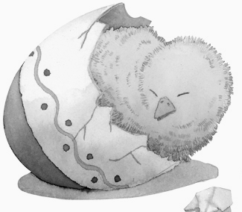
( ) 29.What animals belong to herbivores?
(A)Fish (B)Sheep(C) Pigs(D)None of the above
( ) 30.People belong to the group of
(A) herbivores (B) carnivores (C) omnivores
( ) 31. What might shrubs be ? (A) bacteria (B) little trees (C) lions
( ) 32. According to the article, which of the following is correct ?
(A)It is over 100 years since we had the idea of food chains.
(B)Decomposers are the 2nd link in the food chain.
(C)Bacteria are in fact needed for the food chain.
(D)People are producers, not consumers.
( ) 33. What might be the favorite food for decomposers ?
(A)Plastic Bottles (B) Styrofoam保麗龍 (C)rotten apples. rotten壞掉的
（34~38）奧斯卡金像獎揭曉了!我們一起來看報紙刊登的結果吧~
ROAD TO THE OSCARS ~78th Annual Academy Awards®

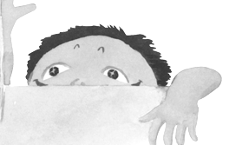
Best Motion Picture of the Year：
Winner~
Crash (2004)
by Paul Haggis Best Achievement in Directing：
Nominees~
＠Ang Lee for
Brokeback Mountain (2005)
Best Performance by an Actor in a ＠George Clooney for~
Leading Role： Good Night, and Good Luck. (2005) Winner～ ＠ Paul Haggis for Crash (2004)
for Capote (2005) ＠Bennett Miller for Capote (2005)
＠Steven Spielberg for Munich (2005)
Winner~ Ang Lee

☆Oscar Annual Academy Awards奧斯卡金像獎/annul一年一次Nominee 入圍者motion動作/achievement成就/direct指導,導演/performance表演/film影片☆
( ) 34.Which is the best action movie this year?
(A) Crash (B) Capote (C) Ann lee (D) Brokeback Mountain
( ) 35.The best actor this year, Philip Seymour, starred the film called
(A)Crash (B) Capote (C) Brokeback Mountain (D) Munich film影片
( ) 36.Which isn’t the nominee for the best film?
(A)Crash (B) Good Night, and Good Luck.
(C) Brokeback Mountain (D) North Country
( )37.Who is the best director this year?
(A) Ang Lee (B) Steven Spielberg (C) Bennett Miller (D) Tom Cruise
( )38. Which are all the words underlined might be?
(A) boxes (B) people (C) movies (D) cities underlined劃底線的


Jenny@yahoo.com.tw
I can’t wait!

Dear Jenny,
Guess what? Gary is having a potluck party after Month Exam! He invites all of us to come! I decide to go and I know you will, too.
Since it is a potluck party, I think I will bring some beef noodles. As I know, Lily will take care of the drinks and Gina will bring a big homemade chocolate cake. Can you ask your mom to buy us some KFC fried chicken? You know it is too far for all of us to ride a bike there, and your mom has learned how to drive a car. Is it OK? We can pay the bill together. Just think about how surprising our classmates will feel when they see what we prepare! Isn’t it great? I almost can’t wait for it :-P
The party will start at noon on March 25th, so be sure to be at Gary’s place around eleven-thirty to prepare for the food. If you have any other questions, just call me or write me back. You know my number, right? By the way, don’t forget to invite Amy, who is good at music. Take care! Leo
( ) 39. Who will hold a potluck party ? (A) Leo.(B)Gary.(C) Lily.(D) Gina.
( )40.The drinks will be brought by____. (A) Leo. (B)Gary.(C) Lily.(D) Gina.
( )41. What does the word “potluck” in line 2 mean?
(A) a meal cooked for the poor.
(B) a free meal served by a church.
(C) a meal served in a restaurant at some special time.
(D) a meal where guests bring food to share
( )42. Why did Leo ask Jenny’s mom to buy the chicken?
(A) He is too lazy for that.
(B) He is afraid of spending too much money.
(C) It is difficult for them to ride to the restaurant far away.
(D) Both of them are busy preparing for the exam.
( )43.According to the email, which is true?
(A)Gina is having a potluck party.
(B) The party will start at 11:30.
(C) Jenny has to pay for the fried chicken alone.
(D) We don’t know if Amy will go to the party.
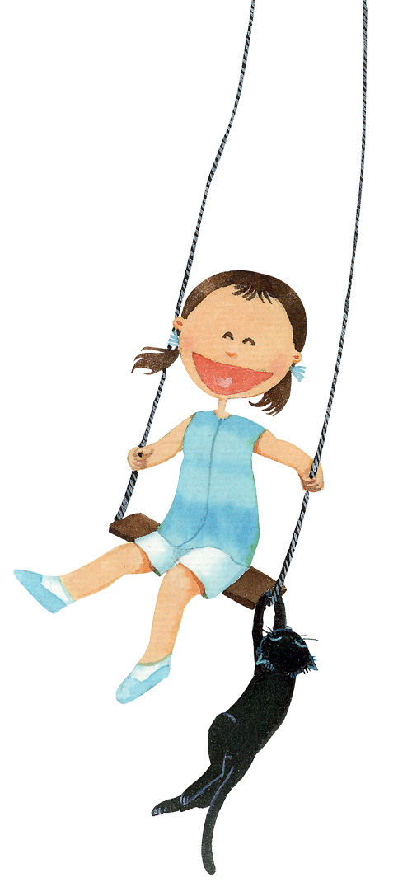
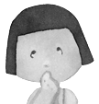
（44~50） Jenny打電話給Amy討論party的事~
Amy: (the phone is ringing) Hello?
Jenny: Hi, this is Jenny. Is Amy there?
Amy: (44) .
Jenny: Amy, I have something bothering to tell you.
BON What’s the voice? Sounds like noise.
Amy: (45) It’s quiet now and I’m listening.
What’s the matter with you?
Jenny: Well, what are you going to wear at Gary’s party?
(46) .
Amy: I think I will be dressed (47) pink.
You know I am fond of pink.
Jenny: Yes. Then will you (48) some time shopping
with me after the exam ?
Amy: (49) .
Jenny: I really look forward to the party.
Amy: (50) . ☆look forward to 期待☆
( )44. (A) Sorry, she’s not home. (B)You have the wrong number.
(C) Speaking. (D)This isn’t she; can I leave the message?
( )45. (A)Oh, sorry. Let me turn the TV off. (B) No, that sounds great.
(C) It’s ok; it’s just my pet rabbit. (D) You are so sweet.
( )46.(A)Listen to me. (B)I have trouble deciding what to wear.
(C)Maybe I should. (D)I have a good time spending money.
( )47. (A) in (B) with (C) on (D) off
( )48. (A) cost (B) spend (C) pay (D) waste
( )49. (A) My mistake. (B) Here you are. (C) That’s not the same.
(D) Don’t worry; I will.
( )50. (A) So do I. (B) So I do. (C) And I am, too. (D) So I am, too.
--The End—

