高雄縣立林園高級中學 國中部95學年度 第一學期 一年級 英文 科第一次段考考卷
範圍：Starter~Unit2 班級： 姓名： 座號：
※聽力測驗
一、圈出你所聽到單字中字尾的音標6%
1. [p] [d] 2. [b] [d] 3. [p] [t]

二、圈出你所聽到的單字4%
- nice well class cat
- thirteen fifteen five fifth

三、勾選與對話內容相符合的圖片10%
1. 2. 3.
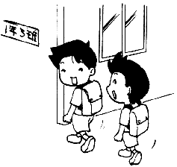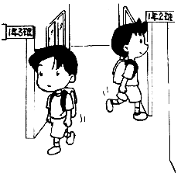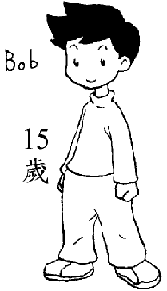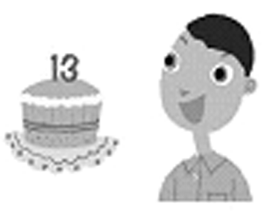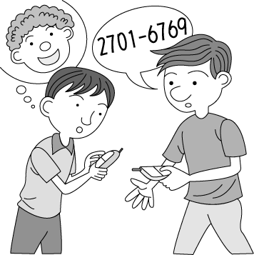
A ( ) B( ) A( ) B( ) A( ) B( )

4. 5.
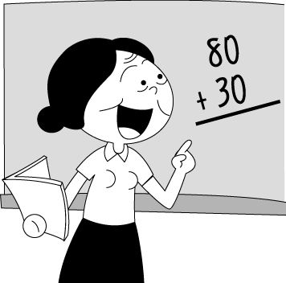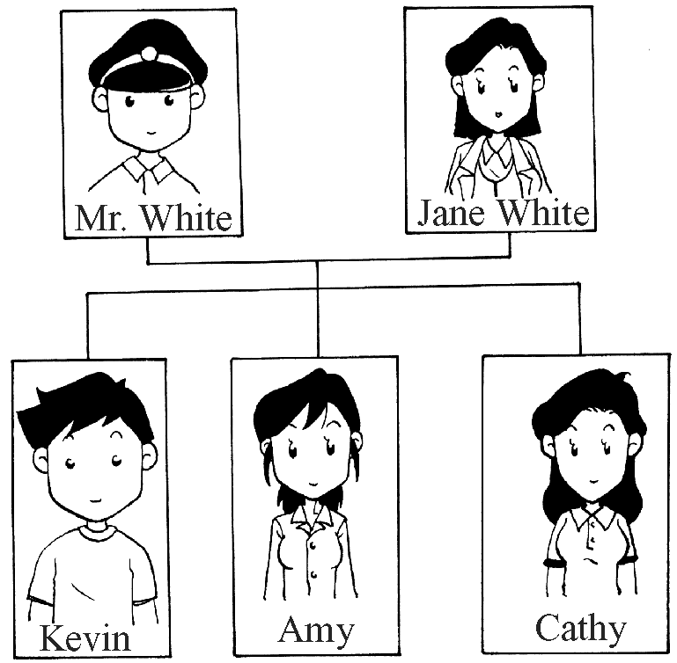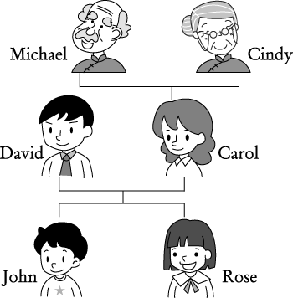
A( ) B( ) A( ) B( )

四、根據問句，選出最適當的答句10%
( )1.(A)I’m 13. (B) I’m David. (C) I’m his mother. (D)I’m great. And you?
( )2.(A)She’s fine. (B)She’s 15. (C)I’m very well. (D)She’s my teacher.
( )3.(A)Yes, you are. (B)No, I’m Tony. (C)That’s right. (D)I’m fine.
( )4.(A)Yes, she’s your sister. (B)Yes, she’s my sister. (C) Yes, she’s Shelly’s sister. (D)Yes, I am.
( )5.(A)No, my number is 0968-228-848. (B)No, I’m fourteen years old.
(C)Yes, my number is 0968-490-203. (D)Yes, it’s 0968-228-848.

※紙筆測驗
五、字母測驗5%(每題1分，錯1字母全錯)
(一)字母接龍 1.大寫 K L M 2.小寫 n p s
(二)字母大小寫轉換
3.winter→ 4.JACKET→ 5.chalk→

六、字彙測驗
- 寫出下列單字的英文5%
1.房子 2.朋友 3.十三 4.街道 5.可愛的
- 文意字彙10%
1.They are my father and mother. We are a happy f y.
2.Peter and I are in Mr. Wang’s class. They’re c s.
3.There is a PG-13 movie at the t r.
4.Look at the p e. It’s my cat, Kitty.
5.They are good students, r t?
七、文法選擇20%
( )1. A: How do you do? B: (Ａ) How are you doing? (Ｂ) How do you do? (Ｃ) I’m OK.
(Ｄ) Very well, thank you.
( )2. The pig is cute. What’s name? (Ａ) its (Ｂ) it’s (Ｃ) your (Ｄ) their
( )3. Mr. Lee is my teacher. I’m . (Ａ) his students (Ｂ) her students (Ｃ) her student (Ｄ) his student
( )4. A: Are Jenny and Terry your students? B: No, .(Ａ) they are. (Ｂ) we aren’t (Ｃ) they’re not (Ｄ) we’re not
( )5. My sister is office worker（上班族）. (Ａ) ╳ (Ｂ) one (Ｃ) a (Ｄ) an
( )6. A: Who’s the boy? B: He’s . (Ａ)very well (Ｂ)thirteen (Ｃ) Mike’s student (Ｄ)Mr. Wang’s students
( )7. A: B: It’s 2388-5431. (Ａ) Your phone number is 2388-5431, right? (Ｂ) What’s your telephone number? (Ｃ) My telephone number is 2388-5431. (Ｄ) Is it your telephone number?
( )8. Bob: How old ? Sue: I am eleven, and(而且) Jenny is twelve. (Ａ) are you (Ｂ) are you and your brother (Ｃ)are they (Ｄ) is that cute girl
( )9.找出與下列對話意思相符的句子：
Tom: Ted, are you twenty? Ted: No, I’m nineteen. My brother, Mike, is twenty.
(Ａ) Tom is twenty years old. (Ｂ) Ted’s brother is nineteen. (Ｃ) Ted is not nineteen.
(Ｄ) Ted isn’t twenty years old, but（但是）Mike is.
( )10.將下列單字按順序重新排列成正確的句子：○ your ○ He ○ right? ○ is ○ brother,
(Ａ)○○○○○ (Ｂ) ○○○○○ (Ｃ) ○○○○○ (Ｄ)○○○○○

八、克漏字選擇10%
David: This is my sister, Sally. She is 6 (1) . Tom: (2) is a cute girl.
David: Thanks. Tom: (3) this man? Is he your brother?
David: (4) , he’s my father. He’s a teacher. Tom: He’s cool.
David: My mother is a teacher, (5) .
( )1.(A) year old (B) years old (C) year-old girl(D) years-old girl
( )2.(A) She (B) He’s (C) He (D) She’s
( )3.(A) Who’s (B) How (C) Who (D) What’s
( )4.(A) Yes (B) × (C) Not (D)No
( )5.(A) to (B) two (C) too (D) ×

九、閱讀測驗10%
Name: Jenny
(Judy’s friend)
Age: 21
TEL:2731-8954
以下是Judy(12歳)的備忘錄，請看筆記回答問題：
Name: Emily
(Jenny’s sister)
Age: 14
TEL: 2735-8869
Name: Shelly.
(Emily’s classmate)
Age: 13
TEL: 2697-0381

Age 年齡

( )1.How old is Jenny? (Ａ) Forty-one. (Ｂ)Thirty-one. (Ｃ) Fifty-one. (Ｄ) Twenty-one.
( )2.Jenny and Judy are . (Ａ) sisters (Ｂ) classmates (Ｃ) friends (Ｄ) twelve years old
( )3.Is Shelly fourteen years old? (Ａ) No, she’s thirteen. (Ｂ)No, she’s twelve. (Ｃ) Yes. (Ｄ)No, Judy is fourteen.
( )4.Whose（誰的）telephone number is 2735-8869? (Ａ)Shelly’s. (Ｂ) Emily’s. (Ｃ). Jenny’s (Ｄ)Judy’s.
( )5.Who is Emily’s sister？(A) Emily (B) Judy (C) Shelly (D) Jenny
十、句子測驗
- 依提示作答4%
My telephone number is 2303-5964.（根據畫線部分造原問句）
The cool man(男人) is my grandpa, Michael. (根據畫線部分造原問句）
(二)翻譯6%
3.Spot不是我的好朋友。
4.你媽媽是警察嗎？不，她不是。
5.那個可愛的男孩幾歲？

高雄縣立林園高級中學 國中部95學年度 第一學期一年級英文科第一次段考 答案卷
範圍：Starter~unit2 班級： 姓名： 座號：
一、圈出你所聽到單字中字尾的音標6%
1. [p] [d] 2. [b] [d] 3. [p] [t]

二、圈出你所聽到的單字4%
- nice well class cat
- thirteen fifteen five fifth

三、勾選與對話內容相符合的圖片10%
1. | A( ) B( ) | 2. | A( ) B( ) | 3. | A( ) B( ) | 4. | A( ) B( ) | 5. | A( ) B( )

四、根據問句，選出最適當的答句10%
1. |  | 2. |  | 3. |  | 4. |  | 5.

五、字母測驗5%(每題1分，錯1字母全錯)
(一)字母接龍
1. | K L M | 2. | n p s
(二)字母大小寫轉換
3. |  | 4. |  | 5.

六、字彙測驗15%
- 寫出下列單字的英文(每題1分)
1. |  | 2. |  | 3. |  | 4. |  | 5.
- 文意字彙(每題2分)
1. |  | 2. |  | 3. |  | 4. |  | 5.

七、文法選擇20%
1. |  | 2. |  | 3. |  | 4. |  | 5.
6. |  | 7. |  | 8. |  | 9. |  | 10.

八、克漏字選擇10%
1. |  | 2. |  | 3. |  | 4. |  | 5.

九、閱讀測驗10%
1. |  | 2. |  | 3. |  | 4. |  | 5.

十、句子測驗
- 依提示作答4%
1.
2.
(二)翻譯6%
3.
4.
5.

高雄縣立林園高級中學 國中部95學年度 第一學期一年級英文科第一次段考 解答
範圍：Starter~unit2 班級： 姓名： 座號：
一、圈出你所聽到單字中字尾的音標6%
1. [p] [d] 2. [b] [d] 3. [p] [t]

二、圈出你所聽到的單字4%
- nice well class cat
- thirteen fifteen five fifth

三、勾選與對話內容相符合的圖片10%
1. | A( ) B( ✓ ) | 2. | A( ) B( ✓ ) | 3. | A( ✓) B( ) | 4. | A( ) B( ✓ ) | 5. | A( ✓ ) B( )

四、根據問句，選出最適當的答句10%
1. | D | 2. | A | 3. | C | 4. | B | 5. | D

五、字母測驗5%(每題1分，錯1字母全錯)
(一)字母接龍
1. | J K L M N | 2. | n o p q r s
(二)字母大小寫轉換
3. | W I N T E R | 4. | j a c k e t | 5. | C H A L K

六、字彙測驗15%
- 寫出下列單字的英文(每題1分)
1. | house | 2. | thirteen | 3. | late | 4. | street | 5. | dear
- 文意字彙(每題2分)
1. | family | 2. | classmate | 3. | theater | 4. | picture | 5. | right

七、文法選擇20%
1. | B | 2. | A | 3. | D | 4. | C | 5. | D
6. | C | 7. | B | 8. | A | 9. | D | 10. | C

八、克漏字選擇10%
1. | B | 2. | A | 3. | A | 4. | D | 5. | C

九、閱讀測驗10%
1. | D | 2. | C | 3. | A | 4. | B | 5. | B

十、句子測驗
- 依提示作答4%
1. | It’s two, five, two, one, zero, eight, eight, nine.
2. | Who’s the cool man?
(二)翻譯6%
3. | Spot isn’t my good friend.
4. | Is your mother a police officer?
5. | How old is the cute boy?

