高雄縣立林園高中九十五學年度第一學期第二次段考國中部一年級英語科試題
※請一律作答於答案卷上
一、聽力測驗：本測驗每題唸兩遍，請同學細心作答(30%)
A. 填入與聽到內容相符合的圖片代號 (每題2分)
(A) 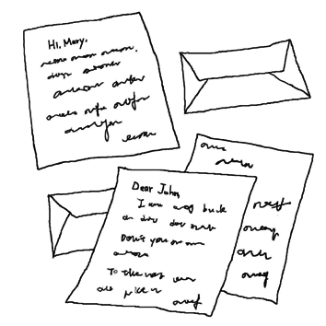 | (B)  | (C) 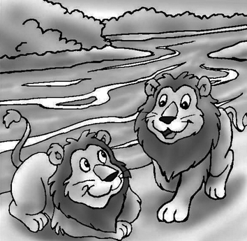 | (D) 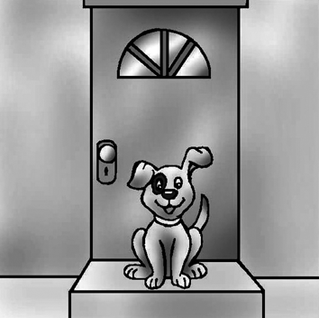 | (E) 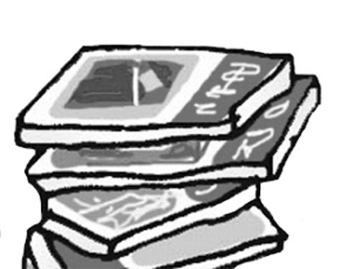 | (F) 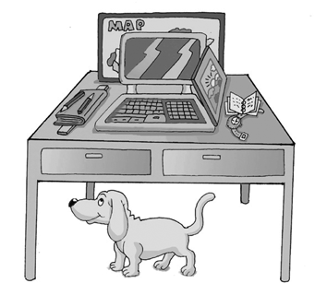
1.________ 2.________ 3.________ 4.________ 5.________

B. 根據聽到的對話及問題，選出正確的答案 (每題2分)
1. (A) Mary’s brother. (B) Judy’s brother. (C) A magician. (D) We don’t know.
2. (A) A teacher. (B) A student. (C) A magician. (D) A doctor.
3. (A) A pen. (B) A ruler. (C) A box. (D) A pencil.
4. (A) The watch is a ruler now. (B) The ruler is a watch now.
(C) The pen is a pencil now. (D) The pencil is a pen now.
5. (A) They are from Tony’s bag. (B) They are from Mary’s bag.
(C) They are from Tony’s pencil box. (D) They are from Judy’s pencil box.

C. 根據聽到的問句，選出適當的答句 (每題2分)
1. (A) He’s Linda’s father. (B) Her name is Kelly.
(C) He is fifteen. (D) He’s fine.
2. (A) Yes, these are rulers. (B) Yes, they are erasers.
(C) No, it’s a pencil. (D) No, it’s on the desk.
3. (A) It’s in my bedroom. (B) It’s from my teacher.
(C) They are for you. (D) They are under the sofa.
4. (A) Yes, he is on the sofa. (B) Yes, she is behind the window.
(C) No, she is under the bed. (D) No, she is behind the door.
5. (A) A chair. (B) In the bedroom. (C) Yes, it is. (D) Yes, it’s a desk.

二、文意字彙 (10%，每題2分)
1. I know the 26 l rs from A to Z in English.
2. They are in the same class. This is their c m.
3. Kevin is not here. M e he is in his room.
4. I see tigers, lions and zebras in the z o.
5. Mom is cooking(煮飯) in the k n.

三、文法選擇 (10%，每題2分)
1. He is not in the dining room, ___________ he is not in the living room.
(A) × (B) and (C) but (D) now
2. ___________ there ____________ on the table?
(A) Is ; the apple (B) Is ; oranges (C) What’s ; bananas (D) Are ; cookies
3. A: ___________ is Kitty? B: ___________ in the bathroom.
(A) Who’s ; She’s (B) What ; She’s (C) How’s ; It’s (D) Where ; It’s
4. A: Aren’t these your pencils? B: Yes, ___________.
(A) there are (B) there aren’t (C) they are (D) they’re not
5. A: ___________ this? B: ___________ a book.
(A) What is ; This (B) What is ; It’s (C) What are ; These (D) What are ; They’re

四、對話 (10%，每題2分)
1. A: Are you OK? B: ___________
(A) Oh, no! (B) Thanks. (C) I’m sorry. (D) Very well!
2. A: There’s a dog over there. B: ___________ It’s big!
(A) Ah-ha! (B) Oh, no! (C) Wow! (D) Hey!
3. A: Where’s my computer game? B: ___________
(A) Isn’t it in your bedroom? (B) Yes, it’s on your desk.
(C) It’s your computer game. (D) They’re on the sofa.
4. A: Are there three books on the desk? B: ___________
(A) Yes, there is. (B) Yes, they are. (C) No, there is one. (D) No, they are two books.
5. A: What’s in the pencil box? B: ___________
(A) There are three pens in it. (B) They are in the pencil box.
(C) Yes, there are a ruler and two pencils. (D) No, it’s a ruler.

五、克漏字選擇：看圖作答 (10%，每題2分)
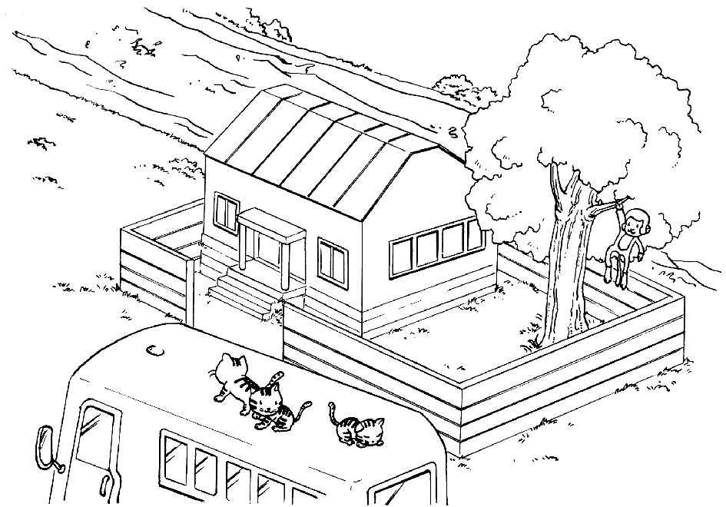 | This is Mr. and Mrs. Wang’s house. There’s a bus  (1.) their house. You can see (2.) on top of it.  (3.) the house is a tree. There’s a (4.) in it. It’s very cute. And there’s a river (5.) the house. The view is beautiful. It is a great house.  1. (A) behind (B) under (C) next to (D) in front of  2. (A) a monkey (B) a tree (C) cats (D) lions  3. (A) Under (B) In (C) Behind (D) Next to  4. (A) bus (B) monkey (C) cat (D) river  5. (A) behind (B) under (C) next to (D) in front of

六、閱讀測驗 (10%，每題2分)
下表為 Amy，Jenny，Bob，Ellen 所擁有的物品，依表回答問題：
Name  Item | Amy | Jenny | Bob | Ellen | 1. They are ___________ notebooks.  (A) Amy and Bob’s (B) Amy’s and Ellen’s  (C) Bob and Jenny’s (D) Amy’s and Bob’s  2. A: Are these ___________ comic books? B: Yes.  (A) Amy’s (B) Jenny’s (C) Bob’s (D) Ellen’s  3. It’s ___________ watch.  (A) Amy’s (B) Jenny’s (C) Bob’s (D) Ellen’s  4. A: Are these Jenny’s pictures? B: ___________  (A) Yes, they are. (B) No, those are Amy’s.  (C) Yes, these are Bob’s. (D) No, those aren’t.  5. Only Ellen has(有) a ___________.  (A) TV (B) game (C) telephone (D) computer
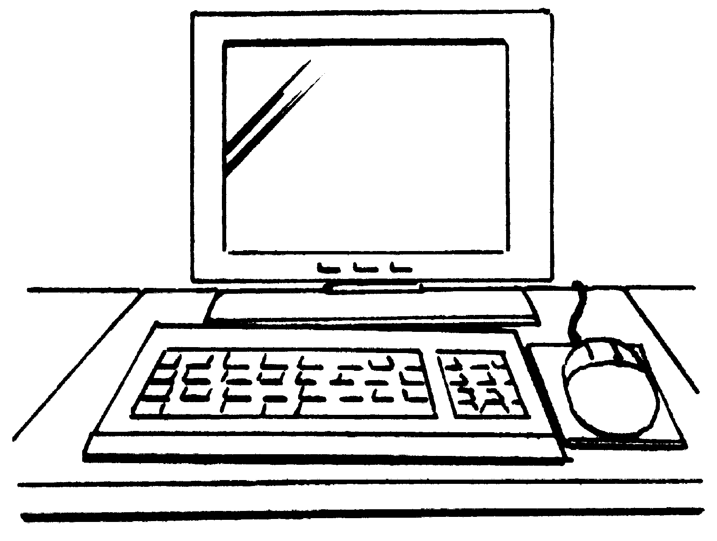 | 0 | 0 | 0 | 1
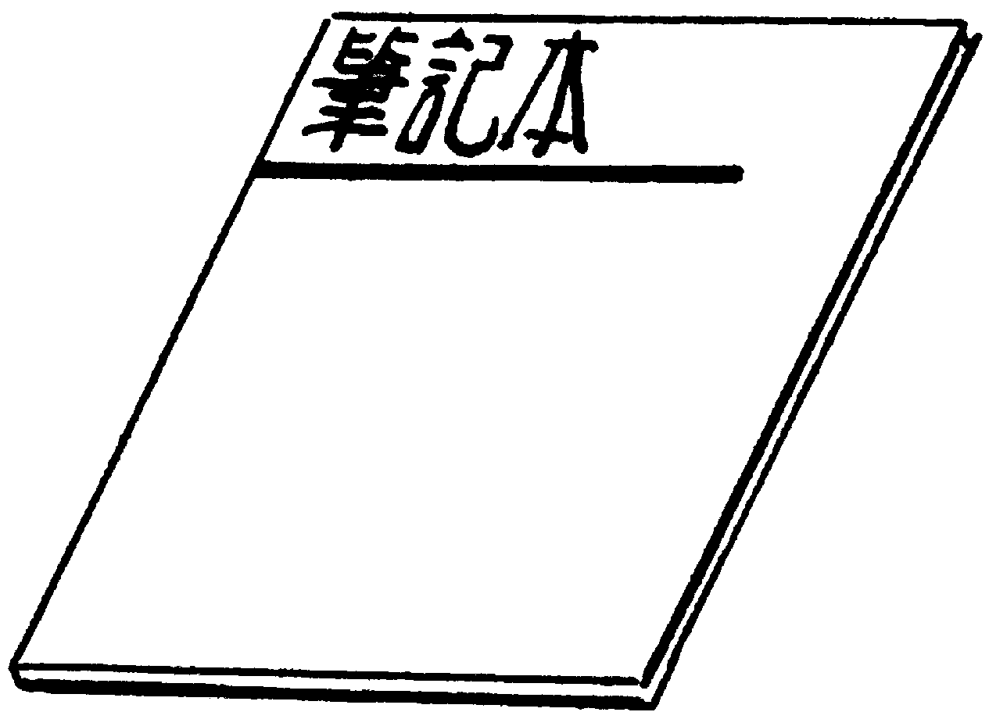 | 2 | 0 | 3 | 0
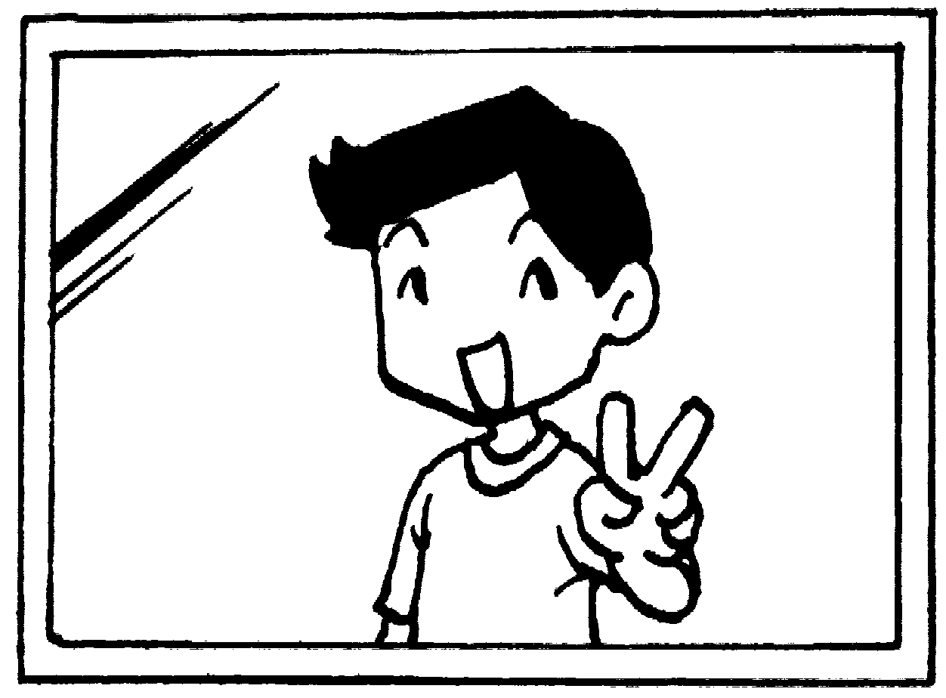 | 16 | 0 | 0 | 0
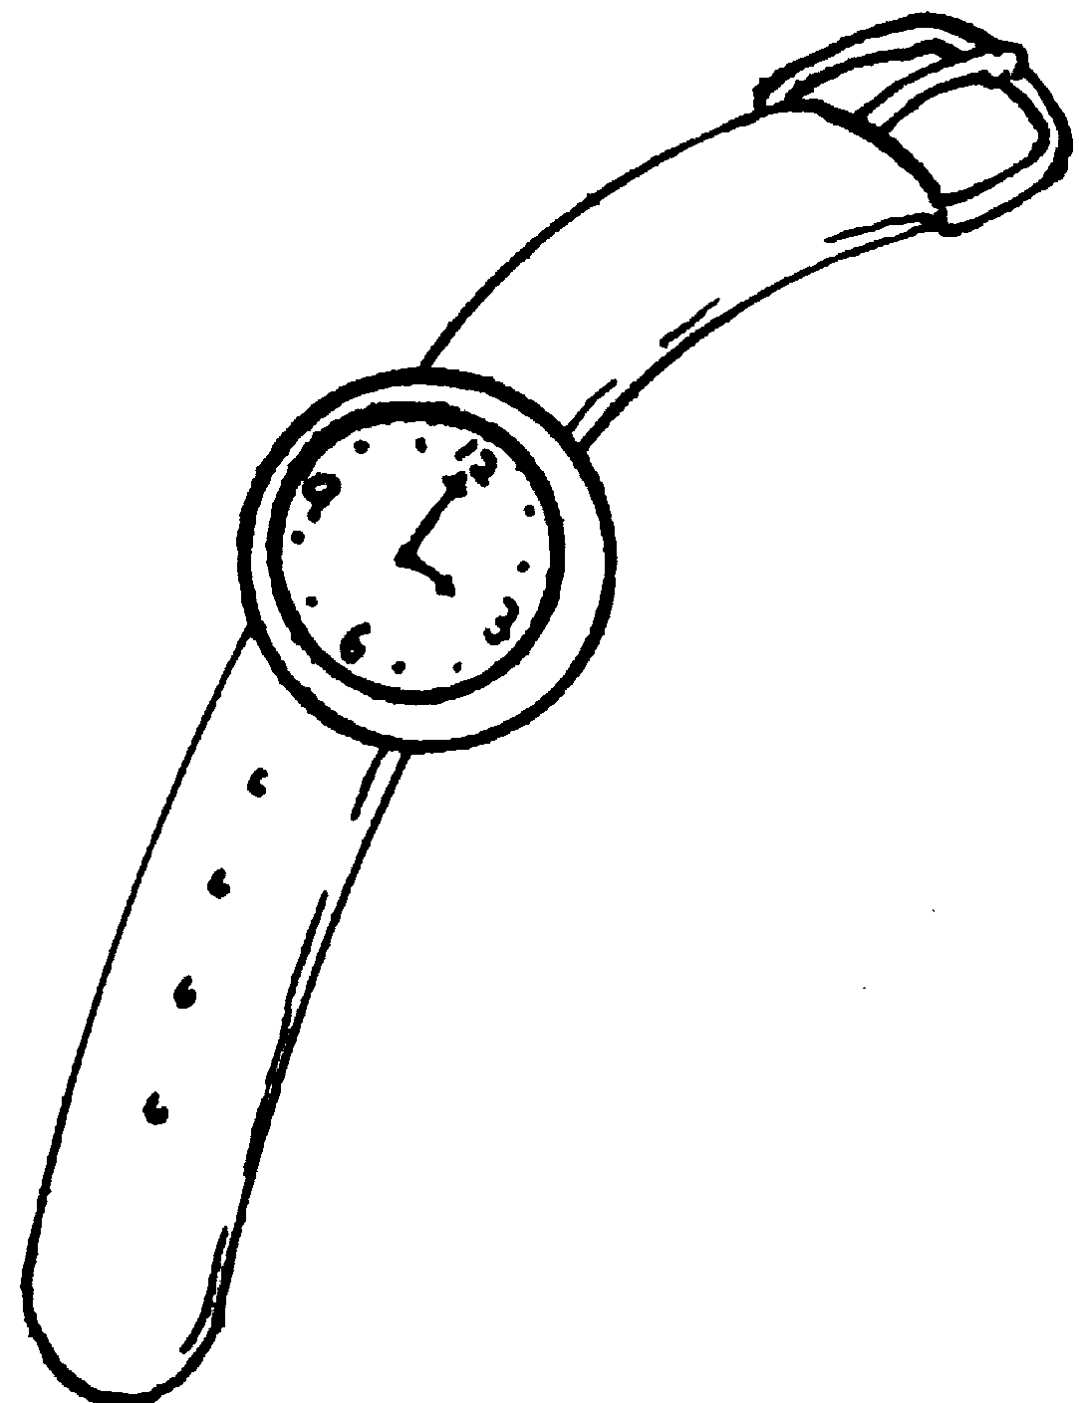 | 0 | 1 | 0 | 0
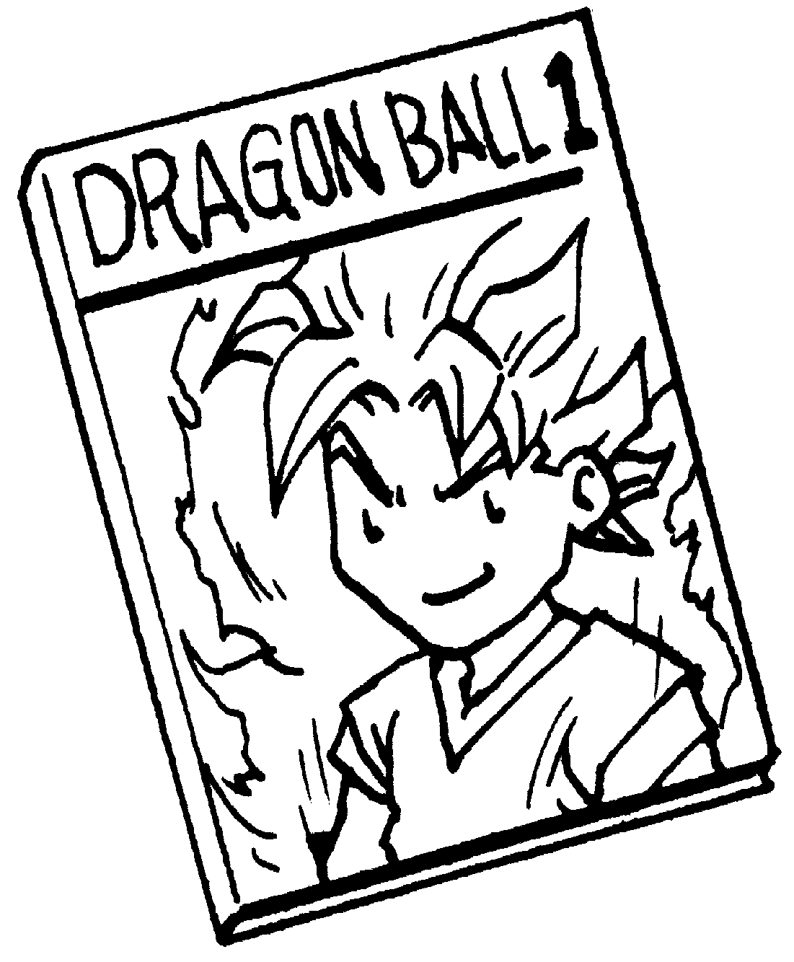 | 0 | 0 | 15 | 0
七、依提示作答 (8%，每題2分)
(題目詳見答案卷)
八、翻譯 (12%，每題3分)
(題目詳見答案卷)
高雄縣立林園高中九十五學年度第一學期第二次段考國中部一年級英語科答案卷
班級: 座號: 姓名: 得分:
一、聽力測驗(30%)
A. 填入與聽到內容相符合的圖片代號 (每題2分)
1. | 2. | 3. | 4. | 5.
B. 根據聽到的對話及問題，選出正確的答案 (每題2分)
1. | 2. | 3. | 4. | 5.
C. 根據聽到的問句，選出適當的答句 (每題2分)
1. | 2. | 3. | 4. | 5.
二、文意字彙 (10%，每題2分)
1. | 2. | 3. | 4. | 5.
三、文法選擇 (10%，每題2分)
1. | 2. | 3. | 4. | 5.
四、對話 (10%，每題2分)
1. | 2. | 3. | 4. | 5.
五、克漏字選擇：看圖作答 (10%，每題2分)
1. | 2. | 3. | 4. | 5.
六、閱讀測驗 (10%，每題2分)
1. | 2. | 3. | 4. | 5.
七、依提示作答 (8%，每題2分)
1. That is a watch, not a clock. (改為複數句)
_____________________________________________________________________
2. There are four erasers in Ben’s bag. (改為單數句)
_____________________________________________________________________
3. there / over / Aren’t / cats / there / ? (重組句子)
_____________________________________________________________________
4. My book bag is in the box. (依劃線部份造原問句)
_____________________________________________________________________
八、翻譯 (12%，每題3分)
1. 看看樹上的猴子。
____________________________________________________________________
2. 河流附近有隻大象嗎？
____________________________________________________________________
3. 那些考試卷是給你們的。
_____________________________________________________________________
4. 那也是張地圖嗎？
_____________________________________________________________________

高雄縣立林園高中九十五學年度第一學期第二次段考國中部一年級英語科解答
一、聽力測驗(30%)
A. 填入與聽到內容相符合的圖片代號 (每題2分)
1. B | 2. F | 3. C | 4. A | 5. D
B. 根據聽到的對話及問題，選出正確的答案 (每題2分)
1. A | 2. C | 3. B | 4. B | 5. D
C. 根據聽到的問句，選出適當的答句 (每題2分)
1. A | 2. C | 3. D | 4. C | 5. A
二、文意字彙 (10%，每題2分)
1. letters | 2.classroom | 3. Maybe | 4. zoo | 5. kitchen
三、文法選擇 (10%，每題2分)
1. B | 2. D | 3. D | 4. C | 5. B
四、對話 (10%，每題2分)
1. D | 2. C | 3. A | 4. C | 5. A
五、克漏字選擇：看圖作答 (10%，每題2分)
1. D | 2. C | 3. D | 4. B | 5. A
六、閱讀測驗 (10%，每題2分)
1. D | 2. C | 3. B | 4. B | 5. D
七、依提示作答 (8%，每題2分)
1. Those are watches, not clocks.
2. There is an eraser in Ben’s bag.
3. Aren’t there cats over there?
4. Where is your book bag?

八、翻譯 (12%，每題3分)
1. Look at the monkey(s) in the tree.
2. Is there an elephant near the river?
3. Those tests are for you.
4. Is that a map, too?

