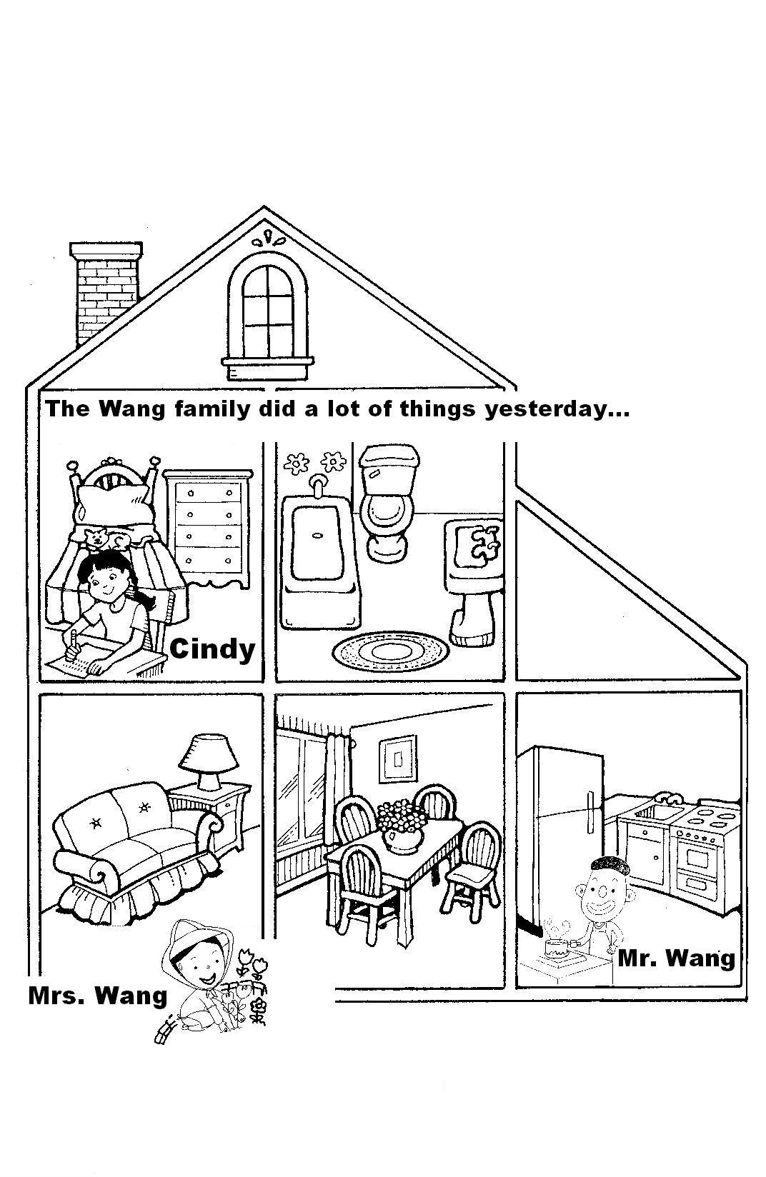
高雄縣立林園高中國中部九十五學年度 第一學期 第一次段考 二年級英語科 試題 (題目卷)
壹、Listening Test (聽力測驗)
一、True or False. (根據下圖以及聽到的句子，正確的寫T，錯誤的寫F) 10%
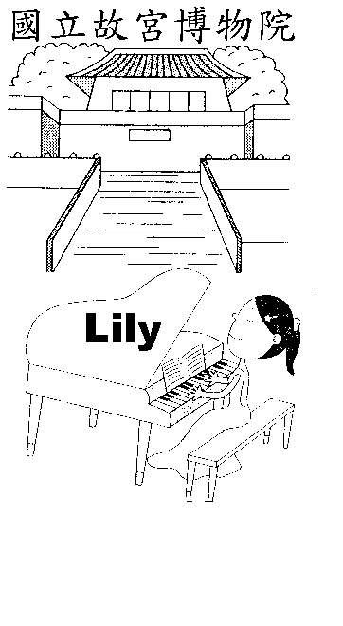

1. _________

2. _________

3. _________

4. _________

5. _________
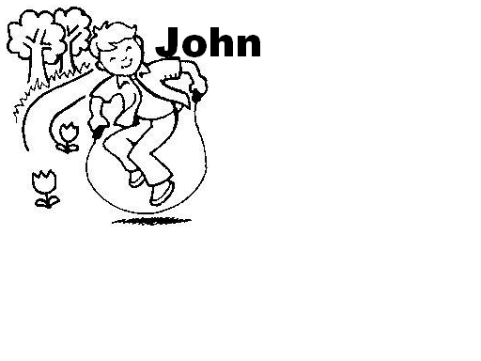

公園

二、Listen and Choose the Right Pictures. (聽CD，選出與單字或句子意思相符的圖片) 10%
題號 | 答案
1 |  | (A)  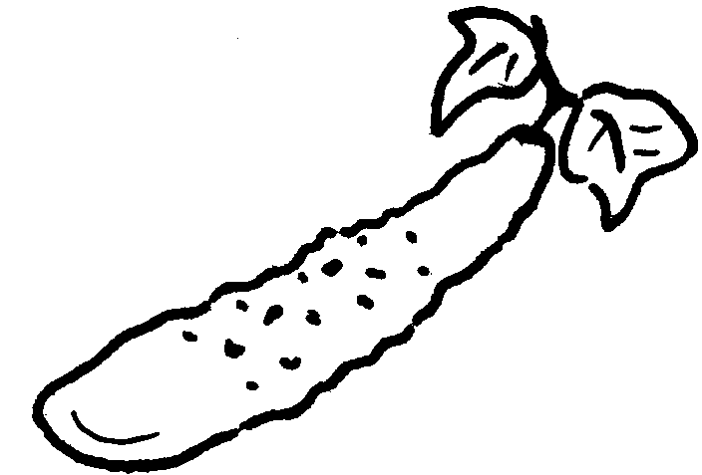 | (B) | (C) | 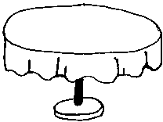(D)
2 |  | (A) | 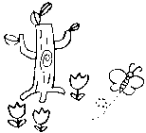(B) | 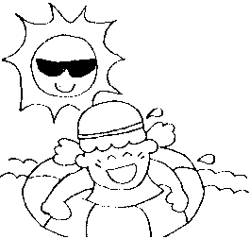(C) | (D)
3 |  | 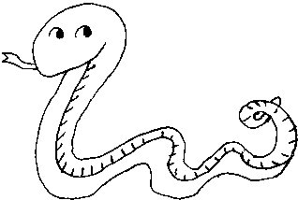(A) | (B) | 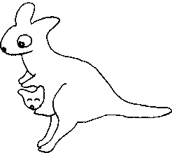(C) | (D)
4 |  | 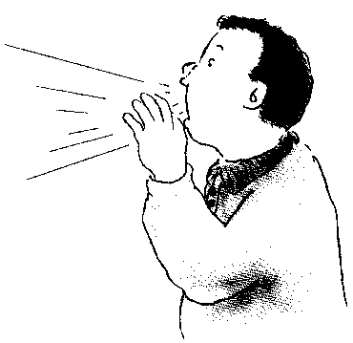(A) | (B) | (C) | 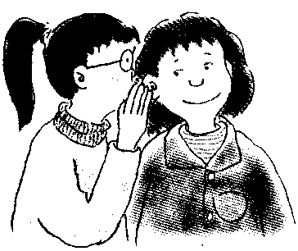(D)
5 |  | (A) | (B) | (C) | (D)
1 《背面有題》

6 |  | 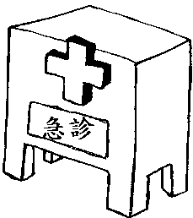(A)  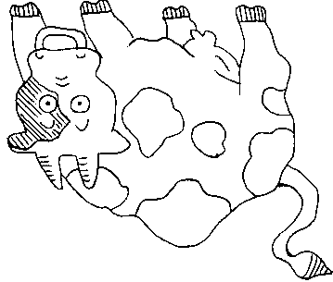 |  | 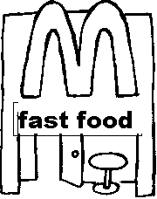(B)
6 |  | (C)  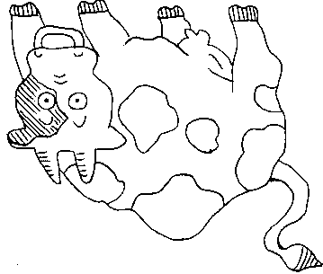 |  | (D)  
7 |  | 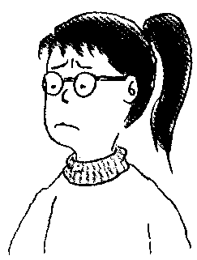(A) | (B) | (C) | (D)
8 |  | 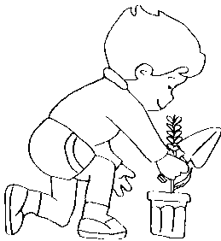(A) | 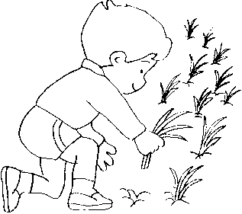(B) | 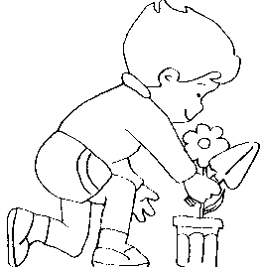(C) | 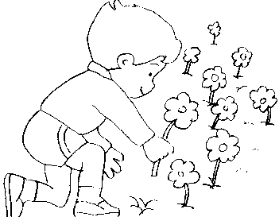(D)
9 |  | 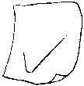(A)  數學 100 | (B)  英文 100 | 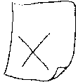(C)  英文 0 | (D)  數學 0
10 |  | (A) | (B) | (C) | 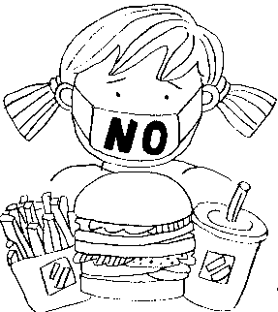(D)

三、Listen and Choose the Right Answer. (根據CD短文內容，選出符合文意的選項) 10%
1. (A) On foot. (Ｂ) By bus. (C) By car. (D) By bike.
2. (A)They didn’t feed the birds. (Ｂ) They talked loudly. (C) It rained heavily. (D) They walked too fast.
3. (A) They didn’t have fun. (Ｂ) They had a lot of fun. (C) They had a lot of time. (D) They didn’t had a lot of time.
4. (A) She lost her bag yesterday. (Ｂ) She didn’t go to her best friend’s party.
rain 下雨
(C) The doctor wasn’t healthy. (D) She ate too much yesterday.
5. (A) Pizza. (Ｂ) Rice. (C) Coke. (D) Cake.

貳、Comprehension Test (紙筆測驗)
一、Choose (選擇) 20%
1. Jerry is a famous singer now, and he ______ every day; Mary was a teacher two years ago, and she ______ every day.
(A) practices; taught English (B) practiced; taught English (C) practice; teach English (D) practices; teaches English
2. Eat more vegetables! They are good ______ health. (A) your (B) for (C) in (D) much
3. My classmates and I ______ like fast food. (A) both (B) all (C) many (D) much
4. A: Who rode a bike in the park? B: Linda ______. (A) is (B) was (C) did (D) does
5. Peter studies ______. No wonder he always does ______ in his classes.
(A) hardly; well (B) hardly; welly (C) hard; goodly (D) hard; well
6. My aunt, Gloria is ______, and she walks ______.
(A) beautiful; beautiful (B) beautiful; beautifully (C) beautifully; beautiful (D) beautifully; beautifully
7. Jack was very hungry, so he ate and drank very ______. (A) fast (B) slow (C) slowlly (D) fastly

2 《背面有題》

8. Peter didn’t ______ any ice cream last night. (A) eat (B) eats (C) ate (D) eating
9. Almost everyone ______ happy at the party. (A) played (B) was (C) were (D) did
10. William ______ five pounds in two ______. (A) losed; months (B) lost; month (C) lost; months (D) losed; month

二、Reading (閱讀測驗) 5%
Grandma had a busy day yesterday. She got up at 6：30 in the morning and had breakfast with her grandchildren. After breakfast, Grandma took them to school. She taught piano lessons. She had some rice and chicken for lunch at 1：00 p.m. After lunch, she went to a supermarket for some vegetables and fruit.
But in the supermarket, she saw a thief stealing things. She caught him and called the police. Then, Grandma went home and cooked dinner. supermarket 超級市場 thief 小偷 steal 偷竊
（ ）1. What does Grandma do?
(A) She works in a supermarket. (B) She is a music teacher. (C) She is a police officer. (D) She is a cook.
（ ）2. What did Grandma have for lunch?
(A) A sandwich and milk. (B) Vegetables and rice. (C) Rice and chicken. (D) A beef sandwich and fruit.
（ ）3. Where did Grandma catch the thief?
(A) In the school. (B) In her office. (C) In her kitchen. (D) In the supermarket.
（ ）4. What did Grandma go to the supermarket for?
(A) Vegetables and fruit. (B) Vegetables and rice. (C) Rice and chicken. (D) A beef sandwich and fruit.
（ ）5. What does the word “them” in line two mean?
(A) Her grandchildren. (B) The breakfast. (C) The thief. (D) The vegetables.

三、Vocabulary (文意字彙) 20%
____________ 1. Amy has $20. Mike has $70. Amy has l______s money.
____________ 2. I have to lose five pounds in a month. I want d______t drinks.
____________ 3. This cake is too big for me. Let’s s______e it.
____________ 4. J.K.Rowling is a f______s writer.
____________ 5. Be q______t! The baby is sleeping.
____________ 6. I visited Ali M______n last weekend. The air there was fresh.
____________ 7. This game was i______ting to us. We enjoyed it.
____________ 8. Spotty is an e______t dog. He can do many things.
____________ 9. Mr. White often goes to that r______t to eat lunch.
____________ 10. The cook cooks with cookers and c______ks.

四、Fill in（填入正確的介系詞及適當變化的動詞）10%
1. Peter’s cousin came Taiwan last year.
2. Peter’s parents are still healthy. He is very happy that.
3. Maybe Peter can teach Chinese his cousin.
4. How do I say “goodbye” Chinese?
5. Peter, thanks the Chinese lesson.
6. Peter (have to) take care of his parents last month.
7. Peter (start) his new way of life yesterday.
8. Peter and his girlfriend (swim) and rode bicycles last weekend.
9. Peter (go) out early in the morning and came home late.
10. Peter’s aunt (jog) with him yesterday.

五、Translate (翻譯) 15%
1. 請再給我一片披薩。
2. 我伯父昨晚睡不好。
3. 我沒想到美國這麼好玩。
4. 正餐之間不要吃過多的零食。
5. 她們昨天看過了美景並一起分享美食。

3 《考試結束》

高雄縣立林園高級中學國中部九十五學年度 第一學期 第一次段考 二年級 英語科考卷 作答卷
範圍： L1~Review 1 班級： 姓名： 座號：

壹、Listening Test (聽力測驗)
一、True or False (根據下圖以及聽到的句子，正確的寫T，錯誤的寫F) （10%，每題2分）
1. | 2. | 3. | 4. | 5.

二、Listen and Choose the Right Pictures. (聽CD選出與單字或句子意思相符的圖片) （10%，每題1分）
1. | 2. | 3. | 4. | 5.
6 | 7. | 8. | 9. | 10.

三、Listen and Choose the Right Answer. (根據CD短文內容，選出符合文意的答案) （10%，每題2分）
1. | 2. | 3. | 4. | 5.

貳、Comprehension Test (紙筆測驗)
一、Choose (選擇題) （20%，每題2分）
1. | 2. | 3. | 4. | 5. | 6. | 7. | 8. | 9. | 10.

二、Reading (閱讀測驗) （5%，每題1分）
1. | 2. | 3. | 4. | 5.

三、Vocabulary (文意字彙) （20%，每題2分）
1. | 2. | 3. | 4. | 5.
6. | 7. | 8. | 9. | 10.

四、Fill in. (填入正確的介系詞及適當變化的動詞) （10%，每題1分）
1. | 2. | 3. | 4. | 5.
6. | 7. | 8. | 9. | 10.

五、Translate (翻譯) （15%，每題3分）
1.
2.
3.
4.
5.

高雄縣立林園高級中學國中部九十五學年度 第一學期 第一次段考 二年級 英語科 答案
壹、Listening Test (聽力測驗)
一、True or False （10%，每題2分）
1. T | 2. F | 3. F | 4. T | 5. T
二、Listen and Choose the Right Pictures.（10%，每題1分）
1. A | 2. C | 3. D | 4. A | 5. B | 6. B | 7. C | 8. B | 9. A | 10. D
三、Listen and Choose the Right Answer. （10%，每題2分）
1. C | 2. C | 3. A | 4. D | 5. B
貳、Comprehension Test (紙筆測驗)
一、Choose（20%，每題2分）
1. A | 2. B | 3. B | 4. C | 5. D | 6. B | 7. A | 8. A | 9. B | 10. C
二、Reading（5%，每題1分）
1. B | 2. C | 3. D | 4. A | 5. A
三、Vocabulary（20%，每題2分）
1. less | 2. diet | 3. share | 4. famous | 5. quiet
6. Mountain | 7. interesting | 8. excellent | 9. restaurant | 10. chopsticks
四、Fill in. （10%，每題1分）
1. to | 2. about | 3. to | 4. in | 5. for
6. had to | 7. started | 8. swam | 9. went | 10. jogged
五、Translate（15%，每題3分）
1. Please give me one more piece of pizza.
2. My uncle didn’t sleep well last night.
3. I didn’t expect so much fun in America.
4. Don’t eat too many snacks between meals.
5. They saw beautiful scenery and shared delicious food together.

