高雄縣立林園高級中學 國中部95學年度 第一學期 二年級 英語科 第二次段考試題卷
範圍：L 4 ~ Review II 班級： 姓名： 座號：
- 一﹑聽力測驗 30%
  - Part I 根據圖片，聽CD中的敘述,正確的寫T,錯誤的寫F
1. 2. 3. 4. 5.
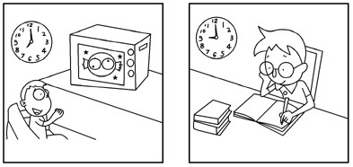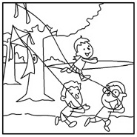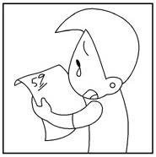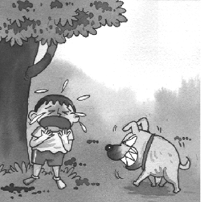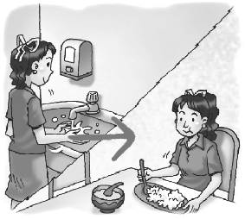
  - Part II 根據圖片,依序選出所聽到的人名(請填代號即可) (A) Mary (B) Cindy (C) John (D) Peter (E) little Jimmy
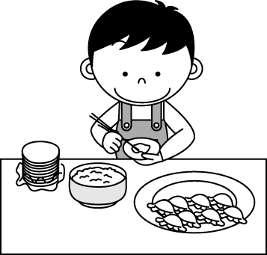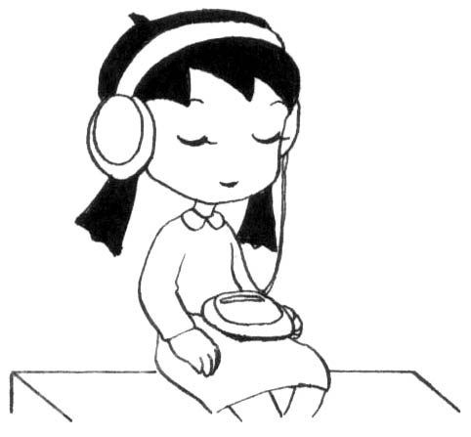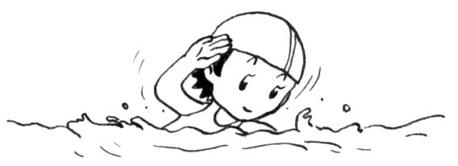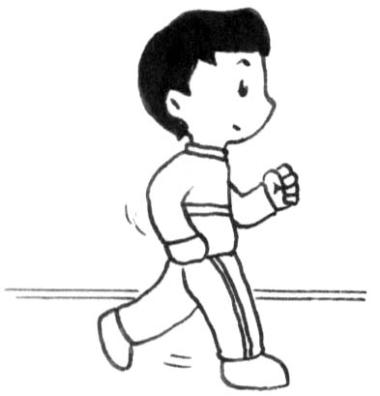

  - Part III根據CD中簡短對話，選出正確答案
- (A) She is fat. (B) She is late. (C) She is sick.
- (A) It’s not very large. (B) It looks beautiful. (C) It has a nice living room.
- (A) It’s too cold. (B) The man died. (C) It’s very hot.
- (A) Before going to bed. (B) After going to school. (C) After going to bed.
- (A) A bookstore. (B) A restaurant. (C) a friend’s house.

< 聽力測驗結束 >

- 二﹑文意字彙 10%
1. John isn’t c e at all. So no one wants to be his friend.
2. Jackson is an honest (誠實的) boy. His mom is p d of him.
3. A：Hello！ Is Tony here？ B：Sorry, he is not here. Can you leave a m e?
4. The restroom is near the e e of the museum？
5. A：May I ask you a q n？ B：Sure.
6. You look very sad. What h ed before I got here.
7. When I have any p m at school, I ask my teachers and classmates for help.
8. Ice Age is a p r movie. Many young people saw it.
9. I don’t understand it. Please give me some e es
10. Linda didn’t blame Ted at all after he a d to her.

- 三﹑文法選擇 20%
- Sally _____ her camera with her. So she can take pictures any time.
  - always bring (B) always brings (C) brings always (D) never bring
- Ben ______ on weekends.
  - usually not busy (B) busy is seldom (C) is always busy (D) never is busy
- A：The boy ______ blue eyes is Mike. B：Wow, he is so handsome.
  - with (B) on (C) in (D) at
- Jolin is my best friend. She _______ like my sister.
  - don't (B) × (C) was (D) is
- I am thankful everyone in my class _______ safe(安全的).
  - am (B) are (C) is (D) be
- There are _________________________ in the park.
  - two thousands students (B) two thousand of students (C) two thousand students (D) thousands of student
- Young people in Taiwan listen to music and play games ________ their cell phones now.
  - with (B) × (C) in (D) at < 背面仍有試題 >
- Let’s _________ to the movies together.
  - going (B) go (C) to go (D) goes
- Tim ____________ when Bob ___________.
(A) roller-blade, jog (B) is roller-blading, is joging (C) was roller-blading, was jogging (D) roller-blades, jogged
10. Always wash your hand ________ you eat. You can be healthy.
(A) to (B) in (C) before (D) after

- 四﹑對話與完成句子 10%
1. A：When did you last see your sister? B：__________.
(A) She is fine. (B) I saw her in the classroom. (C) I didn’t ask her. (D) I saw her last weekend.
2. A：Excuse me, do you have the time？ B：__________.
(A) Not at all. (B) You are right. (C) Yes, it’s 8:30 am now. (D) No, I am here.
3. A：Who went to the restroom in class？ B：__________.
(A) I do. (B) Peter did. (C) He is friendly. (D) Everyone does.
4. A：__________. It looks heavy. B：Nothing. Just some comic books.
(A) What's in your bag？ (B) Where is your bag？ (C) Is that your bag？ (D) Who stole your bag？
5. What was Sandy doing when he was studying？
(A) She lost her dog. (B) She is eating dinner. (C) She was watching TV. (D) She does her homework.

- 五﹑閱讀測驗 10%
Thanksgiving Dinner at Sunflower Kitchen
November 23, 6:00－9:00p.m.
Menu
Soup or Salad
Turkey with stuffing

Cranberry sauce
Sweet potatoes
Apple pie
Coffee or Tea
All for just NT＄600 a person

- When should you go to this place？
  - At night. (B) On the weekend. (C) In the spring. (D) After a holiday.
- What can’t you see on this notice？
  - A date. (B) A story. (C) A time. (D) A price.
- Where can you see this notice？
  - In the classroom. (B) In a bus station. (C) In a restaurant. (D) In a bookstore.
- What can you have at this place？
  - Brown bread. (B) Some fruit. (C) White rice. (D) A drink.
- What must (必須) you do at this place？
(A) Work in a kitchen. (B) Pay for your food. (C) Sing special songs. (D) Cook a nice dinner.

- 六﹑書寫體大小寫轉換 5%
1.( 2分 )
2. Don't put the cart before the horse. ( 3分 )

- 七﹑翻譯 15%
- 十二年前，Linda和她的家人搬到台北並在那裡找到一份工作。
- 昨天在回家途中，我遇到一個穿白色鞋子的電腦工程師。
- 在台灣每天有數百個小孩找不到他們的父母。
- 當沒有足夠食物時，人容易生病死亡。
5. 在感恩節，清教徒以豐盛的晚宴慶祝豐收並邀請印地安人。

高雄縣立林園高級中學 國中部95學年度 第一學期 二年級 英語科 第二次段考 答案卷
範圍： L 4 ~ Review II 班級： 姓名： 座號：
- 一﹑聽力測驗 30%
＊ Part I 10% | 1. | 2. | 3. | 4. | 5.
＊ Part II 10% | 1. | 2. | 3. | 4. | 5.
＊ Part II 10% | 1. | 2. | 3. | 4. | 5.

- 二﹑文意字彙 20%
1. | 2. | 3. | 4. | 5.
6. | 7. | 8. | 9. | 10.

- 三﹑文法選擇 10%
1. | 2. | 3. | 4. | 5. | 6. | 7. | 8. | 9. | 10.

- 四﹑對話與完成句子 10%
1. | 2. | 3. | 4. | 5.

- 五﹑閱讀測驗 10%
1. | 2. | 3. | 4. | 5.

- 六﹑書寫體大小寫轉換 5%
2  分 | 1.  __________________________________________________________________________________________________________
3  分 | 2.  __________________________________________________________________________________________________________

- 七﹑翻譯 15%
1.
2.
3.
4.
5.

高雄縣立林園高級中學 國中部95學年度 第一學期 二年級 英語科 第二次段考 答案
範圍： L 4 ~ Review II 班級： 姓名： 座號：
- 一﹑聽力測驗 30%
＊ Part I 10% | F | T | F | T | F
＊ Part II 10% | C | A | E | B | D
＊ Part II 10% | C | A | C | A | B

- 二﹑文意字彙 20%
1. considerate | 2. proud | 3. message | 4. entrance | 5. question
6. happened | 7. problem | 8. popular | 9. examples | 10. apologized

- 三﹑文法選擇 10%
1. B | 2. C | 3. A | 4. D | 5. C | 6. C | 7. A | 8. B | 9. C | 10. C

- 四﹑對話與完成句子 10%
1. D | 2. C | 3.B | 4.A | 5.C

- 五﹑閱讀測驗 10%
1. A | 2.B | 3.C | 4.D | 5.B

- 六﹑書寫體大小寫轉換 5%
2  分 | 1. Genius often betrays itself into great error.
3  分 | 2.

- 七﹑翻譯 15% 斜線內或劃線部分全對即有一分, 至於某些句子前後排列順序差異，請各位老師自己裁定~~~謝謝
1. | Twelve years ago,／ Linda and her family moved to Taipei ／and found a job there.
2. | Yesterday I met a computer engineer／ in white shoes／ on the way home.
3. | In Taiwan, there are hundreds of children ／can’t find their parents ／every day.
4. | People are sick and die／ easily when there is ／no enough food.
5. | On Thanksgiving, Pilgrims invited Indians ／and celebrated the harvest ／with a big dinner.

